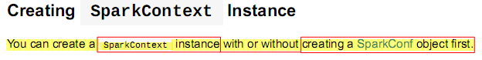

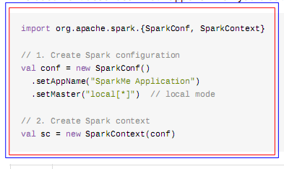

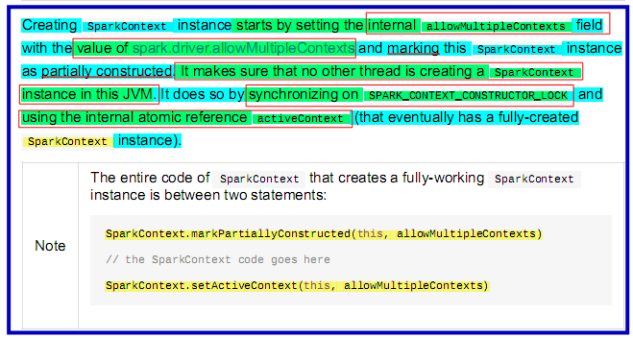

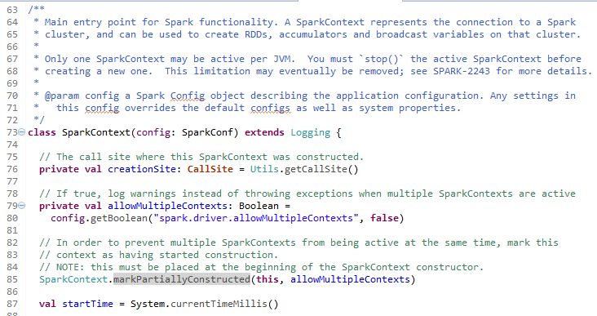

To

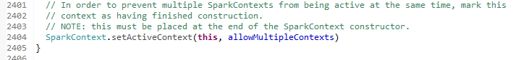

STARTS-from

// If true, log warnings instead of throwing exceptions when multiple SparkContexts are active
private val allowMultipleContexts: Boolean =
config.getBoolean("spark.driver.allowMultipleContexts", false)

// In order to prevent multiple SparkContexts from being active at the same time, mark this
// context as having started construction.
// NOTE: this must be placed at the beginning of the SparkContext constructor.
SparkContext.markPartiallyConstructed(this, allowMultipleContexts)

val startTime = System.currentTimeMillis()

