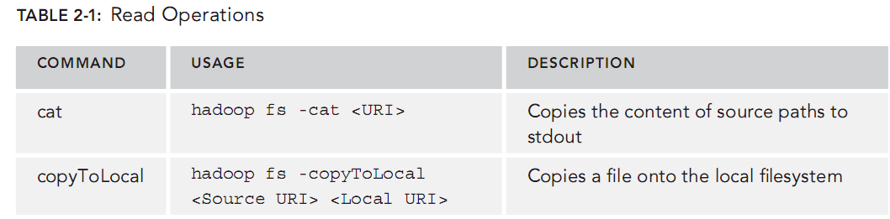
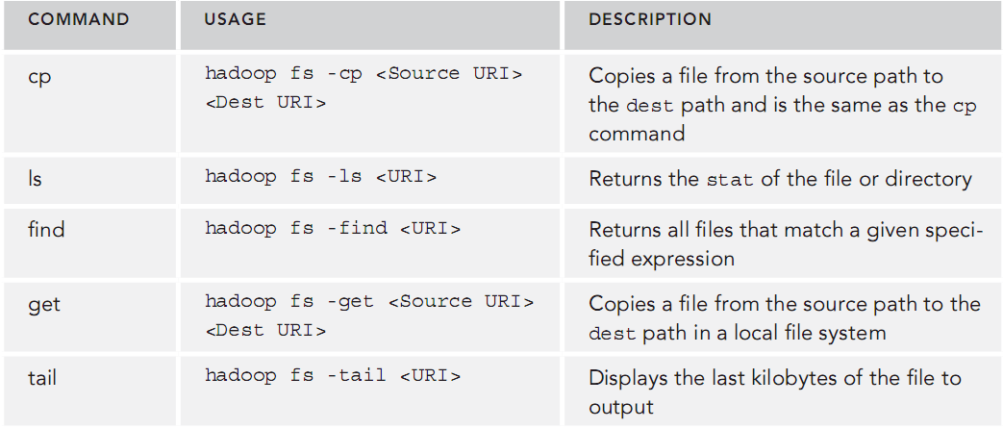
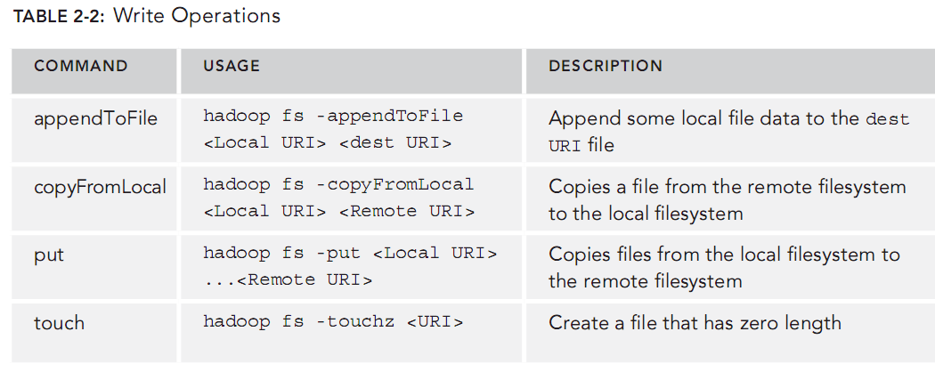
Wrox.Professional.Hadoop.111926717X

Wrox.Professional.Hadoop.111926717XBenoy Antony
Konstantin Boudnik
Cheryl Adams
Branky Shao
Cazen Lee
Kai Sasaki
