Table of Contents
Wrox.Professional.Hadoop.111926717X 2
Spark™ - Big Data Cluster Computing in Production 6

Wrox.Professional.Hadoop.111926717X

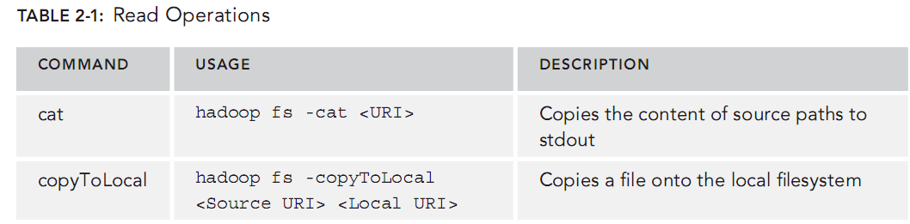
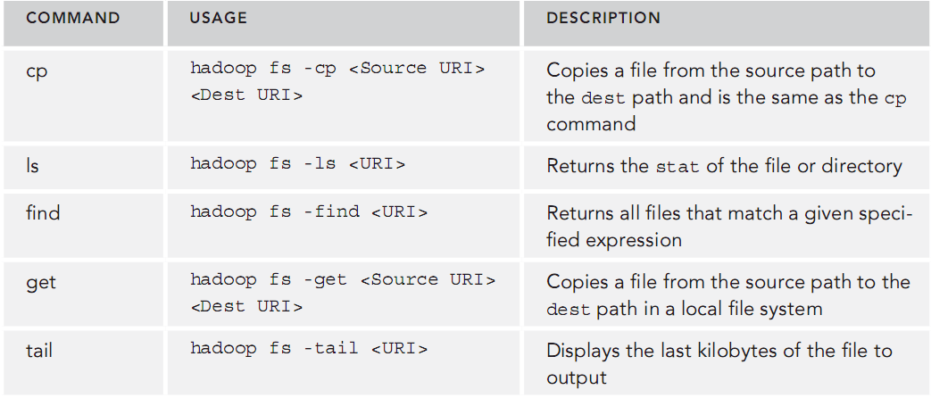
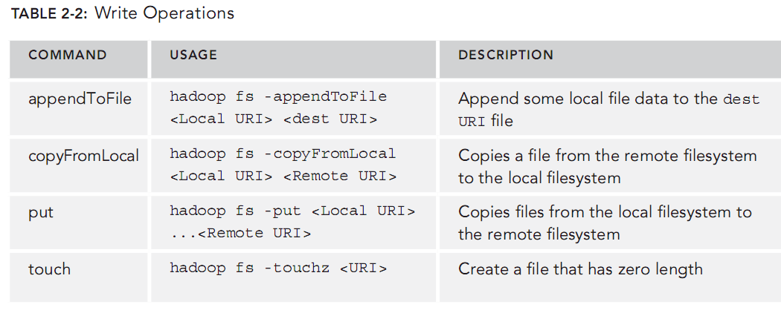
Wrox.Professional.Hadoop.111926717X

Wrox.Professional.Hadoop.111926717X
Benoy Antony, Konstantin Boudnik, Cheryl Adams, Branky Shao, Cazen Lee, Kai Sasaki
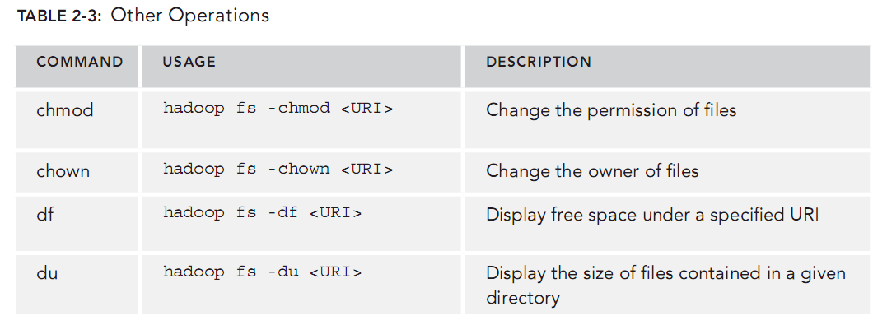
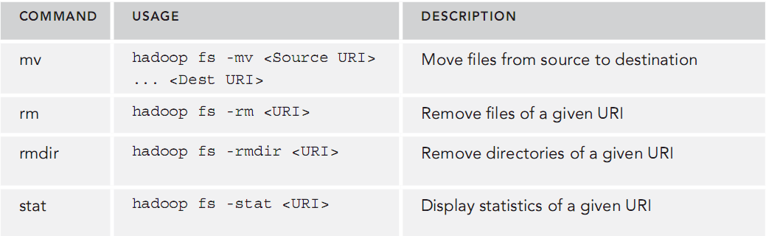
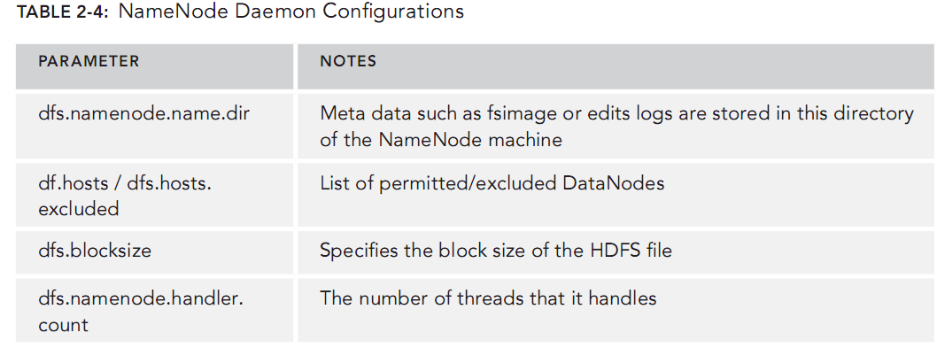

Spark™ - Big Data Cluster Computing in Production
Spark™ - Big Data Cluster Computing in Production

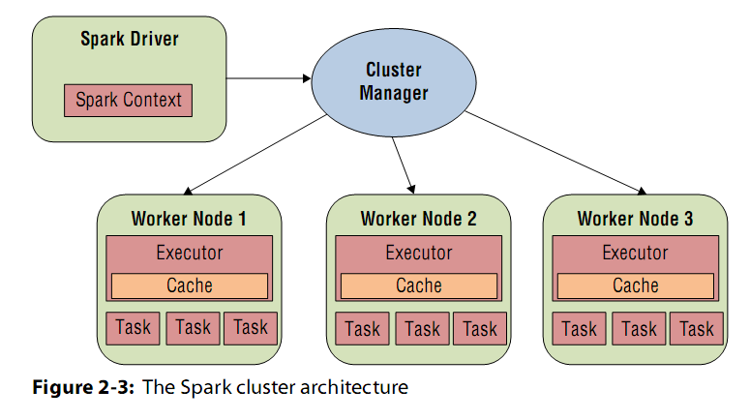

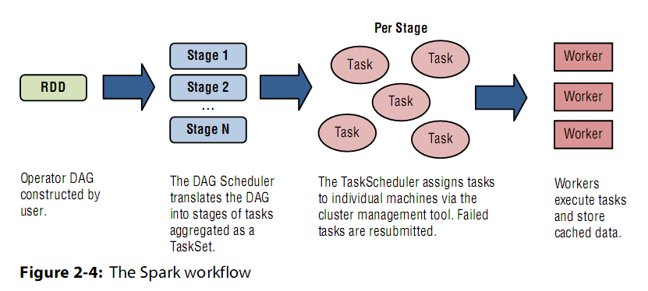

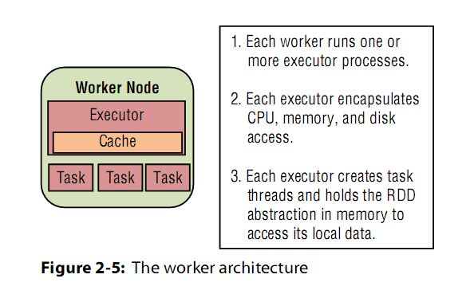

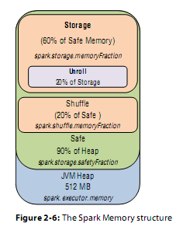

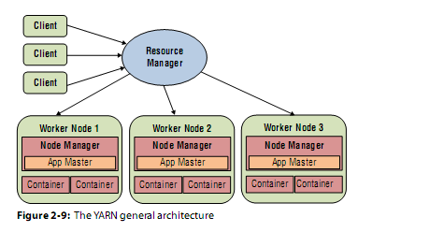

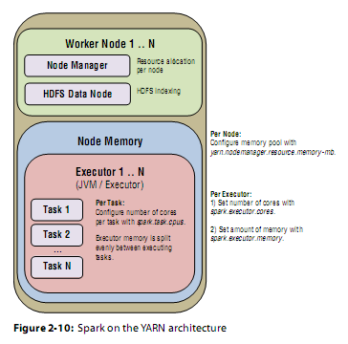

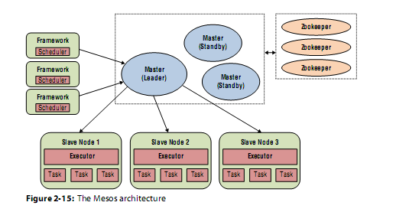

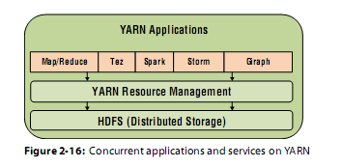

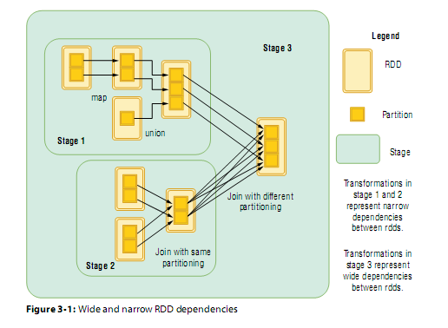

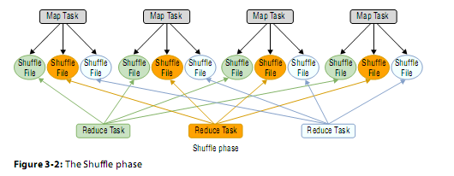

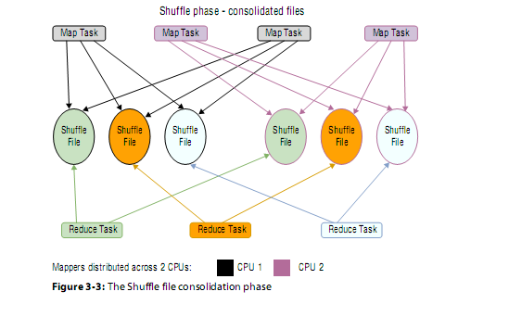

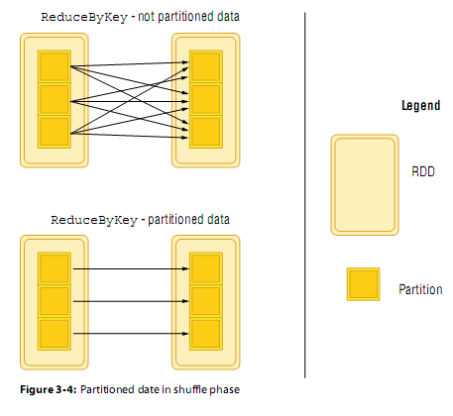

Pro Spark Streaming

The low-latency stipulation of streaming applications, along with requirements they share with
general Big Data systems—scalability, fault-tolerance, and reliability—have led to a new breed of real-
time computation. At the vanguard of this movement is Spark Streaming, which treats stream processing
as discrete microbatch processing. This enables low-latency computation while retaining the scalability
and fault-tolerance properties of Spark along with its simple programming model. In addition, this gives
streaming applications access to the wider ecosystem of Spark libraries including Spark SQL, MLlib,
SparkR, and GraphX. Moreover, programmers can blend stream processing with batch processing to create
applications that use data at rest as well as data in motion. Finally, these applications can use out-of-the-
box integrations with other systems such as Kafka, Flume, HBase, and Cassandra.

, Project Tungsten (first cut in Spark 1.4) has improved the performance of the
underlying engine by many orders of magnitude. When I first started writing the book, the latest version of
Spark was 1.4. Since then, there have been two more major releases of Spark (1.5 and 1.6). The changes in these
releases have included native memory management, more algorithms in MLlib, support for deep learning via
TensorFlow, the Dataset API, and session management. On the Spark Streaming front, two major features have
been added:
mapWithState to maintain state across batches and
using back pressure to throttle the input rate in case of queue buildup.

In addition, managed Spark cloud offerings from the likes of Google, Databricks, and IBM have lowered the barrier to entry for developing and running Spark applications.

Packt.Machine.Learning.with.Spark.2nd.Edition.1785886428

mastering-apache-spark—jacek-lackowski.pdf

Apache Spark
Apache Spark is an open-source distributed general-purpose cluster computing
framework with (mostly) in-memory data processing engine that can do ETL, analytics,
machine learning and graph processing on large volumes of data at rest (batch processing)
or in motion (streaming processing) with rich concise high-level APIs for the programming
languages: Scala, Python, Java, R, and SQL

