ECEN5283 Project 4. Image Segmentation
(Due on March 27, 2013)

In this project, you will apply two clustering techniques learned from the class, K-means and EM, to solve the problem of image segmentation. Two mosaic images (mosaicA.bmp and mosaicB.bmp) are given, and the ground truth maps (mapA.bmp and mapB.bmp) are also provided for numerical comparison. The features to be involved will a multi-dimensional feature vector extracted by a Gabor filter bank. You can use the optimal parameters in your Project 3 here for feature extraction. Then, you need to implement three clustering algorithms based on feature vectors extracted from each pixel.

Specifically, you need to discuss the following issues.
- Please try to use random initialization for K-means which can be used to initialize the EM algorithm. How does the initialization affect the clustering performance?
- Compare the two clustering algorithm in terms of their sensitivity to initialization and their clustering performance.
- Plot the objective function vs. the iteration number for K-mean and EM under different initialization settings. For EM, please compute and compare both the incomplete and complete data log-likelihoods.
- Plot the segmentation accuracy vs. the iteration number for K-means and EM under different initialization settings.
- Find a couple of color images and add RGB (3-channel colors) or XY (pixel coordinates) feature along with Gabor features for segmentation. Discuss your findings.

Report Requirements.
- Briefly discuss the formulation of the two clustering algorithms.
- The source code of each algorithm should be attached.
- Demonstrate your experimental results and discuss your any interesting findings.
- Create a video to show step-by-step segmentation results for each image.
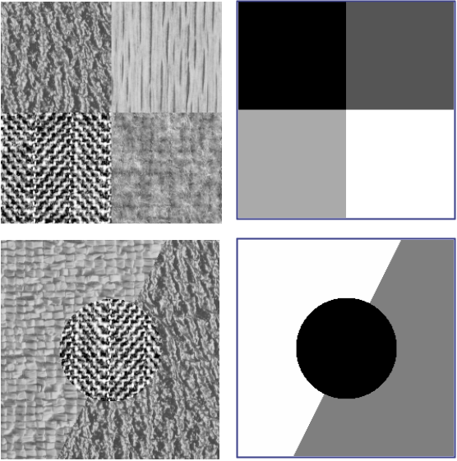

Note : Two Matlab functions are provided. One is for Gabor filtering and the other is for computing the segmentation accuracy by comparing two segmentation maps.

