CHAPTER IV

CENTRAL PHILIPPINE UNIVERSITY ALUMNI ASSOCIATION INCORPORATED (CPUAAI) WEBSITE VER 2.0

*System Overview*

The CPUAAI website in 2013 has given the team an opportunity to come up with an idea to develop a study on which it would be beneficial to both the embodying alumni and its office by enhancing and adding some features to the existing system. As the existing system was studied and reviewed, the system requirements were carefully studied and analyzed in order to give solutions to the problem that were encountered and was not addressed by the current system. Therefore, the CPUAAI Website v. 2.0 was proposed and developed.

The CPUAAI Website v 1.0 is composed of seven main modules: Alumni Membership, New Requests, Web Members, Announcement and News, Event Registration, Payment Donation, Election and Graduates Tracker. Each of these modules has its own main functions that allows the manipulation of data that is essential to the whole systems overall functionality. The alumni membership module accepts the information from all the alumni applicants of Central Philippine University and once approved by the administrator, they are permitted to update their profile to update additional information. Upon successful registration, the other modules will be available for their use. The second module is the New request module, which is intended for the use of the administrator to allow them to control the users who intends to register through the website. The third module, Web Members module, includes the list of members registered as well as those who intends to subscribe for the newsletter being sent out to , to stay in touch with all the events that are hosted by the CPUAAI. The fourth module, Announcement and News, allows the administrator to create the different announcement and news that they intend to send out to all those who are registered. The fifth module, the Event Registration , is very essential during the alumni homecoming event , as hosted by the CPUAAI office, this becomes easy for those who are employed and live abroad.

Since there are modules that has been found to be lacking on the current website that is existing, a recommendation was made that a vast improvement must be needed to the CPUAAI Website Version 1.0. This then allowed the proponents to grab the opportunity to be able to explore the current CPUAAI website and evaluate its current standing and develop a much more productive CPUAAI website. This then is called the CPUAAI Website v 2.0.

The version two of the CPUAAI Website will retain the features and interfaces of the first system. There are three different kinds of interfaces; they are the public user, members and administrator, respectively. Public users has limited features or restricted functions of the website. Public users can view the official homepage of the website and they can view selected parts of the website such as the news and events that are posted on the webpage but they are not allowed to request to the website administrator to publish news and events they want. These type of users are not also allowed to search and view the personal information of an alumnus. Lastly, the public users don’t have the privilege to vote online.

The member interface is for every online registered member of our website. They have access to the features of the website. They can search and view information about the other alumni members, send information of their donation to the alumni office, have access to information on registration details and participate on events, can request for posting of announcements, vote online on the election poll and message the website administrator. Admin interface have access to all the functionalities of the website. It is the only interface that can update the information of the website and. They can accept request for an alumni card, posting of news and announcements, etc. This interface allows the web administrator to view and manage the alumni transactions better.

The CPUAAI Website v. 2.0 has added these following features; a web-service-application that will allow updating of its list of alumni members every end of each semester. The information will be synchronized with the records in the CPU-MIS department through the use of a web service. News and events publishing that will send teaser information via e-mail that will accommodate all the online registered alumni members. Notifications function that allows the alumni user to be informed of important messages and events that have occurred while offline. These notifications will be sent via e-mail. Teleconference feature that will allow the alumni members to communicate with each other through video conference and real-time chat.

*System Objectives*

1. Present a user friendly environment that allows the users to navigate the website easily.
2. Updated list of alumni members are synchronized automatically with that of the records of the current semester as provided by the CPU-MIS department.
3. News and events publishing are properly disseminated to all registered alumni members thru email notifications.
4. Provides the administrator a notification prompt upon new activity has commenced on the user side.
5. Allows the users to user to communicate with other registered alumni members through instant messaging and video conferencing.

*System Functions*

*Public Interface.* A webpage for all the viewers of the website but it is only limited features.

*Home.* It allows the user to directly go back to the home page.

*About Us.* It allows the user to view all the information about CPUAAI.

*Directory.* It allows the user to view and search the list of all the alumni.

*Donations.* It allows the user to post donations made to the alumni organization.

*Gallery.* It allows the user to view pictures uploaded by the admin.

*News/Events.* It allows the user to be updated by latest news.

*Login.* It allows the user to sign in.

*Register.* It allows the user to register/sign-up.

*Retrieve Password.* It allows the user to retrieve their password.

*Contact Admin.* It allows the user to send message to the admin.

*Member Interface.* A webpage for all the members of the website that are registered.

All the buttons in the public interface can also be seen in the members interface except for; Login, Register, Retrieve Password and Contact Admin.

These are the additional functional buttons in the member interface that cannot be seen in the public interface.

*Voting Ballot.* It allows the user to vote online.

*Events.* It allows the user to join events.

*Profile.* It allows the user to update their information.

*Log out.* It allows the user to log out from the page

*Admin Interface.* An interface that will able to control all the functionalities of the website and it is exclusive only for the administrator.

*Alumni.* It allows the administrator to view all the alumni members.

*Requests.* It allows the administrator to view and accept the request for alumni membership, alumni card, donations and appointments.

*Web Members.* It allows administrator to view online registered members and the newsletter subscribers.

*Events.* It allows the administrator to manage the posting of the events that can be viewed by the online registered alumni members.

*Announcements/News.* It allows the administrator to create post and details of information of announcements and events.

*Election.* It allows the administrator to add and update nominees for the election.

*Administrator Privileges.* It allows the administrator to assign administrator privileges to selected online registered members in order to facilitate the registration process in given certain events.

*Physical Environment*

*Hardware Specification*

|  |  |
| --- | --- |
| CPU Type Model | Dual Core 2.4GHz or Higher |
| Storage Type | 160 GB Hard Disk or Higher |
| Input | Standard mouse, Keyboard |
| Output | LCD Monitor |

*Software Specifications*

|  |  |
| --- | --- |
| Operating System | Microsoft Windows 7 (Ultimate) |
| Front End | PHP, JSON, AJAX, CSS |
| Back End | MySQL (Phpmysql.5.1 ) |
| Graphical User Interface | Dreamweaver (CS5) |

*Operating System: Microsoft Windows 7*

Windows 7 is an operating system released by Microsoft on October 22, 2009. It follows the previous (sixth) version of Windows, called Windows Vista.

Like previous versions of Windows, Windows 7 has a graphical user interface (GUI) that allows you to interact with items on the screen using a keyboard and mouse. However, Windows 7 is also includes a feature called "Windows Touch" that supports touchscreen input and multi-touch functionality. Windows 7 is bundled with several touch-ready programs that are designed for touchscreen use.

Windows 7 also includes several new multimedia features. One example is "Play To," a program that allows you to stream audio and video to different computers or devices within your house. The "Home Group" feature makes it easy to share media files and other data between computers. It also makes it possible to share printers on a home network. The "Remote Media Streaming" feature allows you to access the music, video, and photo libraries on your computer from remote locations.

The search feature in Windows 7, called "Windows Search," allows you to see results of searches as soon as you start typing in the search box. Windows Search categorizes the results by file type and displays text snippets that indicate where the search phrase was found in each result. After the search results are returned, it is possible to narrow the results by filtering them by date, file type, file size, and other parameters. You can search local drives, external hard drives, and networked drives all using the standard Windows Search interface. (http://www.techterms.com/definition/windows7)

The researchers would recommend this operating system in our proposed system because of its compatibility with the programming language that was used to create the system and it gives convenience to the users.

*Front End: PHP, JSON, AJAX, CSS*

PHP stands for "Hypertext Preprocessor." (It is a recursive acronym, if you can understand what that means.) PHP is an HTML-embedded Web scripting language. This means PHP code can be inserted into the HTML of a Web page. When a PHP page is accessed, the PHP code is read or "parsed" by the server the page resides on. The outputs from the PHP functions on the page are typically returned as HTML code, which can be read by the browser. Because the PHP code is transformed into HTML before the page is loaded, users cannot view the PHP code on a page. This make PHP pages secure enough to access databases and other secure information.(http://www.techterms.com/defin/php)

PHP serves as the main gateway of coding for the CPUAAI Website. Being the sole and main source of the coding, this has given the programmer the comfortability in using this to develop and further enhance the system.

JSON stands for "JavaScript Object Notation" and is pronounced like the name "Jason." JSON is a text-based data interchange format designed for transmitting structured data. It is most commonly used for transferring data between web applications and web servers.

JSON is often viewed as an alternative to XML, another plain text data interchange format. In most cases, the JSON representation of an object is more compact than the XML representation because it does not require tags for each element.  (http://www.techterms.com/definition/json)

JSON became a part of the system as to mainly decode the source code by the CPU-MIS to be allow the uploading of data of the alumni list into the system proper. JSON allows the file format compatibility to be available so that it will automatically be accepted by the web application of the CPUAAI ver2.0.

Ajax is a combination of Web development technologies used for creating dynamic websites. While the term "Ajax" is not written in all caps like most tech acronyms, the letters stand for "Asynchronous JavaScript and XML." Therefore, websites that use Ajax combine JavaScript and XML to display dynamic content.

The "asynchronous" part of Ajax refers to the way requests are made to the Web server. When a script sends a request to the Web server, it may receive data, which can then be displayed on the Web page. Since these events happen at slightly different times, they are considered to be asynchronous. Most Ajax implementations use the XML Http Request API, which includes a list of server requests that can be called within JavaScript code. The data is usually sent back to the browser in an XML format, since it is easy to parse. However, it is possible for the server to send data as unformatted plain text as well.

What makes Ajax so powerful is that scripts can run on the client side, rather than on the server. This means a JavaScript function can make a request to a server after a webpage has already finished loading. The data received from the server can then be displayed on the page without reloading the other content. If a server-side scripting language like PHP or ASP was used, the entire page would need to be reloaded in order for the new content to be displayed. (http://www.techterms.com/definition/ajax)

Ajax allows the combination of codes to be accept and be understood by PHP. With it being allowed, extensible coding of the data manipulated within the system, including on the area of email notification, caters to a much more efficient executable result.

CSS stands for "Cascading Style Sheet." Cascading style sheets are used to format the layout of Web pages. They can be used to define text styles, table sizes, and other aspects of Web pages that previously could only be defined in a page's HTML.

CSS helps Web developers create a uniform look across several pages of a Web site. Instead of defining the style of each table and each block of text within a page's HTML, commonly used styles need to be defined only once in a CSS document. Once the style is defined in cascading style sheet, it can be used by any page that references the CSS file. Plus, CSS makes it easy to change styles across several pages at once. For example, a Web developer may want to increase the default text size from 10pt to 12pt for fifty pages of a Web site. If the pages all reference the same style sheet, the text size only needs to be changed on the style sheet and all the pages will show the larger text.

While CSS is great for creating text styles, it is helpful for formatting other aspects of Web page layout as well. For example, CSS can be used to define the cell padding of table cells, the style, thickness, and color of a table's border, and the padding around images or other objects. CSS gives Web developers more exact control over how Web pages will look than HTML does. This is why most Web pages today incorporate cascading style sheets. (http://www.techterms.com/definition/css)

CSS defines a different perspective especially when coding the window sizes that will be adopted in the system. This is one of the best things of CSS once connected to PHP.

*Back End: MySQL (Phpmysql.5.1 )*

MySQL is an Application Programming Interface, or API, defines the classes, methods, functions and variables that your application will need to call in order to carry out its desired task. In the case of PHPMySQL applications that need to communicate with databases the necessary APIs are usually exposed via PHP extensions.

APIs can be procedural or object-oriented. With a procedural API you call functions to carry out tasks, with the object-oriented API you instantiate classes and then call methods on the resulting objects. Of the two the latter is usually the preferred interface, as it is more modern and leads to better organized code.

When writing HPMySQLapplications that need to connect to the MySQL server there are several API options available. This document discusses what is available and how to select the best solution for your application. (http://php.net/manual/en/mysqli.overview.php)

*Graphical User Interface: Dreamweaver CS5*

Designing for the web has always been a mixture of right-brain and left-brain disciplines. Over the years, Dreamweaver has strived to recognize and support that. To balance these often-conflicting mindsets, Dreamweaver development team talks to many, many customers each product cycle to find out what's working, what isn't, and what types of workflows and technologies are most important to them. As a result, a few things became very apparent as they started the planning process for Adobe Dreamweaver CS5.

Dreamweaver CS5 turns Live View into a mini browser that enables you to navigate an application through different design states, such as a blog posting, comment form, or search results page. It can navigate Live View by following links, and even view (and inspect using the rich CSS tools in Dreamweaver) the remote source markup and CSS directly. It can be tough to always track down the exact file you need in a dynamic application. The Dynamically Related Files feature in Dreamweaver CS5 tracks down all those references for you in the Related Files bar, and even sorts them based on your preferences. No more digging around for that one file you need. Now you can easily find it in the Related Files bar.

 Dreamweaver CS5 integrates smoothly with Adobe Browser Lab, Adobe's new service for cross-browser and operating system previewing. Either visit browserlab.adobe.com and enter a URL for testing, or send any local design in Dreamweaver directly to Browser Lab for preview. Using Live View (and new navigation features), you can drive any web page, site, or application to a given design state, pause it, and then send that state of the page to Browser Lab directly.

These are just the highlights of Dreamweaver CS5. In addition to these new features, Dreamweaver CS5 offers tons of small enhancements, fixes, tweaks, and improvements. We hope that instead of noticing them specifically, you simply notice that Dreamweaver is smoother and more comfortable to use than ever before. (http://www.adobe.com/inspire-archive/april2010/articles/article4/?trackingid=FDTKA)

Dreamweaver delivers a different feel to the user on a graphical user interface level. As it give a realistic scenario, the use of the website becomes much more valuable and worthwhile, especially when a videoconferencing occurs.

*Cost of Development*

*Hardware Development Cost*

|  |  |
| --- | --- |
| 1 Client/Server Complete Desktop | PHP 12,500.00 |
| Router | PHP 2,000.00 |
| Microsoft Windows 7 | PHP 4,800.00 |
| Dreamweaver | PHP 18,000.00 |
| **Total Hardware Development Cost** | **PHP 37,300.00** |

*System Development Cost*

|  |  |
| --- | --- |
| Project Leader | PHP 16,000.00 |
| System Analyst | PHP 15,000.00 |
| System Programmer | PHP 18,000.00 |
| System Designer | PHP 14,000.00 |
| Researcher | PHP 12,000.00 |
| **Total System Development Cost** | **PHP 75,000.00** |

*System Depreciation*

*Hardware Depreciation*

(Php37, 300.00 /5 years estimated useful life) = Php7, 460.00)

|  |  |  |  |  |  |  |
| --- | --- | --- | --- | --- | --- | --- |
| **Year** | **0** | **1** | **2** | **3** | **4** | **5** |
| Amount | 37,300.00 | 29,840.00 | 22,380.00 | 14,920.00 | 7,460.00 | 0.00 |

*Software Depreciation*

(Php75, 000.00 / 10 years estimated useful life) = Php7, 500.00)

|  |  |  |  |  |  |  |
| --- | --- | --- | --- | --- | --- | --- |
| **Year** | **0** | **1** | **2** | **3** | **4** | **5** |
| Amount | 75,000.00 | 67,500.00 | 60,000.00 | 52,500.00 | 45,000.00 | 37,500.00 |

|  |  |  |  |  |  |
| --- | --- | --- | --- | --- | --- |
| **Year** | **6** | **7** | **8** | **9** | **10** |
| Amount | 30,000.00 | 22,500.00 | 15,000.00 | 7,500.00 | 0.00 |

*Intangible and Tangible Benefits*

By enhancing and adding new features to the website, it will be useful and greatly benefit the CPUAAI Office and all the students and alumni of Central Philippine University.

Tangible Benefits

* Availability of the website and its services for all members of the CPUAAI.
* Minimize printed reports.
* Lessen the time spent in encoding the details of new CPUAAI members into the computer.

Intangible Benefits

* Improves efficiency in terms of searching and contacting fellow alumnus.
* Security of communication with other alumnus and also with online voting.
* A real time system interface that allows encoded information to be monitored immediately after viewed by the user for instant messaging.

*Architectural Design*

*Use Case Diagram of the Proposed System*

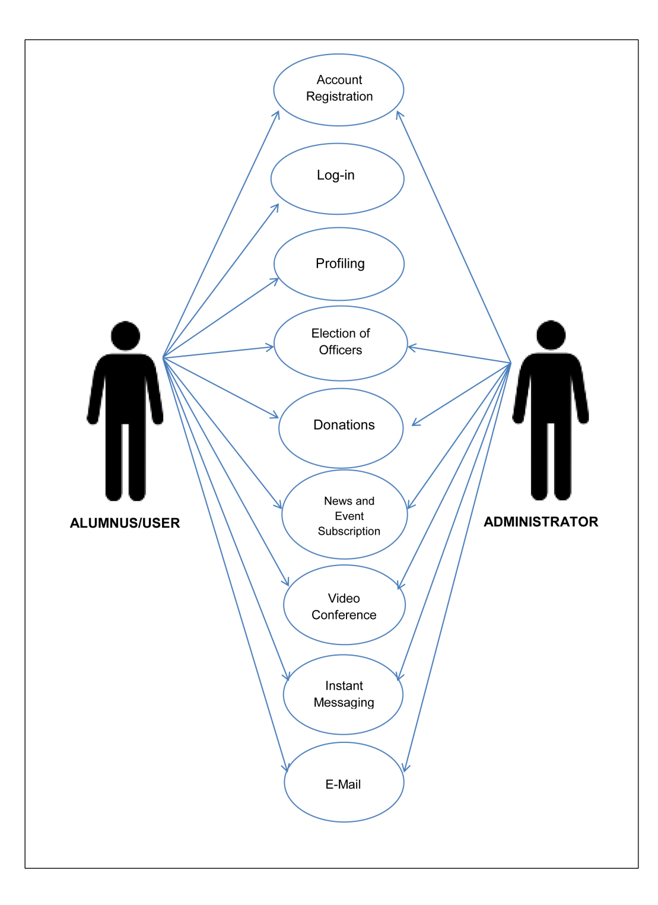

Figure 4.0 Use Case Diagram of the Proposed System

The online membership of the system can be accessed mainly by two users, the alumnus/user and administrator. With the different modules presented on the diagram, each has its own set of access level for each process it may encounter. The administrator who has full access can manage all the processes which includes the managing of the account registrations of those alumnus whose records are not found on the database by the time they have graduated, the elections of the board of alumni officers, posting of donations, news and events subscriptions and the web conferencing.. The alumnus /user tasks are limited to only logging in, registering a new account, updating their own profile, nominating a candidate for a position on the election, request for posting their donation, subscribing to news and events, and participating in the web conference.

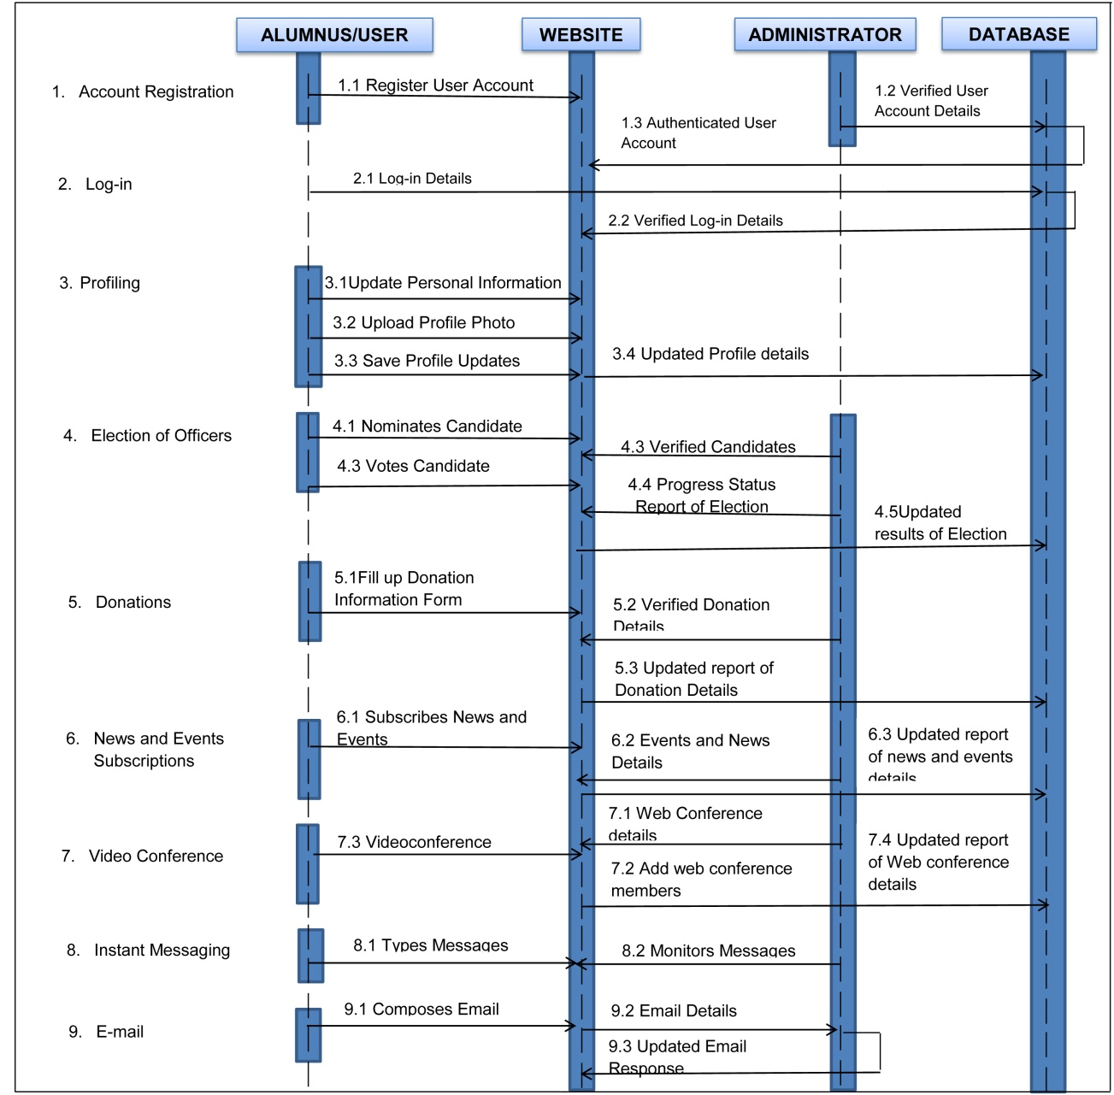

Figure 5.0 Sequence Diagram of the Proposed System

Figure 5.0 presents the detailed manipulation of processes and steps that is being done by the administrator and the customer/user. As each task progress, the interaction tasks between the user and platform is very well explained.

On the following activity diagram presented below, a detailed explanation of the steps taken by the user and administrator on using the android and web application for doing ordering and event registration will be furthered.

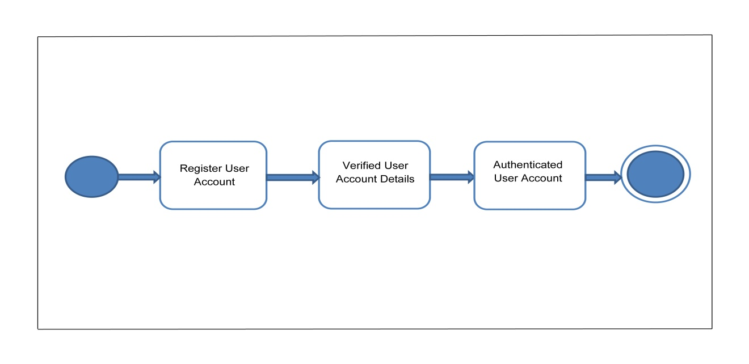

Figure 6.0 Activity Diagram – Account Registration

There are only two major entities that interact with the CPUAAI website. The entities as shown in Figure 5.0 are the user and the admin/CPUAAI staff, where the user will register its name in order to be a member of the website. It will be automatically synchronize with the database records in order to verify the registration. After the registration, the system will update the status of the registered alumni member. The user or the registered online member will then be able to fully use the system features such as the video conferencing. The administrator will have the authority to manage the registered alumni web members. The admin also have the authority to accept or reject any event request and posting of news and announcement that is requested by the member. The admin is the one who manipulates all the system.

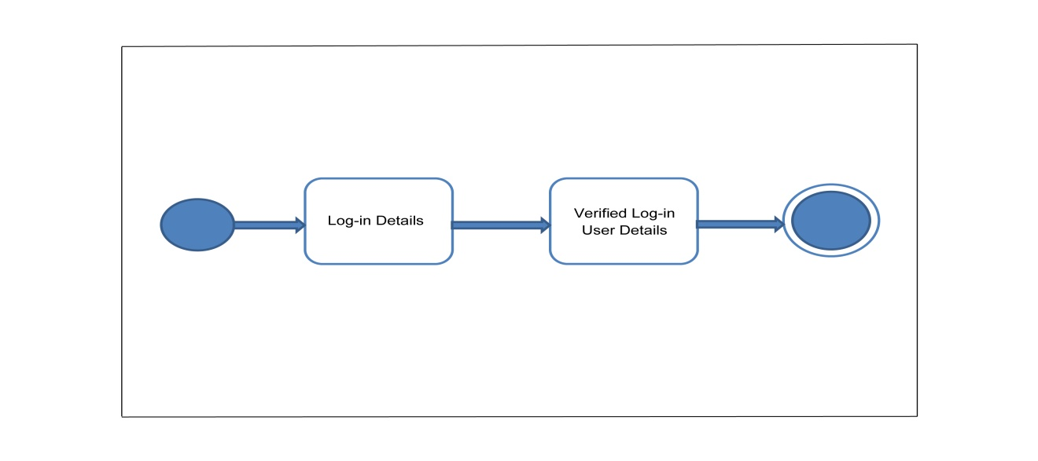

Figure 7.0 Activity Diagram - Log-in

The Figure 7.0 shows the user/alumnus logs-in his/her username such as e-mail and password. It is then verified by the system by synchronizing the information entered to the details in the database.

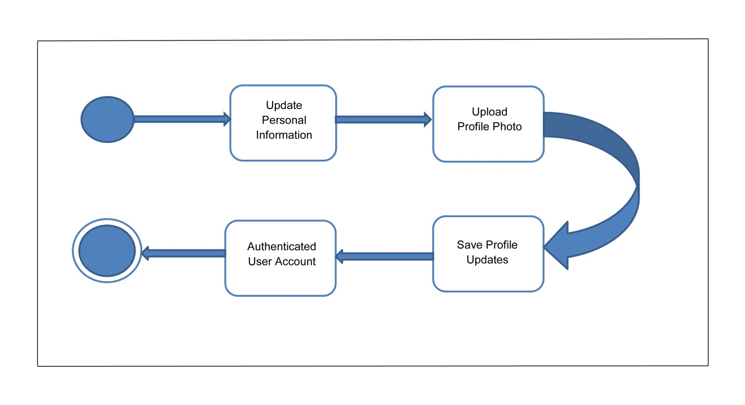

Figure 8.0 Activity Diagram – Profiling

The Figure 8.0 shows the process where the user can update his/her personal information details and uploads a profile photo for identification purposes. The updated profile will then be saved to the database system.

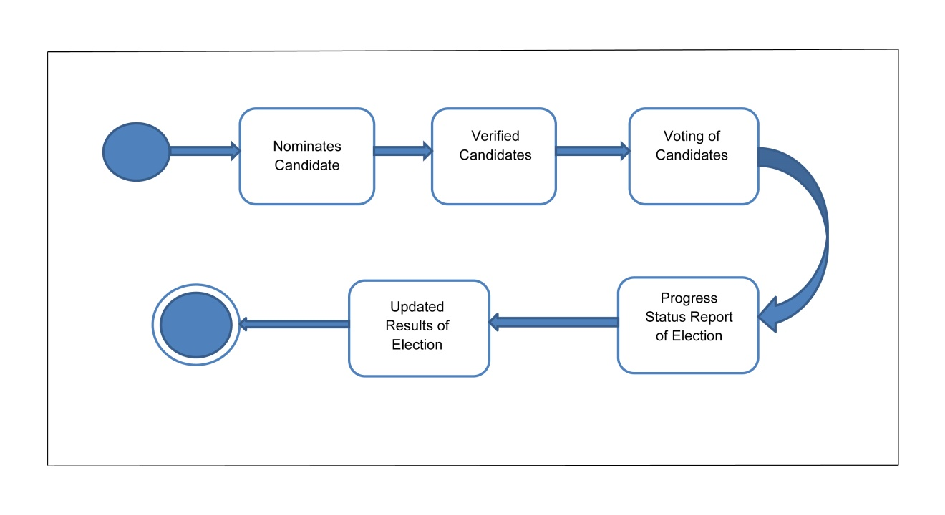

Figure 9.0 Activity Diagram – Election of Officers

The Figure 9.0 shows the election of officer’s module where the user can nominate and vote for a certain alumni member. The administrator then verifies the eligibility of the nominated candidate and manages the election poll. The election results are then record and saved to the database system.

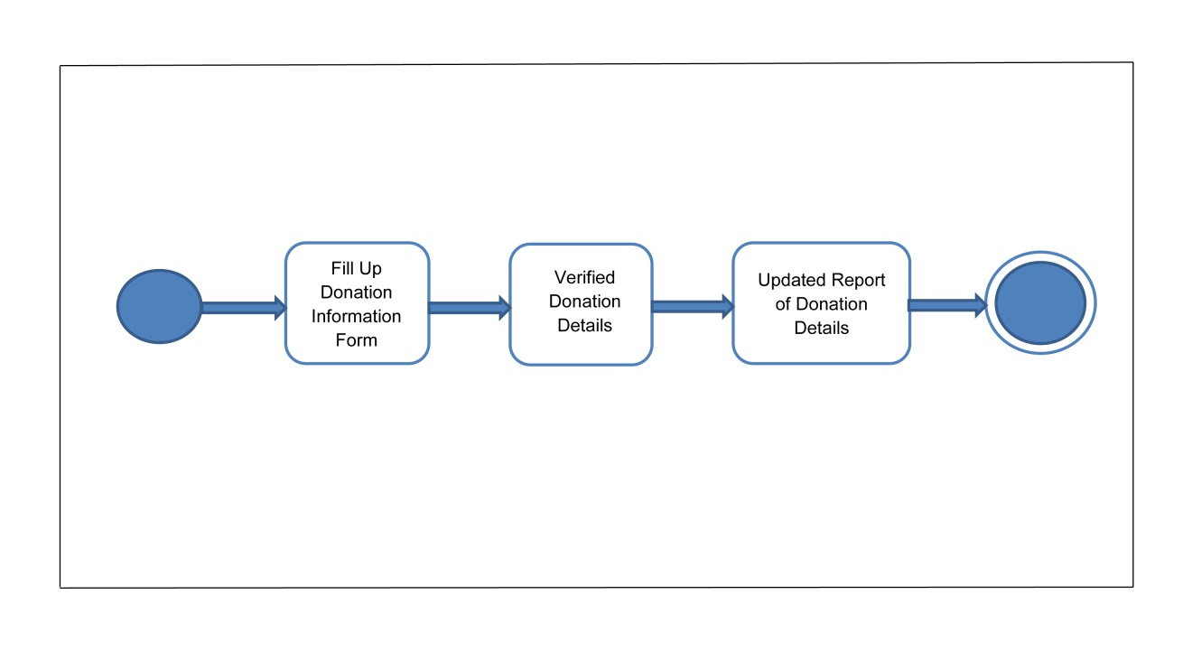

Figure 10.0 Activity Diagram – Donations

The Figure10.0 shows the donations module where the user can ask the administrator for posting of his/her donations made to the organization. The user fills up the donation information form. The administrator checks and verifies the donations made by the user and then posts it on the website. The donation reports are then saved to the database system.

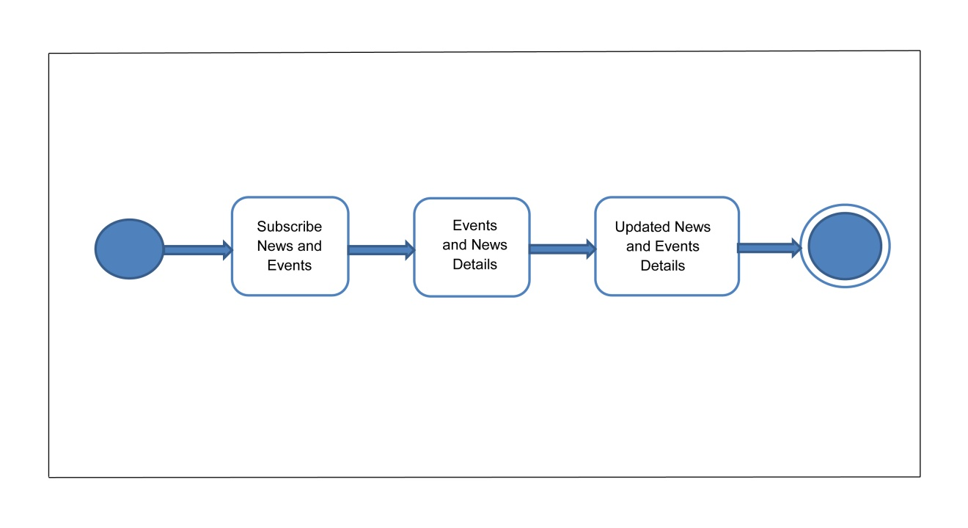

Figure 11.0 Activity Diagram – News and Events Subscription

The figure 11.0 shows the module of news and events subscription of the user. The user subscribes to news and events where every time the administrator creates and post new details about news and events, the user will be able to be notified every time the user logs-in his/her account on the website.

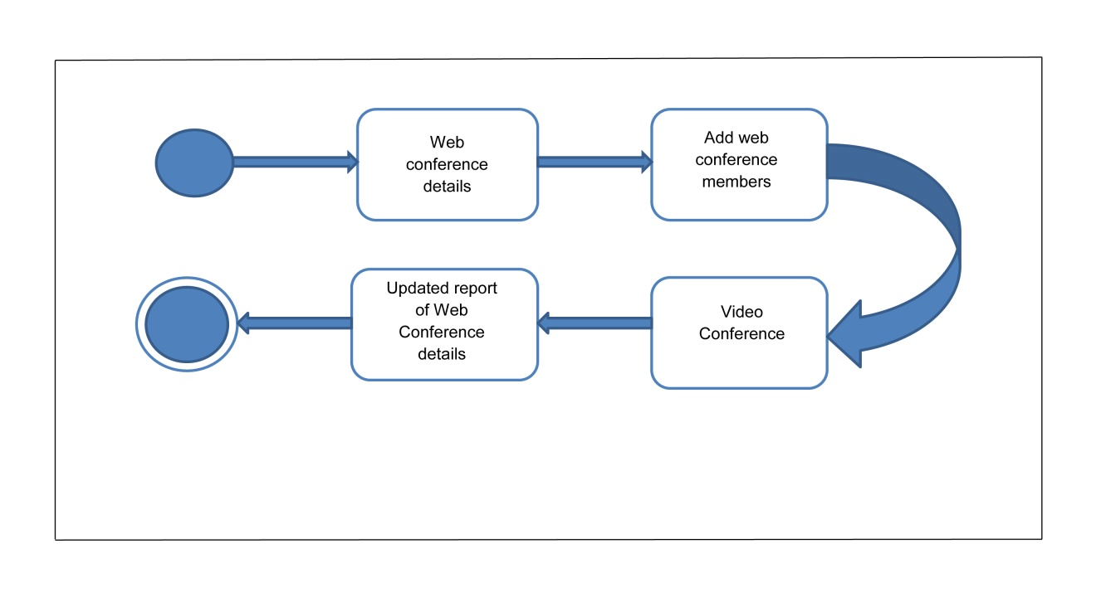

Figure12.0 Activity Diagram – Web Conference

The figure 12.0 shows the web conference module where the administrator creates a web conference and selects members to join the video conference. The administrator sends the link to selected member to join the conference via e-mail. The user invited to join the video conference will be able to join the video conference through the URL link. The user will be able to chat and video call other members in the conference.

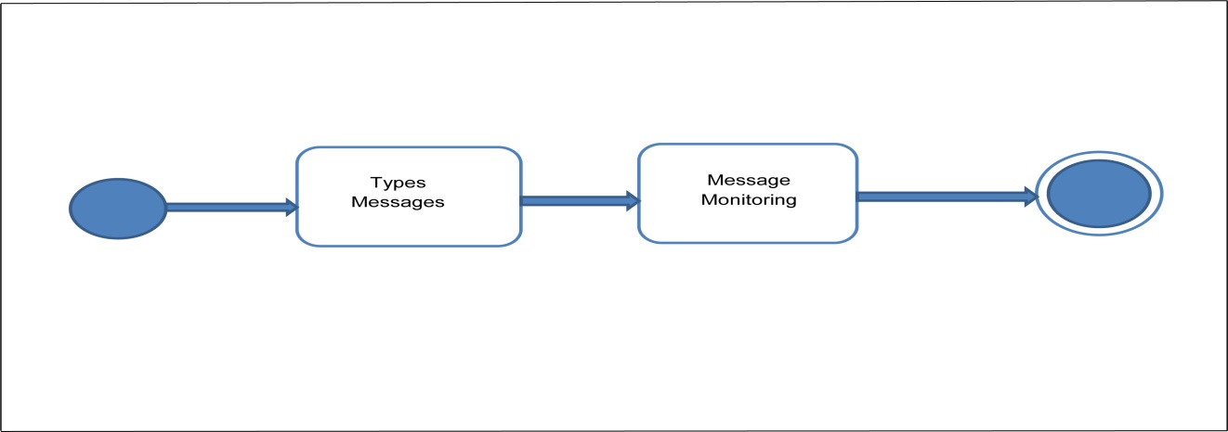

Figure 13.0 Activity Diagram – Instant Messaging

The Figure 13.0 shows the instant messaging function of the system where the user can create messages and converse real time with another fellow user that is currently log-in the system and video conference. The system administrator then monitors the messages that are being sent.

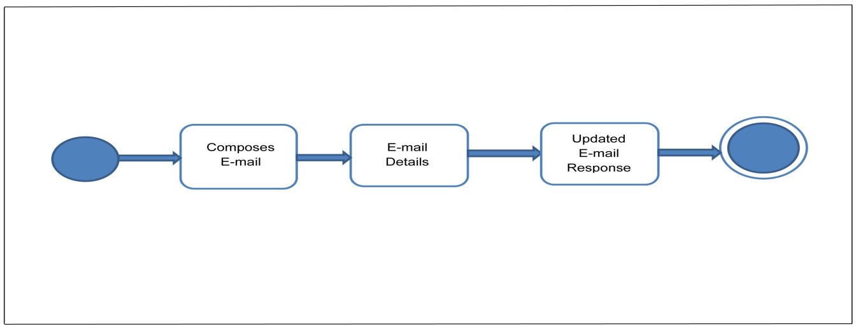

Figure 14.0 Activity Diagram – E-mail

The Figure 14.0 shows the E-mail function of the system where the user can send e-mail to contact the administrator for alumni card subscription and other inquiry. The system then allows the administrator to view the e-mail and then respond to the user about their e-mail.

*Database Structure*

Database Name : scoreon1_cpuaai

Table Number : 1

Table Name : additionalSubscriber

Primary Key : ID

Foreign Key : None

|  |  |  |  |
| --- | --- | --- | --- |
| Field Name | Field Type | Field Size | Field Description |
| ID | int | 11 | ID |
| Email | varchar | 150 | Email Address |
| Date | timestamp | 0 | Date |

This table is used for storing email address of alumni who wishes to enroll in the newsletter.

Database Name : cpuaai_mysql

Table Number : 2

Table Name : alumni

Primary Key : ID

Foreign Key : None

|  |  |  |  |
| --- | --- | --- | --- |
| Field Name | Field Type | Field Size | Field Description |
| ID | int | 100 | ID |
| IDNo | varchar | 100 | ID number of alumni |
| Lname | varchar | 150 | Last name |
| Fname | varchar | 100 | First name |
| Mname | varchar | 100 | Middle name |
| Bday | date | 0 | Birthday |
| Department | varchar | 100 | Department |
| City | varchar | 100 | City |
| ProState | varchar | 100 | Province and state |
| ZipCode | int | 100 | Zip code |
| ContactNo | varchar | 100 | Contact Number |
| EmailAdd | varchar | 100 | Email Address |
| DateApp | date | 0 | Date Applied |
| DateRel | date | 0 | Date Release |
| Note | varchar | 250 | Note |
| Membership | char | 2 | Membership |

This table is used for the profile details of the registered member.

Database Name : cpuaai_mysql

Table Number : 3

Table Name : announcements

Primary Key : ID

Foreign Key : None

|  |  |  |  |
| --- | --- | --- | --- |
| Field Name | Field Type | Field Size | Field Description |
| ID | int | 99 | ID |
| Title | varchar | 199 | Title |
| Teaser | varchar | 199 | Teaser |
| Body | text | 0 | Body |
| Aauthor | varchar | 150 | Author |
| Sstatus | varchar | 150 | Status |
| Date | timestamp | 0 | Date |

This table is used for the announcement details.

Database Name : cpuaai_mysql

Table Number : 4

Table Name : appointments

Primary Key : none

Foreign Key : None

|  |  |  |  |
| --- | --- | --- | --- |
| Field Name | Field Type | Field Size | Field Description |
| ID | int | 10 | ID |
| Schedule | Datetime | 0 | Schedule |
| WebmemberID | int | 10 | ID of web member |
| Response | Int | 2 | Response |
| Message | varchar | 250 | Message |
| Date | timestamp | 0 | Date |

This table is used for the appointments set by the alumni as per request.

Database Name : cpuaai_mysql

Table Number : 5

Table Name : candidate

Primary Key : ID

Foreign Key : None

|  |  |  |  |
| --- | --- | --- | --- |
| Field Name | Field Type | Field Size | Field Description |
| ID | int | 10 | ID |
| OfficerID | int | 10 | Officer ID |
| AlumniID | varchar | 100 | Alumni ID |
| Status | varchar | 100 | Status |

This table is used for the list of candidates nominated in the election.

Database Name : cpuaai_mysql

Table Number : 6

Table Name : comments

Primary Key : ID

Foreign Key : None

|  |  |  |  |
| --- | --- | --- | --- |
| Field Name | Field Type | Field Size | Field Description |
| ID | int | 10 | ID |
| name | varchar | 100 | name |
| email | varchar | 100 | Email address |
| comment | Text | 0 | comment |
| date | timestamp | 0 | date |
| status | int | 5 | status |

This table is used for the comments of the users.

Database Name : cpuaai_mysql

Table Number : 7

Table Name : donations

Primary Key : ID

Foreign Key : None

|  |  |  |  |
| --- | --- | --- | --- |
| Field Name | Field Type | Field Size | Field Description |
| ID | int | 11 | ID |
| dFname | varchar | 25 | First Name |
| dLname | varchar | 25 | Last Name |
| dMname | varchar | 25 | Middle Name |
| dBankname | varchar | 65 | Bank Name |
| dBankRefNo | varchar | 65 | Bank Reference Number |
| dAmount | int | 25 | Amount |
| dDepositslip | varchar | 250 | Deposit Slip |
| dCurrency | varchar | 10 | Currency |
| dDate | timestamp | 0 | Date |

This table is used for the donations made by the member.

Database Name : cpuaai_mysql

Table Number : 8

Table Name : election

Primary Key : ID

Foreign Key : None

|  |  |  |  |
| --- | --- | --- | --- |
| Field Name | Field Type | Field Size | Field Description |
| ID | int | 10 | ID |
| Title | varchar | 250 | Title |
| Year | int | 4 | Year |
| Status | Int | 4 | Status |

This table is used for election poll data.

Database Name : cpuaai_mysql

Table Number : 9

Table Name : eventregistration

Primary Key : ID

Foreign Key : None

|  |  |  |  |
| --- | --- | --- | --- |
| Field Name | Field Type | Field Size | Field Description |
| ID | int | 115 | ID |
| IDno | int | 115 | ID number |
| ProTitle | varchar | 65 | Profession Title |
| Fname | varchar | 115 | First Name |
| Lname | varchar | 115 | Last Name |
| Mname | varchar | 115 | Middle Name |
| Aage | Int | 11 | Age |
| bday | date | 0 | Birthdate |
| Gnder | int | 11 | Gender |
| Cstatus | int | 11 | Civil Status |
| Cnumber | int | 45 | Contact Number |
| Mnumber | int | 45 | Mobile Number |
| Aaddress | varchar | 99 | Address |
| EmailAdd | varchar | 115 | Email Address |
| DepartCollege | varchar | 99 | Department or College |
| DiplomaCourse | varchar | 99 | Diplomacy Course |
| YearGrad | int | 99 | Year Graduated |

This table is used for the event registration.

Database Name : cpuaai_mysql

Table Number : 10

Table Name : events

Primary Key : ID

Foreign Key : None

|  |  |  |  |
| --- | --- | --- | --- |
| Field Name | Field Type | Field Size | Field Description |
| ID | int | 10 | ID |
| Title | varchar | 150 | Title |
| Description | varchar | 250 | Description |
| Venue | varchar | 250 | Venue |
| Organizer | varchar | 100 | Name of organizer |
| ContactDetails | varchar | 100 | Contact Details |
| SDate | date | 0 |  |
| EDate | date | 0 | Event Date |
| Teaser | varchar | 100 | Teaser |
| Banner | varchar | 100 | Banner |
| Status | varchar | 20 | Status |

This table is used for the list of events created.

Database Name : cpuaai_mysql

Table Number : 11

Table Name : graduates

Primary Key : ID

Foreign Key : None

|  |  |  |  |
| --- | --- | --- | --- |
| Field Name | Field Type | Field Size | Field Description |
| ID | int | 10 | ID |
| StudentID | varchar | 20 | Student ID |
| DateIssued | date | 0 | Date Issued |
| Fname | varchar | 100 | First Name |
| Lname | varchar | 100 | Last Name |
| Mname | varchar | 100 | Middle Name |
| Course | varchar | 150 | Course |

This table is used for the gradutes list.

Database Name : cpuaai_mysql

Table Number : 12

Table Name : member_education

Primary Key : ID

Foreign Key : None

|  |  |  |  |
| --- | --- | --- | --- |
| Field Name | Field Type | Field Size | Field Description |
| ID | int | 10 | ID |
| Wid | int | 10 |  |
| IDNo | varchar | 10 | ID Number |
| YearGrad | int | 5 | Year Graduated |
| DiplomaCourse | varchar | 100 | Diplomacy Course |
| DepartCollege | varchar | 100 | Department or College |

This table is used for members education profile.

Database Name : cpuaai_mysql

Table Number : 13

Table Name : messages

Primary Key : ID

Foreign Key : None

|  |  |  |  |
| --- | --- | --- | --- |
| Field Name | Field Type | Field Size | Field Description |
| ID | tinyint | 4 | ID |
| Fname | varchar | 150 | First Name |
| Lname | varchar | 150 | Last Name |
| Email | varchar | 150 | Email Address |
| Lname | varchar | 100 | Last Name |
| Message | text | 0 | Message |
| Status | char | 1 | Status |
| Date | timestamp | 0 | Date |

This table is used for the messages sent and received.

Database Name : cpuaai_mysql

Table Number : 14

Table Name : officer

Primary Key : ID

Foreign Key : None

|  |  |  |  |
| --- | --- | --- | --- |
| Field Name | Field Type | Field Size | Field Description |
| ID | int | 10 | ID |
| Position | varchar | 100 | Possition |
| electionID | int | 10 | Election ID |
| limitPos | int | 2 | Limit Position |
| type | varchar | 10 | Type |

This table is used for the officers of the CPUAAI.

Database Name : scoreon1_cpuaai

Table Number : 14

Table Name : onsiteparticipants

Primary Key : ID

Foreign Key : None

|  |  |  |  |
| --- | --- | --- | --- |
| Field Name | Field Type | Field Size | Field Description |
| ID | int | 225 | ID |
| IDNo | int | 8 | ID Number |
| Fname | varchar | 65 | First Name |
| Lname | varchar | 65 | Last Name |
| Mname | varchar | 65 | Middle Name |
| Tnumber | int | 99 | Telephone Number |
| DiplomaCourse | varchar | 99 | Diplomacy Course |
| YearGrad | int | 99 | Year Graduated |

This table is used for members attendance on onsite events.

Database Name : cpuaai_mysql

Table Number : 15

Table Name : participants

Primary Key : ID

Foreign Key : None

|  |  |  |  |
| --- | --- | --- | --- |
| Field Name | Field Type | Field Size | Field Description |
| ID | int | 10 | ID |
| EventID | int | 11 | Event ID |
| WebmemberID | varchar | 10 | ID of Web member |
| AlumniID | varchar | 10 | Alumni ID |

This table is used for the list of participants in a said event.

Database Name : cpuaai_mysql

Table Number : 16

Table Name : poll

Primary Key : ID

Foreign Key : None

|  |  |  |  |
| --- | --- | --- | --- |
| Field Name | Field Type | Field Size | Field Description |
| ID | Int | 10 | ID |
| candidateID | Int | 10 | Candidate ID |
| alumniID | varchar | 100 | Alumni ID |
| electionID | Int | 10 | Election ID |
| ballotNum | varchar | 20 | Ballot Number |

This table is used for poll to take note of those who participated on it.

Database Name : cpuaai_mysql

Table Number : 17

Table Name : votetracker

Primary Key : ID

Foreign Key : None

|  |  |  |  |
| --- | --- | --- | --- |
| Field Name | Field Type | Field Size | Field Description |
| ID | Int | 10 | ID |
| alumniID | varchar | 100 | Alumni ID |
| electionID | int | 10 | Election ID |
| ballotNum | varchar | 20 | Ballot Number |

This table is used for the election module for the values in the voting proper.

Database Name : scoreon1_cpuaai

Table Number : 18

Table Name : webmembers

Primary Key : ID

Foreign Key : None

|  |  |  |  |
| --- | --- | --- | --- |
| Field Name | Field Type | Field Size | Field Description |
| ID | int | 225 | ID |
| IDno | int | 8 | ID Number |
| ProTitle | varchar | 65 | Profession Title |
| Fname | varchar | 65 | First Name |
| Lname | varchar | 65 | Last Name |
| Mname | varchar | 65 | Middle Name |
| Age | Int | 11 | Age |
| Birthdate | date | 0 | Birthdate |
| Gnder | int | 11 | Gender |
| Cstatus | int | 11 | Civil Status |
| Tnumber | int | 20 | Telephone Number |
| Mnumber | int | 20 | Mobile Number |
| Address | varchar | 250 | Address |
| EmailAdd | varchar | 99 | Email Address |
| DepartCollege | varchar | 99 | Department or College |
| DiplomaCourse | varchar | 99 | Diplomacy Course |
| YearGrad | int | 99 | Year Graduated |
| nameofSpouse | varchar | 99 | Name of Spouse |
| noofChildren | int | 99 | Number of Children |
| Acahonors | varchar | 250 | Academic Awards |
| Employee | varchar | 99 | Employee |
| Owner | varchar | 99 | Owner |
| bCompany | varchar | 99 | Business Company |
| bAddress | varchar | 250 | Business Address |
| naturebusiness | varchar | 250 | Nature of Business |
| bPosition | varchar | 99 | Business Position |
| bContact | varchar | 99 | Business Contact Number |
| RequestedService | int | 10 | Requested Service |
| Photo | varchar | 150 | Picture |
| Password | varchar | 50 | Password |
| Status | varchar | 10 | Status |
| activation_key | varchar | 50 | Activation Key |
| Subscription | int | 2 | Subscription |
| Onsite | int | 10 | Onsite |
| Membership | char | 2 | Membership |
| Date | timestamp | 0 | Date |

This table is used for the list of members who have participated online.

*Network Layout*

**INTERNET**

USER 1

PRINTER

SERVER/ADMIN

USER 2

Figure 15.0 Network Layout

The Central Philippine University Alumni Association Inc. Website version 2 will be the enhanced online based system where internet connection is essential. The administrator will also stand as a server of the website where all the data are stored and recorded. The administrator has full access compare to users. The admin can manage and have the authority to accept or deny the request of the users for the display of any information needed for any events or announcements.

The users must also be connected to the internet before they could have access to the website. User 1 is an example of user that is not a member of the website. They can only see limited services such as donations and viewing news and announcements in the public interface. The user 2 is an example of member of the website where they can use all the services such searching for alumni, voting, update personal information, join events, request of alumni card, request for posting of announcements in the admin, real time chat and video conferencing.

*Design and Implementation Issues*

The CPUAAI Website Ver 2.0 was designed for the CPUAAI members to allow them to communicate with other alumnus, be update with events and news and even exchange messages and video conferences via the website.

Since the events and news has a maximum limit for daily sends, this must be a factor to be considered to avoid wrong sending of news to other alumni members. This implemented issue may be resolved by purchasing an email host that would allow more than the number of clients to be served rather than the ones supplemented by the system.

As the implementation occurred, the liason office found that the voting module might not be as needed but could be used an added feature to become a tool as a poll for nearby election that would occur yearly.