|  |  |  |  |  |  |  |  |  |  |  |  |  |  |  |  |  |  |  |  |  |  |  |  |  |  |  |  |
| --- | --- | --- | --- | --- | --- | --- | --- | --- | --- | --- | --- | --- | --- | --- | --- | --- | --- | --- | --- | --- | --- | --- | --- | --- | --- | --- | --- |
| Pulse | Temp | Baseline  VS | | *(time)* | | | *(time)* | | | | *(time)* | | | | *(time)* | | | | *(time)* | | | | *(time)* | | | |  |
|  |  | |  | |  | |  | |  | |  | |  | |  | |  | |  | |  | |
| 150 |  |  |  |  |  |  |  |  |  |  |  |  |  |  |  |  |  |  |  |  |  |  |  |  |  |  |
|  |  |  |  |  |  |  |  |  |  |  |  |  |  |  |  |  |  |  |  |  |  |  |  |  |
| 140 |  |  |  |  |  |  |  |  |  |  |  |  |  |  |  |  |  |  |  |  |  |  |  |  |  |  |
|  |  |  |  |  |  |  |  |  |  |  |  |  |  |  |  |  |  |  |  |  |  |  |  |  |
| 130 |  |  |  |  |  |  |  |  |  |  |  |  |  |  |  |  |  |  |  |  |  |  |  |  |  |  |
|  |  |  |  |  |  |  |  |  |  |  |  |  |  |  |  |  |  |  |  |  |  |  |  |  |
| 120 |  |  |  |  |  |  |  |  |  |  |  |  |  |  |  |  |  |  |  |  |  |  |  |  |  |  |
|  |  |  |  |  |  |  |  |  |  |  |  |  |  |  |  |  |  |  |  |  |  |  |  |  |
| 110 |  |  |  |  |  |  |  |  |  |  |  |  |  |  |  |  |  |  |  |  |  |  |  |  |  |  |
|  |  |  |  |  |  |  |  |  |  |  |  |  |  |  |  |  |  |  |  |  |  |  |  |  |
| 100 | 41 |  |  |  |  |  |  |  |  |  |  |  |  |  |  |  |  |  |  |  |  |  |  |  |  |  |
|  |  |  |  |  |  |  |  |  |  |  |  |  |  |  |  |  |  |  |  |  |  |  |  |  |
| 90 | 40 |  |  |  |  |  |  |  |  |  |  |  |  |  |  |  |  |  |  |  |  |  |  |  |  |  |
|  |  |  |  |  |  |  |  |  |  |  |  |  |  |  |  |  |  |  |  |  |  |  |  |  |
| 80 | 39 |  |  |  |  |  |  |  |  |  |  |  |  |  |  |  |  |  |  |  |  |  |  |  |  |  |
|  |  |  |  |  |  |  |  |  |  |  |  |  |  |  |  |  |  |  |  |  |  |  |  |  |
| 70 | 38 |  |  |  |  |  |  |  |  |  |  |  |  |  |  |  |  |  |  |  |  |  |  |  |  |  |
|  |  |  |  |  |  |  |  |  |  |  |  |  |  |  |  |  |  |  |  |  |  |  |  |  |
| 60 | 37 |  |  |  |  |  |  |  |  |  |  |  |  |  |  |  |  |  |  |  |  |  |  |  |  |  |
|  |  |  |  |  |  |  |  |  |  |  |  |  |  |  |  |  |  |  |  |  |  |  |  |  |
| 50 | 36 |  |  |  |  |  |  |  |  |  |  |  |  |  |  |  |  |  |  |  |  |  |  |  |  |  |
|  |  |  |  |  |  |  |  |  |  |  |  |  |  |  |  |  |  |  |  |  |  |  |  |  |
| 40 | 35 |  |  |  |  |  |  |  |  |  |  |  |  |  |  |  |  |  |  |  |  |  |  |  |  |  |
|  |  |  |  |  |  |  |  |  |  |  |  |  |  |  |  |  |  |  |  |  |  |  |  |  |
| 30 | 34 |  |  |  |  |  |  |  |  |  |  |  |  |  |  |  |  |  |  |  |  |  |  |  |  |  |
|  |  |  |  |  |  |  |  |  |  |  |  |  |  |  |  |  |  |  |  |  |  |  |  |  |
| 20 | 33 |  |  |  |  |  |  |  |  |  |  |  |  |  |  |  |  |  |  |  |  |  |  |  |  |  |
|  |  |  |  |  |  |  |  |  |  |  |  |  |  |  |  |  |  |  |  |  |  |  |  |  |

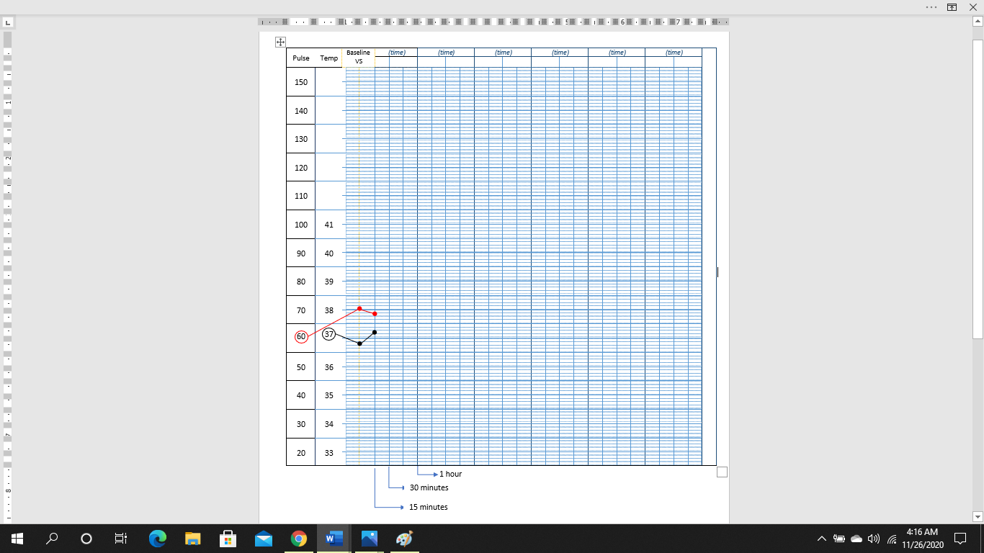

1 hour

30 minutes

15 minutes