Recording Ground Truth measurements with CANoe

# Introduction

Why use CANoe?

* It records the raw data.
* It’s tested and fairly reliable.
* Standard file format.
* Data can be replayed to the Master for hardware-in-loop testing.

CANalyzer can also work

# Requirements

CANoe.

CANcase (or equivalent) supporting CAN-FD.

# Starting

Open the CANoe configuration DV5187_PK_Private.cfg. (Or make your own)

Select the ‘Ground Truth’ tab.

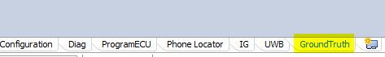

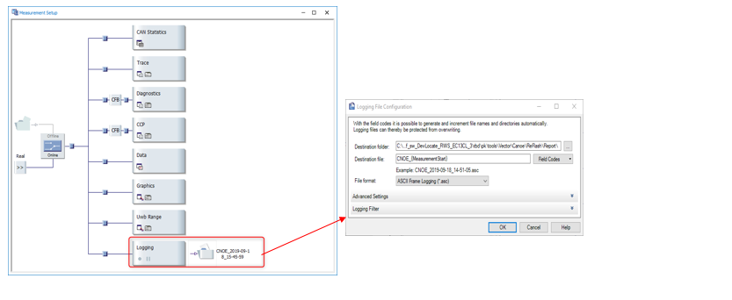

Configure logging to a .asc file

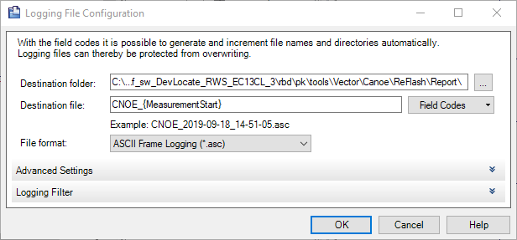

Enable logging

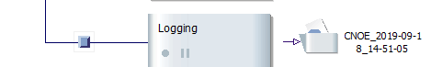

Open the Interactive Generator block.

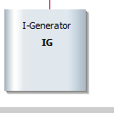

Check the GroundTruth message is configured for cyclic transmission

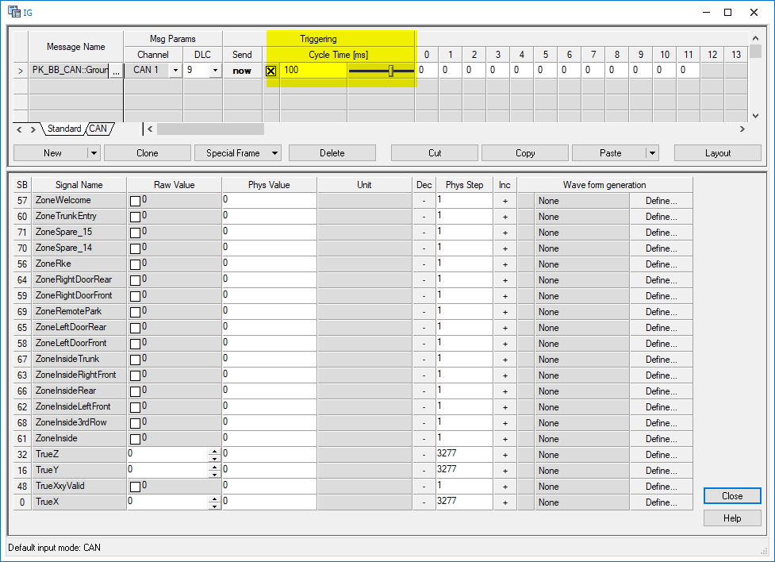

# Configure vehicle CAN

Optional: add the vehicle CAN bus to the trace.

# Measuring

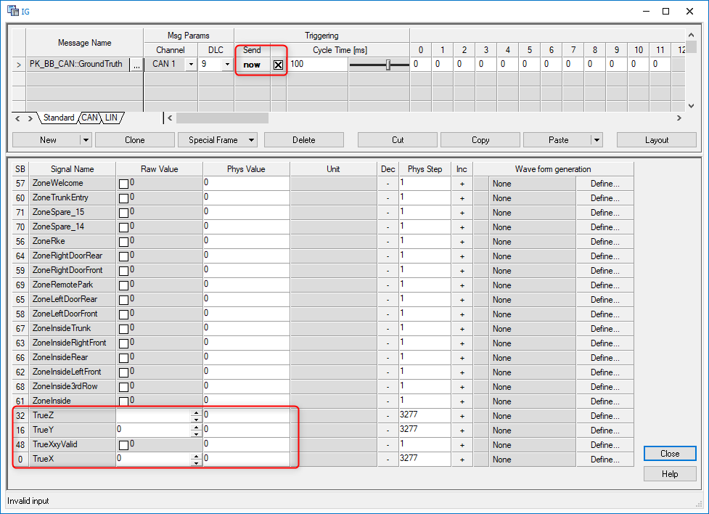

* Start recording.
* Check the trace window to ensure data is being received.
* Repeat:
  + Move tripod
  + Enter x,y,z, zone values into IG block, enable transmission.
  + Set valid flags
  + Wait for measurements to collect
  + Clear valid flags

# Package data

The data to save is:

* CANoe DBC and configuration
* The raw CANoe files, because this has the time-domain information (useful for more advanced simulations)
* SW version used, calibration file used.
* Anchor locations (xyz) & pictures
* Vehicle make, model, VIN or plate, picture
* Tag used (hardware & software version, serial number)