Requirements to do:

Dashboard module (optional)

* We can see the Sales summary, total patients and total sales
* Admin can filter today’s sales, month sales and (filter custom is optional)

Patient module

* admin can create, edit and delete patient information

Fields in patient form must have the following:

* Patient id (auto increment, auto fill)
* First name
* Middle initial
* Last name
* Suffix
* Phone number
* Date of birth
* PWD Citizen no.
* Senior Citizen no.
* Home address
* Medical History

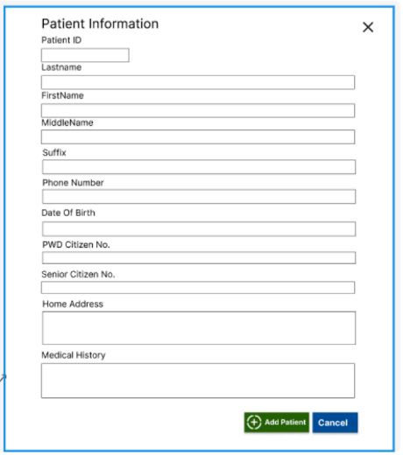

Prescription module

* admin can create, edit and delete patient prescription information

Fields in prescription form must have the following:

* Rx id (auto increment)
* Patient (name of patient from patient module)
* Date
* refraction_od_sph
* refraction_od_cyl
* refraction_od_axis
* refraction_od_add
* refraction_od_prism_base
* refraction_od_pd
* refraction_os_sph
* refraction_os_cyl
* refraction_os_axis
* refraction_os_add
* refraction_os_prism_base
* refraction_os_pd
* spectacle_od_sph
* spectacle _od_cyl
* spectacle _od_axis
* spectacle _od_add
* spectacle _od_prism_base
* spectacle _od_pd
* spectacle _os_sph
* spectacle _os_cyl
* spectacle _os_axis
* spectacle _os_add
* spectacle _os_prism_base
* spectacle _os_pd
* contact_lens_od_sph
* contact_lens _od_cyl
* contact_lens _od_axis
* contact_lens _od_add
* contact_lens _od_prism_base
* contact_lens _od_pd
* contact_lens _os_sph
* contact_lens _os_cyl
* contact_lens _os_axis
* contact_lens _os_add
* contact_lens _os_prism_base
* contact_lens _os_pd
* diagnosis
* frame type (Full Rim, Semi Rim, Rimless)

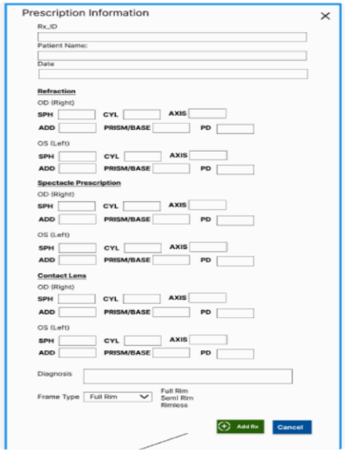

Special prescription module

admin can create, edit and delete patient’s special prescription information

Fields in special prescription form must have the following:

* order_id (auto increment)
* patient (can select from patient module)
* supplier (can select supplier from supplier module)
* date
* due_date
* od_sph
* od_cyl
* od_axis
* od_add
* od_prism_base
* od_pd
* od_quantity
* dbc
* lfv
* tint
* lens
* frame code
* frame type (dropdown values are: Full Rim, Semi rim, Rimless)
* frame Material (dropdown values are: Metal and Plastic)
* description
* remarks
* status (dropdown values are: Claimed and Unclaimed)
* claimed date

Payments module

Admin can add and track patient’s payments record including their balance, total amount paid and remaining balance

* payment_id
* SI_no.
* payment_date
* patients_name (connected from patient module)
* total_amount
* amount_paid
* remaining_balance
* products_order (this is an array of product/products ordered by patient)
* Status (paid, unpaid, partially)

These are the fields in supplier module

* supplier_id (auto increment)
* supplier_name
* contact_no.
* address
* date_created

These are the fields in Inventory module

* category (dropdown menu options are: lens, frame and accessories)
* product_id
* date_ordered
* model_number
* frame_brand
* frame_type
* lens_type (dropdown values are: single vision, bifocal, progressive lenses)
* lens_coating (dropdown values are: uncoated, multicoated, anti-radiation, photochromic, blue cut)
* sph
* add
* supplier (supplier company name from supplier module)

User module (admin can manage it’s credential add crud)