1. Create view button in all data table with delete button on form (same feature on patient)

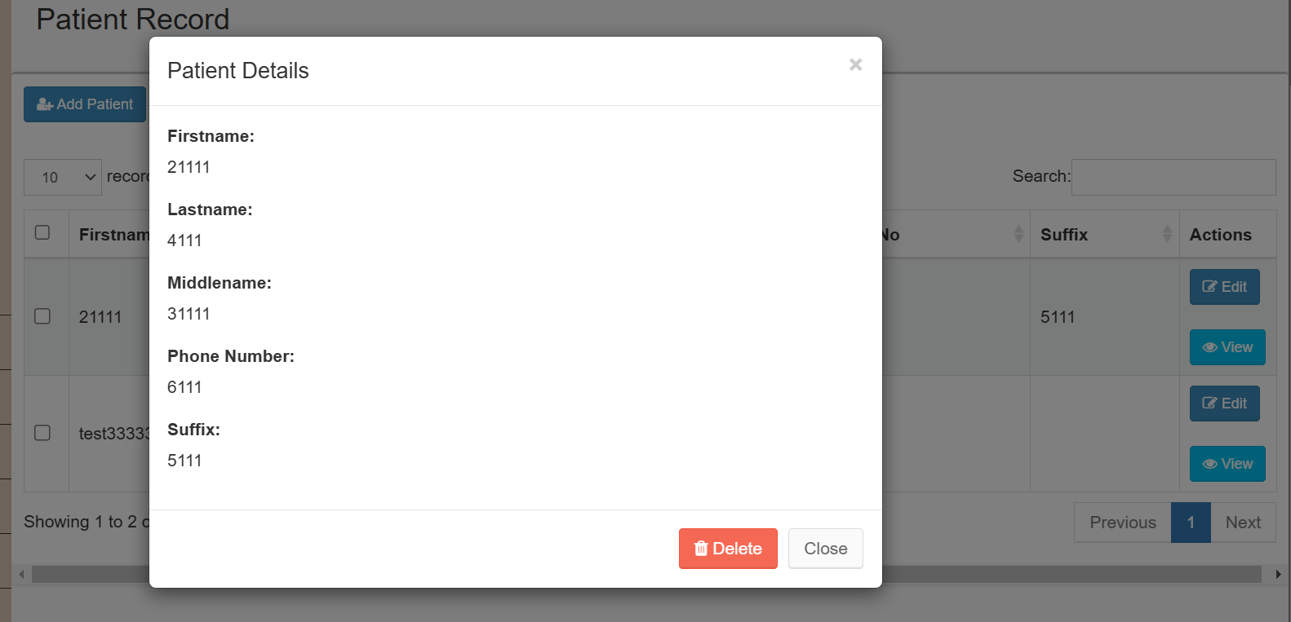

1. A screenshot of a computer

   Description automatically generatedSearch patient feature but be searchable instead of dropdown. Do it in all patient field
2. All record in the data table must display the latest data added first from top to bottom (the newly added data will be on top instead of last)
3. On Prescription -> Add prescription form, the “date” field must be manual date input and not automatically.
4. Download pdf button on Special Prescription, after implementation of No. 1, add a button name “download pdf” beside on delete button where I can download a pdf file of the record of all information on special prescription.
5. Sales module – Transfer the “checkout” button to top instead of bottom
6. Put asterisk (\*) for those required fields and remove required on sql for those who don’t need it – here’s the list  
   Patient Module: First and last name, phone number, Date of birth, Address

Prescription Module: Patient name, Frame type

Special Prescription: Patient, Supplier

1. Dynamic form for Add Product Form

If the category type is Lens, the fields will be the following:  
- Code

- Category Type

- Lens Type

- Lens Coating

- Prescription

- Supplier

- Quantity

- Price

If the category type is Frame, the fields will be the following:  
- Code

- Category Type

- Date Ordered

- Frame Brand

- Frame Type

- Supplier

- Quantity

- Price