**CHAPTER ONE**

**ABSTRACT**

As the complexity and degree of complains among students on campuses grow, a well-structured software with a good database will have to be utilized to aid lecturers and school authorities fight this trend, a computerized complaint system will offer a solution on this issue.  This software is set up in order to meet the complaints submitted by students, which is handled by the appropriate body. The software is divided into three different sections:  Student Login, Student Register, and The Administrator Session.

The Complaint record gives information on any complain submitted by the user (the student) which can be viewed by the Administrator and also chats with the student in other to get a better understanding of the complaint, before taking the complains to the appropriate school authority. The Student Login requires the student to log into the software to be able to lay a complaint; The Student Register is a form to collect the students’ information before he or she can use the system; The Administrator is the one in charge of the system to access all the submitted Complaints. The aim of designing this software is to model a computerized complaint system to enable students submit complains or any wrong doing on the campus, to be handled by a professional administrator who will send the complaints to the appropriate body.

**INTRODUCTION**

Establishments like IT firm, Schools, hospitals, government secretarial, financial institution etc. which have large numbers of customers or client received enormous amount of complains per day, and these complain has to be documented and filed for access and stored for future reference. A complaint system (also known as a conflict management system, internal conflict management system, integrated conflict management system or dispute system) is a set of procedures used in organizations to address complaints and resolve disputes.

Complain Management System Software is one of latest productivity enhancement tools used widely by all organizations wherever there is a need of booking of complaints via operators and analysis of complaints which are made or pending.

* 1. **Background of the Study**

An academic growth can be of various concerns in academic environment to promote social and functioning educational system. For an effective educational system to take place there are some issues in academic environment that should be properly addressed, take for instance issue of complaints management system in the university. This issue had created a lot of problems for an academic growth in the various aspects of the educational system. To support this approach, this project identifies a range of options that can be used to manage and resolve Academic complaints. This includes, where the opportunity presents itself, the need for administrator to make every effort to resolve potential or actual academic complaints as informally as possible in the first instance.

Handling complaints often involve first, to listen and understand, empathize, offer a solution, execute the solution and then follow up. Dogan and Wilkinson (2016) defined complaint as any expression of dissatisfaction about services(s) or about any professional conduct. It prompts more prominent clarity and consistency of executive activities to determine the protests. Design and implementation of online complaint management system is to maintain an effective, timely, and equitable complaint handling system which is easily accessible and offered to complainants (students) at no charge. A computerized complaint system can generally collect complaints, store them and these records are collected by the appropriate authority and then decide on the next step to be taken in solving the issues. In relation to the above preposition by Marcus, it is possible for the design and implementation of an online complaint management system to yield substantial benefits for the users (Marcus, 2000).

* 1. **Statement of the Problem**

During the analysis and data collection of this project, it was discovered that there existed a manual form of collecting and storing students complains in other for them to be attended to, and for future purpose by the Students Affairs Department of the Imo State Polytechnic. That is to say that the process of daily task and activities are done manually which is quite unfortunate; manual procedural for complains execution delays and reduces result output quality. Manual complain record keeping has resulted in many setbacks to the expected standard.  The setback encountered includes:

* Time wastage and long quarries.
* Partial or total loss of file or documents.
* Under recording of criminal analysis.
* Exposures of confidential matters.
  1. **Aim and Objectives of the Study**

The main aim of this project is to design an online student database and complaint management system that will manage student complaints of Imo state polytechnic.

Specific objectives includes:

* To model a computerized complain system to enable proper complain submitting and control.
* To upgrade from manual student complaint management to computerize student complaint management.
* To do an overall study and analysis of online student complaint system
  1. **Significant of the Study**

This study will improve the database, enhance effectiveness, efficiency, and security of the existing system. It is also intended that the study will help in the development of a new and hopefully a standard better computer-aided system.

The new system will save time, reduce improper handling of complaint system and also improve the relationship between student, lecturer and management.

* 1. **Scope of the Study**

The scope of this project is limited to the Students Affairs Department of Imo State Polytechnic. Emphasis is laid on the unit that oversees student’s complaints headed by Dr. John Ezenwankwor, Dean of student affairs.

* 1. **Limitation of Study**

The limitation of this project work is that the application will not process the penalties for anybody found being grieved or the punishment for any staff or student found being at fault of any complaints. Other limitations are as follows:

1. The initial difficulty of grasping the knowledge of this field.
2. Inadequate financial resources and the expenses made when photocopying some important and relevant material used in carrying out this research.
3. Time, energy consumed and high cost of transportation made when sourcing out different information about the research.
   1. **Definition of Terms**

To fully understand what the study is all about, important and dispensable terms have been chosen and due definition given to them.

**Computer:**  This is an electronic device operated under the control of instruction stored in its memory unit which can accept and store data for future use as well as produce output from the processing.

**Complaint:**an expression of discontent, regret, pain, censure, resentment, or grief; lament, faultfinding a cause of discontent, pain, grief e.t.c.

**Online:** It is the condition of being connected to a network of computers or other devices.

**Manually**:  Done, Operated, Worked, e.t.c by the hand or hands rather than by an electronic or electrical device.

**Computerized:**  To control, perform, or store (a system operation or information) by means of an electronic Computer.

**INEFFICIENCY:**the state of not achieving maximum productivity; failure to make the best use of time or resources.

**INFORMATION STORAGE:**Information storage is an act of a system that keeps data accessible to the information processors; the information storage unit is either a hard drive or a server that usually contains a database.

**RETRIEVAL:**the action of obtaining or consulting material stored in a computer system.

**CHAPTER TWO**

**LITERATURE REVIEW**

**2.0 INTRODUCTION**

This project concentrates on the design and implementation of online complaint management system. Such as any general public or government needs laws to govern the procedure among its citizen, a college, as well, needs regulations to characterize the procedure among its students, academic regulations ought to both involve the faculty's requirements for a complaint and give student the rules to achieving their individual goals or objectives; they have to give an intends to student to consider their improvement and for staff to monitor the relative execution of different student. In this manner, student regulations ought to give certifications to student as of now selected and the individuals who look for affirmation that however many controls as could reasonably be expected will be accessible inside the Polytechnic in other to abstain from being grieved.

Complaint managing should be specifically designed with attention on academic part affected by the student. A complaint management system is one of the latest productivity enhancement tools used widely by all organizations whenever there is need of booking of complaints via operators and analysis of complaints which are made or are pending.

**2.1 CONCEPT OF COMPLAINT MANAGEMENT SYSTEM**

**2.1.1 Definition of an Academic Complaint**

An academic complaint refer to a move made by a student against a member of the faculty, colleagues, a part-time instructors or lecturer, a teaching or lecturer assistant, security, or an administrator that allegedly either violates a university, college, or department academic policy or procedure or mostly treats the student on the premise of race, state origin, religious conviction, sex, age, handicap, veteran status, or some other non-academic standing not secured under the college procedure as for sexual behavior or other major college strategies or policies.

Since engaging an evaluation or assessing a student's work or performance includes the faculty's professional decision and is a necessary piece of the faculty' instructing obligations Leat (2007), a complaint is an expression of dissatisfaction or a complaint of a worker and who usually deal with the application, explanation, presentation or moving a statutory right or a procedure, law, custom, working practice or existing agreement.

According to University of Cambridge manual (2016) student complaint procedure allows student to express dissatisfaction about the standard of service provided by the university and it is entitled to any matriculated student.

**2.2 HISTORY OF COMPLAINT SYSTEM**

There is a substantial early history of scholarly work on [due process](https://en.wikipedia.org/wiki/Due_process), and union and non-union [grievance procedures](https://en.wikipedia.org/wiki/Grievance_(labour)) within organizations. This work focused primarily on [rights](https://en.wikipedia.org/wiki/Rights)-based [conflict resolution](https://en.wikipedia.org/wiki/Conflict_resolution) between union and non-union workers and their managers. Scholarly work has evolved to cover both a wider range of conflict management channels, and, also, a much wider range of disputants.

In the 1970s and 1980s much interest arose in the United States, in dealing with conflict informally as well as formally, and in learning from conflict and managing conflict. In contemporary language, these discussions centered on the "interests" of all who would consider themselves stake-holders in a given conflict and on systems change as well as resolving grievances.

These discussions led to questions of how to think about complaint systems and how to link different conflict management offices and processes within an organization. Papers by Ronald Berenbeim, Mary Rowe, and Michael Baker, described a systems approach for dealing with complaints and all kinds of disputes within organizations.

Many authors extended the work of Berenbeim, Rowe, and Rowe and Baker, on the topic of internal complaint systems. They included: Douglas M. McCabe, [William L. Ury](https://en.wikipedia.org/wiki/William_L._Ury), Jeanne M. Brett, and Stephen B. Goldberg. (Ury, Brett and Goldberg in particular described conflict resolution within organizations in terms of interests, rights and power and the possibility of looping back from rights-based processes to interest-based solutions.) Cathy Costantino and Cristina S Merchant, and Karl A. Slaikeu and Ralph H. Hassonextensively explored issues of designing conflict management systems.

The concept of an integrated conflict management system was conceived and developed by Mary Rowe, in numerous articles in the 1980s and 1990s. She saw the need to offer options for complainants and therefore a linked system of choices within an organizational system.

The idea of a systems approach has endured well. In recent years however, there has been discussion as to whether conflict should be "managed" by the organization or whether the goal is to understand, deal with and learn from conflict. There is also concern about practical and theoretical issues in "integrating" a system, with some observerspreferring the idea of "coordinating" a conflict system. However 2012 research by David Lipsky *et al.*, suggests that an increasing number of corporations see themselves as having "integrated conflict management systems," or "ICMS."

There is also a major need to collect, review and understand the nature of conflict management and complaint systems around the world. Studies and citations are needed about how complaint systems work for women as well as men. Research is needed as to how systems work for many different national groups, for people of different socio-economic classes, and different ages, and different religions, and especially for contract workers and immigrant workers, in every country. Studies (and citations) are needed about complaint systems in health care, in faith-based organizations, in schools, in political organizations, in the military and in many specialized occupations. Studies are needed about important specialized issues like free speech.

A number of [artificial intelligence](https://en.wikipedia.org/wiki/Artificial_intelligence) technologies are helpful in complaint resolution process, understanding the attitudes of involved parties and reasoning about them, in particular, based on the [belief–desire–intention model](https://en.wikipedia.org/wiki/Belief%E2%80%93desire%E2%80%93intention_model). Concept learning is an adequate formalism to reason about complaints.

**2.4 CATEGORIES OF AN ACADEMIC COMPLAINT**

1. Academic complaint
2. Non-academic complaint

There are formal methods for student to take in the process that they have a complaint or issues. The formal position regarding to a request against grades rewarded that is allowed and that Board of Examiners’ making on examination decisions results are final. Nevertheless, the Board revealed clear confirmation that this approach was not connected consistently over the University. In testing this matter, the Panel realizes that work can be re-marked and grades changed by virtue of conceivable error of marks or slips in grading. At the same time a few student were clearly welcomed to look for a survey of evaluations on events; others had their work re-stamped. Course documentation assessed by the board refers to the strategies for students to claim against evaluation results. What's more the staff position on whether students can advance was conflicting.

The University observes that student may wish to raise a complaint, problem, Issues or concern detecting with their present or past association with the University. Complaint can be about any number of difficulties including matters that may influence a student's feeling of wellbeing and security.

**2.4.1 Academic Complaint**

A sincere issue or concern of an academic or non-academic natureraised by an enlisted student or potential student, which is accepted by that student, recognize with student academic advancement, assessment, educational module, nature obviously delivery, academic accomplishment in a course and awards.

**Others include:**

1. Appeal of grading decision (e.g. failure of an assessment piece or subject)
2. Elimination from study or continual enrolment
3. Findings of accusations of academic student misconduct (e.g. cheating or plagiarism)
4. Quality of course conveyance
5. Outcomes of credit transfer

**2.4.2. Non-Academic Complaint**

Protest/s which do not identify with student improvement,evaluation, educational program and rewards in a course of study. Non-Academic Complaints combines protests in connection to the following:

* + 1. Discrimination
  1. Shamefulness and injustice treatment
  2. Attack or vilification
  3. Sexual harassment, other types of harassment
  4. Student amenities
  5. Worries about grounds offices, environment, well-being and security or equipment and so forth.

**2.5 THE BENEFIT OF HAVING AN INTERNAL ONLINE COMPLAINTS SYSTEM**

A good complaint system will provide important response from administrator and will benefit students by:

1. Serving as a fast and efficient means of resolving concerns which may arise to student.
2. Indicating where problem exist in the procurement of managements and strategy of a foundation
3. Highlighting weaknesses in guiding system and zones which may require change
4. It gives student verification that their affirmations or issues are usually considered important and that they are consistently treated appropriately, decently and unbiased.

**2.6** **The Values for Complaints and Appeal Management Policy**

1. Procedural fairness and regular equity;
2. A code of conduct or morals and behaviour;
3. An administration society free from separation and provocation;
4. Straightforward arrangements
5. Avenue for response and further investigation.

The policy Code of Conduct guides the Complaints and Complaints Management Policy and procedures were defined by Ombudsman (2005).

* 1. **NEED FOR COMPLAINT REGISTRATION AND APPEAL SYSTEM**

To obtain a well-functioning complaint mechanism and appeal registration system, student needs to abide under the following process:

1. Student must be well registered (known) in other to have an account with complaint web application to generate password to login their complaints.
2. Student must know the entire student misbehaviour act provided by the school management/administrator before apply for any appeal.
3. Informing students of the procedure and the policy during their course orientation and counselling students to read it at the beginning of a course.
4. Allowing the accuser and / or respondent to be accompanied and / or helped by a third party if desired throughout the interrogation from the management/administrator.

**2.8 Motivation for Registration and Appeal System**

The previous manual system cannot be easily traced back due to the blunder of data, forms, and some other document. The process below motivate the undertaking analysis of preventing complaint been prolong more than the accurate or normal time of solving it.

The motivation of this system is to undergo the following processes**:**

1. To promote unity between the students to student, staffs and administrator/management.
2. To secure life-threatening protection against non-academic complaints (such as sexual harassment, discrimination, student amenities, unfairness and injustice).
3. To provide an adequate complaint/grievance website that a student can easily login with their student ID or Matric number and password generating from the complaint control system and issue a complaint for a proper addressing from the management.
4. Students will have chances to be involved in the processes of approval, progress, monitoring and evaluation of the complaints.
5. Provides a predictable, clear, and credible process to all parties involved, resulting in outcomes that are seen as fair, effective, and fixed.

**2.9 Principles for Addressing Complaint**

* 1. Staff must act decently and unbiased. While they may look for genuine or other expert appeal about the procedure, or their obligations inside it, they still must activity free judgment about the specific charge or advance, taking into description their target evaluation of the proof;

1. Choose the overall complaint included in the determination of claims or bids are required to act in an expert, standard and polite way at all times;

iii. Staff parts who examine or choose affirmations or requests, must treat them and the methodology as classified, and not talk about any part of the case or issues with anybody not included in that process. Any form of data to others included immediately might be on an entirely "need-to-know" premise, provisional upon the way of their part in that process.

**CHAPTER THREE**

**SYSTEM ANALYSIS AND DESIGN**

**3.0 Introduction**

System analysis is a method in computing which deals with the separation of an information system into its basic component parts and study in response to many types of problem or requirement with the use of computer and other resources to perform task which meets the information needs of an organization. In a broader sense, it can be considered as the examination, identification and evaluation of component of the system and the interrelationship from problem definition through design, implementation and modification or maintenance.

**3.1 Research methodology**

Methodology herein, refers to a techniques used while conducting a research. It explains how data is to be collected and the tools for collecting the data, the system methodology, the proposed system input and output, the users and also systems development tools.

**3.2.1 Primary data collection**

We prepared a number of questionnaires whereby we submitted to some defined population in the academia in other to get a deeper understanding of how the system is going to work. We prefer this method because it gives more information from various individuals and offers greater flexibility as the opportunity to restructure questions. This technique is preferred because it will provide a closer contact between the users and the developer hence dispelling the probability of the completed system being rejected by the user.

**3.2.2 Secondary Data Collection**

During the course of the study, we collected information from existing sources e.g books, internet, journals and magazines. After analysis of the primary data, the result was then compared with the primary data to make a conclusive decision.

**3.3 Analysis of Existing System**

The processing system of complaints that exists is manually based. But this is hardly used in the monitoring process since it cannot be accessed online. Monitoring is done using the customary methods, which contains the use of paper, but in the proposed new system we shall automate all the complaints details online using web-based application.

**3.3.2 Limitation of the Existing System**

The problems experienced are a result of the system being manual which include the following,

1. Time consuming and slow: The method of using paper in the process of monitoring complaints is slow and time consuming. For example the educational staffs have to physically move to individual units to total or tally their book list for any available complaint or issues.
2. Too much paper work**:** This generates a lot of records and keeping them can be a problem in a sense that they can be easily mixed up, making retrieval difficult particularly when the appeal are urgently needed for decision-making and report, complaint registration policy using a manual system are prone to mistakes.
3. Lack of security of data and information concern any complaint/issues.
   * 1. No monitor rule that support complaints and appeal registration
   1. To avoid all these restrictions and make the working more appropriately and accurate, the system require to be computerized or automate.

**3.3.3 Proposing for the New System**

Because of the problems eminent in the existing system, this research proposes a new complaints system for the institution. The proposed system will be a computerized system which will enable student to make their complaints online and at their comfort zone once they have internet access.

**3.3.4 Justification of the New System**

The new system is an internet or web-based application that can be accessed within the campus. These system quota some forms of security and provide easy solution on how to operate and appeal concern of any complaints. It will definitely work perfectly than that of existing system due to time limitation of attending each portion of complaints.

**3.4 Requirement Specifications**

**3.4.1 Functional Requirements**

This is a necessary task, action or activity that was accomplished by the system. The computerized complaints system is able to:

* Allow a student create an account in the system.
* Allow a student to login to the system.
* Allow student to make complaints.
* Allow student to view his/ her complaints.
* Allow student chat with the Admin.
* Allow student logout.
* Allow Admin view student’s complaints.
* Allow admin to manage student complaints.
* Allow Admin logout.

**3.4.2 Non-functional Requirements**

The new computerized complaints system with regards to non-functional requirements will have the following characteristics:

* The system will improve on the efficiency of prospective student’s complaint process.
* The system will be easy to learn and use.
* The system will be easy to maintain.
* The system will be flexible, safe and convenient.
* The system should be available at all time.

**3.5 Analysis Model**

A model is an abstract representation of something real or imaginary. A model is developed to learn all aspects of a problem domain to determine the best way to solve a specific set of user needs.

**3.5.1 Use Case Diagrams**

A use case is a diagram that is used to show or represent the functions or features of the new system. The use case diagram here illustrates the interactions among the students, system administrator and the complaint system.

**USECASE DIAGRAM FOR COMPLAINT SYSTEM**

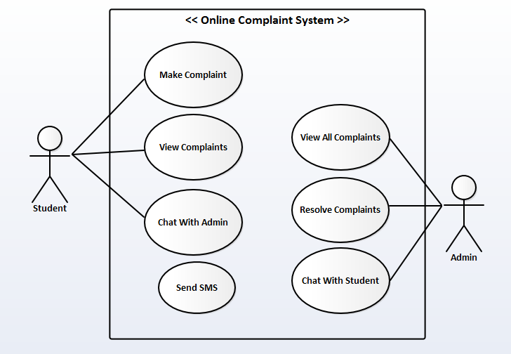

**Use Case Description for Make Complaint**

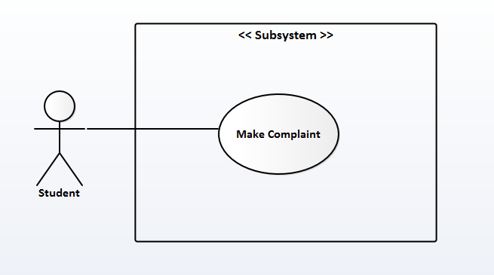

**Title:** Make Complaint

**Purpose:** This feature / functionality allows the primary actor (Student) to make a complaint on any issue.

**Pre-condition(s):** Student must be authenticated.

**Description:**

**Actor Action**  **System Response**

1. Select option to make a complaint 2) Displays a message box for student to type

in their complaint

3) Student types his/her complaints and 4) Displays complaint submitted successfully.

select the complain button

**Use Case Description for View Complaint**

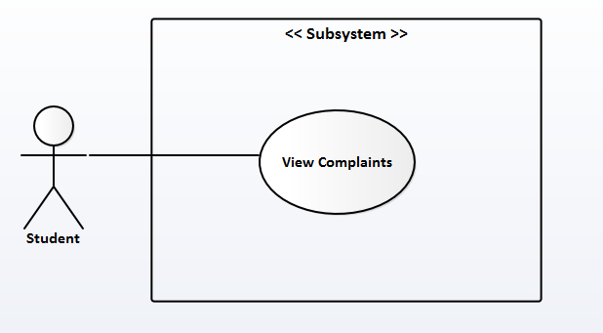

**Title:** View Complaints

**Purpose:** This feature / functionality allows the primary actor (Student) to view his/her complaints

**Pre-Condition(s):** Student must be authenticated and have also made a complaint(s)

**Description:**

**Actor Action** **System Response**

1) Student selects mycomplaints button 2) Displays student complaint(s)

**Use Case Description of Chat with Admin**

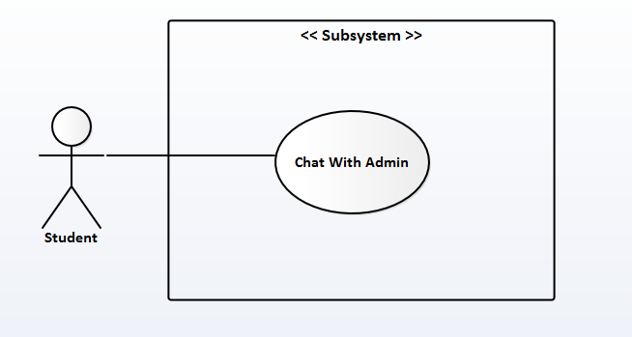

**Title:** Chat with Admin

**Purpose:** This feature / functionality allows the primary actor (Student) to have conversation with the Admin.

**Pre-Condition(s):** Student must be authenticated, have made a complaint(s) and have viewed his/her complaint(s).

Description:

Actor Action System Response

1) Student selects chat button 2) Displays the chatting page for student

to start chatting with Admin

**3.5.2 Activity Diagram**

Activity Diagram is a graphical representation of workflows of stepwise activities and actions with support for choice, iteration and concurrency. Activity diagram is a UML diagram in used to describe the dynamic aspects of the system.

**3.5.2.1 Activity Diagram for Log-in**

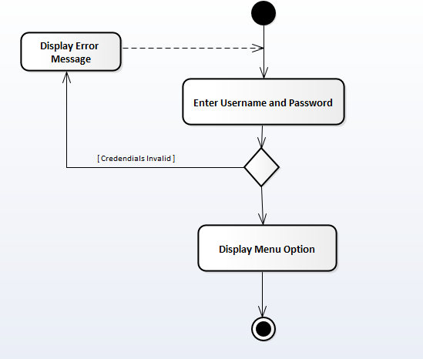

**3.5.2.2 Activity Diagram for Make Complaint**

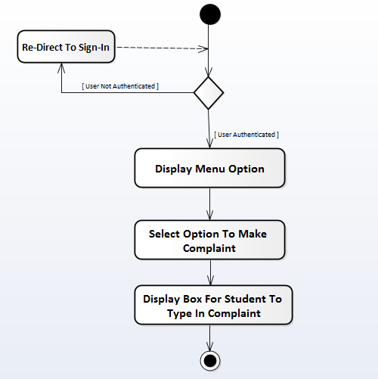

**3.5.2.3 Activity Diagram for View Complaints**

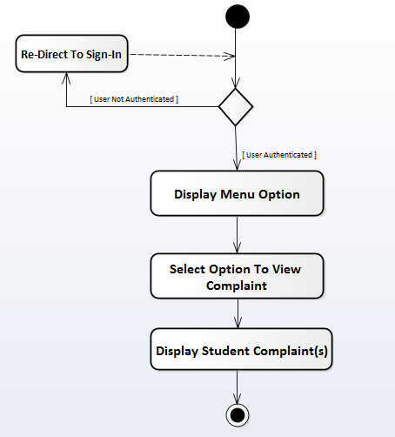

**3.5.2.4 Activity Diagram for Chat with Admin**

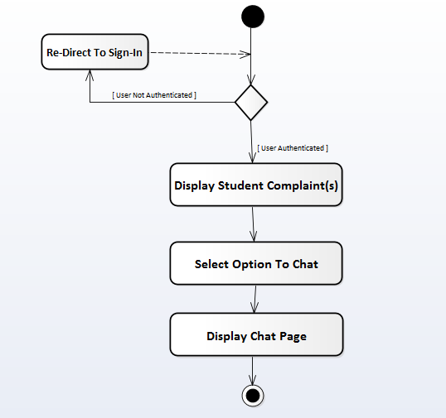

**3.7 Design Model**

**3.7.1 Class Diagram**

A class diagram models the static structure of a system. It shows the relationships between classes, objects, attributes, and operations.

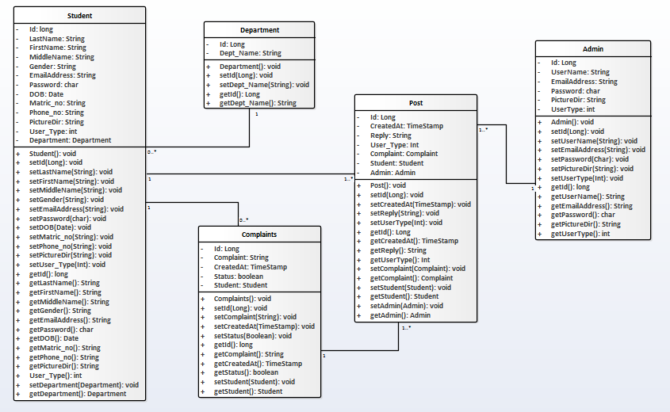

**3.7.3 Data Management Design**

The database use to implement the back-end of the system is MySql. Access to the database management system was made possible by phpMyAdmin. The name of the database is “complaint-system” and the structure of the data tables are; admin, complaints, student, department, and post.

“admin” Table Structure

|  |  |  |  |  |  |
| --- | --- | --- | --- | --- | --- |
| S/N | Field Name | Type | Length | Collation | Extra |
| 1 | admin_id | Int | 3 |  | Auto_increment |
| 2 | username | Varchar | 30 | latin1_swedish_ci |  |
| 3 | email_address | Varchar | 30 | latin1_swedish_ci |  |
| 4 | password | Char | 60 | latin1_swedish_ci |  |
| 5 | pictureDir | Varchar | 100 | latin1_swedish_ci |  |
| 6 | user_type | Int | 3 |  |  |

“complaints” Table Structure

|  |  |  |  |  |  |
| --- | --- | --- | --- | --- | --- |
| S/N | Field Name | Type | Length | Collation | Extra |
| 1 | complaint_id | Int | 3 |  | Auto_increment |
| 2 | complaint | Varchar | 500 | latin1_swedish_ci |  |
| 3 | createdAt | Timestamp |  |  | Current_Timestamp |
| 4 | status | Tinyint | 1 |  |  |
| 5 | Student_id | Int | 3 |  |  |

“department” Table Structure

|  |  |  |  |  |  |
| --- | --- | --- | --- | --- | --- |
| S/N | Field Name | Type | Length | Collation | Extra |
| 1 | dept_id | Int | 3 |  | Auto_increment |
| 2 | dept_name | Varchar | 30 | latin1_swedish_ci |  |

“post” Table Structure

|  |  |  |  |  |  |
| --- | --- | --- | --- | --- | --- |
| S/N | Field Name | Type | Length | Collation | Extra |
| 1 | post_id | Int | 3 |  | Auto_increment |
| 2 | createdAt | Timestamp |  |  | Current_timestamp |
| 3 | reply | Varchar | 500 | latin1_swedish_ci |  |
| 4 | complaint_id | Int | 3 |  |  |
| 5 | student_id | Int | 3 |  |  |
| 6 | admin_type | Int | 3 |  |  |
| 7 | user_type | Int | 3 |  |  |

“student” Table Structure

|  |  |  |  |  |  |
| --- | --- | --- | --- | --- | --- |
| S/N | Field Name | Type | Length | Collation | Extra |
| 1 | student_id | Int | 3 |  | Auto_increment |
| 2 | lastname | Varchar | 30 | latin1_swedish_ci |  |
| 3 | firstname | Varchar | 30 | latin1_swedish_ci |  |
| 4 | middlename | Varchar | 30 | latin1_swedish_ci |  |
| 5 | gender | Varchar | 6 | latin1_swedish_ci |  |
| 6 | email_address | Varchar | 40 | latin1_swedish_ci |  |
| 7 | password | Char | 60 | latin1_swedish_ci |  |
| 8 | dob | Date |  |  |  |
| 9 | matric_no | Varchar | 30 | latin1_swedish_ci |  |
| 10 | phone_no | Varchar | 20 | latin1_swedish_ci |  |
| 11 | pictureDir | Varchar | 100 | latin1_swedish_ci |  |
| 12 | dept_id | Int | 3 |  |  |
| 13 | user_type | Int | 3 |  |  |

**CHAPTER FOUR**

**SYSTEM DESIGN AND IMPLEMENTATION**

**4.1 Introduction**

System implementation is the delivery of fully tested system into production for its daily operation. The purpose of this phase is to smoothly changeover from the old system to the new system. This stage involves the writing of computer program, tools and eventually, changes over to the new system. The software design is now realized as a set of program which are written in some executable programming language.

**4.2 Justification of Software Development Tools/Environment**

The development tools are the necessary requirement tools used during the design to enable us achieve the system design. The listed packages was used because of their features, accessibility and also because it is more effective.

1. Visual Studio Code
2. MySql database
3. Nodejs

**Visual Studio Code**: Visual Studio Code is a code editor redefined and optimized for building and debugging modern web and cloud applications. It is a lightweight but powerful source code editor developed by Microsoft for Windows, Linux and macOS. The source code is free and open source and released under the permissive MIT License. The compiled binaries are freeware and free for private or commercial use.

**MySQL Database Server:** MySQL is a popular choice for database for use in web applications, and is a central component of the widely used LAMP open source web application software stack. LAMP is an acronym for “Linux, Apache, MySQL, Perl/PHP/Python”. The MySQL Database powers the most demanding Web. It is a fully integrated transaction-safe, ACID compliant database with full commit, rollback, crash recovery and row level locking capabilities. MySQL delivers the ease of use, scalability, and performance that has made MySQL the world’s most popular open source database. It is a Structured Query Language server designed for delivery for heavy loads and processing of complex queries. As a relational database system, MySQL allows many different tables to be joined together for maximum efficiency and speed.

Some of the more popular features of MySQL are as follows:

1. Multiple CPUs usable through kernel threads
2. .Multi-platform operation.
3. Numerous column types cover virtually every type of data.
4. Commands that allow information about the databases to be easily and succinctly shown to management.
5. Function names that do not affect table or column names.
6. A password and user verification system for added security.
7. International error reporting usable in many different countries.

**Nodejs:** Nodejs is an open-source, cross-platform JavaScript run-time environment that executes JavaScript code outside of a browser. Node.js lets developers use JavaScript both for client-side and server-side scripting to produce dynamic web pages content before the page is sent to the user’s web browser. Node.js uses an event-driven, non-blocking I/O model that makes it lightweight and efficient. It has a unique advantage because millions of front-end developers that write JavaScript for the browser are now able to write the server-side code in addition to the client-side code without the need to learn a completely different language. It represents a “JavaScript everywhere” paradigm.

**4.3 Hardware and Software Requirements**

**Hardware Requirements**

Hardware is physical components that can make up the computing system (that is everything we can both be seen and touched). Hardware component of the new system include:

* A microcomputer with microprocessor of Intel 386.
* An uninterrupted power supply.
* The system will require 2gb of memory space to enable the program run.
* A laser printer will be required to print out the copy.
* A flash drive and a scanner.

**Software Requirement**

Software requirements includes:

* A windows XP or higher version operating system
* SQL Server
* Google Chrome browser to view the application pages
* Visual studio code or NotePad++ (Text Editors)
* Node.js

Instructions for software deployment

In other to deploy the completed application, the following instructions should be able to be adhered to:

**4.4.1 Software Deployment**

The software will be fully deployed online by deploying it to github.com and then pushed to heroku.com which the web address will shared to the students to enable them access it anywhere once there is internet access. The following git and heroku commands will be use to deploy the application online:

* git init
* git add .
* git commit –m “my full app”
* git push
* git push heroku master
* heroku open.

**4.4.2 Installation**

As said earlier, the application is web based and will be fully deployed online, so the application does not require installation, all that is required is the application web-address, a device with internet access and a browser to launch the application.

**4.5 System Testing and Output**

This involves the various test made to ensure that the system as a whole will function properly, it involves program testing, system testing and operational testing. Each program module is tested independently to ensure that each program yield the required result. The hardware and software components of system are tested before they are recommended for business use. Then the complete application is tested using both abstract and concrete data to ensure that it is accurate and efficient.

**4.5 Documentation**

This involves the process of recording the activities and communicating the gathered information during analysis, design and other system development stages. It is a form of a written text that accompanies computer software, explaining how to use the computer software. It mean different things to different people put still stands as a vital tool for proper implementation and maintenance of the new system.

**User Manual is of 3 types. Examples are;**

* Design documentation
* Technical documentation
* End-User documentation

Design documentation is also referred to as architectural documentation. It is an overview of the software program in relation to the environment and construction principles which are to be used in the design of the software components.

Technical Documentation is referred to as tool documentation in an overview of the codes, algorithms, interface designs etc. This usually is not availed to the students unless they are programmers in most cases.

End-User Documentation is the documentation for the students describing how the software is to be used after installation as discussed earlier. It describes these features to the students and assists in realizing these features. It can be extended to troubleshooting assistance and be considered to consist of contracts that specify the limit of the software. It avails manuals for support students end user and the system administration of the constitution.

The researcher considered the end-user documentation as the best user manual documentation approach for the security after training the students.

**CHAPTER FIVE**

**SUMMARY CONCLUSION AND RECOMMENDATION**

**5.1 Summary**

Online complaint system is a secured system which is used to keep record of student’s complaints in any institution. The system is an automated system that enables quick / easy capturing, processing, and retrieval of prospective student’s complaints.

It also reduces the problems encountered by operating complaint system manually. A complaint management system is an innovation or invention approach to improve the service of the student affairs work and it should be well acknowledged or accepted by the polytechnic in addition to the existing means.

With these advantages, it is a wonderful system which every institution has to introduce as to help them curb and experience these great advantages.

**5.2 Conclusion**

**REFERENCES**

Complaint handling and resolution policy Retrieved 2014 from international Finance Corporation 2121 Pennsylvania avenue NW Washington, dc 20433, USA Five steps in processing complaint mechanism P 20.

M. Leat, (2007) Exploring Employee Relations, Butterworth-Heinemann Publishing, Oxford

Marching ton, A. Wilkinson (2005) Automation of web Application by Human Resource Management at Work Chartered Retrieved from Institute of Personnel and Development Publishing, London, 2005.

Student’s Handbook,Proceduralfor Handling(2013/2014)ComplaintsandStudent Complaint against Staff Retrieved from Federal University of technology, Niger State, Nigeria.

Terje H (2005). HTM*L* from Digital text cycles from Medieval Manuscript to Modern Mark up: Journer of Digital Information p: 309