**CHAPTER ONE**

**INTRODUCTION**

Biometrics is the measurement and recording of the physical characteristics of an individual for use in subsequent personal identification.

Finger vein recognition is a method of biometric authentication that uses pattern-recognition techniques based on images of human finger [vein](https://en.wikipedia.org/wiki/Vein) patterns beneath the skin's surface. Finger vein recognition is one of many forms of [biometrics](https://en.wikipedia.org/wiki/Biometrics) used to identify individuals and verify their identity. Finger vein ID is a biometric authentication system that matches the vascular pattern in an individual's finger to previously obtained data.

Smart recognition of human identity for security and control is a global issue of concern in our world today. Financial losses due to identity theft can be severe, and the integrity of security systems compromised. Hence, automatic authentication systems for control have found application in criminal identification, autonomous vending and automated banking among others. Among the many authentication systems that have been proposed and implemented, finger vein biometrics is emerging as the foolproof method of automated personal identification. Finger vein is a unique physiological biometric for identifying individuals based on the physical characteristics and attributes of the vein patterns in the human finger. It is a fairly recent technological advance in the field of biometrics that is being applied to different fields such as medical, financial, law enforcement facilities and other applications where high levels of security or privacy is very important. This technology is impressive because it requires only small, relatively cheap single-chip design and has a very fast identification process that is contact-less and of higher accuracy when compared with other identification biometrics like fingerprint, iris, facial and others. This higher accuracy rate of finger vein is not unconnected with the fact that finger vein patterns are virtually impossible to forge thus it has become one of the fastest growing new biometric technology that is quickly finding its way from research labs to commercial development.

Historically, R&D at Hitachi of Japan (1997-2000) discovered that finger vein pattern recognition was a viable biometric for personal authentication technology and by 2000-2005 were the first to commercialize the technology into different product forms, such as ATMs. Their research reports false acceptance rate (FAR) of as low as 0.0001 % and false reject rate (FRR) of 0.1%. Today 70% of major financial institutions in Japan are using finger vein authentication.

The technology is currently in use or development for a wide variety of applications, including credit card authentication, automobile security, employee time and attendance tracking, computer and network authentication, end point security and [automated teller machines](https://en.wikipedia.org/wiki/Automated_teller_machine).

It is difficult to steal since the vein is hidden inside the body and is mostly invisible to human eyes. The vein patterns can only be taken from a live body. Hence it is a natural and convincing proof that the subject whose veins are successfully captured is alive. Finger vein authentication is a new biometric method utilizing the vein patterns inside one’s fingers for personal identity verification. Biometric systems based on fingerprints can be fooled with a dummy finger fitted with a copied fingerprint; voice and facial characteristic based systems can be fooled by recordings and higher solution images. The finger vein ID system is much harder to fool because it can only authenticate the finger of a living person.



**Source: Hitachi of Japan history of Research and development on finger vein recognition technology.**

Fingerprints have been the most widely used and trusted biometrics. The reasons being: the ease of acquiring fingerprints, the availability of inexpensive fingerprint sensors and a long history of its use. However, limitations like the deterioration of the epidermis of the fingers, finger surface particles etc result in inaccuracies that call for more accurate and robust methods of authentication. Vein recognition technology however offers a promising solution to these challenges due the following characteristics. (1) Its universality and uniqueness. Just as individuals have unique fingerprints, so also they do have unique finger vein images. The vein images of most people remain unchanged despite ageing. (2) Hand and finger vein detection methods do not have any known negative effects on body health. (3) The condition of the epidermis has no effect on the result of vein detection. (4) Vein features are difficult to be forged and changed even by surgery. These desirable properties make vein recognition a highly reliable authentication method. Vein object extraction is the first crucial step in the process. The aim is to obtain vein ridges from the background. Recognition performance relates largely to the quality of vein object extraction. The standard practice is to acquire finger vein images by use of near-infrared spectroscopy. When a finger is placed across near infra-red light rays of 760 nm wavelength, finger vein patterns in the subcutaneous tissue of the finger are captured because deoxygenated hemoglobin in the vein absorb the light rays. The resulting vein image appears darker than the other regions of the finger, because only the blood vessels absorb the rays. The extraction method has a direct impact on feature extraction and feature matching. Therefore, vein object extraction significantly affects the effectiveness of the entire system.

**CHAPTER TWO**

**EVALUATION OF THE FINGER-VEIN RECOGNITION**

**INTRODUCTION**

Finger vein recognition is a process wherein a person's finger vein patterns are used as a basis for biometric authentication. Images are taken of one's finger vein patterns and then verified through pattern-recognition techniques. It has recently gained attention and favor owing to its high authentication accuracy, so much so that it has received wide acceptance as a security measure in banks. This process is largely considered to be safer than fingerprint recognition, as it cannot be replicated or fooled since the pattern is hidden from view. Finger vein recognition is also known as vein matching or vascular technology.

Finger vein authentication can be a leading biometric technology nowadays in terms of security and convenience, since it introduces the features inside the human body. An image of a finger captured by the web camera under the IR light transmission contains not only the vein pattern itself, but also shade produced by various thickness of the finger muscles, bones, and tissue networks surrounding the vein.

The algorithm used for pattern matching varies from vendor to vendor. However, differences in apparatus do not affect the output since the basis for authentication — one's veins — remains relatively the same. Compared to commonly used biometric authentication methods, finger vein recognition has a higher security level because it is found inside the body and cannot be duplicated or removed. It also leaves no mark during the authentication process, as is the case with fingerprints, which can be lifted and duplicated.

**FINGER VEIN RECOGNITION (FVR) TECHNIQUES**

Generally, FVR consists of image acquisition, preprocessing, feature extraction and matching methods. This section presents a detailed discussion on finger vein identification approaches/techniques.

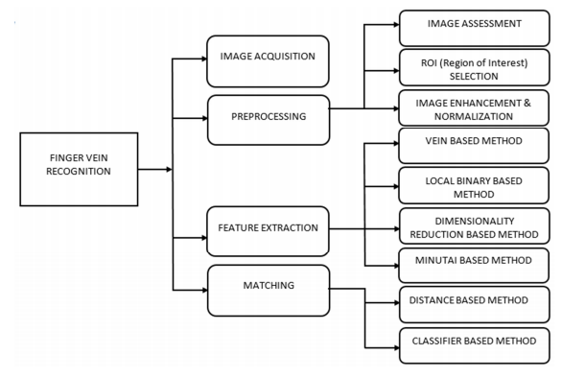

**Figure 1. Block diagram of finger vein recognition techniques.**

1. **Image Acquisition**

Image acquisition is the first basic step in FVR in which the finger vein image is captured by using NIR (near infra-red) light in the illumination transaction method. The acquisition device consists of an NIR assembly part for placement of the finger, and a charge-coupled device (CCD) preprocessor camera is then used to obtain an image of the finger vein. The NIR light can pass through a finger but hemoglobin in the blood can absorb more NIR light than other tissues (such as bones and muscles). When the vein of a finger absorbs infrared light, the image of the finger vein can be acquired as a dark line. Figure 2 shows how the finger vein scanner works, and Figure 3 presents the finger vein scanner. NIR imaging is secure because it passes through the finger to capture the images. Three methods are mainly used for finger vein image acquisition: light transmission method, light reflection method and two-way radiating method. Among these methods, a high contrast image is captured using the transmission method, therefore most of finger vein imaging devices employ the light transmission method. However, for optimization of the image acquisition device, there are always some problems, such as low contrast, translational and rotational variation and noise, which cannot be solved during the image capturing process, hence the next step—image preprocessing—which resolves these problems.

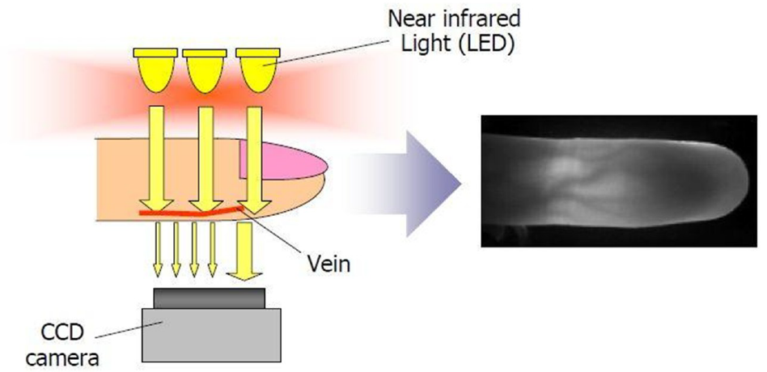

**Figure 2: How a finger vein scanner works**

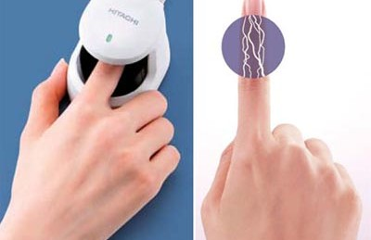

**Figure 3: Finger vein scanner**

1. **Preprocessing**

Before the feature extraction step, the data from the image sensor device should be preprocessed. The objective of image preprocessing is to provide a robust Region of Interest (ROI) image for feature extraction. Good performance of a finger vein image depends on the finger vein image quality. The finger vein image usually consists of noise, shades and low contrast. This is because of light fluctuation, a rotational and translational variation of the finger and also the performance of the capturing device. The preprocessing step is applied to relieve these problems. The three common preprocessing stages are (i) image quality assessment, (ii) region of interest (ROI) extraction, and (iii) normalization and enhancement.

* **Image Quality Assessment**

Image assessment acts as the first sub-step of preprocessing. During this stage, quality of acquired image samples is examined to estimate the suitability for further processing. If the raw data of the required sample is not satisfactory then there are two options. One is to acquire the data again from the user and another option is to generate an exception which alerts the administrator to implement other suitable procedures. Recently, several quality assessment schemes have been proposed to advance the performance of finger vein identification. To evaluate the quality of images, (signal to noise ratio based on the human visual system) evaluation index is proposed to simulate the properties of the human visual system. Based on Radon transform, Qin et al. proposed new image quality assessment algorithm to enhance the performance of finger vein system, where the quality score was predicted from the curvature of corresponding Radon Space. A quality metric finger vein quality evaluation based on a hierarchical feature of the vein was presented, which was shown with better matching performance. In order to reduce the authentication error rate, Nguyen et al. measured the finger vein image quality by detecting number of vein points in the image. Yang et al. estimated the quality of finger vein by combining image contrast, information capacity, and gradient, based on SVM, and filtered out the low-quality images. Peng et al. used a triangular norm approach for performance improvement using attributes illustrated in Reference. Zhou et al. associated three local and two global level features based on SVR to determine the quality of the finger vein image, but the scores of training data need to be annotated manually in advance. To predict vein quality and also to reduce recognition error rate, Qin et al. proposed a Deep Neural Network (DNN) for representation learning from the binary image, although it does not rely upon mean, energy and contrast features of the finger vein image; however it is complex in its application and requires more training data to train the deep neural network. Extracted stable and prominent features from a finger vein image can obviously upgrade the quality assessment of a vein image. Huang et al. proposed a method based on information fusion of structure and texture that takes both the recognition strategy and feature extraction into account, which in turn enhances the recognition performance.

* **ROI Extraction**

The second most important stage is ROI extraction. In finger vein images, there are undesirable regions (image background) and the valuable area (finger area) in the image. The valuable area is called ROI, and ROI extraction is the processing to localize and extract the finger area from the captured image and delete the image background. Different approaches are used to segment the finger region from the captured image such as region-based method, thresholding, template method, and edge-based method. Brindha et al. extracted the ROI from the original image by using two morphological operations. Wang et al. extracted the ROI from finger vein image by cutting the maximum inscribed rectangle of the finger vein image, and the original image was binarized using a selected threshold. In Reference the ROI was obtained from the original image by using Sobel operator. The finger region was segmented by using sub window scheme. Multiple image acquisitions are used in finger vein recognition system. Hence, different imaging devices using the ROI extraction method face challenges, such as gray level, image size variation, and background noise appearances in finger vein images, which affect the performance of the ROI extraction method. In order to address the sensor impact on finger vein images in a finger vein recognition system, Yang et al. proposed a cross-sensor super-pixel-based ROI extraction method. In this work, the super-pixel segmentation method was conducted on the finger vein image and finger vein boundaries were tracked from the segmented image. One other issue in former ROI extraction approaches is that some important information is lost in cropped ROI. In order to solve the information loss problem, Wang proposed a new ROI extraction method for finger vein images with fewer information losses by using modified sliding window method and outer rectangle method. The parameter used in the algorithm is also very important and they will influence the performance of the finger vein recognition systems. Zhang et al. presented a parameter adjustment method in the preprocessing stage to select the filter in noise reduction and threshold in edge detection.

* **Normalization and Enhancement**

Normalization is a process that normalizes the range of pixel intensity values in an image. After extracting the ROI, the finger vein image is normalized in order to accommodate geometric changes and to get consistent image size. In addition, normalization in the preprocessing stage eliminates the diverse variation problems of the image. Image enhancement is another key stage in the preprocessing phase. The basic goal of image enhancement is to advance the interpretable or knowledge of information in images for human viewers or to get the standard enhanced image from the unclear acquired image. In finger vein recognition, image enhancement is required to get better matching performance. Enhancement of a finger vein image mainly focuses on contrast enhancement and noise removal. There are many enhancement techniques used to improve the image quality. Contrast limited adaptive histogram equalization is one of the common enhancement approaches in finger vein recognition. Additionally, some other enhancement algorithms have also presented good results. Yang et al. have employed Circular Gabor Filter approach to improve finger vein images. Histogram equalization technique was employed by Liu and Song to enhance the gray level contrast in finger vein images. Gaussian matching technique was proposed by Wang to enhance finger vein image. Adaptive histogram equalization enhancement was implemented by Reference to detect edges of vein significantly and enhanced the global contrast of input image. In References, Gabor filter technique was used to enhance finger vein images and remove noise from images. Zhang et al. applied Circular Gabor Filter for image enhancement of finger vein. Xie et al. proposed a normalization method for finger vein image enhancement using a guided filter-based single scale retinex. Moreover, some enhancement techniques were combined to enhance the finger vein image and reduce the noise. Pflug et al. employed adaptive non-local mean and non-linear diffusion method to enhance image and reduce noise. Kayode et al. combined Gabor filter and canny edge detector to enhance the finger vein image and remove noise.

1. **Feature Extraction**

Feature extraction represents one of the most crucial and major steps of FVR. During this step, the quantifiable property of the basic biometric trait is created, called the template, which is helpful for identifying the individual. For example, in a fingerprint biometric system, position and orientation of minutiae points in a fingerprint image is the key feature which needs to be different from another person. An efficient feature extraction technique is a step which enhances the precision of finger vein recognition. Numerous feature extraction techniques have been presented, and this paper discusses four groups of feature extraction methods, i.e., vein-based method, local binary-based method, dimensionality-based method and minutiae-based method.

* **Local Binary-Based (LBP) Method**

Local Binary Pattern is a local feature descriptor used to represent the finger vein local feature information. The LBP code may be described as an ordered set of binary values determined by comparing the gray value of a central pixel with its neighboring pixels.

Several approaches have been developed to extract a local feature of finger vein images. For example, Lee used the locally based feature extraction scheme to remove the problem of irregular shading and the highly saturated area in the image, which greatly reduced the processing time and improved recognition. Rosdi et al. introduced the local line binary pattern approach to extract features and achieved excellent results over previous methods. Local line binary pattern method is a revised version of LBP (Local binary pattern), which extracts feature in both horizontal and vertical direction. Finger vein images have rich orientation information, and the line patterns obtained only from vertical and horizontal orientation may not have enough discrimination information for matching. To further enhance the discriminatory information, Yu et al. proposed poly directional line pattern and generalized local line binary pattern methods, which extract line pattern at an arbitrary orientation. However, LLBP and PLLBP have low discriminatory information and a jumble of redundant information. Hence, Liu et al. advance a novel customized local line binary pattern approach to eliminate the information reduction, increase discriminatory information of local features and reduce the matching time of recognition system. Extraction of powerful feature greatly improves the performance of finger vein identification. For extracting powerful features, Xi et al. introduced Pyramid histograms of gray, textures and orientation gradient (PFS-PHGTOG) technique by discriminating subset features from PHGTOG to reduce the verification error rate (EER). Translation and rotational variation of finger cause change of finger vein image which degrades performance of the FVR system. To deal with this difficulty, Wang and Yang proposed translational and rotational invariant feature extraction approach for FVR. A remarkable result is obtained. A Multi-scale Sobel Angle Local Binary Pattern (MSALBP) novel feature extraction approach is presented for personal verification using finger texture pattern of five fingers. Xi proposed feature extraction technique which outperforms the existing techniques.

* **Dimensionality Reduction-Based Method**

In dimensionality reduction-based method, finger vein image is transformed into a low dimensional space by dimension reduction, in which the discriminating information is kept and noises are discarded. Mostly feature extraction technique in this kind of method requires a training process to learn the transformation matrix, and a classifier is employed in the matching process. During image acquisition, the residual information is also obtained such as pose variation, shades of finger muscle and bone around the vein, which may affect the accuracy of the identification system. In order to remove these problems, Liu et al. presented Orthogonal Neighborhood Preserving Projection (ONPP) manifold learning method for the first time to handle the pose variation problem in finger vein image and obtained 97.8% recognition rate. Due to the acquisition devices, torsion, translational and other deformation in the local area, the traditional approach achieved very low identification precision. Guan et al. proposed a feature extraction method named Bi-directional Weighted Modular B2DPCA (BWMB2DPCA), which obtained a better result than the traditional techniques. The BWMB2DPCA method shortened the size of image feature matrix, which also decreased the recognition accuracy as different feature vectors effect identification efficiency. Additionally, the experimental result of BWMB2DPCA was not conclusive because the eigenvectors of column are ignored.

* **Minutiae Point-Based Method**

The point where the ridge lines end or fork is defined as a minutiae point. Minutiae points refer to the terminal point and bifurcation point of blood vessels, and are one kind of important feature of a finger vein image. Minutiae points are used in finger vein recognition, and such methods are already used in fingerprint recognition technique. Mantrao et al. presented a minutiae-based point feature extraction and matching approach which greatly improved the performance of the identification system. Aziz et al. extracted minutiae points of finger vein by combining two methods, namely maximum curvature points and fingerprint application method. Prabhakar et al. used endpoints and bifurcation points to eliminate false minutiae and make the identification more precise.

1. **Matching**

The matching technique is the last step of recognition to decide whether an input image is genuine or an imposter for one enrolled image, in which a matching score is generated. A matching score measures the likeness between the enrolled template and the input image. Two types of matching techniques are used, i.e., distance-based matching and classifier-based matching. Conventional finger vein identification approach uses the distance-based matching technique, while by machine learning techniques finger vein recognition can employ classifier-based matching technique. Classifier-based matching techniques were employed for finger vein recognition systems.

**BENEFITS OF FINGER VEIN RECOGNITION**

1. Finger vein patterns are unique to each individual, even among identical twins. The false acceptance rate is very low (close to zero).
2. Placing a hand or finger is less intrusive compared to other biometric technologies.
3. Because veins are located inside the body, it is extremely difficult to read or steal. There is little risk of forgery or theft.
4. Finger veins do not leave any trace during the authentication process and so cannot be duplicated.
5. Finger vein patterns remain relatively constant through the adult years so that re-enrollment of the vein pattern will not be required once enrolled.
6. Finger veins are less likely to be influenced by changes in the weather or physical condition of the individual.
7. Rushes, cracked and rough skin do not affect the result of authentication.

**Applications:**

• ATM

• Keyless engine starters

• Financial institutions

• Immigration

• Entry control

**CHAPTER THREE**

**SUMMARY AND CONCLUSION**

**SUMMARY**

Biometric system is very useful as it employs biology features of an individual. Finger vein features are one of the good biological characteristic that is stable and distinct for everybody. Thus, it can ensure a higher security of the developed system. Compare to other biological traits such as finger mark, finger vein provides more advantages in terms of their uniqueness. Therefore, it strictly disallows frauds and intruders into its system. Finger vein verification verifies an individual’s finger vein by comparing and matching the person’s finger vein with the stored templates.

**CONCLUSION**

Finger-vein based identification technology has high security and reliability compared to the traditional authentication mode. It also can be applied in public or private equipments, such as entrance control systems, home or office door entry control systems, and ATM (Automated Teller Machine) systems.

**REFERENCES**

["Barclays - Hitachi Digital Security"](http://digitalsecurity.hitachi.eu/case-studies/barclays/). Retrieved 17 May 2018.

Qin, H.; He, X.; Yao, X.; Li, H. Finger-vein verification based on the curvature in Radon space. Expert Syst. Appl. 2017, 82, 151–161.

Prabhakar, P.; Thomas, T. Finger vein identification based on minutiae feature extraction with spurious minutiae removal. In Proceedings of the 2013 Third International Conference on Advances in Computing and Communications (ICACC), Kerala, India, 29–31 August 2013; pp. 196–199.

Rosdi, B.A.; Shing, C.W.; Suandi, S.A. Finger vein recognition using local line binary pattern. Sensors **2011**, 11, 11357–11371. [CrossRef] [PubMed]

Liu, X.Z.; Yang, G. Block-wise two-dimensional maximum margin criterion for face recognition. Sci. World J. **2014**. [CrossRef] [PubMed]