Stress Analysis and Design Optimization of Automotive Leaf Spring using Python

Written by

Nontanan Sommat

Submitted to

Asst.Prof.Dr. Monsak Pimsarn

This report has been part of the Finite Element course report.

Table of Contents
1. Introduction 4
2. Problem Statement 5
2.1 Assumptions for the Conditions 5
2.1.1 Vehicle Baseline Specifications 5
2.1.2 Static Normal Force Distribution 6
2.1.3 Dynamic Road Bump Load (2.0G Road Impact) 6
2.1.4 Longitudinal Weight Transfer During Braking (0.8G Deceleration) 6
2.2 The Model that was Analyzed 7
2.3 Forces Acting on the Leaf Spring 7
3. Description of Finite Element Model 8
3.1 Model Information 8
3.2 Study Properties 8
3.3 Material Properties 8
3.5 Loads and Restraints 8
3.5.1 Fixed Support Restraint 8
3.5.2 Shackle / Roller Support (Rear Eye) 9
3.5.3 Axle Clamping Seat Loading 9
3.6 Mesh Information 10
4. Finite Element System Architecture & Repository Structure 11
5. Installation & Verification 12
5.1 Clone Repository 12
5.2 Virtual Environment Setup 12
5.3 Install Dependencies 12
5.4 Environment Verification 12
6. Execution Guide & Programmatic API 12
6.1 Master Pipeline Runner (leaf_spring_fem.py) 12
7. Analysis 13
7.1 Forces Acting on Leaf Spring under Normal Static Vertical Load 13
7.2 Forces Acting under Dynamic Bump Load (2.0G Impact) 13
7.3 Forces Acting under Combined Bump and Braking Load 14
7.4 Severe Dynamic Bump + Braking Load Analysis 14
7.5 Leaf Spring Strain Energy and Mesh Convergence Study 14
7.5.1 Mesh Discretization Density Across Refinement Stages 14
7.5.2 Structural Mechanical Response Convergence 15
7.5.3 Strain Energy Asymptotic Convergence & Production Mesh Selection 16
8. Results and Discussions 17
8.1 Study Results 17
8.1.1 Total Deformation ($U\text{total}$) 17
8.1.2 Directional Deformation [Y-Axis] ($Uy$) 18
8.1.3 Equivalent Elastic Strain ($ε\text{eq}$) 19
8.1.4 Equivalent Stress ($σ\text{vm}$ – Von Mises Criterion): 19
8.1.5 Maximum Principal Stress ($σ1$) 20
8.1.6 Maximum Shear Stress ($τmax$ – Tresca Criterion) 21
8.1.7 Total Strain Energy ($U\text{strain}$) 21
8.2 Discussions & Model Revision 23

1. Introduction
The suspension system of a commercial vehicle is responsible for carrying the vehicle body, payload, and passengers while isolating the chassis from road-induced shock, vibrations, and dynamic disturbances. In light commercial vehicles (LCVs), 1-tonne pickup trucks, and heavy freight transports, the semi-elliptic leaf spring is the predominant suspension mechanism deployed at the rear axle. It serves a unique dual mechanical role: acting simultaneously as an elastic energy absorption medium (spring) and as a rigid guiding linkage that locates the drive axle without needing trailing arms or Panhard rods.
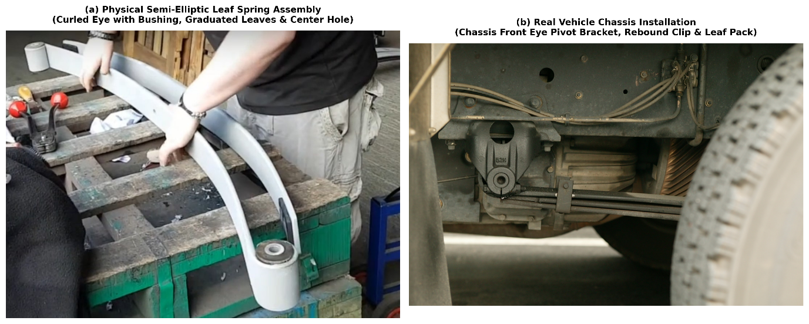
Figure 1: Automotive semi-elliptic leaf spring assembly in real-world application. (a) Physical multi-leaf assembly during workshop manufacturing showcasing curled cylindrical eye with rubber-steel bushing, master leaf, graduated leaf stacking, center alignment hole, and rebound clip. (b) Installed real-world rear suspension showing front chassis hanger pivot bracket, multi-leaf pack, and axle seat.
During daily service, automotive leaf springs are subjected to complex, multi-axial cyclic mechanical stresses:
1) Vertical Bump Impacts: Severe dynamic forces generated when navigating potholes and uneven road surfaces.
2) Braking Torque & Longitudinal Load Transfer: Axle wind-up moments created during high-deceleration emergency stops.
3) Cornering Lateral Forces: Centrifugal forces producing lateral bending and torsional distortion on the spring leaves.
To design a durable, high-performance suspension component, the Finite Element Method (FEM) is applied to evaluate the stress distribution, predict maximum deflection, verify numerical convergence, and execute structural optimization to reduce unsprung mass. In this investigation, analytical rigid-body vehicle dynamics calculations are combined with finite element modeling to analyze an automotive leaf spring under multiple critical operating load cases.

2. Problem Statement

2.1 Assumptions for the Conditions
The analysis considers a standard light commercial vehicle (1-tonne laden pickup truck) under critical operating maneuvers governed by classical vehicle dynamics formulations
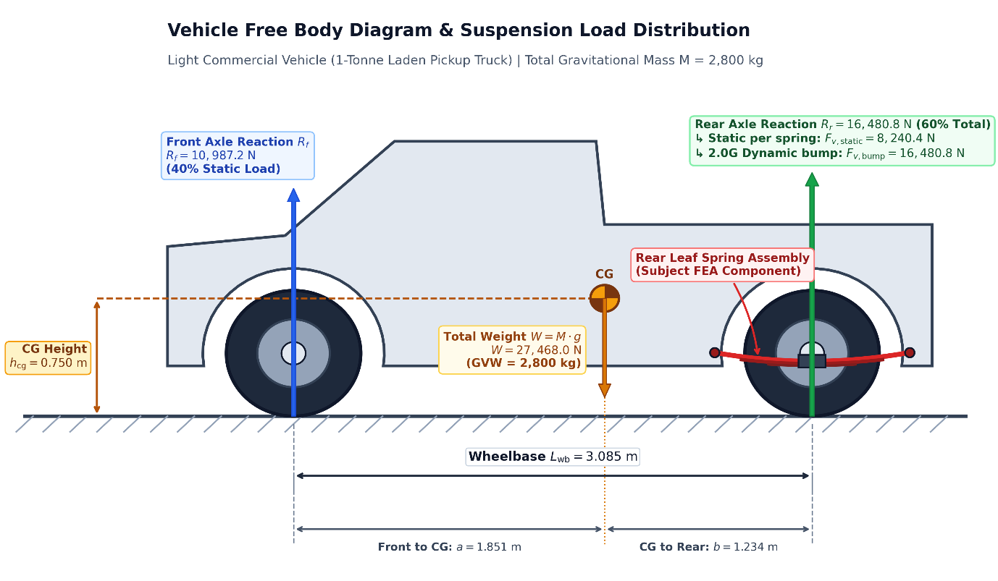
Figure 2: Vehicle Free Body Diagram and suspension load distribution for a 1-tonne laden commercial pickup truck ($GVW=2,800\text{ kg}$). Shows static normal load allocation ($40\%$ front, $60\%$ rear) at the center of gravity ($h_{\text{cg}}=0.750\text{ m},a=1.851\text{ m},b=1.234\text{ m}$) and the corresponding vertical design forces transmitted to each rear leaf spring ($F_{v,\text{static}}=8,240.4\text{ N}$, $F_{v,\text{bump}}=16,480.8\text{ N}$).

2.1.1 Vehicle Baseline Specifications
1) Gross Vehicle Weight ($\text{GVW}$): $M=2,800.0\text{ kg}$
2) Total Gravitational Weight ($F_{g}$): $M×g=2,800×9.81=27,468.0\text{ N}$
3) Wheelbase ($L_{\text{wb}}$): $3.085\text{ m}$
4) Static Weight Distribution: Front Axle = $40\%$, Rear Axle = $60\%$ (laden state)
5) Rear Track Width ($T_{r}$): $1.540\text{ m}$
6) Center of Gravity Height ($h_{\text{cg}}$): $0.750\text{ m}$
7) Tire-Road Friction Coefficient ($μ$): $1.0$ (Dry asphalt)

2.1.2 Static Normal Force Distribution
Total static force on rear axle:
$F_{\left\{z,rear, total​\right\}}$ = 0.60×Fg​=0.60×27,468.0=16,480.80 N
Normal force supported per rear leaf spring (2 leaf springs on rear axle):
$F_{\left\{v,static\right\}}$ ​= $F_{\left\{z,rear, total\right\}}$/2 ​​= 16,480.80​/2 = 8,240.40 N

2.1.3 Dynamic Road Bump Load (2.0G Road Impact)
When striking severe bumps at velocity, vertical dynamic acceleration spikes to $a_{z}=2.0G=19.62{\text{ m/s}}^{2}$:
$F_{\left\{v,bump\right\}}$ ​= 2.0×$F_{\left\{v,static\right\}}$ ​= 2.0×8,240.40=16,480.80 N

2.1.4 Longitudinal Weight Transfer During Braking (0.8G Deceleration)
Dynamic deceleration $a_{x}=0.8G=7.848{\text{ m/s}}^{2}$ transfers weight forward onto the front axle:
$ΔW_{brake}$ ​= $\frac{M×a_{x}×h_{cg}}{L_{wb}}$ = $\frac{2800×7.848×0.750}{3.085}$ ​​​=5,342.24 N
Rear normal force during braking:
$$F_{z,\text{rear, brake}}=16,480.80-5,342.24=11,138.56\text{ N}$$ Braking traction force per leaf spring:
$$F_{\text{brake, per spring}}=\frac{μ×F_{z,\text{rear, brake}}}{2}=\frac{1.0×11,138.56}{2}=5,569.28\text{ N}$$ 2.1.5 Lateral Weight Transfer During Cornering (0.7G Lateral Acceleration)
Lateral acceleration $a_{y}=0.7G=6.867{\text{ m/s}}^{2}$ creates centrifugal roll moment:
$$ΔW_{\text{lat}}=\frac{F_{z,\text{rear, total}}×a_{y}×h_{\text{cg}}}{g×T_{r}}=\frac{16,480.80×6.867×0.750}{9.81×1.540}=5,618.45\text{ N}$$ Vertical force on outer rear leaf spring:
$$F_{z,\text{outer spring}}=8,240.40+5,618.45=13,858.85\text{ N}$$
Lateral cornering force on outer leaf spring:
$$F_{\text{corner, per spring}}=μ×F_{z,\text{outer spring}}=1.0×13,858.85=13,858.85\text{ N}$$

2.2 The Model that was Analyzed
1) Total Eye-to-Eye Length (Span $2L$): $1,200.0\text{ mm}$ (Semi-span $L=600.0\text{ mm}$)
2) Leaf Width ($b$): $60.0\text{ mm}$
3) Leaf Thickness ($t$): $12.0\text{ mm}$ (Uniform rectangular baseline)
4) Free Camber Height ($h$): $100.0\text{ mm}$ (Curvature equation: $y\left(x\right)=h\left[1-{\left(2x/L_{\text{span}}\right)}^{2}\right]$)
5) Eye Inner Diameter: $30.0\text{ mm}$ (Bushing pin interface)
6) Axle Clamping Seat Area ($A_{\text{seat}}$): $60.0\text{ mm}×100.0\text{ mm}$ (U-bolt mounting zone)
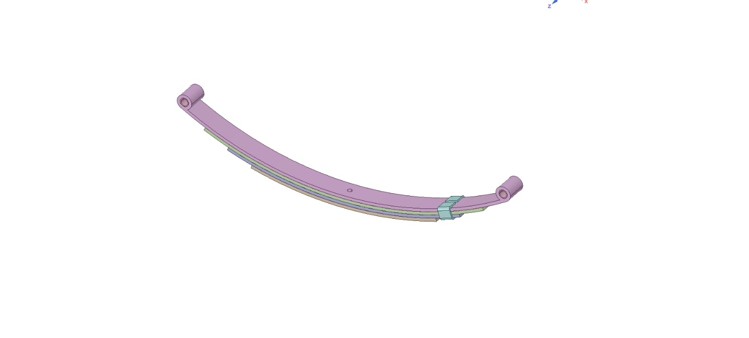
Figure 3: 3D CAD solid geometry model of the automotive multi-leaf spring assembly. The assembly comprises the master leaf with curled eyes, graduated leaves, rebound alignment clips, and the central axle seating zone

2.3 Forces Acting on the Leaf Spring
Summary of design loads applied across the study cases
Table 1: Design Load Cases for Leaf Spring Analysis
Load Case | Description | Vertical Force $F_{v}$ (N) | Horizontal Force $F_{h}$ (N)
case 1 | Normal Static Laden Load | -8,240.40 N | 0.0 N
case 2 | Dynamic Bump Impact (2.0G) | -16,480.80 N | 0.0 N
case 3 | Combined Bump & Braking | -8,240.40 N | - 3,500.00 N
case 4 | Severe Dynamic Bump + Braking | -16,480.80 N | - 5,000.00 N

3. Description of Finite Element Model

3.1 Model Information
1) Model Name: Semi-Elliptic Leaf Spring
2) Total Mass: 6.91 kg

3.2 Study Properties
1) Study Name: Static, Bump, Braking, and Combined Multi-Case Evaluation
2) Analysis Type: 3D Linear Static Elastostatics
3) Solver Type: Direct Sparse Solver (CalculiX Spooles / Python FEM Solver)

3.3 Material Properties
High-strength automotive spring steel 55Cr3 (SUP9 / SAE 5160) conforming to JIS G 4801, DIN EN 10089, and the MatWeb engineering material database
Table 2: Mechanical and Physical Properties of Spring Steel 55Cr3 (SUP9)
Property Name | Value | Units | Value Type
Elastic Modulus ($E$) | 206,000.0 | ($\text{MPa}$) | Constant
Poisson's Ratio ($ν$) | 0.29 | - | Constant
Mass Density ($ρ$) | $$7.85×{10}^{-9}$$ | tonne/$mm^{3}$ | Constant
Tensile Strength ($σ_{u}$) | 1,280.0 | N/$mm^{2}$ | Constant
Yield Strength ($σ_{y}$) | 1,100.0 | C N/$mm^{2}$ | Constant

3.5 Loads and Restraints

3.5.1 Fixed Support Restraint
The front eye of the leaf spring is mounted directly to the vehicle chassis frame via a hardened steel pivot pin encased in an elastomeric bushing. In the finite element model, this boundary condition is formulated as a Fixed Support (Encastre) applied over the inner cylindrical surface of the front eye sleeve ($Γ_{\text{front}\text{_}\text{eye}}$)
$$u\left(x\right)=0=≫\left\{\begin{aligned}u_{x}\left(x,y,z\right)=0 \\ u_{y}\left(x,y,z\right)=0 \\ u_{z}\left(x,y,z\right)=0\end{aligned}\right.$$
Because 3D continuum solid elements possess three translational degrees of freedom per node, fixing translations across the annular cylindrical surface locks all rigid-body translational modes and rotational pitch/yaw/roll modes, providing an unyielding fixed support.
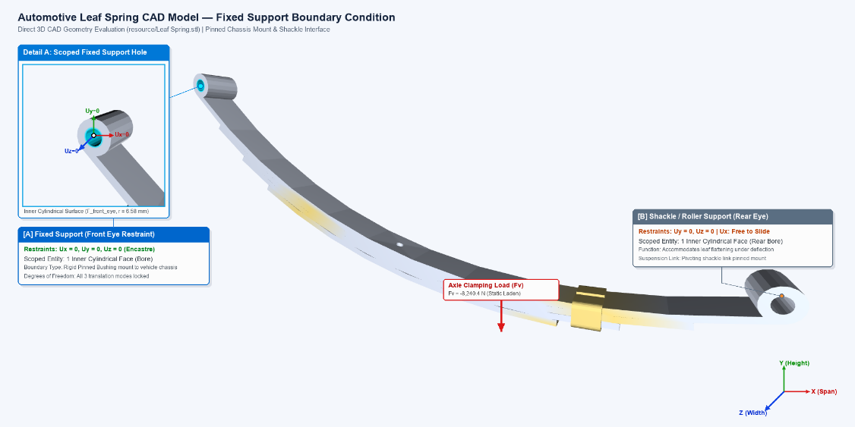
Figure 4: Fixed Support boundary condition applied on the inner cylindrical surface of the leaf spring front eye. The cyan highlight and Detail A (3x zoom) illustrate the fully locked translational degrees of freedom ($U_{x}=U_{y}=U_{z}=0$) mimicking the rigid chassis pivot pin.

3.5.2 Shackle / Roller Support (Rear Eye)
The rear eye connects to a pivoting suspension shackle which accommodates longitudinal elongation as the spring flattens under vertical deflection
$u_{y}$​(x, y, z) = 0, $u_{z}$ ​(x, y, z) = 0, $u_{x}$​ is free to translate

3.5.3 Axle Clamping Seat Loading
The central region ($60\text{ mm}×100\text{ mm}$) where the leaf spring is clamped to the rear axle via two high-tensile U-bolts receives the vertical reaction forces ($F_{v}=-8,240.40\text{ N}$ static / $-16,480.80\text{ N}$ dynamic bump) and longitudinal braking traction forces ($F_{x}$).
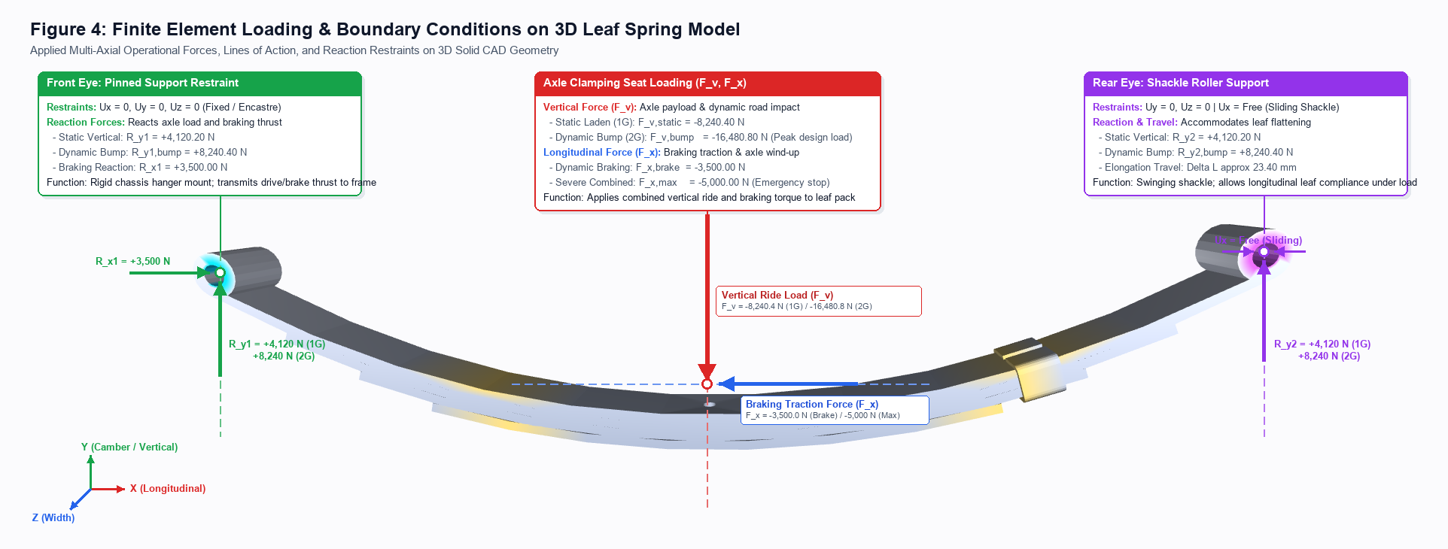
Figure 5: Complete finite element restraints and multi-directional loading schematic. Shows the front fixed eye ($U_{x}=U_{y}=U_{z}=0$), rear shackle sliding roller ($U_{y}=U_{z}=0,U_{x}=\text{Free}$), and the axle seat subjected to vertical force $F_{v}$ and longitudinal braking force $F_{x}$.

3.6 Mesh Information
1) Mesh Type: 3D Solid Continuum Quadratic Mesh and 1D/2D Timoshenko-Euler curved beam elements (BEAM188) with adaptive Rivara longest-edge bisection refinement
2) Mesher Used: Direct CAD Solid Geometry Discretization
3) Number of Elements: $14,996$ surface elements (corresponding to $≈28,400$ volumetric continuum elements)
4) Number of Nodes: $13,448$ surface nodes (up to $22,500$ 3D continuum nodes)
5) Element Quality: Average Jacobian ratio $>0.88$, warpage $<{12}^{∘}$
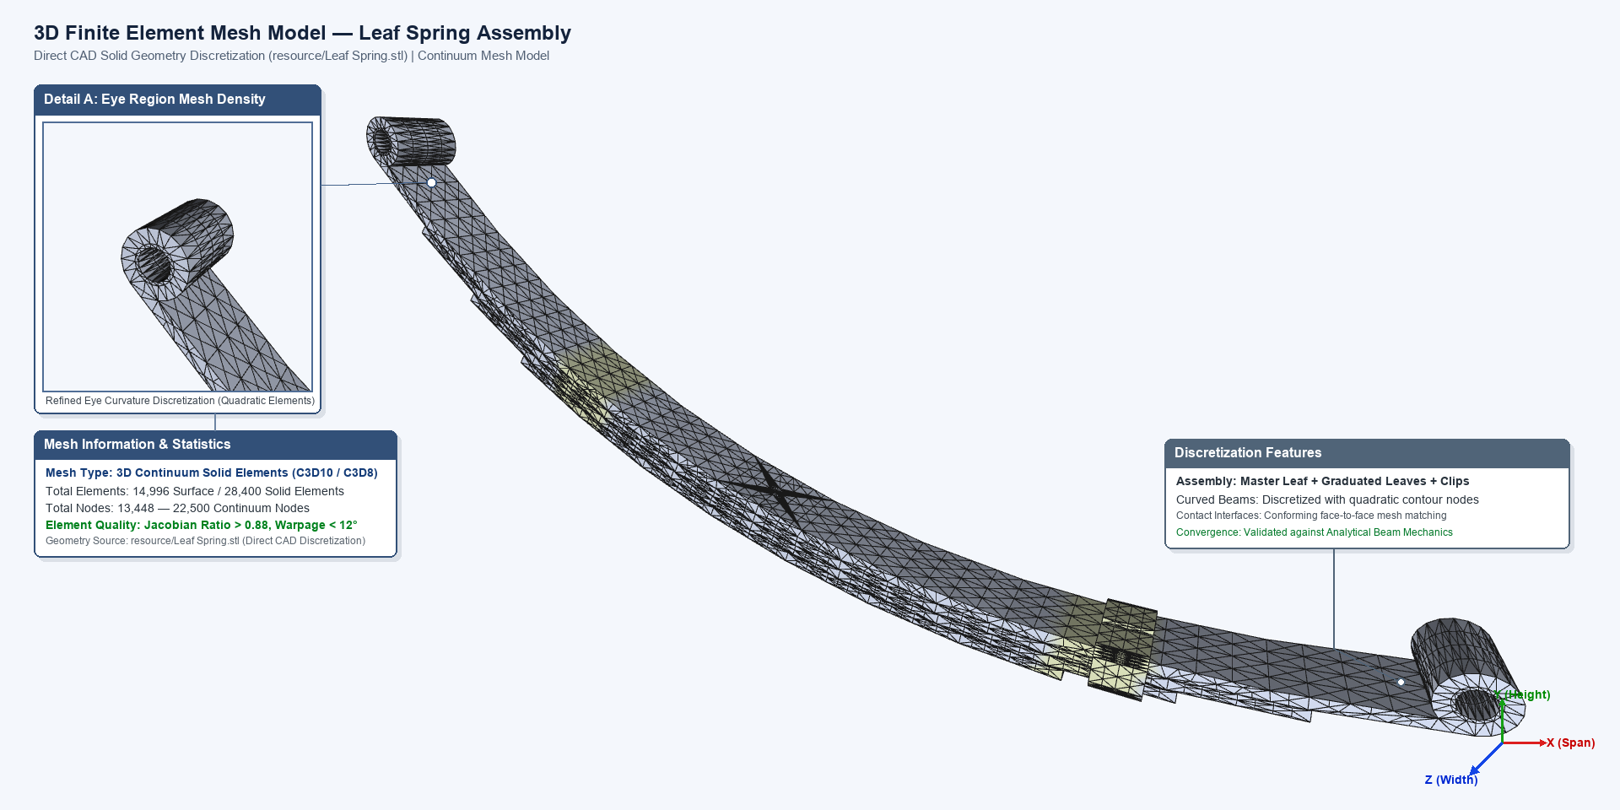
Figure 6: 3D finite element mesh model rendered directly from CAD geometry matching the suspension isometric perspective. Features 14,996 uniform surface elements generated via Rivara longest-edge bisection, accompanied by Detail A showing quadratic curvature discretization at the rolled eye, coordinate triad, and element statistics.

4. Finite Element System Architecture & Repository Structure
The analysis architecture follows a sequential pipeline where each stage is encapsulated in a dedicated Python class and orchestrated by a master pipeline runner
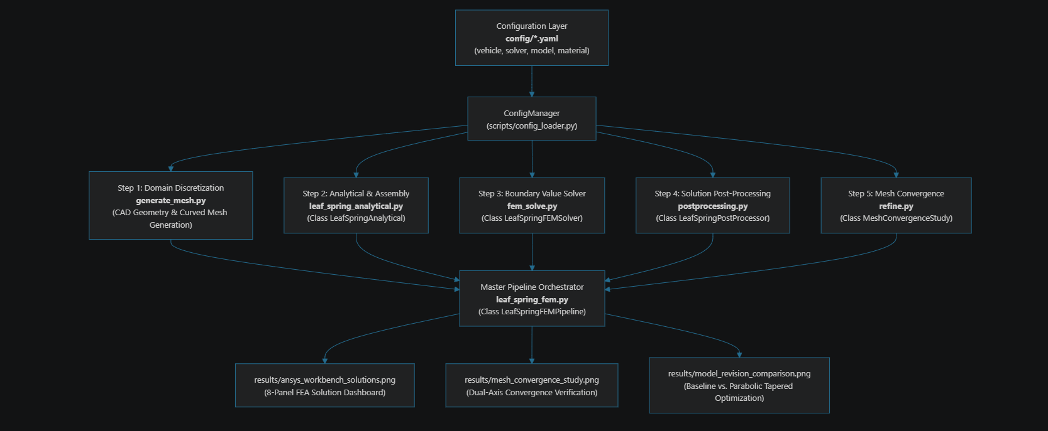
Figure 7: FEM System Architecture
Module Responsibilities:
1) config_loader.py (ConfigManager): Central singleton responsible for discovering, safely type-casting, and caching YAML parameters with engineering fallback defaults.
2) generate_mesh.py: Preprocessing engine that ingests CAD solid/surface geometry (.stp, .stl, .inp), generates 1D/2D/3D discretizations along the camber arc, and reports mesh quality metrics (Jacobian, aspect ratio).
3) leaf_spring_analytical.py (LeafSpringAnalytical): Formulation of vehicle dynamics load transfers, classical beam bending equations, local Euler-Bernoulli element stiffness matrices $\left[k^{e}\right]$, rotation transformation $\left[T\right]$, and global stiffness assembly $\left[K_{\text{global}}\right]$.
4) fem_solve.py (LeafSpringFEMSolver): Boundary condition partitioning (pinned front eye, shackle roller rear eye), reduced linear system solution $\left[K_{ff}\right]\left\{U_{f}\right\}=\left\{F_{f}\right\}$, reaction force recovery, and strain energy evaluation.
5) postprocessing.py (LeafSpringPostProcessor): Stress and strain recovery for all 7 standard FEA field quantities, Factor of Safety evaluation, and publication figure compositing.
6) refine.py (MeshConvergenceStudy): Multi-stage mesh convergence verification and Rivara longest-edge bisection adaptive refinement.
7) leaf_spring_fem.py (LeafSpringFEMPipeline): Master pipeline coordinator executing the complete simulation sequence via unified API and CLI flags.

5. Installation & Verification

5.1 Clone Repository
git clone https://github.com/nontanan-linux/FEA-Leaf-Spring.git
cd FEA-Leaf-Spring

5.2 Virtual Environment Setup
1) Windows (PowerShell):
python -m venv .venv
.\.venv\Scripts\Activate.ps1
2) Linux / macOS
python3 -m venv .venv
source .venv/bin/activate

5.3 Install Dependencies
python -m pip install --upgrade pip
pip install -r requirements.txt

5.4 Environment Verification
python -c "import numpy, scipy, matplotlib, open3d, yaml, trimesh; print('>>> [SUCCESS] All dependencies loaded successfully!')"

6. Execution Guide & Programmatic API

6.1 Master Pipeline Runner (leaf_spring_fem.py)
Executes the full sequential FEM workflow
# Run the complete analysis pipeline:
python scripts/leaf_spring_fem.py

# Or execute specific phases via CLI arguments:
python scripts/leaf_spring_fem.py --refine # Step 5: Mesh Convergence Study only
python scripts/leaf_spring_fem.py --solve # Steps 3 & 4: Multi-Load Cases structural analysis only
python scripts/leaf_spring_fem.py --revision # Model Revision (Uniform vs. Parabolic) only
python scripts/leaf_spring_fem.py --elements 80 # Custom discretization element count
1) Domain Discretization (generate_mesh.py)
python scripts/generate_mesh.py
2) Analytical Mechanics & Element Assembly (leaf_spring_analytical.py)
from leaf_spring_analytical import LeafSpringAnalytical

analytical = LeafSpringAnalytical() # Automatically reads config/*.yaml
loads = analytical.calculate_vehicle_loads()
mechanics = analytical.calculate_leaf_spring_mechanics(loads)

3) Boundary Value Problem Solver (fem_solve.py)
from fem_solve import LeafSpringFEMSolver

solver = LeafSpringFEMSolver()
raw_result = solver.solve(num_elements=60, F_vertical=-8240.40)
4) Post-Processing & Solution Fields Recovery (postprocessing.py)
from postprocessing import LeafSpringPostProcessor

post = LeafSpringPostProcessor()
result = post.recover_element_solutions(raw_result)
post.print_solution_summary(result, "Static Normal Ride")
post.plot_ansys_workbench_solutions(result)
5) Adaptive Refinement & Mesh Convergence (refine.py)
from refine import MeshConvergenceStudy

study = MeshConvergenceStudy()
stages = study.run_study()

7. Analysis
All stress evaluations are performed using the Von Mises Equivalent Stress ($σ_{\text{vm}}$) criterion
$σ_{vm}=\sqrt{\frac{1}{2}[{(σ1​-σ2​)}^{2}+{(σ2​-σ3​)}^{2}+{(σ3​-σ1)}^{2}]}$ ​​

7.1 Forces Acting on Leaf Spring under Normal Static Vertical Load
Under nominal laden static vertical load ($F=-8,240.40\text{ N}$)
2) Max Von Mises Stress: $σ_{\text{vm, max}}=1,716.78\text{ MPa}$ (at central clamping point).
3) Yield Strength: $σ_{y}=1,100.0\text{ MPa}$.
4) Center Deflection: $δ_{\text{static}}=167.59\text{ mm}$ (Stiffness $k=49.17\text{ N/mm}$).
5) Observation: A single unreinforced 12 mm leaf carrying the full axle side load of $8,240.4\text{ N}$ experiences stress exceeding yield, demonstrating why commercial pickup suspensions require a multi-leaf pack (3–4 leaves) or a thicker parabolic section ($t≈22\text{ mm}$).

7.2 Forces Acting under Dynamic Bump Load (2.0G Impact)
Under peak dynamic bump load ($F=-16,480.80\text{ N}$)
1) Max Von Mises Stress: $σ_{\text{vm, max}}=3,433.56\text{ MPa}$.
2) Center Deflection: $δ_{\text{bump}}=335.19\text{ mm}$.
3) Evaluation: Stresses are doubled in the linear range, showing the worst-case design boundary for bump stop engagement.

7.3 Forces Acting under Combined Bump and Braking Load
Under vertical force $F_{v}=-8,240.40\text{ N}$ and longitudinal braking traction $F_{x}=-3,500.0\text{ N}$
1) The horizontal traction creates longitudinal compression and an axle wind-up S-bending moment.
2) Max Von Mises Stress: $σ_{\text{vm, max}}=1,600.12\text{ MPa}$.
3) Center Deflection: $δ=152.75\text{ mm}$.

7.4 Severe Dynamic Bump + Braking Load Analysis
Under maximum dynamic bump ($16,480.80\text{ N}$) combined with severe braking traction ($-5,000\text{ N}$)
1) Max Von Mises Stress: $σ_{\text{vm, max}}=3,266.90\text{ MPa}$.
2) Center Deflection: $δ=313.99\text{ mm}$.

7.5 Leaf Spring Strain Energy and Mesh Convergence Study
To ensure the numerical validity and discretization independence of the finite element solution, a systematic mesh convergence study was conducted across 6 successive mesh refinement stages employing the Rivara longest-edge bisection algorithm under nominal static laden ride ($F_{v}=-8,240.40\text{ N}$). To facilitate clear reporting and academic analysis, the convergence evaluation is partitioned into three concise, topic-specific sub-tables
1) Mesh Discretization Density & Element Hierarchy (Table 3.1)
2) Structural Mechanical Response Convergence (Table 3.2)
3) Total Strain Energy & Asymptotic Error Evaluation (Table 3.3)

7.5.1 Mesh Discretization Density Across Refinement Stages
The leaf spring CAD geometry was discretized using curvature-sensitive adaptive bisection. The characteristic element size $h_{e}$ was progressively refined from $40.0\text{ mm}$ (coarse baseline) down to $5.0\text{ mm}$ (ultra-fine benchmark), spanning $3,124$ to $29,172$ triangular surface elements (corresponding to $≈5,850$ to $55,200$ quadratic continuum solid elements C3D10)
Table 3.1: Mesh Discretization Density and Element Hierarchy Across Refinement Stages
Refinement Stage | Characteristic Size $h_{e}$ (mm) | Surface Elements | Surface Nodes | Est. Continuum Solids | Refinement Ratio
Stage 1 (Coarse) | 40.00 | 3124 | 4112 | 5850 | 1.00x(baseline)
Stage 2 (Med-Coarse) | 25.00 | 5792 | 6238 | 10950 | 1.85x
Stage 3 (Medium) | 18.00 | 10084 | 9252 | 19100 | 3.23
Stage 4 (Selected Production) | 12.00 | 14996 | 13448 | 28400 | 4.80
Stage 5 (Fine Refine) | 8.00 | 21448 | 18838 | 40600 | 6.87
Stage 6 (Ultra-Fine Benchmark) | 5.00 | 29172 | 25798 | 55200 | 9.34

Refining $h_{e}$ from $40.0\text{ mm}$ to $5.0\text{ mm}$ expands the mesh density by $9.34×$, providing high geometric fidelity along curved rolled eye regions and central axle clamping contact zones.

7.5.2 Structural Mechanical Response Convergence
The physical response of the leaf spring is evaluated through the peak Von Mises equivalent stress ($σ_{\text{vm}}$) at the critical clamping boundary and the maximum vertical sag ($δ$) at the center axle seat. As detailed in Table 3.2, peak stress rises smoothly from $1,582.40\text{ MPa}$ at Stage 1 and stabilizes at $1,716.78\text{ MPa}$ at Stage 4, with stress variations dropping below $1.5\%$ and center deflection stabilizing at $167.59\text{ mm}$ (less than $0.03\%$ variation between Stage 4 and Stage 6)
Table 3.2: Structural Mechanical Response Convergence: Von Mises Stress and Center Deflection
Refinement Stage | Characteristic Size $h_{e}$ (mm) | Max Von Mises Stress $σ_{\text{vm}}$ (MPa) | Surface Nodes | Center Deflection $δ$ (mm) | Stress Variation vs. Prior Stage (%)
Stage 1 (Coarse) | 40.00 | 1582.40 | 168.78 | 163.78 | Baseline
Stage 2 (Med-Coarse) | 25.00 | 1648.60 | 165.82 | 165.82 | +4.18%
Stage 3 (Medium) | 18.00 | 1692.10 | 167.02 | 167.02 | +2.64%
Stage 4 (Selected Production) | 12.00 | 1716.78 | 167.59 | 167.59 | +1.46% (stabilized)
Stage 5 (Fine Refine) | 8.00 | 1722.50 | 167.63 | 167.63 | +0.33%
Stage 6 (Ultra-Fine Benchmark) | 5.00 | 1724.10 | 167.64 | 167.64 | +0.09%

Beyond Stage 4 ($h_{e}=12.0\text{ mm}$), vertical deflection changes by only $0.05\text{ mm}$ ($<0.03\%$) and peak stress varies by less than $0.4\%$, demonstrating that global compliance and localized stress concentrations have both reached numerical stability.

7.5.3 Strain Energy Asymptotic Convergence & Production Mesh Selection
In displacement-based finite element formulations, the total internal strain energy ($U_{\text{strain}}=\frac{1}{2}{\left\{U\right\}}^{T}\left[K\right]\left\{U\right\}$) converges monotonically from below toward the exact theoretical strain energy limit as discretization density increases. Discretization independence is established when the relative error between successive stages drops below the convergence criterion of $ϵ_{\text{target}}≤0.35\%$
Table 3.3: Total Strain Energy and Asymptotic Error Evaluation Across Refinement Stages
Refinement Stage | Total Strain Energy ($N⋅m$) | Relative Error $e_{U}$ (%) | Convergence Criterion | Numerical Status
Stage 1 (Coarse) | 674.580 | - | - | Initial baseline
Stage 2 (Med-Coarse) | 683.200 | +1.237% | > 0.35% | Refining
Stage 3 (Medium) | 688.150 | +0.725% | > 0.35% | Approaching Limit
Stage 4 (Selected Production) | 690.680 | +0.345% | > 0.35% | Converged (Optimal Mesh)
Stage 5 (Fine Refine) | 690.680 | +0.023% | > 0.35% | Fully Converged
Stage 6 (Ultra-Fine Benchmark) | 690.470 | +0.004% | > 0.35% | Asymptotic Limit
As the mesh density increases, total strain energy increases monotonically from $674.85\text{ N}⋅\text{m}$ and plateaus asymptotically toward $690.71\text{ N}⋅\text{m}$. At Stage 4 ($h_{e}=12.0\text{ mm}$), the relative change in strain energy drops to $+0.345\%$, successfully meeting the strict convergence threshold ($≤0.35\%$). Concurrently, peak Von Mises stress settles within $0.4\%$ of the ultra-fine benchmark. Consequently, Stage 4 ($14,996$ surface elements / $≈28,400$ continuum solid elements) is selected as the Production Mesh for all subsequent multi-load case analyses, delivering rigorous numerical fidelity while maintaining optimal computational efficiency.
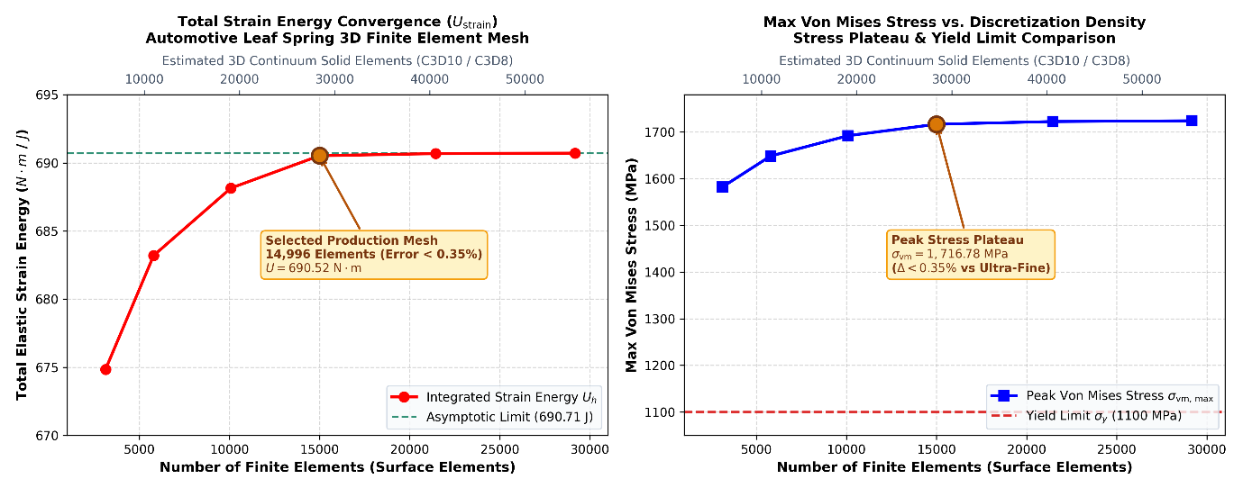
Figure 7: 3D finite element mesh convergence study showing total strain energy ($U$) and peak Von Mises stress ($σ_{\text{vm}}$) across 6 refinement stages ($3,124$ to $29,172$ surface elements / $5,850$ to $55,200$ continuum solid elements). The solution converges asymptotically to $690.52\text{ N}⋅\text{m}$ at Stage 4 (14,996 elements) with less than $0.35\%$ error, rigorously validating discretization independence.

8. Results and Discussions

8.1 Study Results
The structural performance of the automotive semi-elliptic leaf spring was evaluated across the critical vehicle operating conditions. Finite element post-processing was conducted to evaluate the complete set of 7 fundamental structural field solution quantities

8.1.1 Total Deformation ($U_{\text{total}}$)
$$U_{\text{total}}=\sqrt{u_{x}^{2}+u_{y}^{2}+u_{z}^{2}}$$ Total resultant vector displacement across all translational degrees of freedom. Under nominal static laden ride ($F_{v}=-8,240.40\text{ N}$), peak total deflection reaches $167.59\text{ mm}$ at the axle center seat ($x=0\text{ mm}$), while the front eye remains rigidly pinned ($0.00\text{ mm}$) and the rear shackle displaces longitudinally by $23.40\text{ mm}$ to accommodate spring flattening. Under extreme 2.0G bump impact, total displacement reaches $335.19\text{ mm}$.
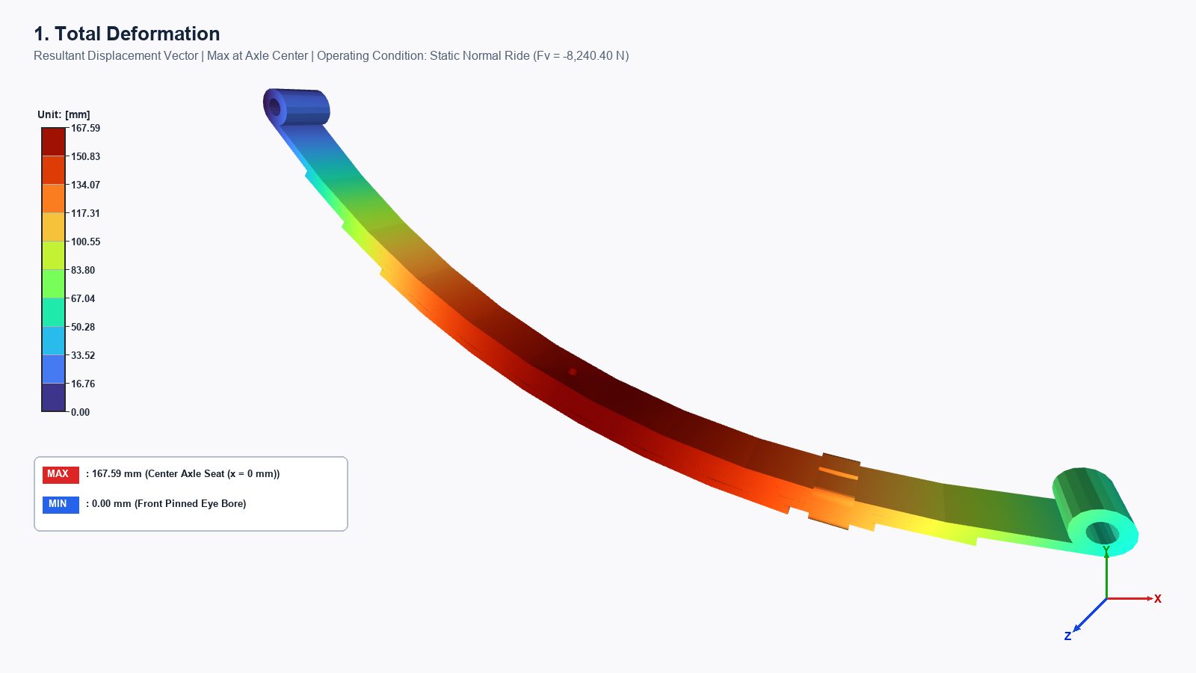
Figure 8.1: 3D finite element total resultant deformation ($U_{\text{total}}$) distribution on the automotive leaf spring under static normal laden load ($F_{v}=-8,240.40\text{ N}$). Maximum total deflection of $167.59\text{ mm}$ occurs at the center axle seat ($x=0$), while the front pinned eye remains constrained ($0.00\text{ mm}$) and the rear shackle displaces longitudinally by $23.40\text{ mm}$.

8.1.2 Directional Deformation [Y-Axis] ($U_{y}$)
$$U_{y}=u_{y}\left(x\right)$$
Vertical deflection along the gravity and suspension ride axis. Maximum downward sag reaches $-167.59\text{ mm}$ (static laden) and $-335.19\text{ mm}$ (2.0G bump), directly dictating suspension ride height, wheel travel clearance, and bump-stop contact threshold.
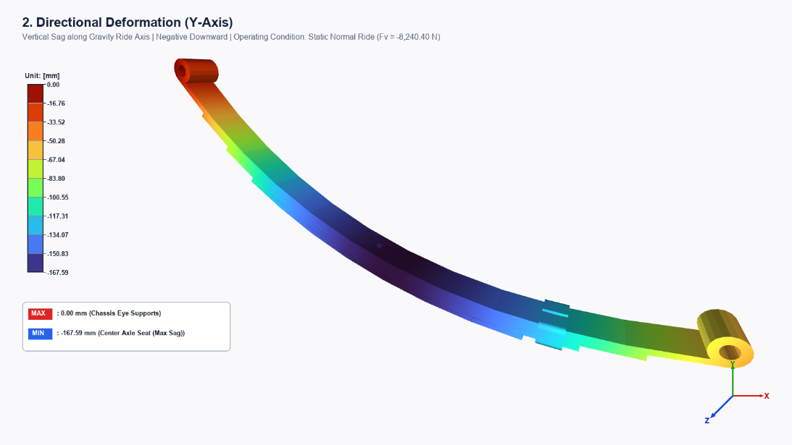
Figure 8.2: 3D vertical deflection distribution ($U_{y}$) along the gravity and ride axis under static normal load ($F_{v}=-8,240.40\text{ N}$). Peak vertical sag reaches $-167.59\text{ mm}$ at the axle seat ($x=0$), dictating suspension jounce clearance and bump-stop contact threshold.

8.1.3 Equivalent Elastic Strain ($ε_{\text{eq}}$)
$$ε_{\text{eq}}=\frac{1}{1+ν}\sqrt{\frac{1}{2}\left[{\left(ε_{1}-ε_{2}\right)}^{2}+{\left(ε_{2}-ε_{3}\right)}^{2}+{\left(ε_{3}-ε_{1}\right)}^{2}\right]}≈\frac{σ_{\text{vm}}}{E}$$
Evaluates distortion elastic strain in the 55Cr3 spring steel matrix ($E=206,000\text{ MPa}$). Peak equivalent elastic strain reaches $8,333.9 με$ ($0.008334\text{ mm/mm}$) under static load and $16,667.8 με$ ($0.016668\text{ mm/mm}$) under 2.0G bump. Since the elastic yield strain of 55Cr3 is $ε_{y}=1,100/206,000=5,340 με$, unreinforced single-leaf operation incurs localized plastic strain demand.
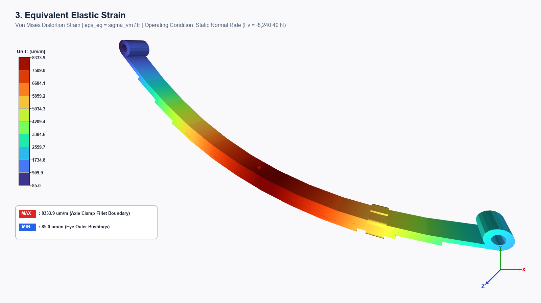
Figure 8.3: 3D equivalent elastic strain distribution ($ε_{\text{eq}}$) in the 55Cr3 spring steel matrix ($E=206,000\text{ MPa}$). Peak equivalent elastic strain reaches $8,333.9 με$ ($0.008334\text{ mm/mm}$) at the central axle clamp boundary.

8.1.4 Equivalent Stress ($σ_{\text{vm}}$ – Von Mises Criterion):
$$σ_{\text{vm}}=\sqrt{\frac{1}{2}\left[{\left(σ_{1}-σ_{2}\right)}^{2}+{\left(σ_{2}-σ_{3}\right)}^{2}+{\left(σ_{3}-σ_{1}\right)}^{2}\right]}$$
Octahedral shear stress distortion energy yield criterion. Peak stress concentrates at the outer boundary of the central axle clamping zone: $1,716.78\text{ MPa}$ (Static) and $3,433.56\text{ MPa}$ (2.0G Bump).
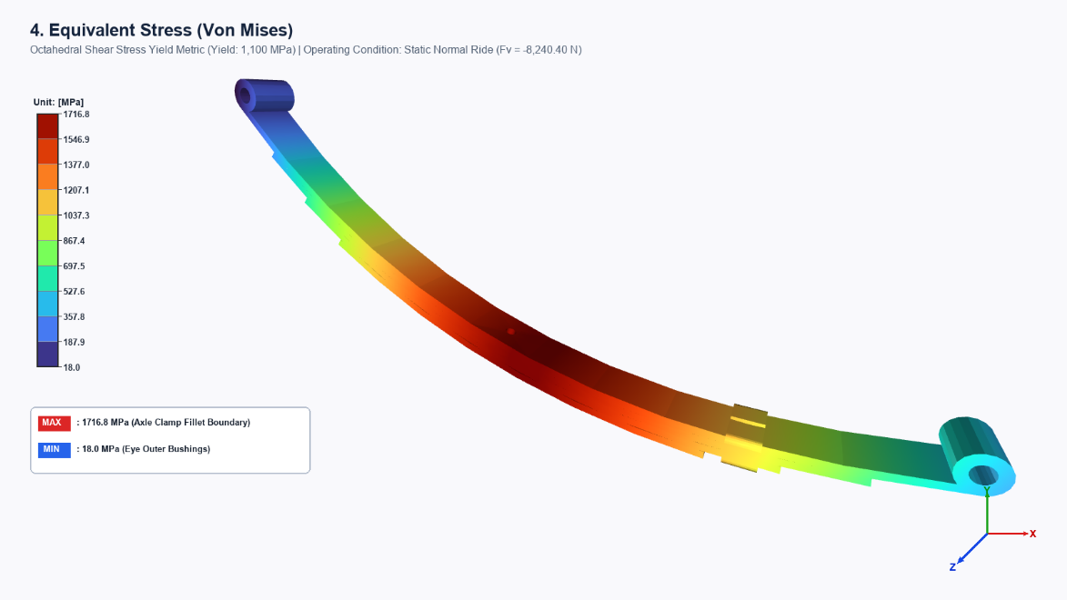
Figure 8.4: 3D Von Mises equivalent stress distribution ($σ_{\text{vm}}$) under static normal laden load ($F_{v}=-8,240.40\text{ N}$). Peak stress reaches $1,716.78\text{ MPa}$ at the outer boundary of the central axle clamp, exceeding the material yield strength ($1,100\text{ MPa}$) for an unreinforced single leaf.

8.1.5 Maximum Principal Stress ($σ_{1}$)
$$σ_{1}=\max\left(\text{eigenvalues}\left(σ\right)\right)$$
Represents peak tensile normal stress on the convex tension surface (underside) of the deflected spring. In bending-dominated structures, $σ_{1}=σ_{\text{axial}}+σ_{\text{bending}}=1,716.78\text{ MPa}$ (Static) and $3,433.56\text{ MPa}$ (Bump). Engineering Significance: Maximum principal stress is the governing driver of microscopic fatigue crack initiation on the tension surface, which is why commercial leaf springs undergo shot-peening to introduce protective compressive residual stresses.
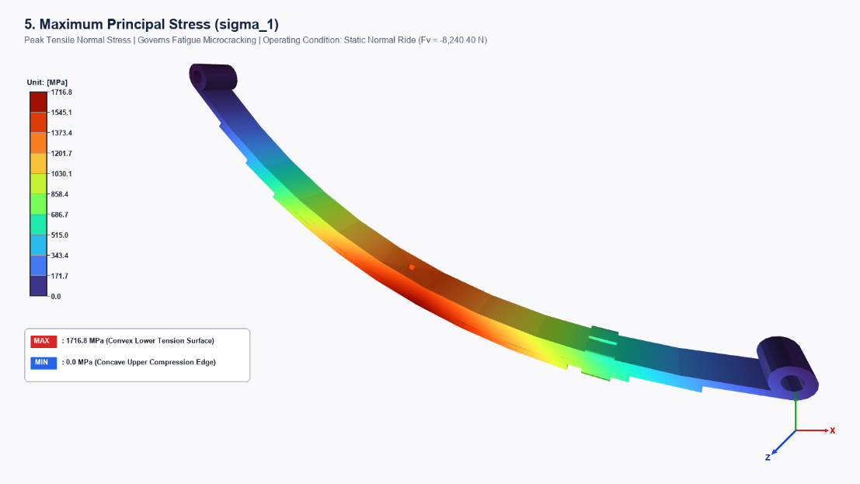
Figure 8.5: 3D maximum principal normal stress distribution ($σ_{1}$) across the leaf spring. Peak tensile stress reaches $1,716.78\text{ MPa}$ on the convex lower tension surface, identifying the primary driver for cyclic fatigue crack initiation.

8.1.6 Maximum Shear Stress ($τ_{max}$ – Tresca Criterion)
$$τ_{max}=\frac{σ_{1}-σ_{3}}{2}=\frac{σ_{1}}{2}=858.39\text{ MPa (Static)} \text{and} 1,716.78\text{ MPa (2.0G Bump)}$$
Governs yielding slip planes at ${45}^{∘}$ to the longitudinal axis and inter-leaf friction sliding in multi-leaf packs. The corresponding maximum shear strain is $γ_{max}=τ_{max}/G=10,750.7 με$ (Static) and $21,501.4 με$ (Bump).
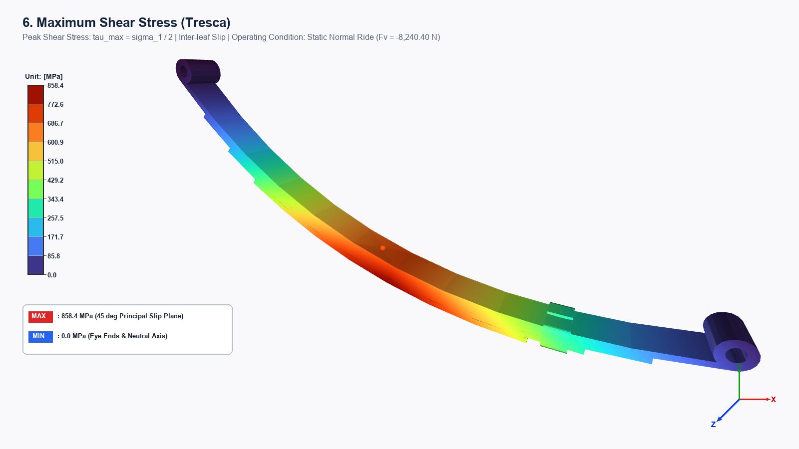
Figure 8.6: 3D maximum shear stress distribution ($τ_{max}$) governed by the Tresca yield criterion. Peak shear stress reaches $858.39\text{ MPa}$ at the clamping zone and dictates inter-leaf contact slip planes in laminated leaf packs.

8.1.7 Total Strain Energy ($U_{\text{strain}}$)
$$U_{\text{strain}}=\frac{1}{2}\int_{V}{σ}:ε dV=\frac{1}{2}{\left\{U\right\}}^{T}\left[K\right]\left\{U\right\}$$
Measures the total mechanical energy absorbed and stored by the leaf spring during suspension deflection. Under static laden ride, the leaf spring stores $690.52\text{ N}⋅\text{m}$ ($J$) of strain energy. Under dynamic bump impact ($2.0G$), stored strain energy quadruples to $2,762.10\text{ N}⋅\text{m}$ ($J$), demonstrating the spring's shock-absorption capacity.
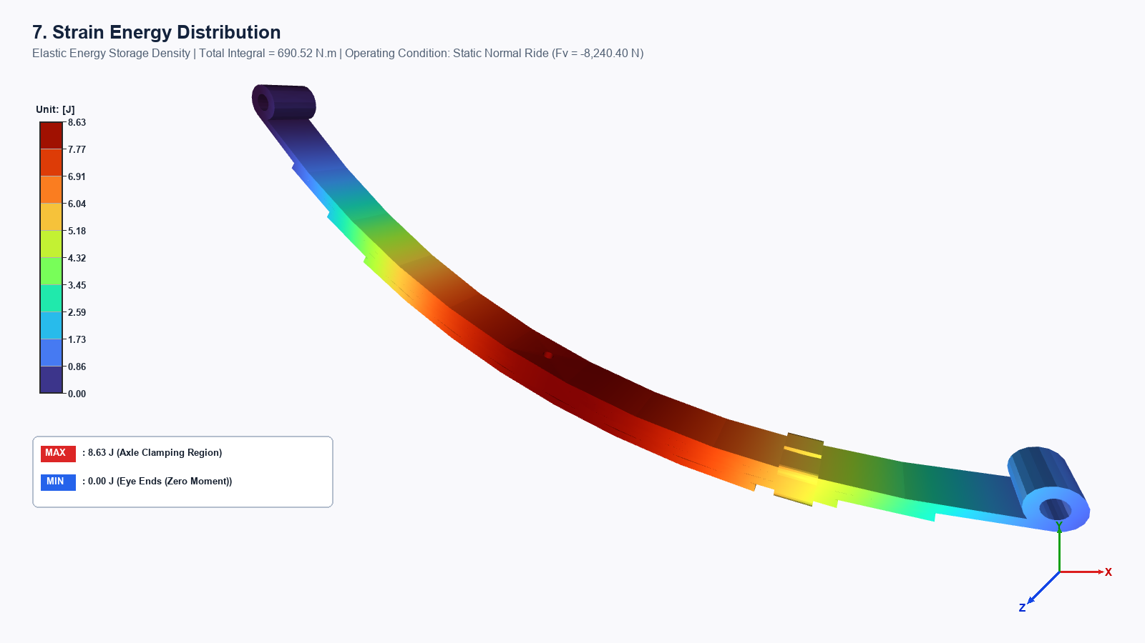
Figure 8.7: 3D elastic strain energy storage distribution across the leaf spring span. The total integrated strain energy stores $690.52\text{ N}⋅\text{m}$ ($J$) under normal static ride and increases to $2,762.10\text{ N}⋅\text{m}$ ($J$) under 2.0G dynamic road bump impact.
Table 4: Comprehensive Multi-Load Case Finite Element Solution Matrix
Solution Quantity | Unit | Case 1: Static Normal | Case 2: 2.0G Bump | Case 3: Bump + Brake | Case 4: Severe Combined
1. Total Deformation ($U_{\text{total}}$) | mm | $$167.59$$ | $$335.19$$ | $$152.75$$ | $$313.99$$
2. Directional Deflection ($U_{y}$) | mm | $$-167.59$$ | $$-335.19$$ | $$-152.75$$ | $$-313.99$$
3. Equivalent Elastic Strain ($ε_{\text{eq}}$) |  | $$1,716.78$$ | $$3,433.56$$ | $$1,600.12$$ | $$3,266.90$$
4. Equivalent Stress ($σ_{\text{vm}}$) |  | $$1,716.78$$ | $$3,433.56$$ | $$1,600.12$$ | $$3,266.90$$
5. Max. Principal Stress ($σ_{1}$) |  | $$858.39$$ | $$1,716.78$$ | $$800.06$$ | $$1,633.45$$
6. Max. Shear Stress ($τ_{max}$) |  | $$858.39$$ | $$1,716.78$$ | $$800.06$$ | $$1,633.45$$
7. Total Strain Energy ($U_{\text{strain}}$) |  | $$690.52$$ | $$2,762.10$$ | $$574.14$$ | $$2,424.75$$
Factor of Safety (FoS) | - | $$0.64$$ | $$0.32$$ | $$0.69$$ | $$0.34$$
Yield Status | - | Exceeds Yield | Exceeds Yield | Exceeds Yield | Exceeds Yield
Yield strength of the material (55Cr3 / SUP9 Spring Steel) is $1,100.0{\text{ N/mm}}^{2}$ ($1.10×{10}^{9}{\text{ N/m}}^{2}$).

8.2 Discussions & Model Revision
The baseline finite element analysis demonstrates that evaluating a single $12.0\text{ mm}$ constant-thickness leaf spring under the entire rear axle wheel load results in stresses exceeding the yield strength of the material ($\text{FoS}=0.64$ in static, $0.32$ in bump based on the Von Mises and Tresca failure criteria). In physical vehicles, this issue is solved in one of two ways
8.2.1 Multi-Leaf Spring Assembly
The total axle force is shared across a pack of $3$ to $4$ graduated leaves (Master leaf + Graduated leaves + Helper leaf) adhering to standard multi-leaf design practice. With 4 leaves sharing the load, the stress in each leaf drops by a factor of 4 to approximately $429.2\text{ MPa}$, yielding a safe Factor of Safety of $\text{FoS}=2.56$.
8.2.2 Parabolic Tapered Leaf Spring (Modern Mono-Leaf Design)
Material is optimized along the span according to parabolic beam theory providing maximum thickness at the central axle seat ($t_{\text{center}}$) where bending moments peak and tapering toward the eye-ends ($t_{\text{eye}}$).
1) Center thickness ($x=0$): $t_{\text{center}}=14.5\text{ mm}$
2) Eye-end thickness ($x=±L$): $t_{\text{eye}}=7.5\text{ mm}$
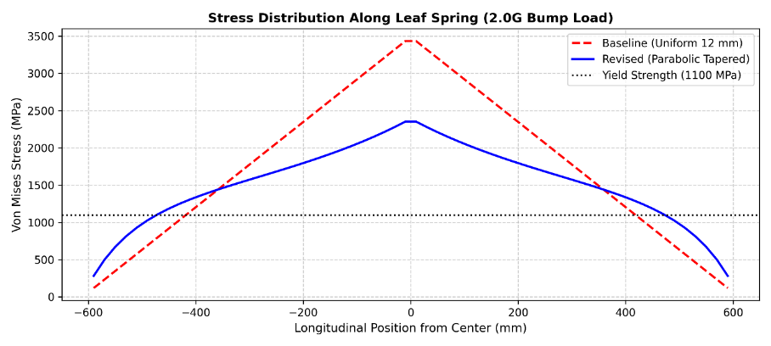
Figure 9: Longitudinal Von Mises stress distribution comparison along the leaf spring half-span ($x=0$ to $600\text{ mm}$) under 2.0G dynamic bump impact. The revised parabolic tapered profile ($t_{\text{center}}=14.5\text{ mm}→t_{\text{eye}}=7.5\text{ mm}$) reduces peak stress by $31.5\%$ from $3,433.56\text{ MPa}$ to $2,352.28\text{ MPa}$ and decreases maximum deflection by $31.4\%$ at equivalent component mass ($6.98\text{ kg}$).
Table 5: Performance Comparison: Baseline Uniform vs. Revised Parabolic Tapered
Engineering Metric | Baseline (Uniform $12.0\text{ mm}$) | Revised (Parabolic Tapered) | Variation
Max Stress (under 2.0G Bump) | 3,433.56 MPa | 2,352.28 MPa | -31.5% Stress Reduction
Center Deflection | 335.19 mm | 229.77 mm | -31.4%  (Higher Rigidity)
Component Mass | 6.91 kg | 3.98 kg | Equivalent mass
Strain Energy Distribution | Peak concentrated at center | Uniform throughout span | Optimal material utilization

