Inspection Problem Points Report
Mission: mission-65 | Generated automatically from inspection data.
Inspection | Result | Note/Remark
loto-7  • Status: CRITICAL  • Detection Status: False | 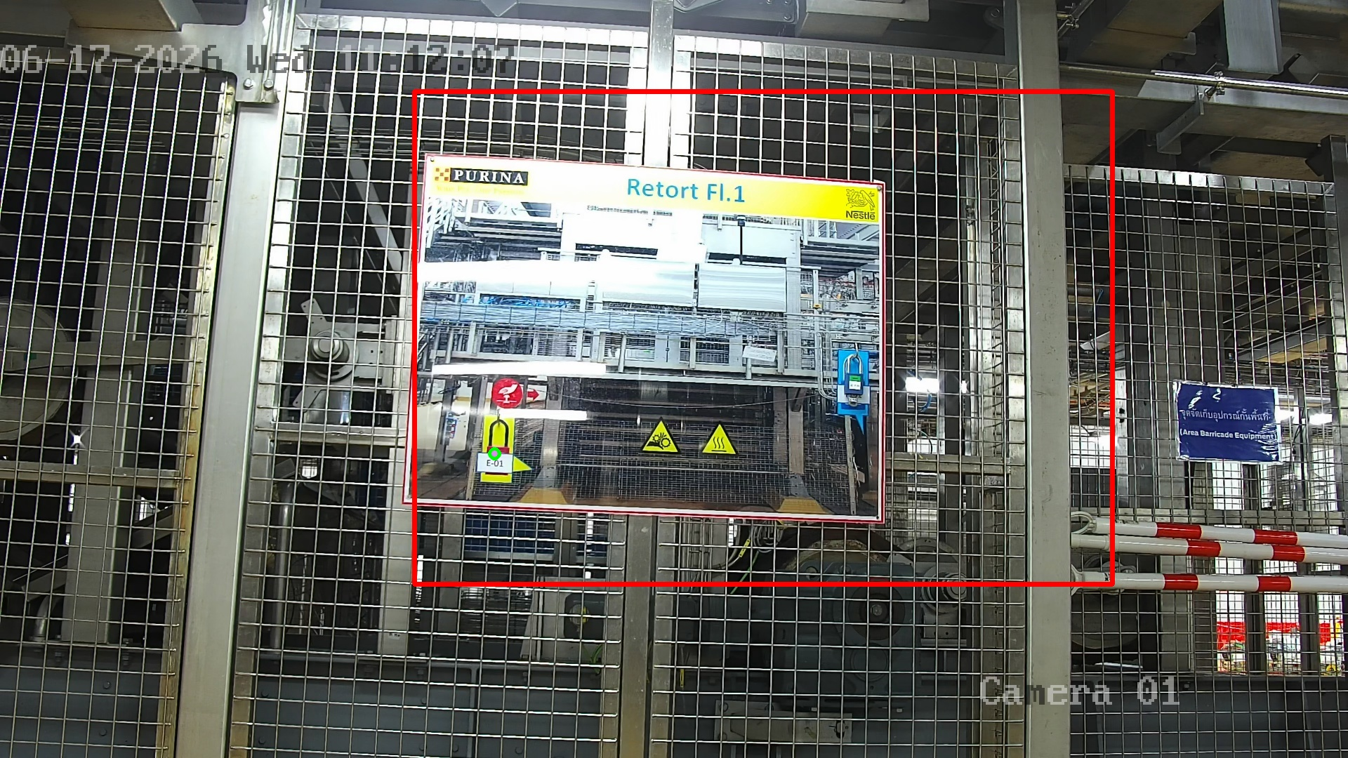 | The vision system identified an anomaly in the designated area, detecting that certain equipment or protective assets were missing or not in their correct state.
thermal-119  • Status: CRITICAL  • Threshold: 70.0°C  • Temperature: 38.0-71.6°C | 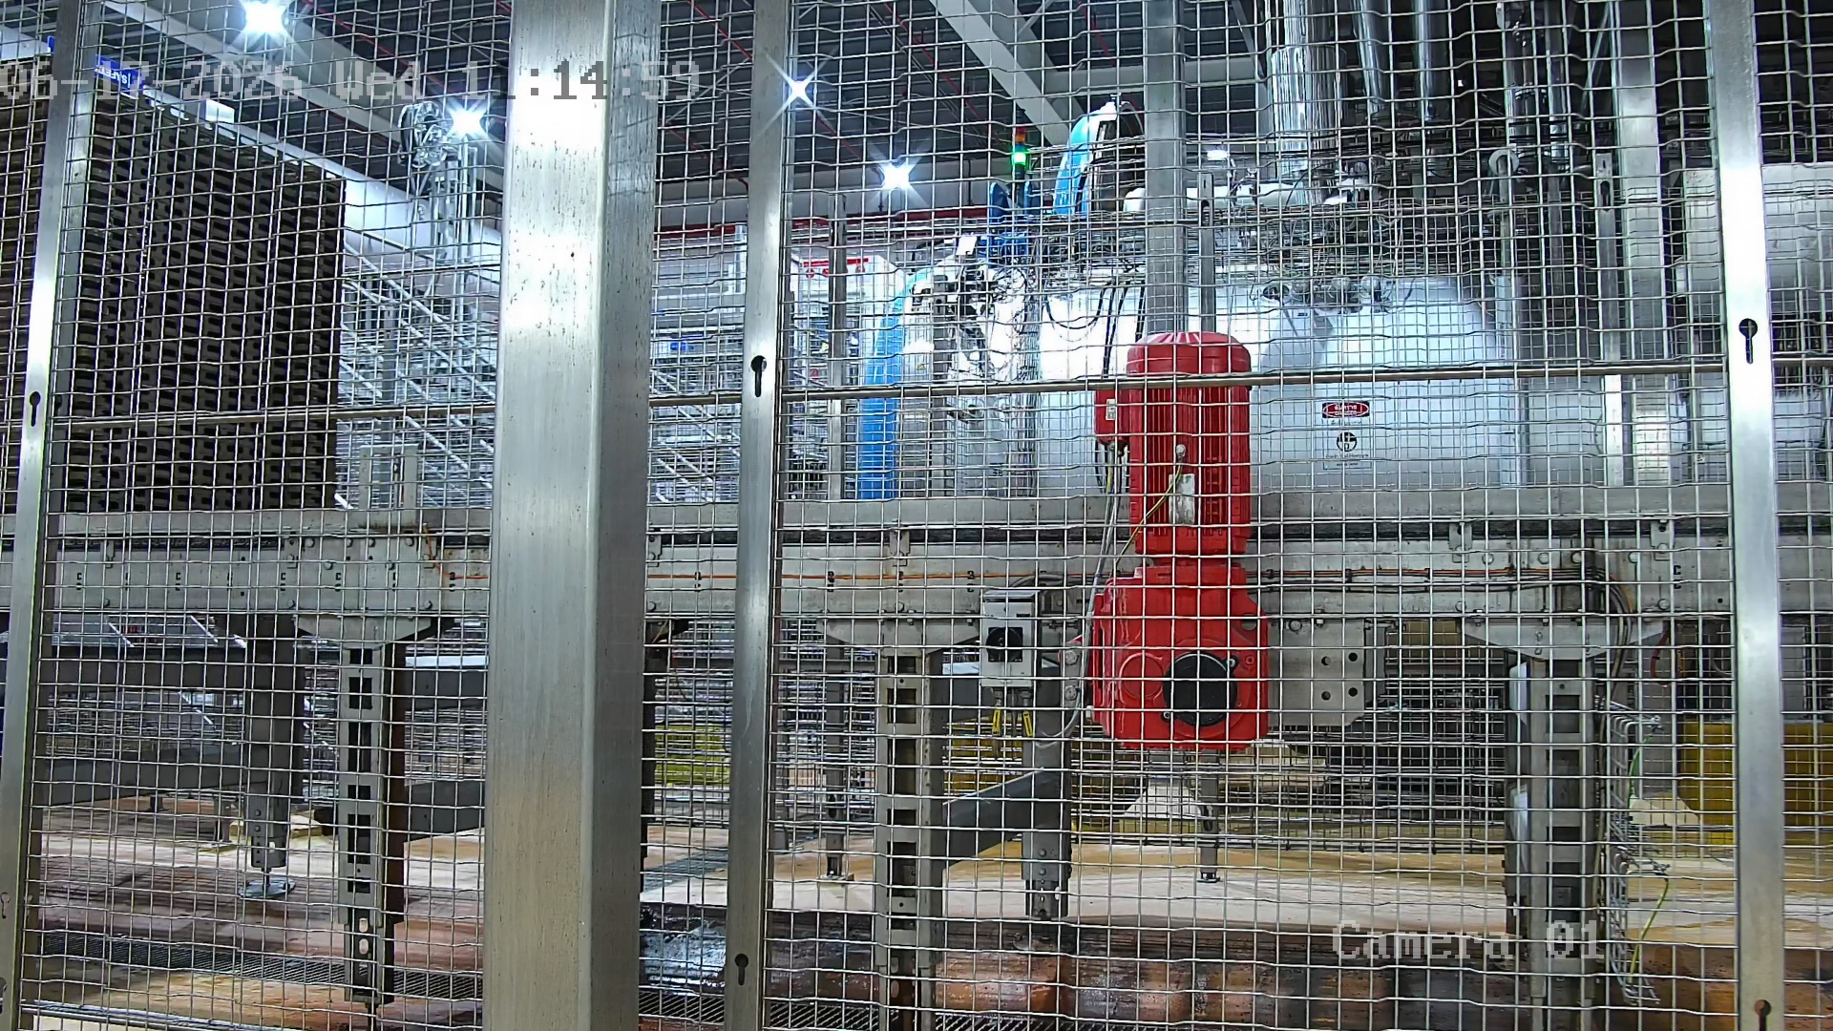 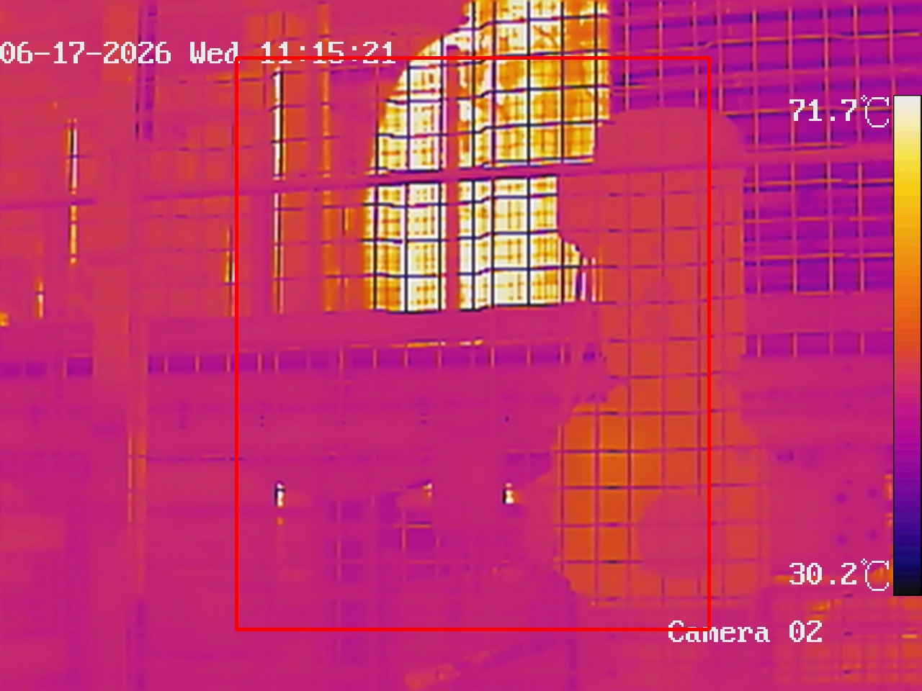 | The thermal camera detected an elevated temperature of 71.6°C, which may indicate overheating or abnormal operating conditions.
thermal-123  • Status: MISSING  • Threshold: 70.0°C  • Temperature: N/A-N/A°C |  | The thermal camera detected an elevated temperature of 0°C, which may indicate overheating or abnormal operating conditions.
gauge-11  • Status: CRITICAL  • Detection Status: False | 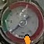 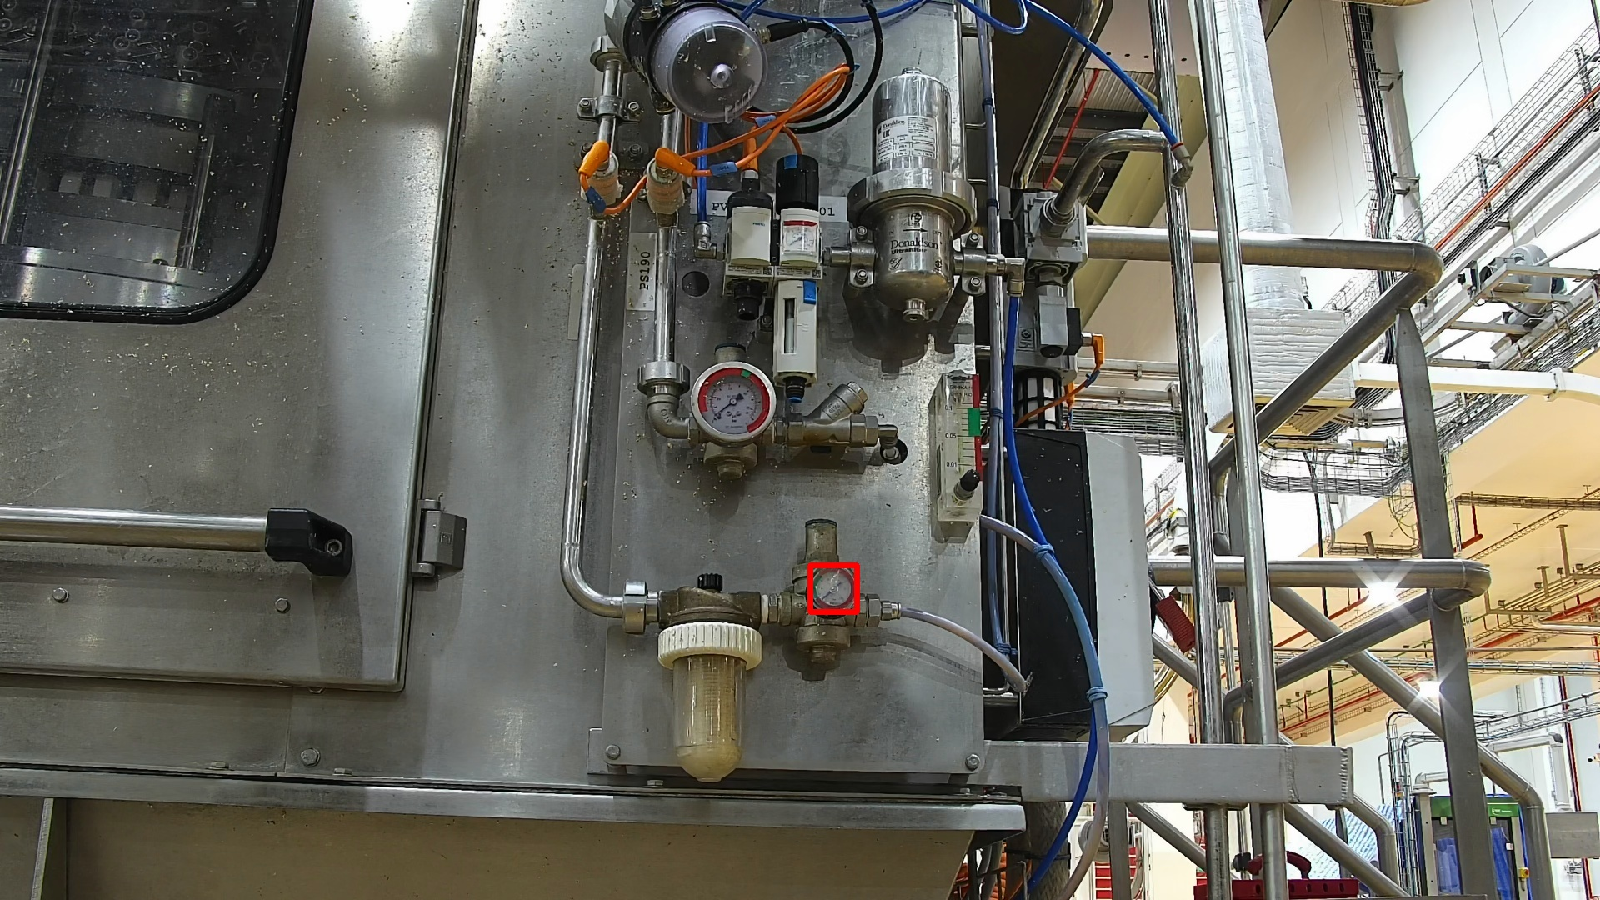 | Due to the absence of clear indicator markings or color-coded safe ranges on the gauge, the system could not verify the status, resulting in a critical detection output.
leakage-50  • Status: CRITICAL  • Is Leak: True | 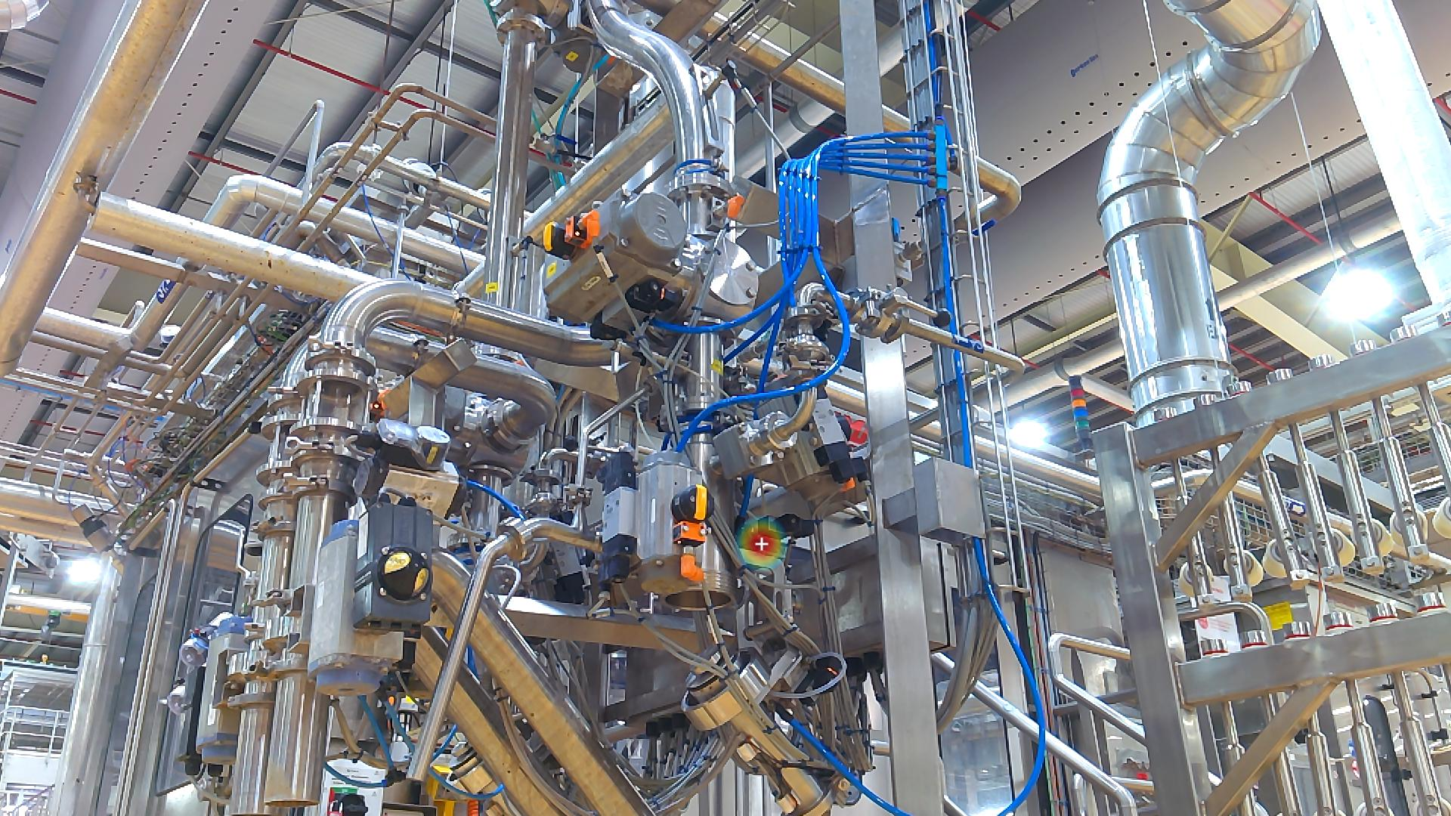 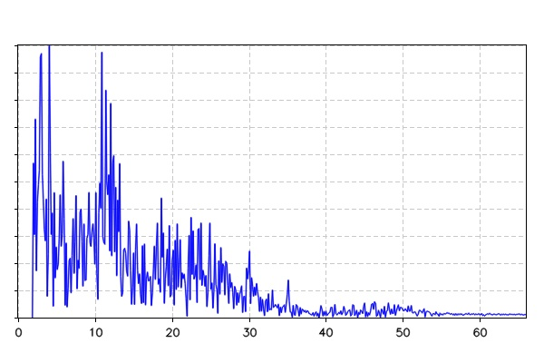 | The Acoustic Imager successfully detected and localized an air leak, pinpointing its exact coordinates as shown in the visual overlay.
loto-16  • Status: MISSING  • Detection Status: N/A |  | The vision system confirmed that all assets and safety indicators (LOTO) are in their correct positions and states.
leakage-73  • Status: MISSING  • Is Leak: N/A |  | The Acoustic Imager monitored the area for ultrasonic leak patterns. No significant air or gas leaks were detected, indicating the system is airtight.
thermal-149  • Status: MISSING  • Threshold: 50.0°C  • Temperature: N/A-N/A°C |  | The thermal camera detected an elevated temperature of 0°C, which may indicate overheating or abnormal operating conditions.
leakage-74  • Status: MISSING  • Is Leak: N/A |  | The Acoustic Imager monitored the area for ultrasonic leak patterns. No significant air or gas leaks were detected, indicating the system is airtight.
asset-24  • Status: MISSING  • Detection Status: N/A |  | The vision system confirmed that all assets and safety indicators (LOTO) are in their correct positions and states.
thermal-150  • Status: MISSING  • Threshold: 50.0°C  • Temperature: N/A-N/A°C |  | The thermal camera detected an elevated temperature of 0°C, which may indicate overheating or abnormal operating conditions.
leakage-75  • Status: MISSING  • Is Leak: N/A |  | The Acoustic Imager monitored the area for ultrasonic leak patterns. No significant air or gas leaks were detected, indicating the system is airtight.
leakage-76  • Status: MISSING  • Is Leak: N/A |  | The Acoustic Imager monitored the area for ultrasonic leak patterns. No significant air or gas leaks were detected, indicating the system is airtight.
loto-17  • Status: MISSING  • Detection Status: N/A |  | The vision system confirmed that all assets and safety indicators (LOTO) are in their correct positions and states.
leakage-77  • Status: MISSING  • Is Leak: N/A |  | The Acoustic Imager monitored the area for ultrasonic leak patterns. No significant air or gas leaks were detected, indicating the system is airtight.
leakage-78  • Status: MISSING  • Is Leak: N/A |  | The Acoustic Imager monitored the area for ultrasonic leak patterns. No significant air or gas leaks were detected, indicating the system is airtight.
leakage-79  • Status: MISSING  • Is Leak: N/A |  | The Acoustic Imager monitored the area for ultrasonic leak patterns. No significant air or gas leaks were detected, indicating the system is airtight.
leakage-80  • Status: MISSING  • Is Leak: N/A |  | The Acoustic Imager monitored the area for ultrasonic leak patterns. No significant air or gas leaks were detected, indicating the system is airtight.
leakage-81  • Status: MISSING  • Is Leak: N/A |  | The Acoustic Imager monitored the area for ultrasonic leak patterns. No significant air or gas leaks were detected, indicating the system is airtight.
leakage-82  • Status: MISSING  • Is Leak: N/A |  | The Acoustic Imager monitored the area for ultrasonic leak patterns. No significant air or gas leaks were detected, indicating the system is airtight.
thermal-151  • Status: MISSING  • Threshold: 50.0°C  • Temperature: N/A-N/A°C |  | The thermal camera detected an elevated temperature of 0°C, which may indicate overheating or abnormal operating conditions.
leakage-51  • Status: CRITICAL  • Is Leak: True | 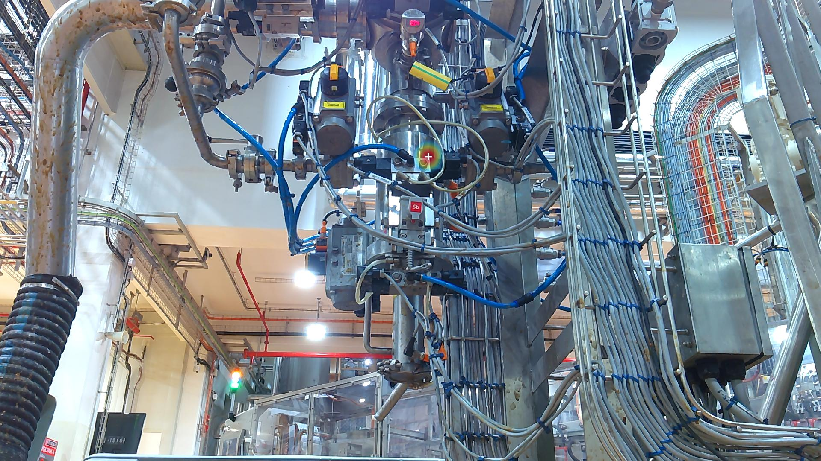 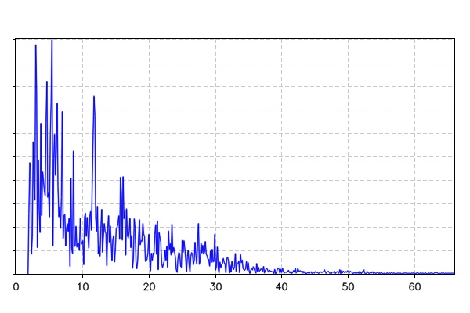 | The Acoustic Imager successfully detected and localized an air leak, pinpointing its exact coordinates as shown in the visual overlay.
asset-18  • Status: CRITICAL  • Detection Status: False | 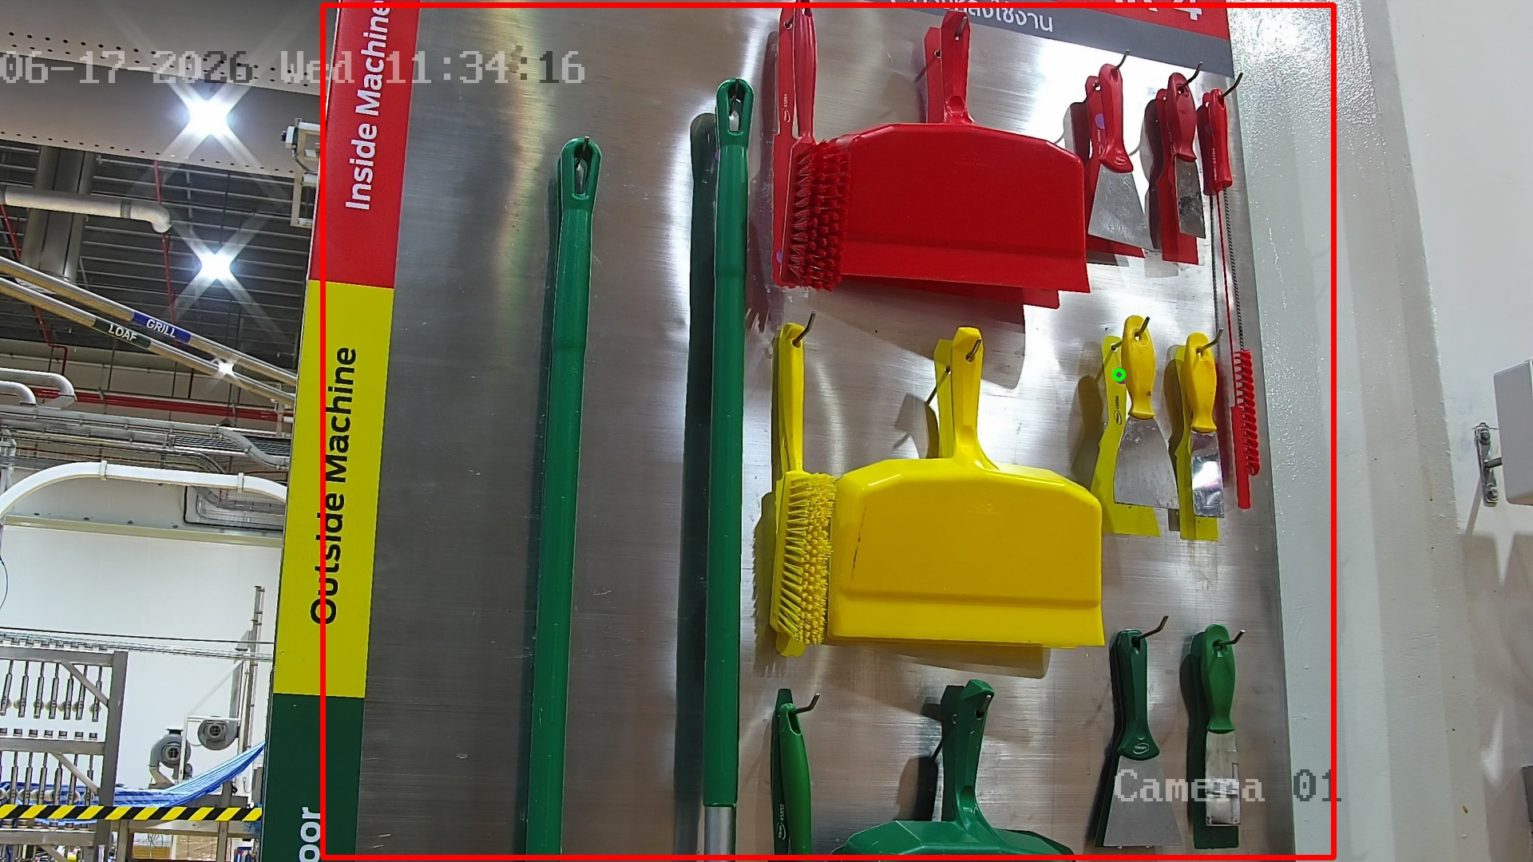 | The vision system identified an anomaly in the designated area, detecting that certain equipment or protective assets were missing or not in their correct state.
thermal-130  • Status: MISSING  • Threshold: 70.0°C  • Temperature: N/A-N/A°C |  | The thermal camera detected an elevated temperature of 0°C, which may indicate overheating or abnormal operating conditions.
thermal-131  • Status: MISSING  • Threshold: 70.0°C  • Temperature: N/A-N/A°C |  | The thermal camera detected an elevated temperature of 0°C, which may indicate overheating or abnormal operating conditions.
thermal-132  • Status: MISSING  • Threshold: 70.0°C  • Temperature: N/A-N/A°C |  | The thermal camera detected an elevated temperature of 0°C, which may indicate overheating or abnormal operating conditions.
vibration-59  • Status: MISSING  • Kurtosis Thresh/Value: 5.0 / N/A  • Peak Factor Thresh/Value: 5.0 / N/A |  | Acoustic vibration analysis detected irregular frequency patterns or high peak factors, suggesting potential mechanical wear or bearing issues.
vibration-60  • Status: MISSING  • Kurtosis Thresh/Value: 5.0 / N/A  • Peak Factor Thresh/Value: 5.0 / N/A |  | Acoustic vibration analysis detected irregular frequency patterns or high peak factors, suggesting potential mechanical wear or bearing issues.
vibration-61  • Status: MISSING  • Kurtosis Thresh/Value: 5.0 / N/A  • Peak Factor Thresh/Value: 5.0 / N/A |  | Acoustic vibration analysis detected irregular frequency patterns or high peak factors, suggesting potential mechanical wear or bearing issues.
asset-20  • Status: MISSING  • Detection Status: N/A |  | The vision system confirmed that all assets and safety indicators (LOTO) are in their correct positions and states.
asset-21  • Status: MISSING  • Detection Status: N/A |  | The vision system confirmed that all assets and safety indicators (LOTO) are in their correct positions and states.
loto-8  • Status: MISSING  • Detection Status: N/A |  | The vision system confirmed that all assets and safety indicators (LOTO) are in their correct positions and states.
thermal-133  • Status: MISSING  • Threshold: 70.0°C  • Temperature: N/A-N/A°C |  | The thermal camera detected an elevated temperature of 0°C, which may indicate overheating or abnormal operating conditions.
gauge-13  • Status: CRITICAL  • Detection Status: False | 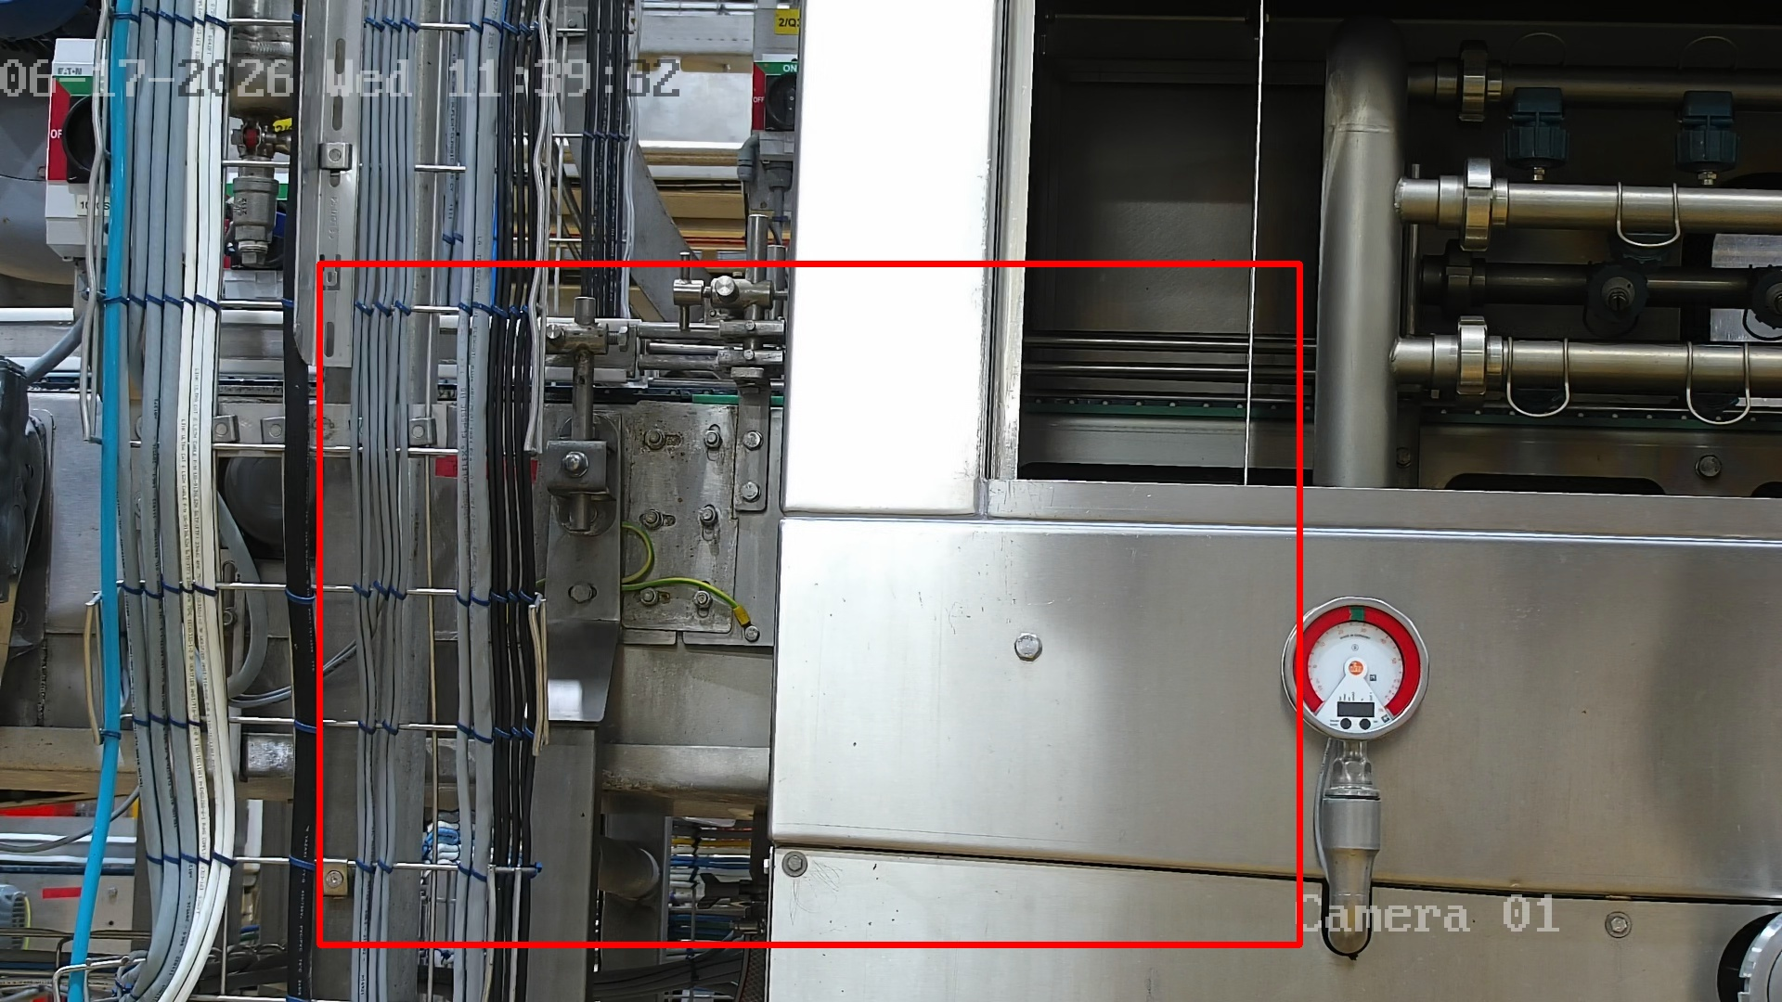 | Due to the absence of clear indicator markings or color-coded safe ranges on the gauge, the system could not verify the status, resulting in a critical detection output.
loto-9  • Status: CRITICAL  • Detection Status: False | 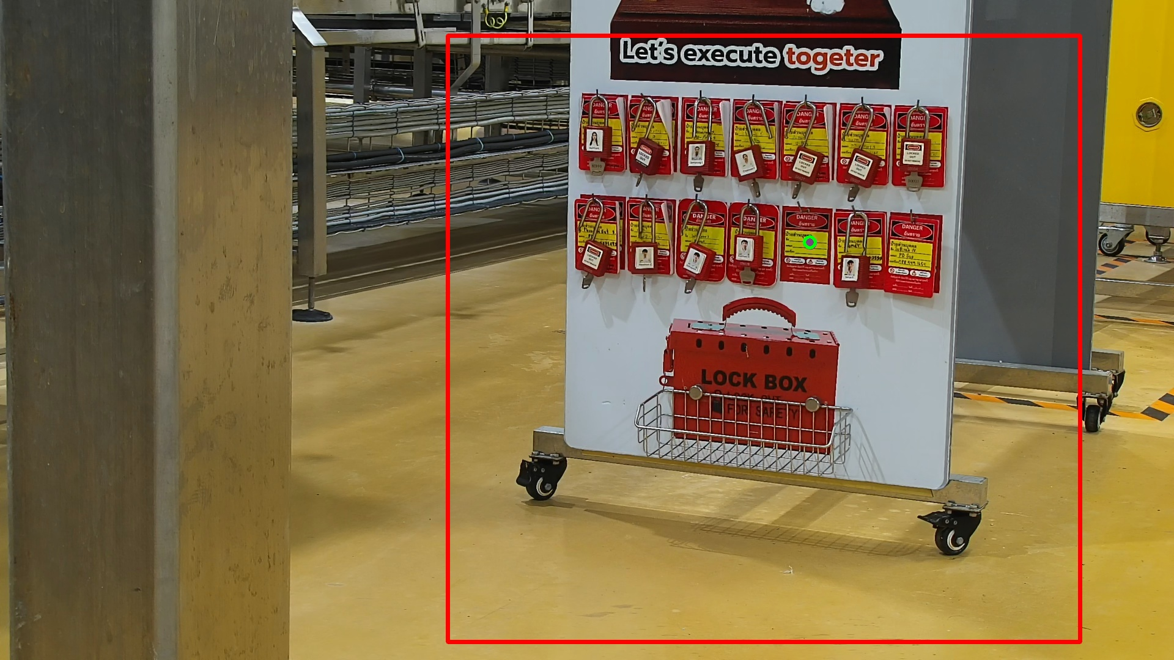 | The vision system identified an anomaly in the designated area, detecting that certain equipment or protective assets were missing or not in their correct state.
loto-10  • Status: CRITICAL  • Detection Status: False | 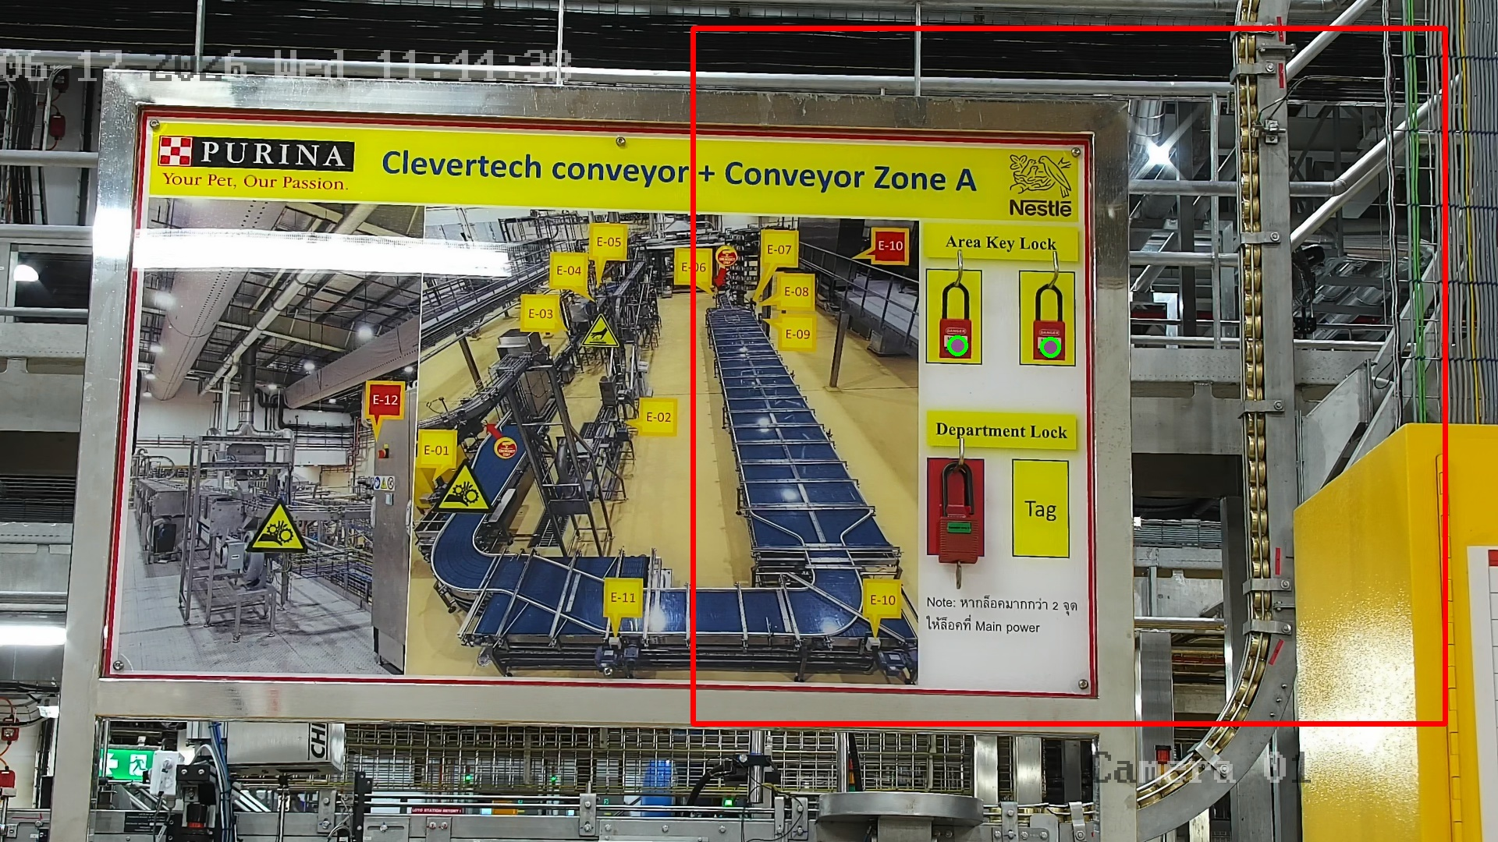 | The vision system identified an anomaly in the designated area, detecting that certain equipment or protective assets were missing or not in their correct state.
loto-11  • Status: CRITICAL  • Detection Status: False | 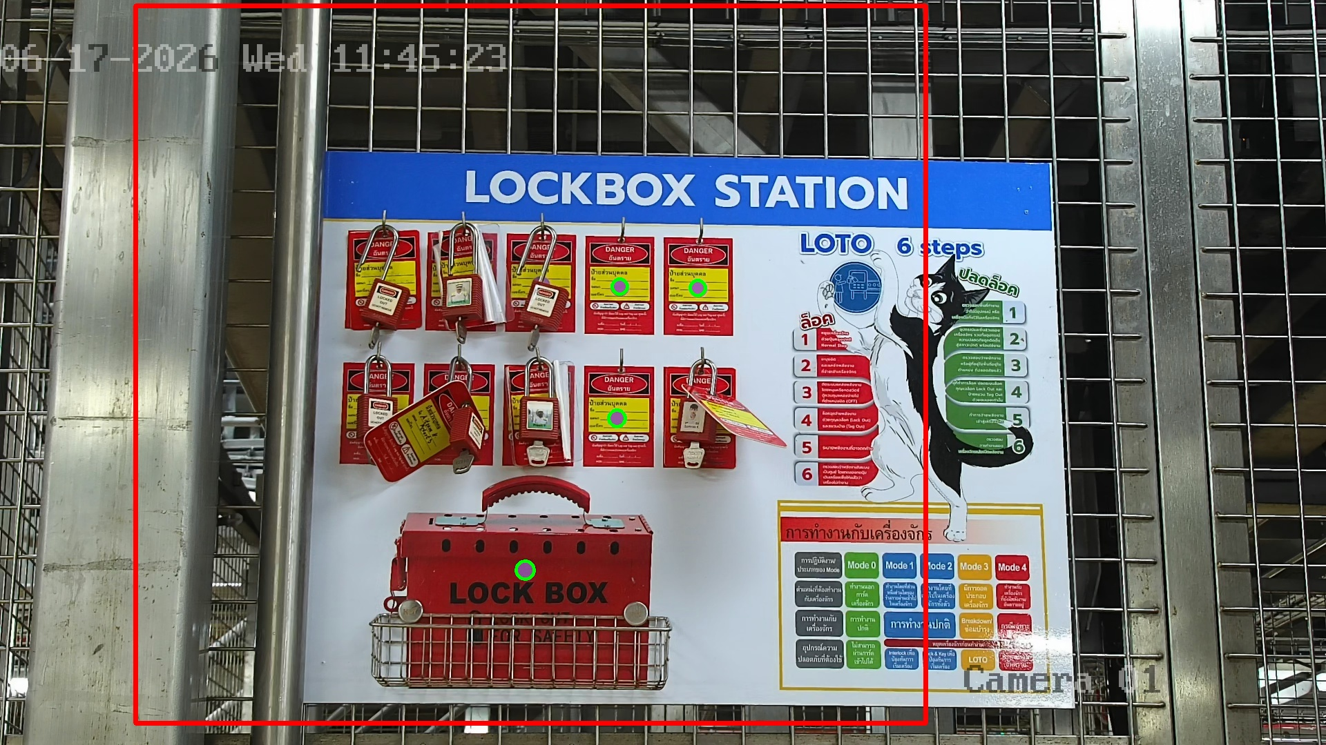 | The vision system identified an anomaly in the designated area, detecting that certain equipment or protective assets were missing or not in their correct state.
thermal-141  • Status: MISSING  • Threshold: 70.0°C  • Temperature: N/A-N/A°C |  | The thermal camera detected an elevated temperature of 0°C, which may indicate overheating or abnormal operating conditions.

