Inspection Problem Points Report
Mission: mission-66 | Generated automatically from inspection data.
Inspection | Result | Note/Remark
loto-7  • Status: CRITICAL  • Detection Status: False | 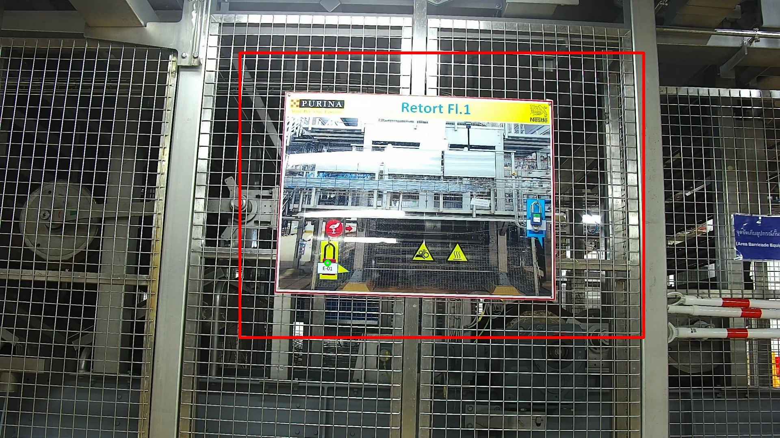 | The vision system identified an anomaly in the designated area, detecting that certain equipment or protective assets were missing or not in their correct state.
thermal-126  • Status: MISSING  • Threshold: 70.0°C  • Temperature: N/A-N/A°C |  | The thermal camera detected an elevated temperature of 0°C, which may indicate overheating or abnormal operating conditions.
gauge-11  • Status: CRITICAL  • Detection Status: False | 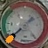 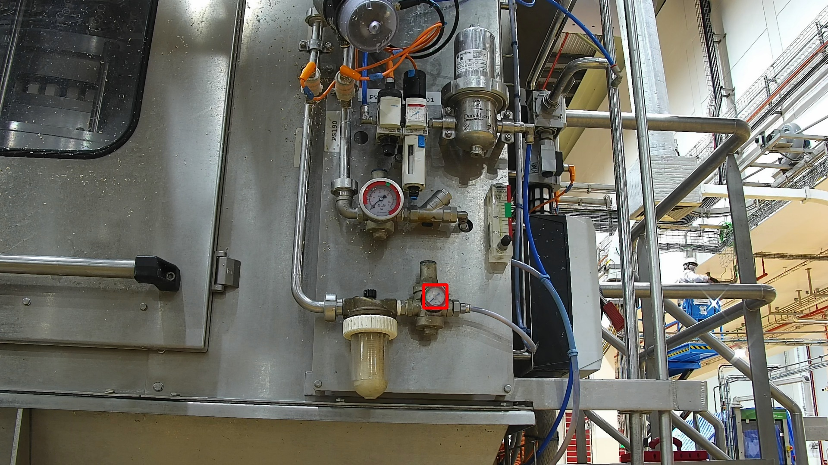 | Due to the absence of clear indicator markings or color-coded safe ranges on the gauge, the system could not verify the status, resulting in a critical detection output.
leakage-50  • Status: CRITICAL  • Is Leak: True | 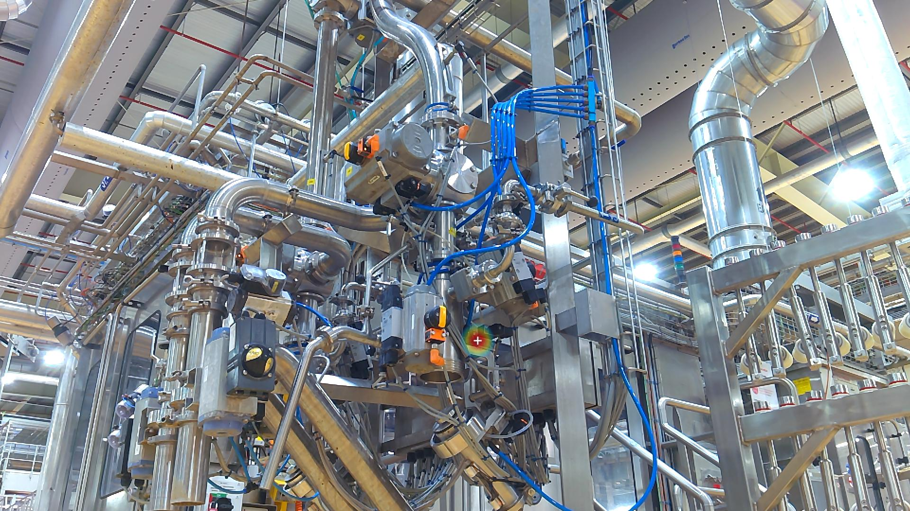 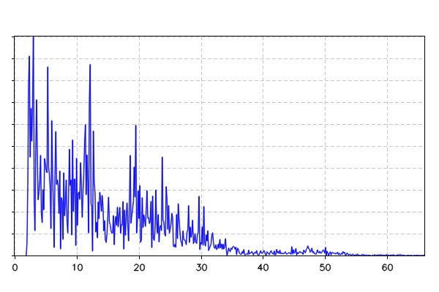 | The Acoustic Imager successfully detected and localized an air leak, pinpointing its exact coordinates as shown in the visual overlay.
loto-16  • Status: MISSING  • Detection Status: N/A |  | The vision system confirmed that all assets and safety indicators (LOTO) are in their correct positions and states.
thermal-149  • Status: MISSING  • Threshold: 50.0°C  • Temperature: N/A-N/A°C |  | The thermal camera detected an elevated temperature of 0°C, which may indicate overheating or abnormal operating conditions.
asset-24  • Status: CRITICAL  • Detection Status: False | 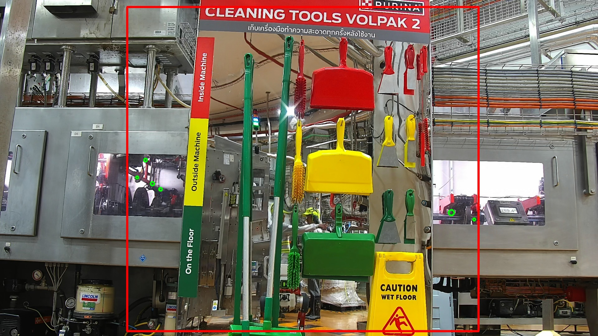 | The vision system identified an anomaly in the designated area, detecting that certain equipment or protective assets were missing or not in their correct state.
thermal-150  • Status: CRITICAL  • Threshold: 50.0°C  • Temperature: 35.1-50.2°C | 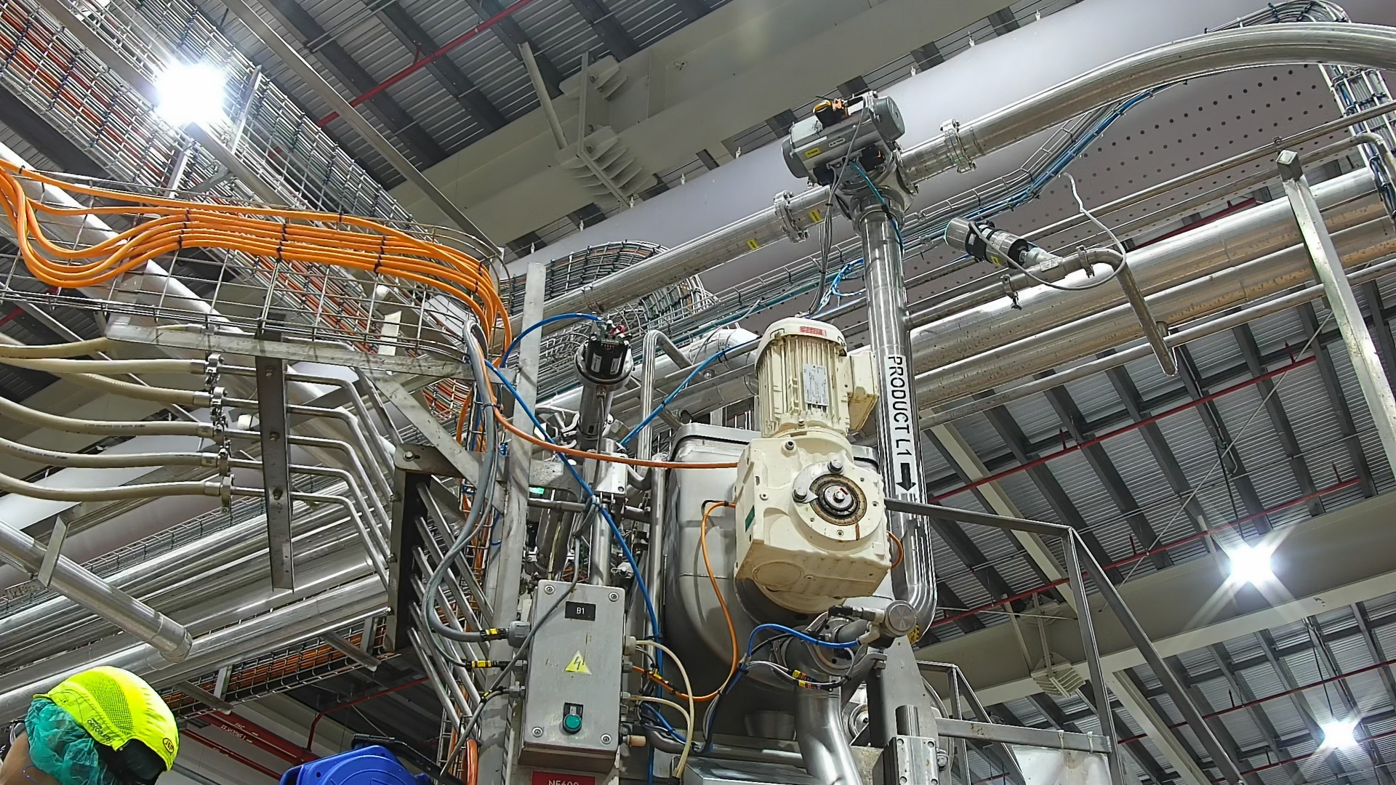 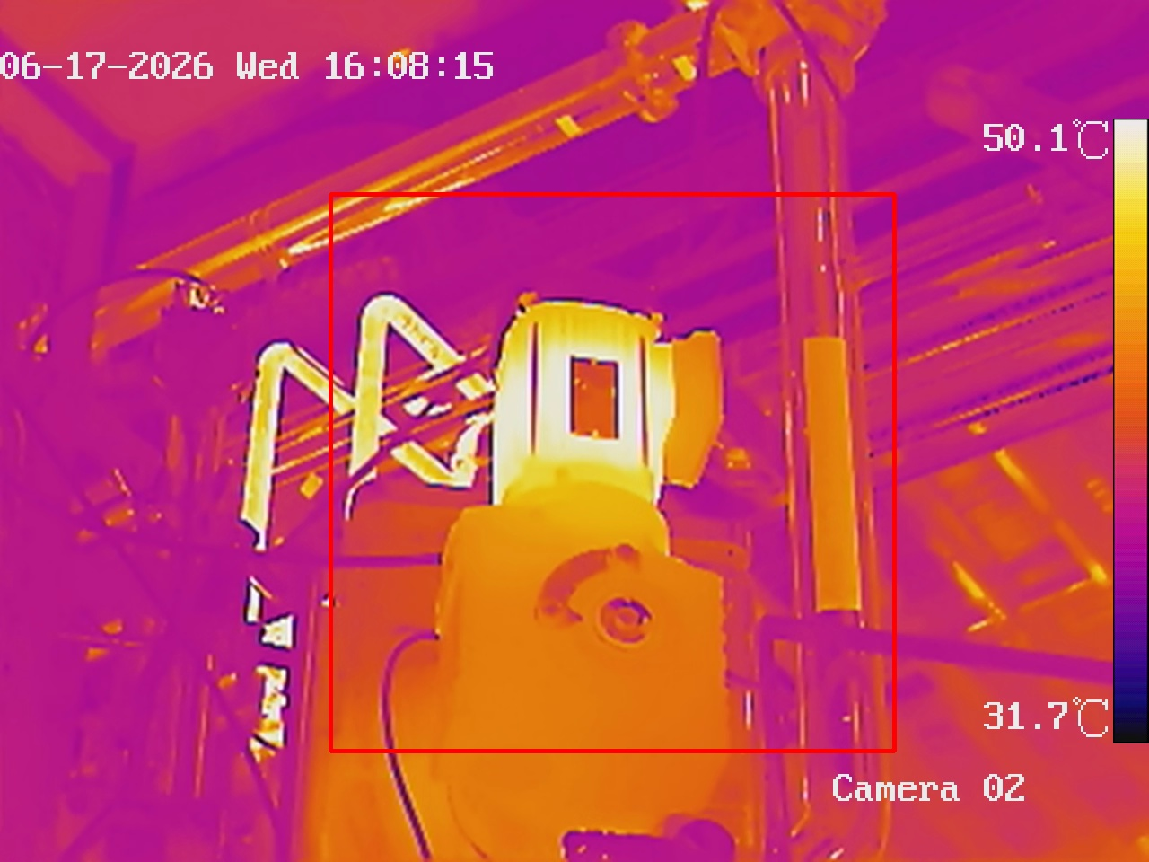 | The thermal camera detected an elevated temperature of 50.2°C, which may indicate overheating or abnormal operating conditions.
leakage-75  • Status: CRITICAL  • Is Leak: True | 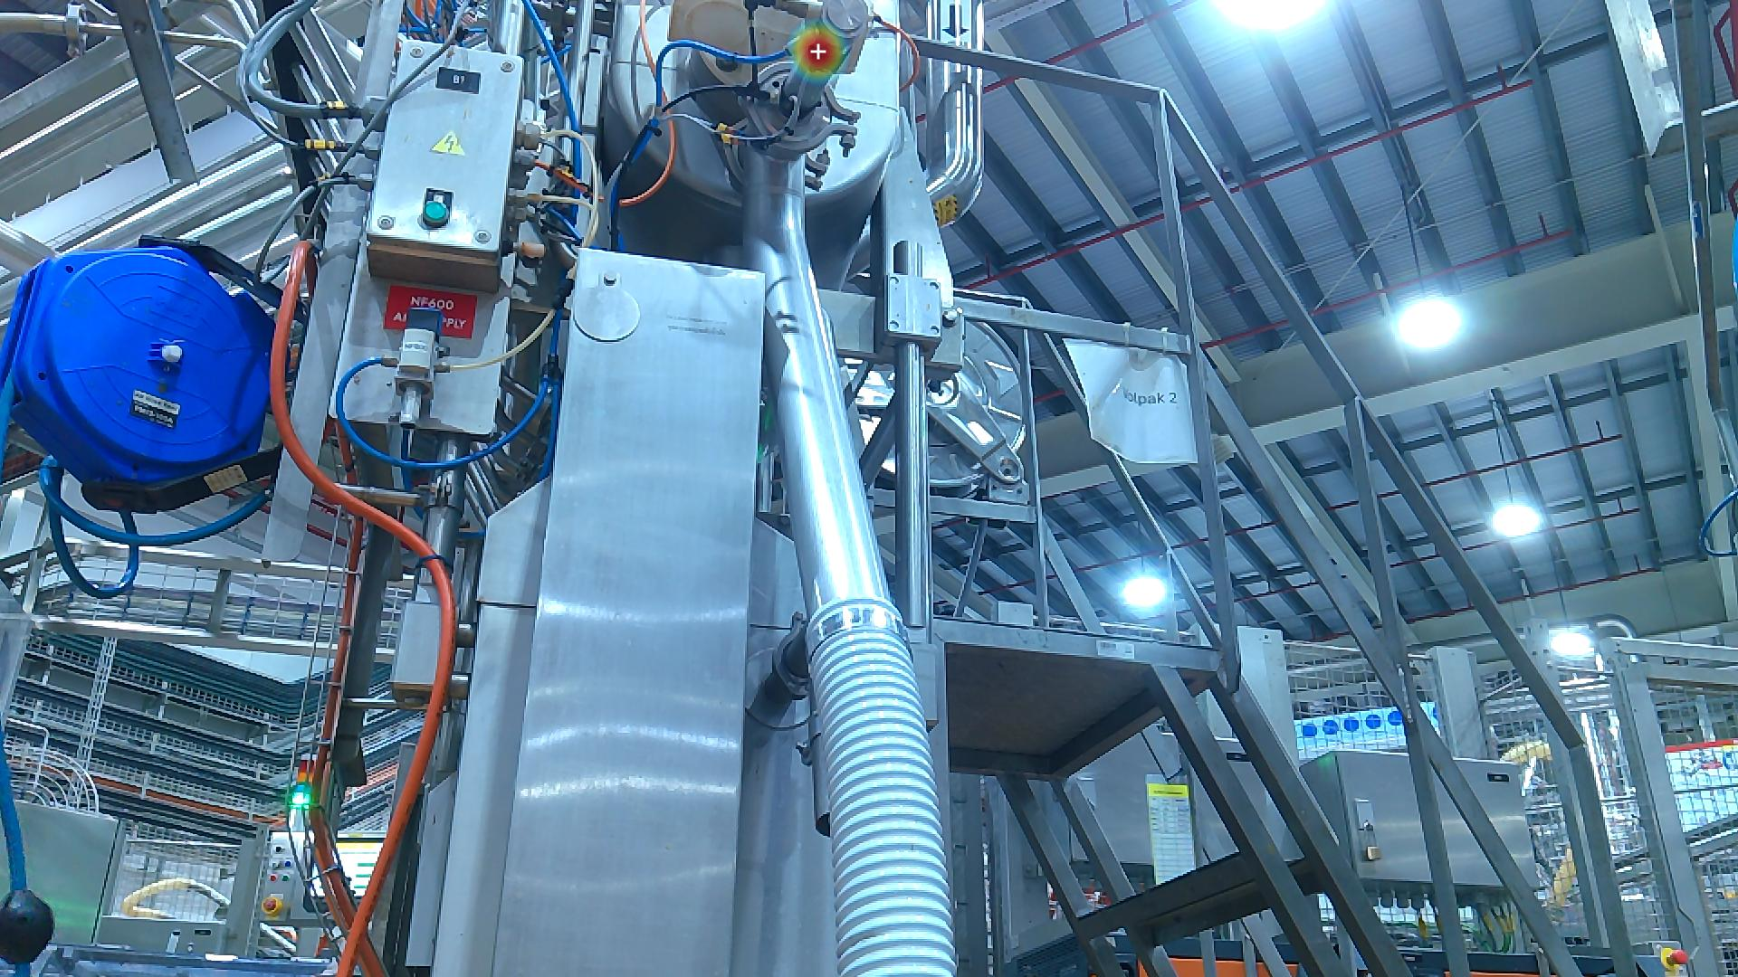 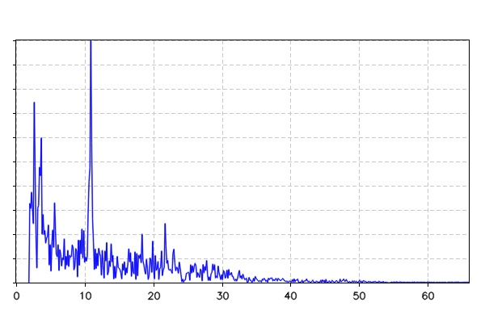 | The Acoustic Imager successfully detected and localized an air leak, pinpointing its exact coordinates as shown in the visual overlay.
leakage-76  • Status: CRITICAL  • Is Leak: True | 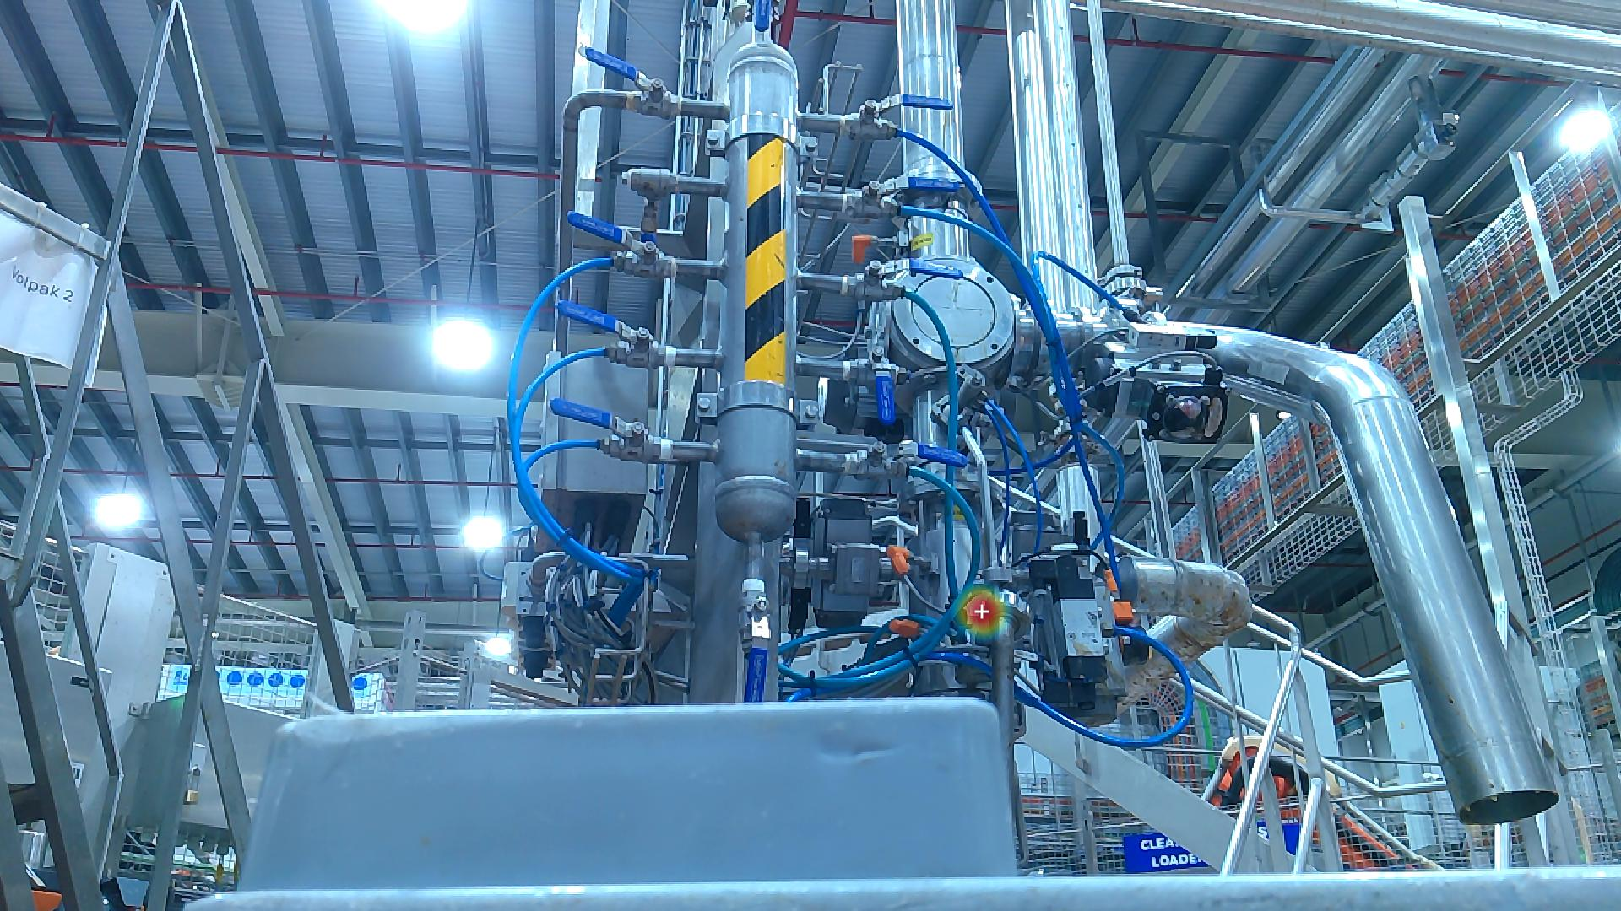 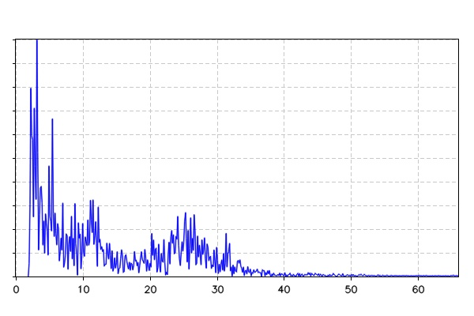 | The Acoustic Imager successfully detected and localized an air leak, pinpointing its exact coordinates as shown in the visual overlay.
loto-17  • Status: MISSING  • Detection Status: N/A |  | The vision system confirmed that all assets and safety indicators (LOTO) are in their correct positions and states.
leakage-78  • Status: CRITICAL  • Is Leak: True | 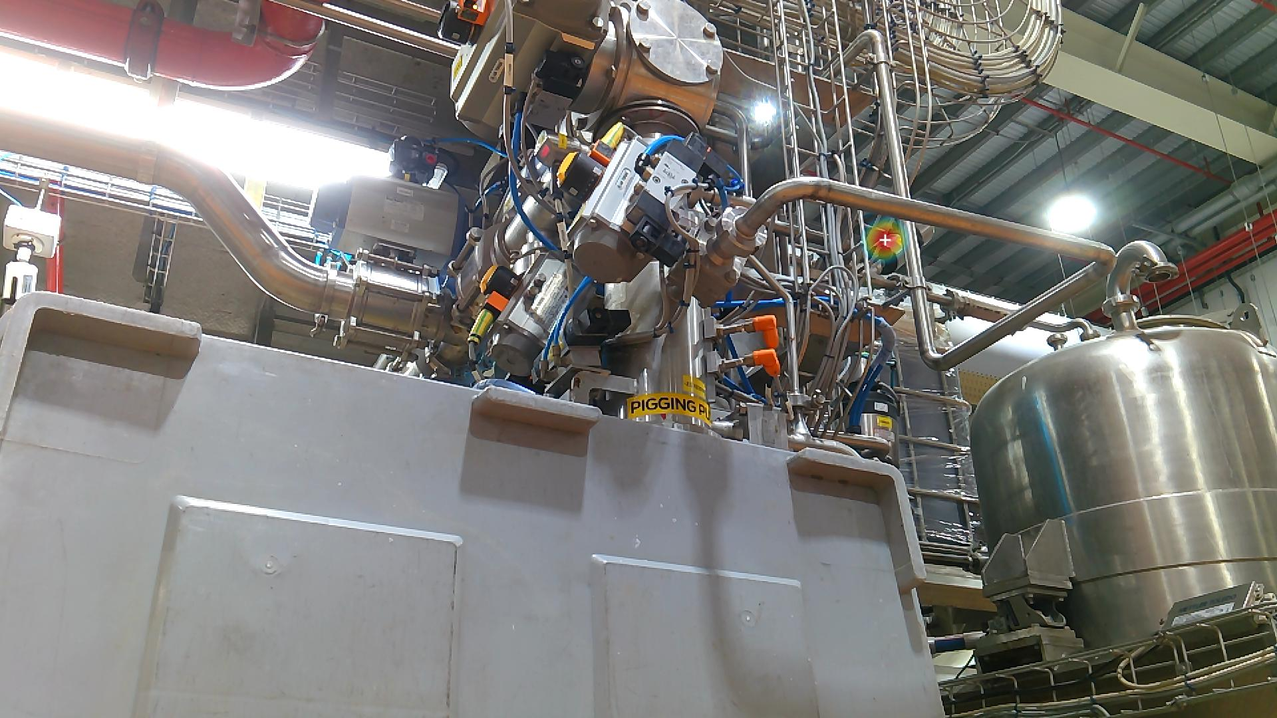 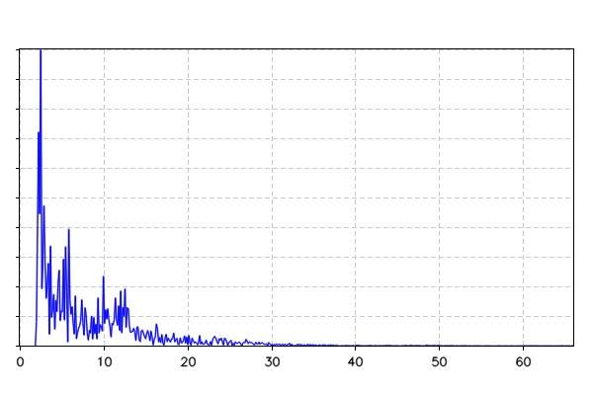 | The Acoustic Imager successfully detected and localized an air leak, pinpointing its exact coordinates as shown in the visual overlay.
leakage-79  • Status: CRITICAL  • Is Leak: True | 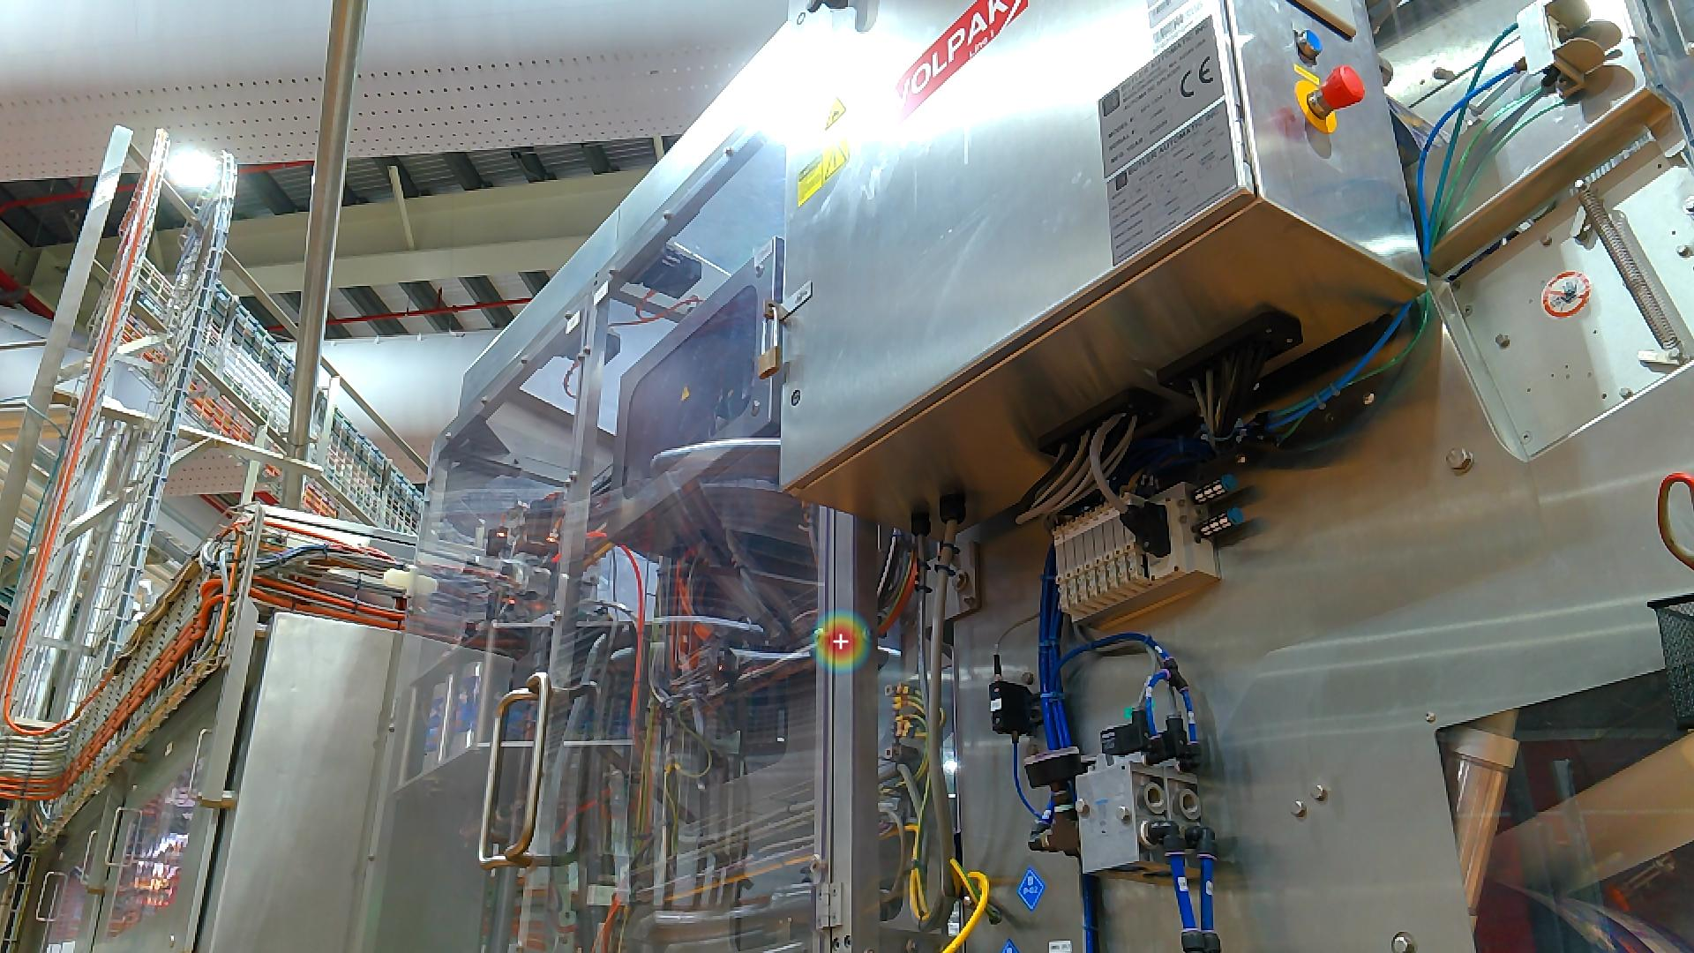 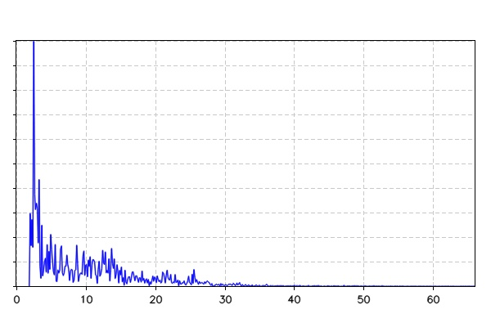 | The Acoustic Imager successfully detected and localized an air leak, pinpointing its exact coordinates as shown in the visual overlay.
leakage-80  • Status: CRITICAL  • Is Leak: True | 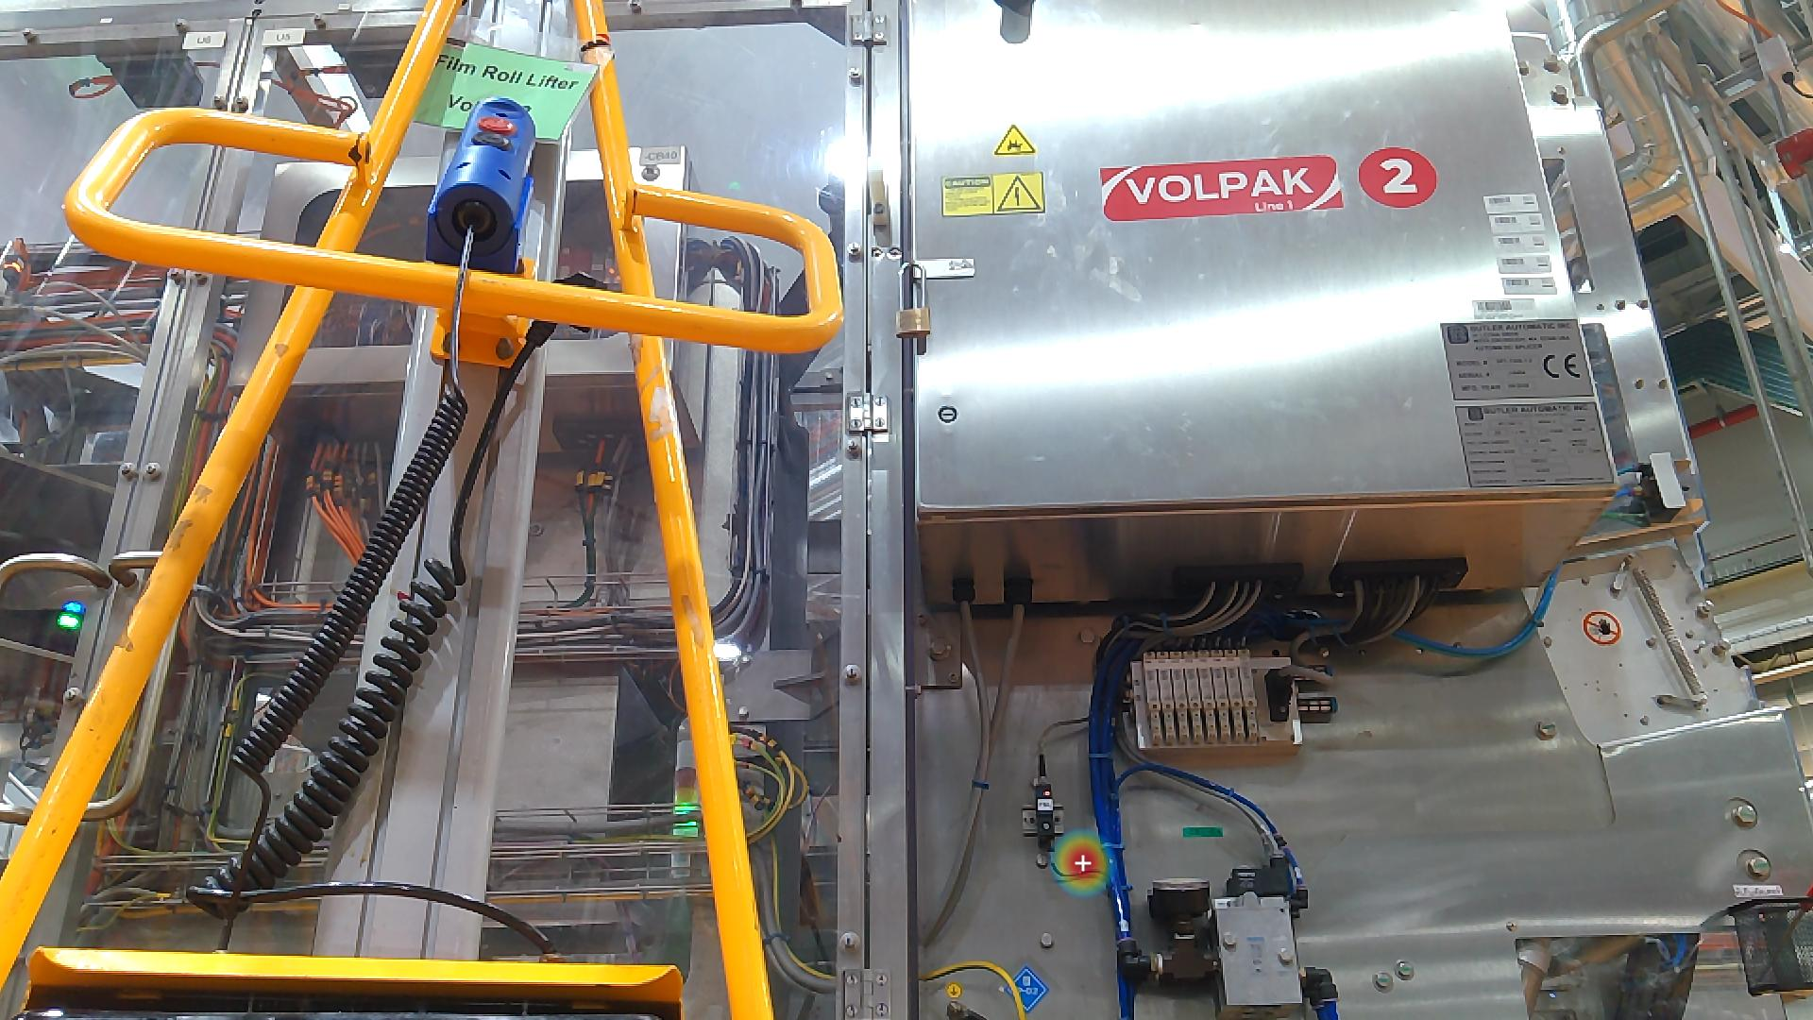 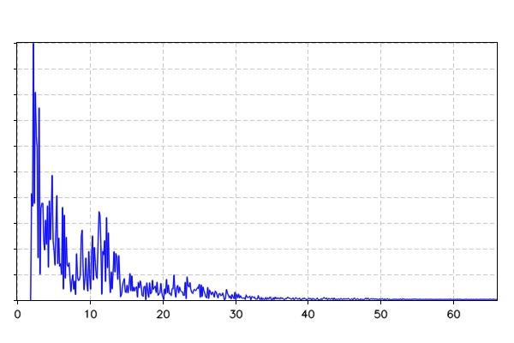 | The Acoustic Imager successfully detected and localized an air leak, pinpointing its exact coordinates as shown in the visual overlay.
leakage-81  • Status: CRITICAL  • Is Leak: True | 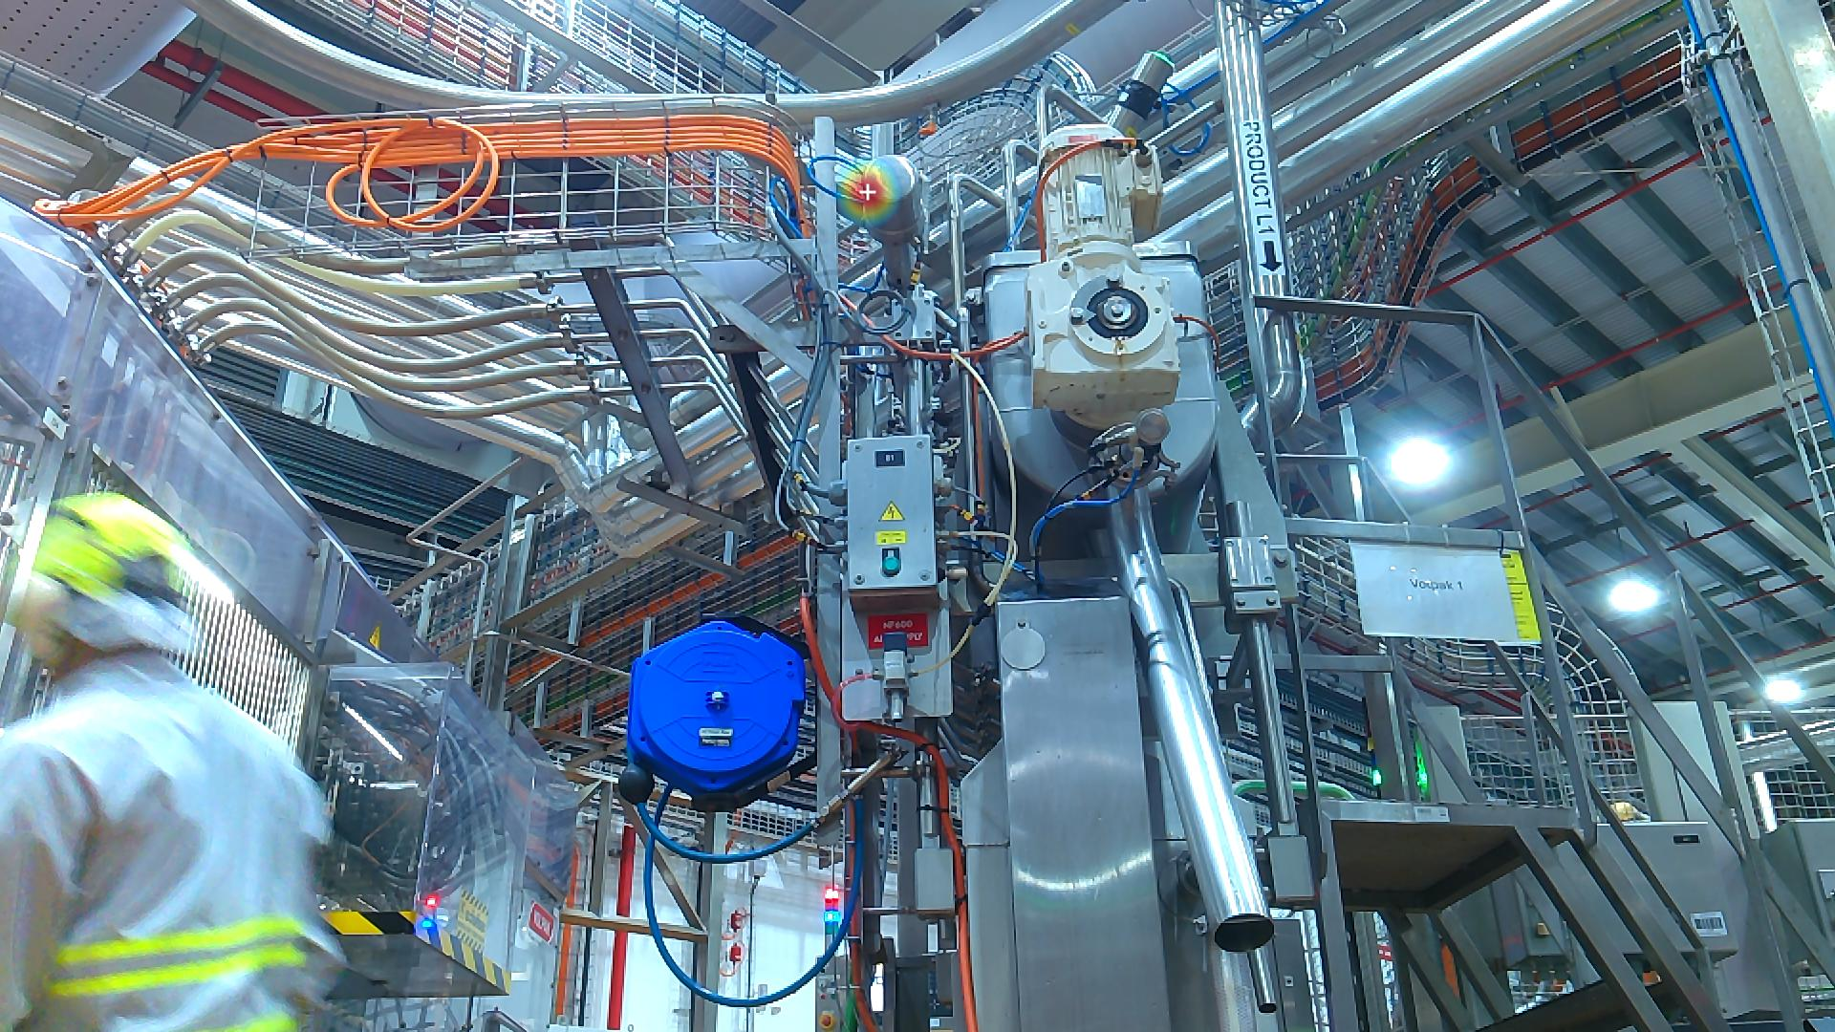 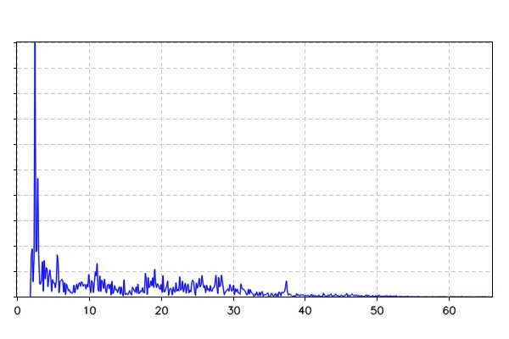 | The Acoustic Imager successfully detected and localized an air leak, pinpointing its exact coordinates as shown in the visual overlay.
thermal-151  • Status: MISSING  • Threshold: 50.0°C  • Temperature: N/A-N/A°C |  | The thermal camera detected an elevated temperature of 0°C, which may indicate overheating or abnormal operating conditions.
leakage-51  • Status: CRITICAL  • Is Leak: True | 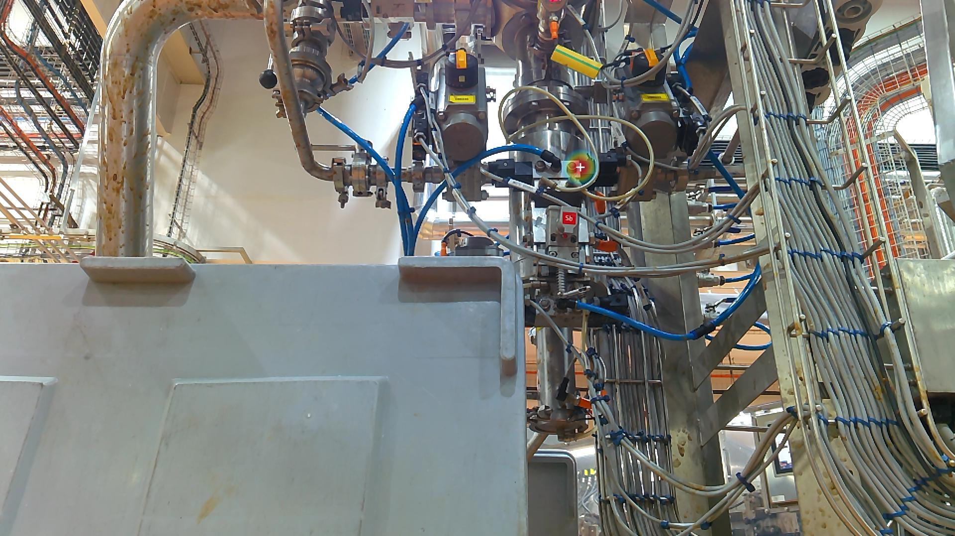 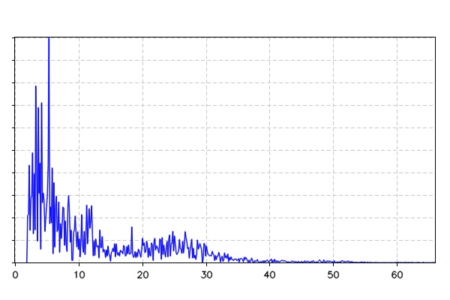 | The Acoustic Imager successfully detected and localized an air leak, pinpointing its exact coordinates as shown in the visual overlay.
asset-18  • Status: CRITICAL  • Detection Status: False | 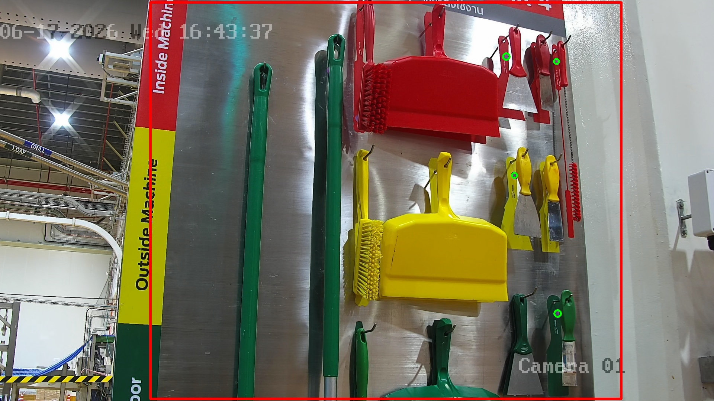 | The vision system identified an anomaly in the designated area, detecting that certain equipment or protective assets were missing or not in their correct state.
leakage-52  • Status: CRITICAL  • Is Leak: True | 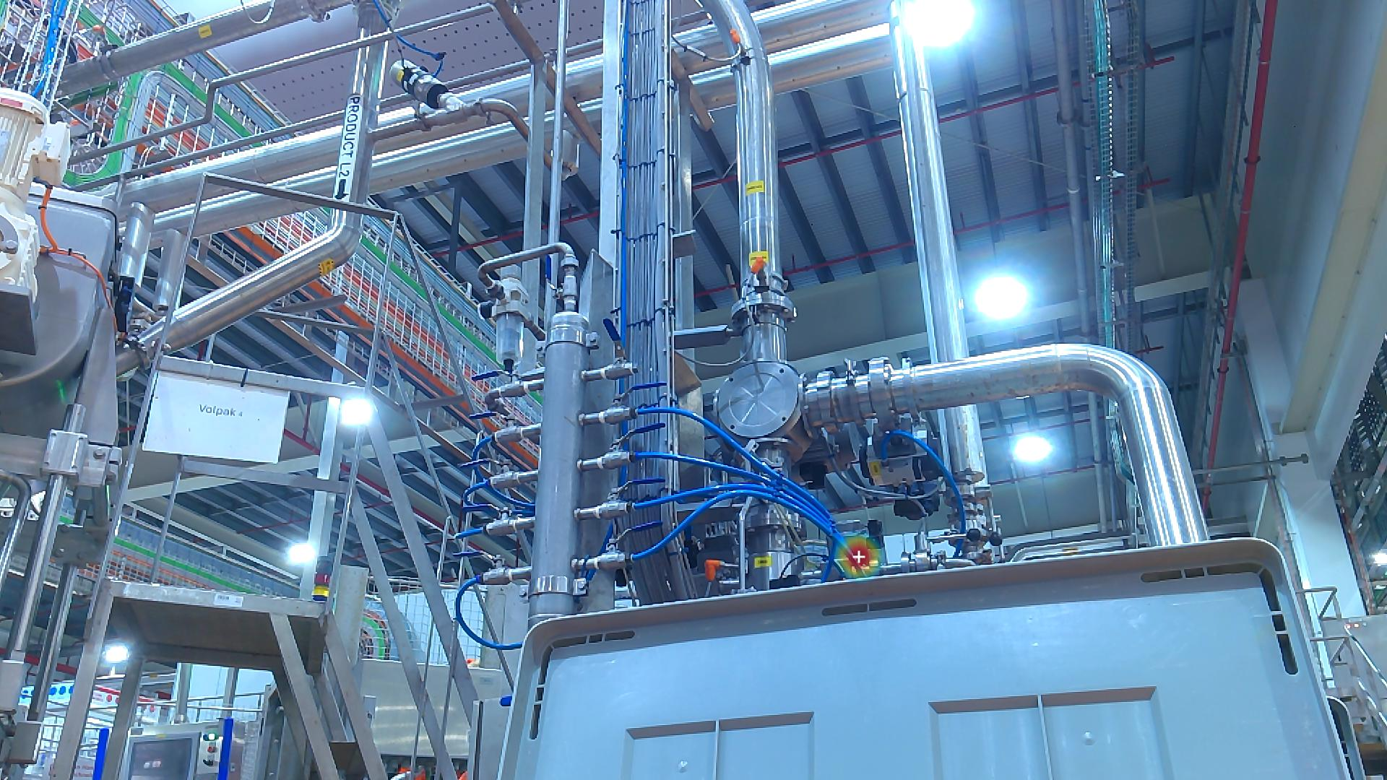 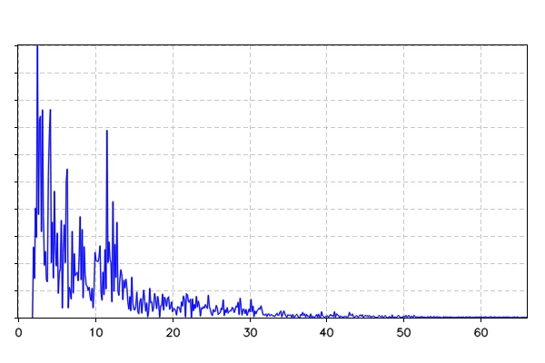 | The Acoustic Imager successfully detected and localized an air leak, pinpointing its exact coordinates as shown in the visual overlay.
loto-9  • Status: CRITICAL  • Detection Status: False | 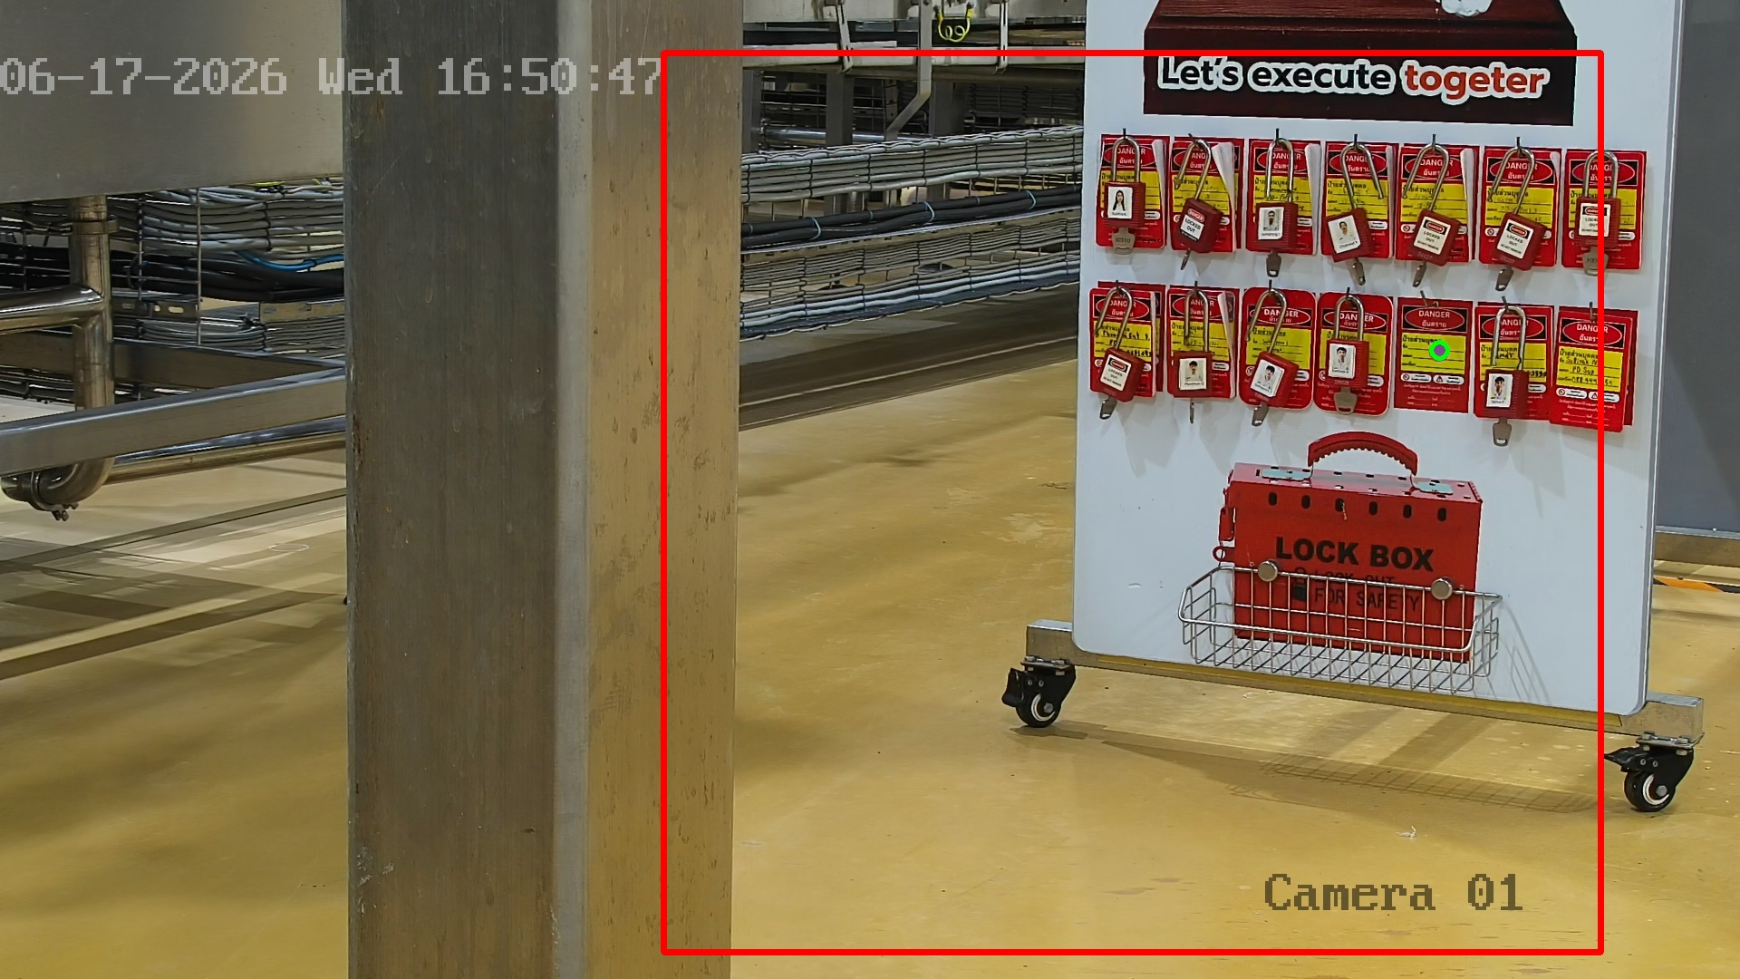 | The vision system identified an anomaly in the designated area, detecting that certain equipment or protective assets were missing or not in their correct state.
loto-10  • Status: CRITICAL  • Detection Status: False | 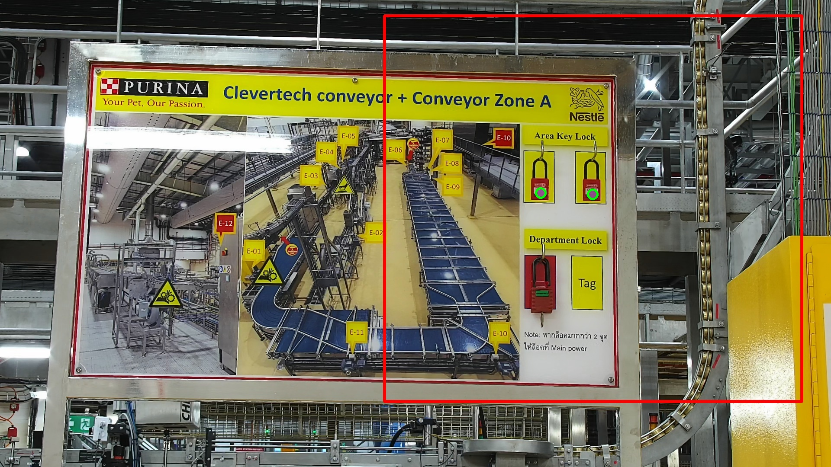 | The vision system identified an anomaly in the designated area, detecting that certain equipment or protective assets were missing or not in their correct state.
loto-11  • Status: CRITICAL  • Detection Status: False | 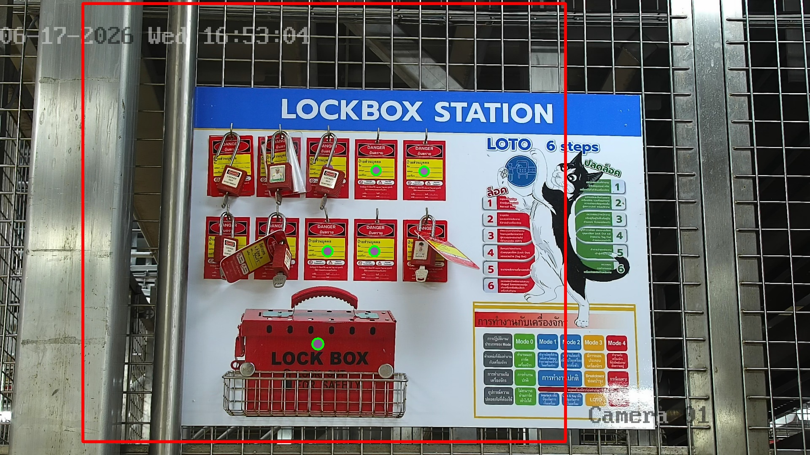 | The vision system identified an anomaly in the designated area, detecting that certain equipment or protective assets were missing or not in their correct state.
thermal-141  • Status: MISSING  • Threshold: 70.0°C  • Temperature: N/A-N/A°C |  | The thermal camera detected an elevated temperature of 0°C, which may indicate overheating or abnormal operating conditions.

