Department of Information Technology

Academic Year: 2023-24 Name of Student:
Semester: III Student ID:
Class / Branch/ Div: SE- IT C Roll No.
Subject: CPPL Date of Submission:
Name of Instructor: SB

Experiment No.:1
Aim: To Implement a program in C++ to demonstrate concepts like – Encapsulation, Initialization and Finalization.

Software Used: Codeblocks
// Program to illustrate the working of public and private in C++ Class

#include <iostream>
using namespace std;
class Room {
private:
double length;
double breadth;
double height;
public:
// function to initialize private variables
void initData(double len, double brth, double hgt) {
length = len;
breadth = brth;
height = hgt;
}

double calculateArea() {
return length * breadth;
}

double calculateVolume() {
return length * breadth * height;
}
};

int main() {

// create object of Room class
Room room1;

// pass the values of private variables as arguments
room1.initData(42.5, 30.8, 19.2);

cout << "Area of Room = " << room1.calculateArea() << endl;
cout << "Volume of Room = " << room1.calculateVolume() << endl;

return 0;
}

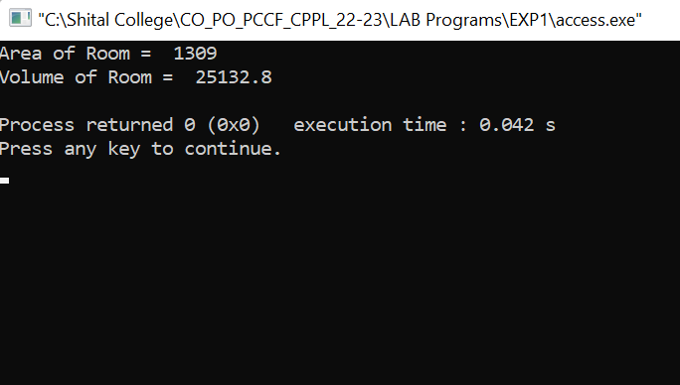

Example : C++ Parameterized Constructor
// C++ program to calculate the area of a wall

#include <iostream>
using namespace std;
// declare a class
class Wall {
private:
double length;
double height;
public:
// parameterized constructor to initialize variables
Wall(double len, double hgt) {
length = len;
height = hgt;
}

double calculateArea() {
return length * height;
}
};

int main() {
// create object and initialize data members
Wall wall1(10.5, 8.6);
Wall wall2(8.5, 6.3);

cout << "Area of Wall 1: " << wall1.calculateArea() << endl;
cout << "Area of Wall 2: " << wall2.calculateArea();

return 0;
}

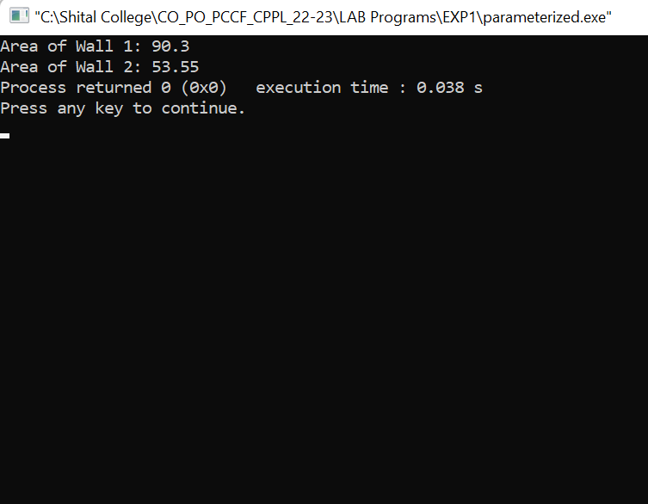

Conclusion: Thus,we have studied and implemented program for Encapsulation and data hiding through the creation of user-defined types, called classes that contain private, and public members. We also implemented a program for Initialization of variables using constructor.

