Department of Information Technology

Academic Year: 2023-24 Name of Student:
Semester: III Student ID:
Class / Branch/ Div: SE- IT C Roll No.
Subject: CPPL Date of Submission:
Name of Instructor: Prof. Shradha Birje

Experiment No.:10
Aim: To implement addition of two numbers using SWI Prolog . Implement a Prolog predicate max(X,Y,Z,M) that says that M is the maximum of the three input numbers X, Y, and Z. Use only ">" to compare numbers.
Objectives: To understand the basics of prolog programming language like facts,relations,rules and queries.
Software used : SWI prolog version 8.2.2

program:
max(X,Y,Z,M):-X>Y,X>Z,M is X.
max(X,Y,Z,M):-X<Y,Y>Z,M is Y.
max(X,Y,Z,M):-Z>Y,X<Z,M is Z.
max(X,Y,Z,M):-X=Y,X<Z,M is Z.
max(X,Y,Z,M):-X<Y,X=Z,M is Y.
max(X,Y,Z,M):-Y=Z,X>Y,M is X.
max(X,Y,Z,M):-X=Y,X>Z,M is X.
max(X,Y,Z,M):-X=Z,Y<Z,M is Z.
max(X,Y,Z,M):-Y=Z,X<Z,M is Z.
max(X,Y,Z,M):-X=Y,X=Z,M is X.

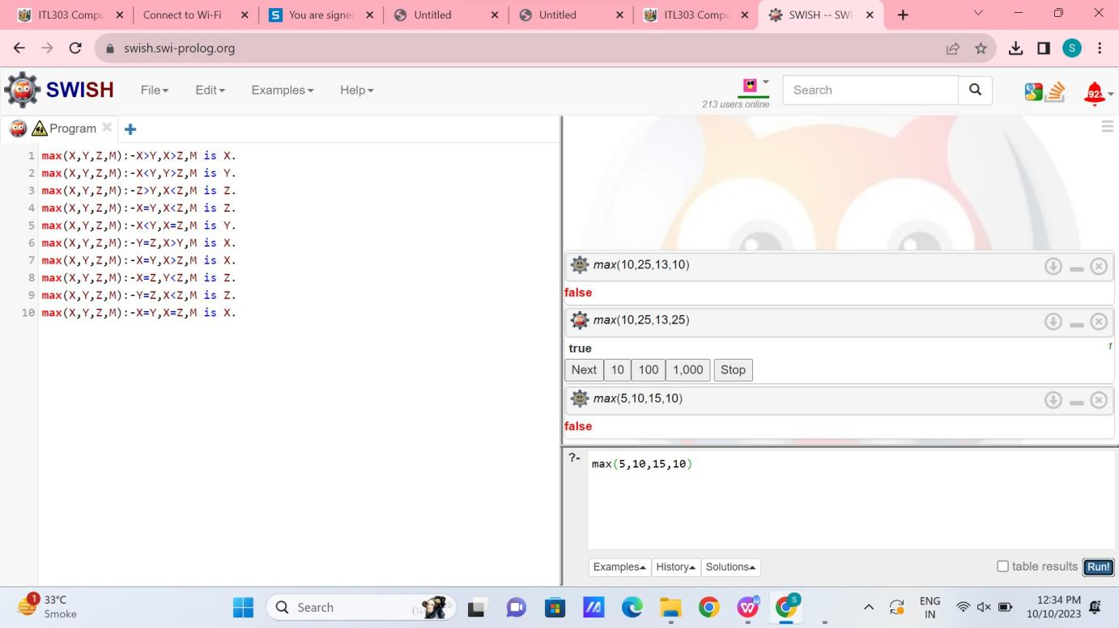

Conclusion: Thus, In this experiment we have studied how to use prolog predicate max(X,Y,
Z,M) that says that M is the maximum of the three input numbers X, Y, and Z.

