Academic Year: 2022-23 Name of Student:
Semester: III Student ID:
Class / Branch/ Div: SE- IT A Roll No.
Subject: CPPL Date of Submission:
Name of Instructor: SA

Experiment No 11

Aim: Implement a program to represent list in prolog.
- Objectives: To understand lists and its applications in Prolog and the problem domains of prolog.
- Prerequisites : It is required that students should have basic knowledge of how recursion works in imperative programming and unification in prolog.
- Software used : SWI prolog version 8.2.2

Problem Statement:
- Create a list containing all integers within a given range.

- Implement a predicate named enumerate: This predicate should take a list as the first argument, and return an integer number as the second argument, representing the length of the list, or the number of items it contains.
Examples: (a) enumerate([john], , R). Should return R = 1

- Design an application of membership in lists: You’re working as a bouncer at a nightclub, and you want to write a predicate which will let us know whether someone should be allowed in or not, based on whether their name is on the guest list. If their name is on the list, then they should be permitted to enter. Otherwise, they will have to wait outside.

- Implement append method on list using recursion.

Problem statement :
- Create a list containing all integers within a given range.
Example:
?-range(4,9,L).
L = [4,5,6,7,8,9

% Create a list containing all integers within a given range.
% range(I,K,L) :- I <= K, and L is the list containing all
% consecutive integers from I to K.
% (integer,integer,list) (+,+,?)

range(I,I,[I]).
range(I,K,[I|L]) :- I < K, I1 is I + 1, range(I1,K,L).

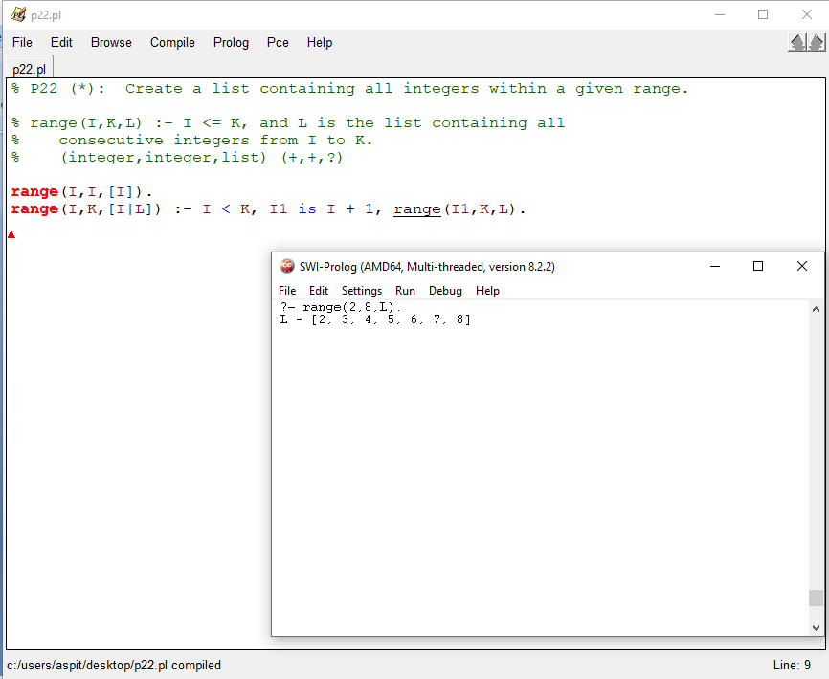

- Implement a predicate named enumerate: This predicate should take a list as the first argument, and return an integer number as the second argument, representing the length of the list, or the number of items it contains.
Examples: (a) enumerate([john],R). Should return R = 1

% To count no of elements in a list.
% size([_|T],N) :- size(T,N1), N is N1+1. Is recursively defined
% to find the count N of numbers in terms of N1+1 on the sublist
% (list,list,integer) (+,+,?)

size([],0).
size([_|T],N) :- size(T,N1), N is N1+1.

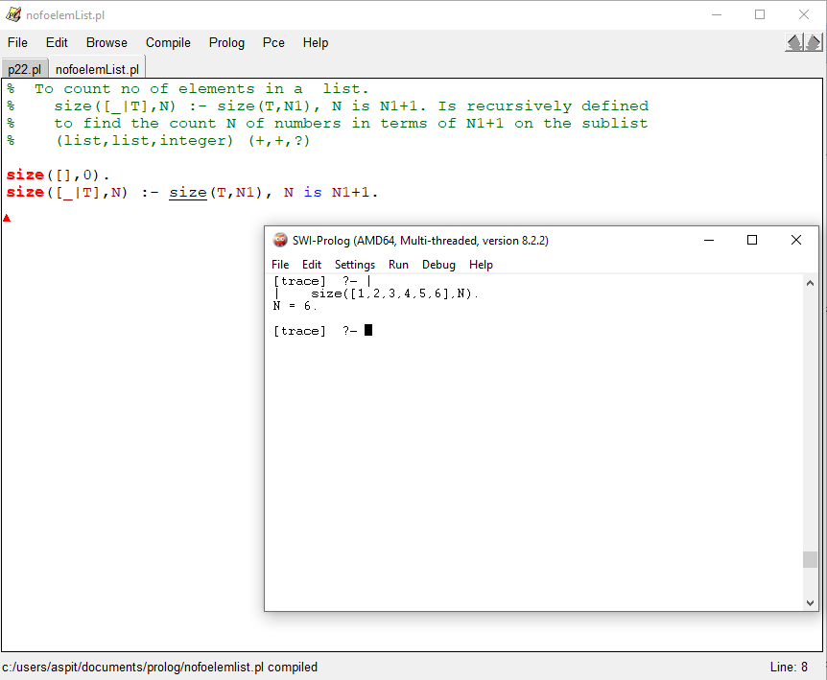

- Design an application of membership in lists: You’re working as a bouncer at a nightclub, and you want to write a predicate which will let us know whether someone should be allowed in or not, based on whether their name is on the guest list. If their name is on the list, then they should be permitted to enter. Otherwise, they will have to wait outside.

% To check if an element is a member of the list
% member(X,[X|_]) here check if the element X (name of person)is the head of the list.
% member(X,[Y|R]) :- member(X,R). check recursively, the element(person’s name) is in the tail %of the list by checking the head of the sublist obtained
% (integer,list) (?,+)

onTheGuestList(Name, [Name|_RestOfTheList]).
onTheGuestList(Name, [_FirstPerson|RestofTheList]) :- onTheGuestList(Name,RestofTheList).

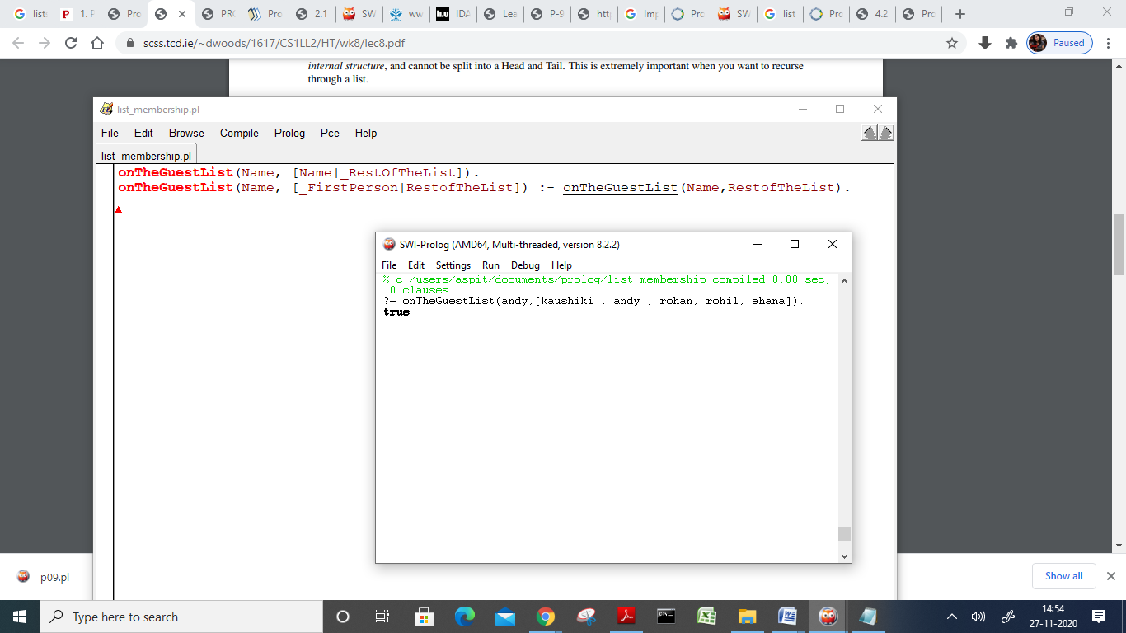

- Implement append method on list using recursion.

% To append a list at the back of an exsisting list
% append1([],L2,L2). Works as the base condition, states if an empty list is added to L2 ,result is L2
% append1([H|T],L2,[H|L3]) :- append1(T,L2,L3). The recursive function produces a list L3 that is
% a combination of the head of the list1 with concatenation of Tail of list1 and list 2 stored in L3.
% (list,list,list) (+,+,?)

append1([],L2,L2).
append1([H|T],L2,[H|L3]) :- append1(T,L2,L3).
