Department of Information Technology

Academic Year: 2023-24 Name of Student:
Semester: III Student ID:
Class / Branch/ Div: SE- IT C Roll No.
Subject: CPPL Date of Submission:
Name of Instructor: Shradha Birje

Experiment No.:2
Aim: To implement a program in C++ to demonstrate concepts like Dynamic Binding.

Theory:
What is Dynamic Binding?

C++ provides facility to specify that the compiler should match function calls with the correct definition at the run time; this is called dynamic binding or late binding or run-time binding.Dynamic binding is achieved using virtual functions. Base class pointer points to derived classobject. And a function is declared virtual in base class, then the matching function is identified atrun-time using virtual table entry. So, Dynamic biding can be achieved in C++ via the Virtual keyword.

Program
#include <iostream>
using namespace std;
class Base
{
public:
virtual void show()
{
cout<<" In Base \n";
}
};
class Derived : public Base
{
public:
void show()
{
cout << "Derived class is derived from the base class." ;
}
};
int main()
{
Base *bptr;
//Base b;
Derived d;
bptr = &d;
bptr->show();
return 0;
}
Output:
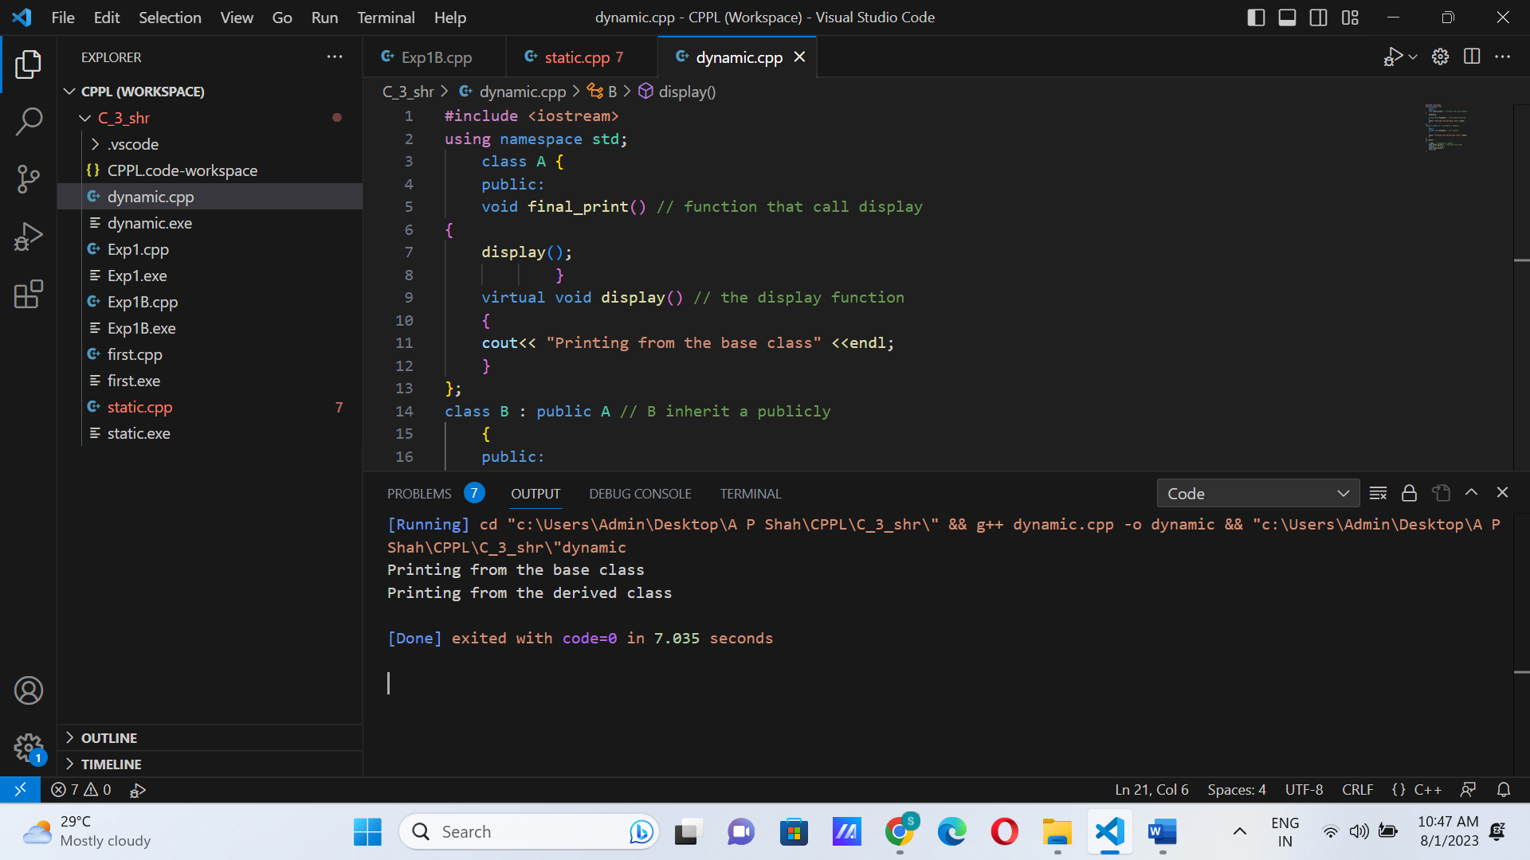

Program
#include <iostream>
using namespace std;
class A
{
public:
int x=5;
public:
virtual void display()
{
cout << "Value of x is : " << x<<endl;
}
};
class B: public A
{
int y = 10;
public:
void display()
{
cout << "Value of y is : " <<y<<endl;
}
};
int main()
{
A *a;
B b;
a = &b;
a->display();
return 0;
}

Output:

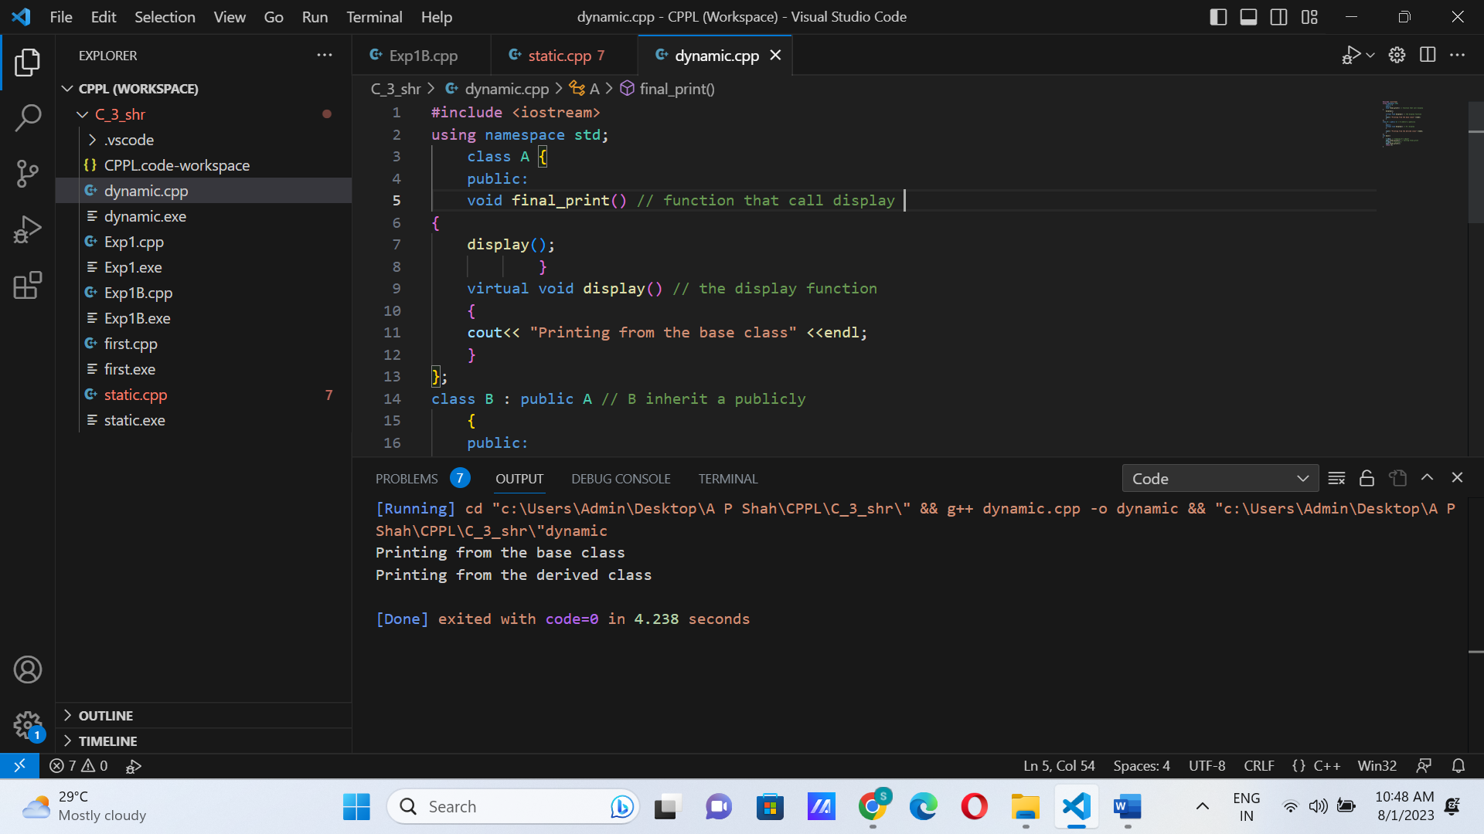

Conclusion: In this experiment, we went through the concept of dynamic binding in C++. To summarize, dynamic binding allows us flexibility by calling a single function to handle different objects. Considering our program, we called the same function display () by making two different objects to give us two different outputs. This is possible because dynamic binding happens at runtime, unlike static binding which happens at compile time.

