Department of Information Technology

Academic Year: 2023-24 Name of Student:
Semester: III Student ID:
Class / Branch/ Div: SE- IT C Roll No.
Subject: CPPL Date of Submission:
Name of Instructor: Shradha Birje

Experiment No.:3
Aim:. Create a base class “Student” which accept student details like Name, DoB, Year, Moodle Id. Create derived classes, Academic-Marks & Sport-Mark from Student Class and accept marks of student. Derive a Performance class from both Academic-Marks & Sport-Mark, which displays student’s details, academic performance and Sports performance.

Prerequisites: It is required that students should have basic knowledge of object oriented programming concepts.

Software used: Visual Studio Code

Single Inheritance
#include <iostream>
using namespace std;
class Animal {
public:
void eat() {
cout<<"Eating..."<<endl;
}
};
class Dog: public Animal
{
public:
void bark(){
cout<<"Barking...";
}
};
int main(void) {
Dog d1;
d1.eat();
d1.bark();
return 0;
}
Output:
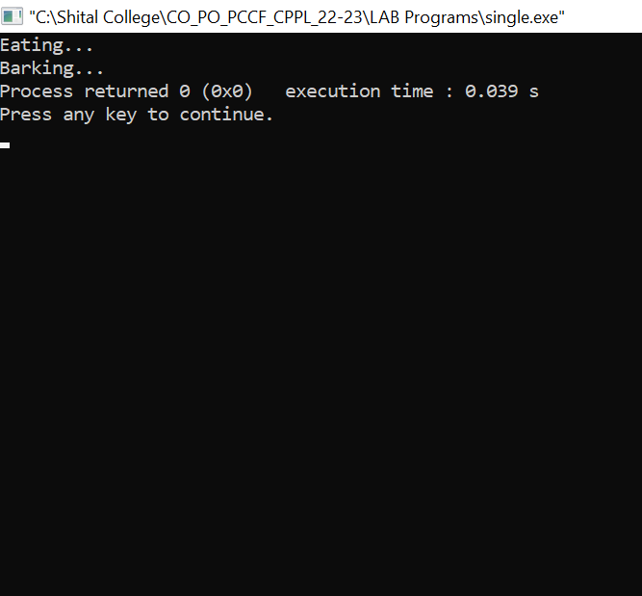
Multilevel Inheritance
#include <iostream>
using namespace std;
class Animal {
public:
void eat() {
cout<<"Eating..."<<endl;
}
};
class Dog: public Animal
{
public:
void bark(){
cout<<"Barking..."<<endl;
}
};
class BabyDog: public Dog
{
public:
void weep() {
cout<<"Weeping...";
}
};
int main(void) {
BabyDog d1;
d1.eat();
d1.bark();
d1.weep();
return 0;
}
Output:
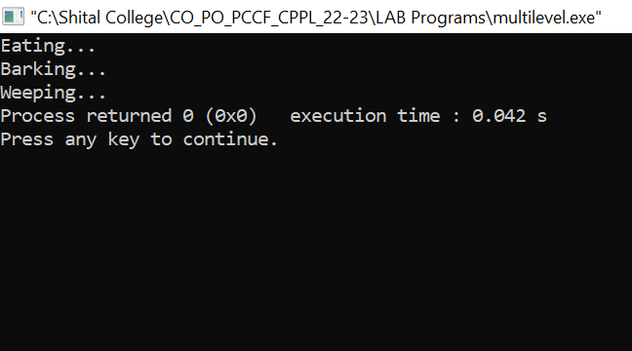

Multiple Inheritance
#include <iostream>
using namespace std;
// create add class
class add
{
public:
int x = 20;
int y = 30;
void sum()
{
cout << " The sum of " << x << " and " << y << " is " <<x+y << endl;
}
};

// create Mul class
class Mul
{
public:
int a = 20;
int b = 30;
void mul()
{
cout << " The Multiplication of " << a << " and " << b << " is " <<a*b << endl;
}
};

// create Subclass
class Sub
{
public:
int a = 50;
int b = 30;
void sub()
{
cout << " The Subtraction of " << a << " and " << b << " is " <<a-b << endl;
}
};

// create Div class
class Div
{
// access specifier
public:
int a = 150;
int b = 30;
void div()
{
cout << " The Division of " << a << " and " << b << " is " <<a/b << endl;
}
};

// create a derived class to derive the member functions of all base classes
class derived: public add, public Div, public Sub, public Mul
{
// access specifier
public:
int p = 12;
int q = 5;
void mod()
{
cout << "The Modulus of " << p << " and " <<q << " is " << p % q << endl;
}
};

int main ()
{
// create an object of the derived class
derived dr;
dr.mod(); // call derive class member function
// call all member function of class add, Div, Sub and Mul
dr.sum();
dr.mul();
dr.div();
dr.sub();
}

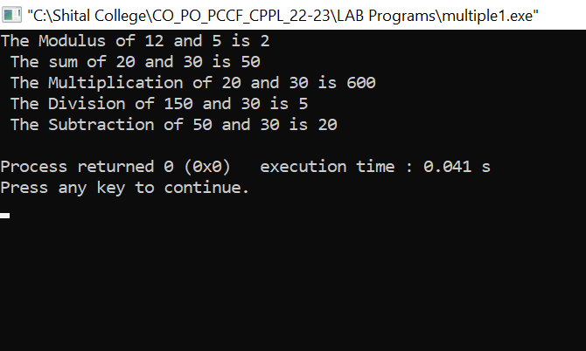
Hybrid Inheritance

Conclusion: In this Experiment we studied and implemented program for hybrid inheritance where we have one base(Student class) and three (Academic marks, Sports marks, Performance marks) derived classes ,i.e single inheritance and multiple inheritance which lets the last derived class(Performance marks) to acquire member functions, properties, characteristics from more than one base class(Academic, Sports and Student). As both single and multiple inheritance is used together it is known as Hybrid inheritance.

