Department of Information Technology

Academic Year: 2023-24 Name of Student:
Semester: III Student ID:
Class / Branch/ Div: SE- IT C Roll No.
Subject: CPPL Date of Submission:
Name of Instructor: Prof. Shradha Birje

Experiment No. 4

Aim : To Implement a program in C++ and JAVA to understand Exception handling and Garbage collection with the syntactic differences between the two languages.

- Output :
Exception handling in C++.
Program:
#include <iostream> #include <stdexcept> using namespace std; int main()
{
int a=10,b=0,c; try{
if(b==0)
{
throw runtime_error("divide by zero is an error"); c=a/b;
}

}
catch(int error)
{
cout<<"exception ocured :"<<endl<<error;
}
catch(...)
{
cout<<"some exception occured"<<endl;
}

return 0;

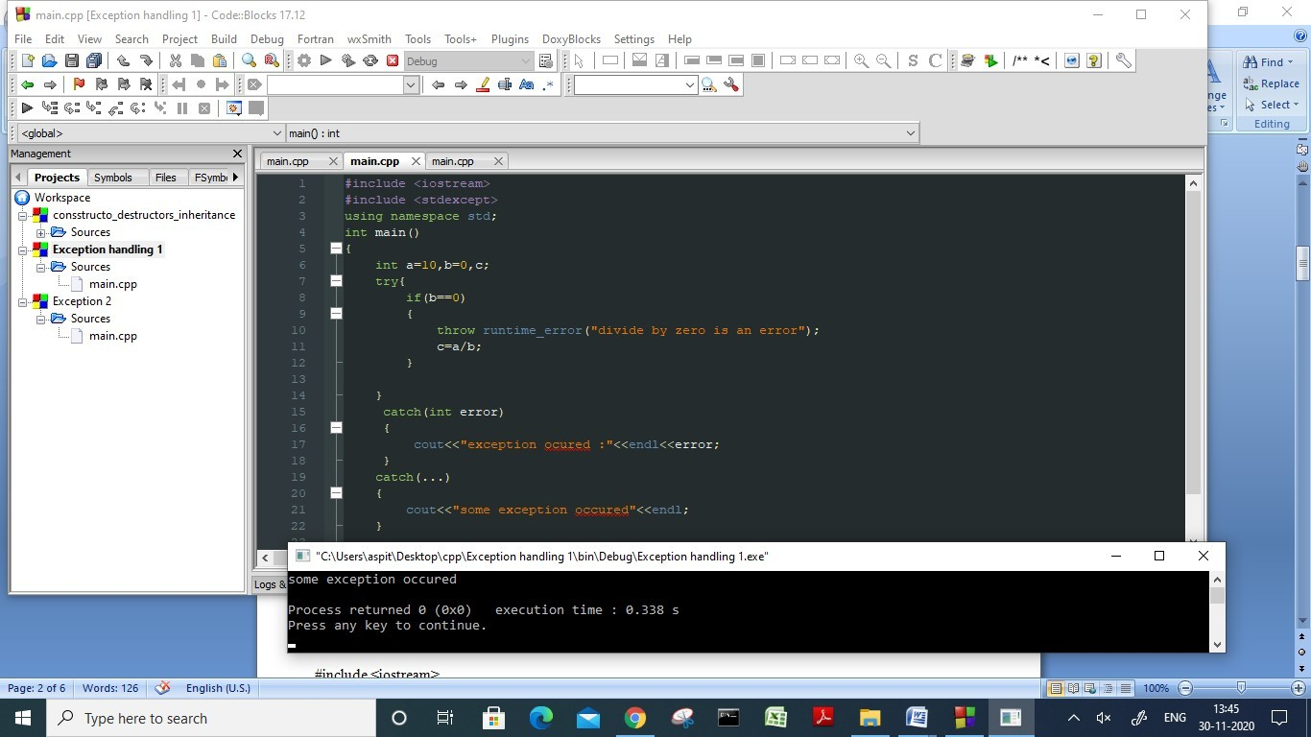

Exception handling in JAVA-

Exception handling using try-catch-

public class JavaExceptionExample{
public static void main(String args[]){
try{
//code that may raise exception
int data=100/0;
}catch(ArithmeticException e){System.out.println(e);}
//rest code of the program
System.out.println("rest of the code...");
}
}

Output:
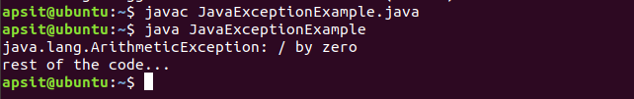

Use of multiple catch blocks :

public class MultipleCatchBlock1 {
public static void main(String[] args) {
try{
int a[]=new int[5];
a[5]=30/0;
}
catch(ArithmeticException e)
{
System.out.println("Arithmetic Exception occurs");
}
catch(ArrayIndexOutOfBoundsException e)
{
System.out.println("ArrayIndexOutOfBounds Exception occurs");
}
catch(Exception e)
{
System.out.println("Parent Exception occurs");
}
System.out.println("rest of the code");
}
}

Output :
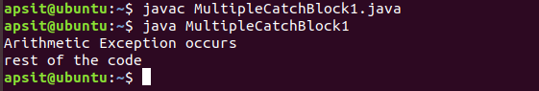

Use of finally keyword :

Here you can see that the exception occurred in try block which has been handled in catch block, after that finally block got executed.

Use of finally keyword with return statement :

class TestFinallyBlock {
public static void main(String args[]){
try{
//below code do not throw any exception
int data=25/5;
System.out.println(data);
}
//catch won't be executed
catch(NullPointerException e){
System.out.println(e);
}
//executed regardless of exception occurred or not
finally {
System.out.println("finally block is always executed");
}
System.out.println("rest of the code...");
}
}

Output :

