Department of Information Technology

Academic Year: 2023-24 Name of Student:
Semester: III Student ID:
Class / Branch/ Div: SE- IT C Roll No.
Subject: CPPL Date of Submission:
Name of Instructor: Shradha Birje

Experiment No 5

Aim : Perform Installation of Haskell compiler. Perform simple exercise on operators, types etc to
Demonstrate the use of GHCI.

Theory

To install Haskell on Linux ,run following command on terminal:

~$ sudo apt install haskell-platform -y

run our first Hello Word program using ghci

Code:

main = putStrLn "Hello world"

compilation

ghc -o filename filename.hs

ghc -o demo demo.hs

Execution

./filename

./demo

Description:

putStrLn :function to print on screen

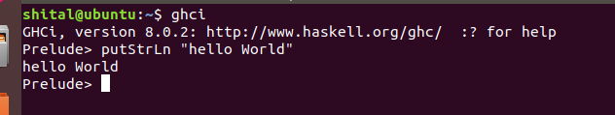

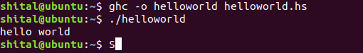

b) Using the ghci compiler perform addition and subtraction operation

Functions play a major role in Haskell, as it is a functional programming language. Like other languages, Haskell does have its own functional definition and declaration.

Function declaration consists of the function name and its argument list along with its output.

Function definition is where you actually define a function.

Let us take small example of add function to understand this concept in detail.

Prelude> :{
Prelude| add :: Integer -> Integer -> Integer --function declaration
Prelude| add x y = x + y --function definition
Prelude|
Prelude| main = do
Prelude| putStrLn "The addition of the two numbers is:"
Prelude| print(add 2 5) --calling a function
Prelude| :}
Prelude> add 2 3
5

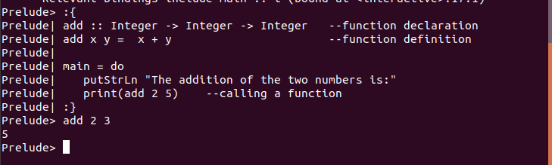

c)Determine the type of each of the following expressions using : type keyword

Prelude> pi
3.141592653589793

Prelude> :type pi
pi :: Floating a => a

Prelude> "abc"++"xyz"
"abcxyz"

Prelude> :type "abc"++"xyz"
"abc"++"xyz" :: [Char]
Prelude> :type (True, False)
(True, False) :: (Bool, Bool)
Prelude> :type (True, False, 'a')
(True, False, 'a') :: (Bool, Bool, Char)

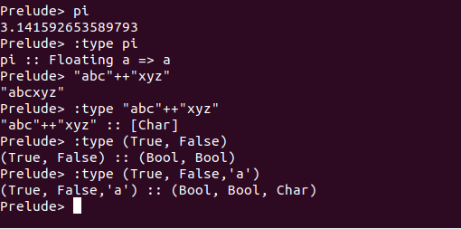

Conclusion:

Thus, In this experiment we have performed Installation of Haskell compiler. We also performed simple exercise on operators, types etc to demonstrate the use of GHCI.

