Department of Information Technology

Academic Year: 2022-23 Name of Student:
Semester: III Student ID:
Class / Branch/ Div: SE- IT A Roll No.
Subject: CPPL Date of Submission:
Name of Instructor: Shital Agrawal

Experiment No 6

Aim : To implement a function safetail that behaves in the same way as tail, except that safetail maps the empty list to the empty list, whereas tail gives an error in this case.

Program:

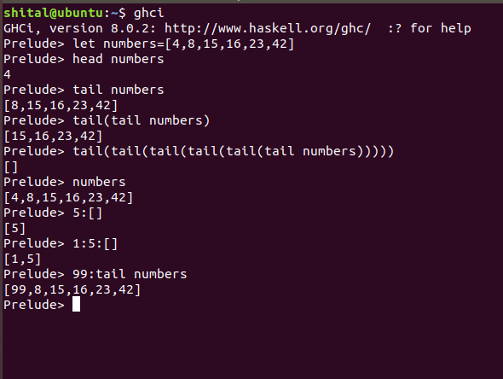

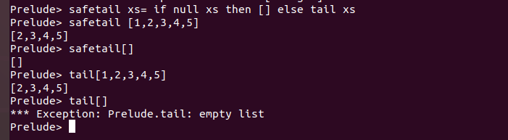

Conclusion:

Thus, In this experiment we learnt that function safetail behaves in the same way as tail, except that safetail maps the empty list to the empty list, whereas tail gives an error in this case.

