Department of Information Technology

Academic Year: 2023-24 Name of Student:
Semester: III Student ID:
Class / Branch/ Div: SE- IT C Roll No.
Subject: CPPL Date of Submission:
Name of Instructor: Shradha Birje

Experiment No.:7
Aim:
To implement user defined functions in Haskell, considering three types of function definition using (a) a conditional expression; (b) guarded equations; (c) pattern matching
a) conditional experssion
main = do
let var = 23
if var `rem` 2 == 0
then putStrLn "Number is Even"
else putStrLn "Number is Odd"

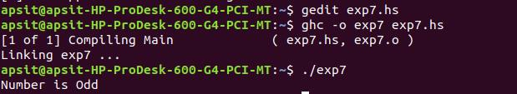
b) Guarded equation
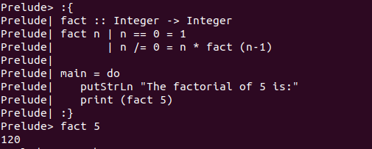

c) pattern matching
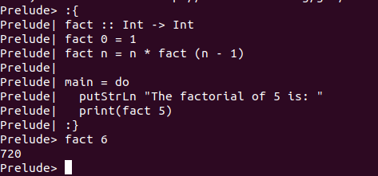

Conclusion: - Hence, we have studied implementation of user defined functions considering three types i.e conditional statements, pattern matching and guarded equations.

