Department of Information Technology

Academic Year: 2023-24 Name of Student:
Semester: III Student ID:
Class / Branch/ Div: SE- IT C Roll No.
Subject: CPPL Date of Submission:
Name of Instructor: Shradha Birje

Experiment No.:8

Aim: To implement multiplication of two natural numbers using recursion and the function add, define a function that multiplies two natural numbers.
Program For Multiplication
Prelude> :{
Prelude| mult _ 0 = 0
Prelude| mult n m = ( mult n (m-1)) + n
Prelude| :}
Prelude> mult 2 3
6
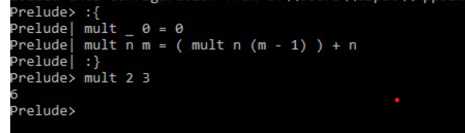

Program For Addition
Prelude> :{
Prelude| addition x 0 = x
Prelude| addition x y = (1 + addition x (y-1))
Prelude| :}
Prelude> addition 1 3
4
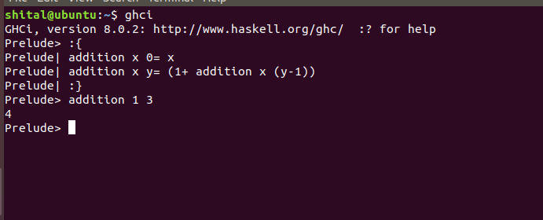
Conclusion: Thus, In this experiment we have simple recursion of two natural numbers multiplication and addition by using of GHCI.

