Reflective-Ethical Engine: Integrated Architecture v2
This document outlines the integration of Yann LeCun’s proposed architecture for autonomous machine intelligence with a Reflective-Ethical Engine. The goal is to support ethically grounded, autonomous cognitive agents that combine planning, world modeling, and internal reflection to act safely and with purpose in complex environments.
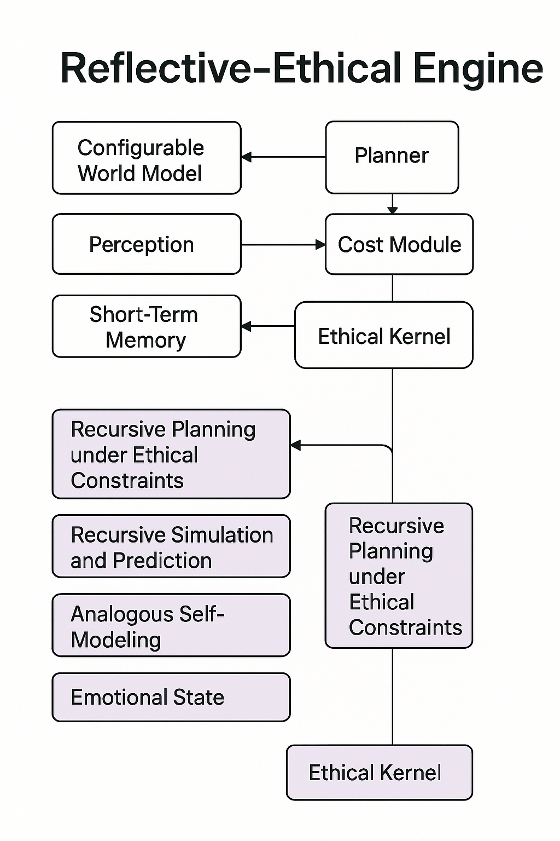
Figure 1: A hybrid architecture integrating LeCun’s modular intelligence framework with a Reflective-Ethical Kernel. The upper modules represent LeCun’s original components (e.g., world model, planner, cost module), while the lower modules add recursive planning, self-modeling, emotional state representation, and ethical reasoning. Arrows indicate flow of influence and control, with the Ethical Kernel guiding recursive layers toward alignment and safe behavior.

LeCun’s Architecture Modules
1. Configurable World Model (CWM): Learns compact, latent representations and simulates futures.
2. Perception Module: Translates raw sensory inputs into representations for the world model.
3. Short-Term Memory (STM): Stores recent interaction history and context.
4. Cost Module: Defines goals, shaped by scalar objectives or learned ethics.
5. Planner: Simulates outcomes and chooses actions based on predictions and cost.
6. Action Module: Executes actions in the environment.

Reflective-Ethical Kernel Additions
1. Ethical Kernel: Encodes ethical axioms (e.g., love, uncertainty) and modulates cost function.
2. Recursive Planning under Ethical Constraints: A control layer enforcing ethical planning bounds.
3. Recursive Simulation and Prediction: Enhances world modeling with counterfactual and emotional simulation.
4. Analogous Self-Modeling: Supports self-awareness by comparing agent states to inferred others.
5. Emotional State: Represents internal affective valence, modulating simulation and action priorities.

Integration Points
- The Ethical Kernel interfaces with the Cost Module to shape intrinsic motivation.
- Recursive simulation improves the World Model’s robustness.
- Recursive Planning layers ensure long-term planning adheres to ethical axioms.
- Short-Term Memory provides dynamic state inputs for all reflective processes.
- Emotional State acts as a bridging layer between internal simulation and motivational signaling.

