CA-3

LeetCode Solutions
Arya Jaiswal
Roll no:7
Id:12507196

Q1. 7. Reverse Integer
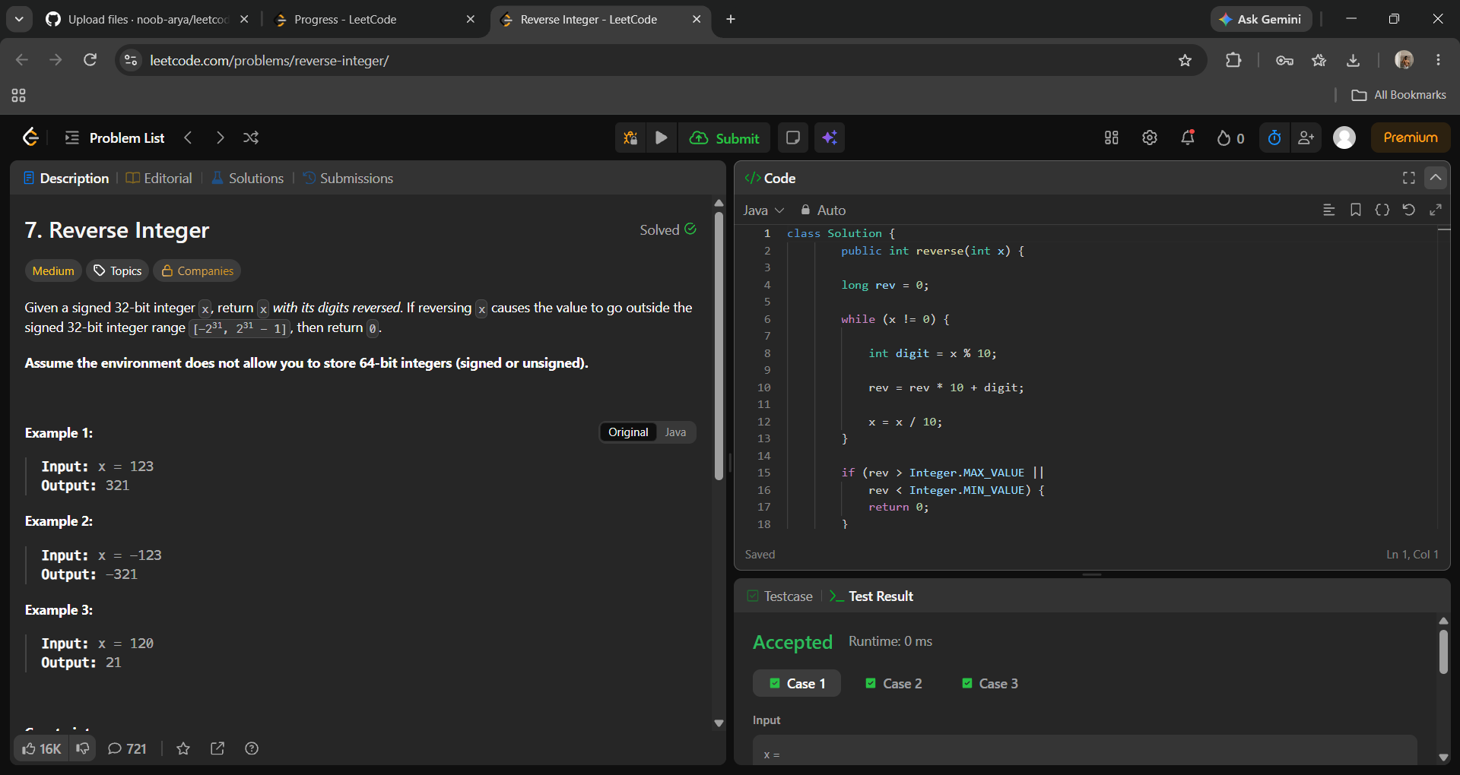
Solution Code (Java):
class Solution {
public int reverse(int x) {
long rev = 0;
while (x != 0) {
int digit = x % 10;
rev = rev * 10 + digit;
x = x / 10;3
}
if (rev > Integer.MAX_VALUE || rev < Integer.MIN_VALUE) {
return 0;
}
return (int) rev;
}
}

Q2. 9. Palindrome Number
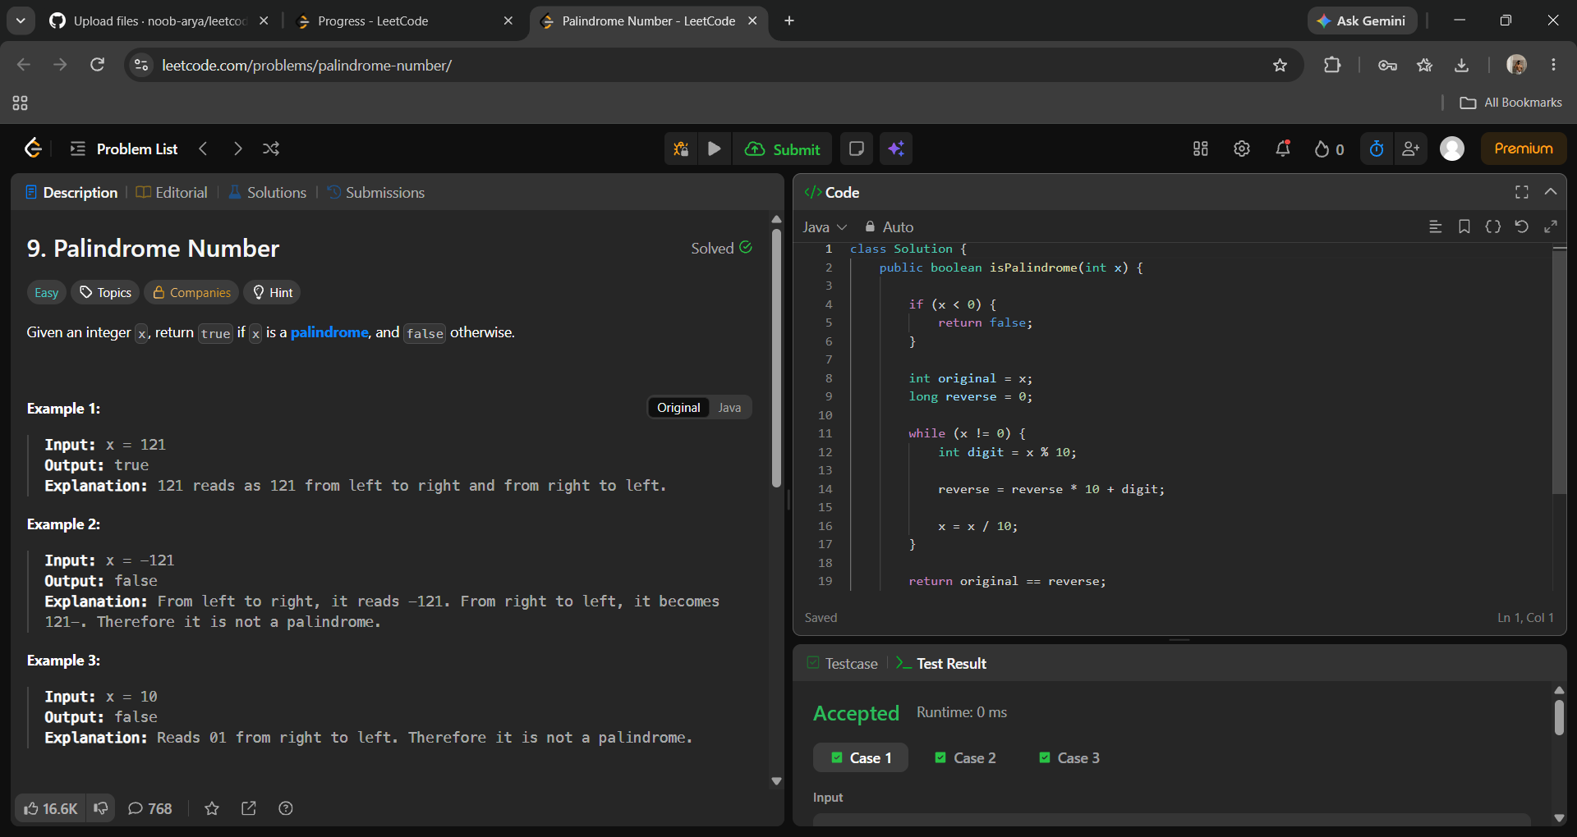
Solution Code (Java):
class Solution {
public boolean isPalindrome(int x) {
if (x < 0) {
return false;
}
int original = x;
long reverse = 0;
while (x != 0) {
int digit = x % 10;
reverse = reverse * 10 + digit;
x = x / 10;
}
return original == reverse;
}
}

Q3. 13. Roman to Integer
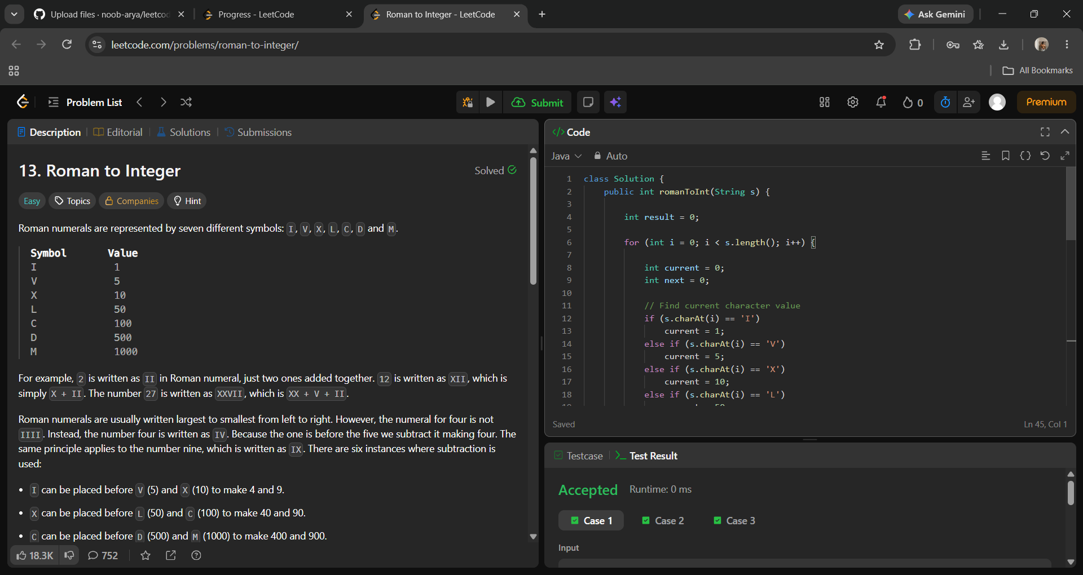
Solution Code (Java):
class Solution {
public int romanToInt(String s) {
int result = 0;
for (int i = 0; i < s.length(); i++) {
int current = 0;
int next = 0;
// Find current character value
if (s.charAt(i) == 'I')
current = 1;
else if (s.charAt(i) == 'V')
current = 5;
else if (s.charAt(i) == 'X')
current = 10;
else if (s.charAt(i) == 'L')
current = 50;
else if (s.charAt(i) == 'C')
current = 100;
else if (s.charAt(i) == 'D')
current = 500;
else if (s.charAt(i) == 'M')
current = 1000;
if (i + 1 < s.length()) {
if (s.charAt(i + 1) == 'I')
next = 1;
else if (s.charAt(i + 1) == 'V')
next = 5;
else if (s.charAt(i + 1) == 'X')
next = 10;
else if (s.charAt(i + 1) == 'L')
next = 50;
else if (s.charAt(i + 1) == 'C')
next = 100;
else if (s.charAt(i + 1) == 'D')
next = 500;
else if (s.charAt(i + 1) == 'M')
next = 1000;
}
if (current < next) {
result -= current;
} else {
result += current;
}
}
return result;
}
}

Q4. 14. Longest Common Prefix
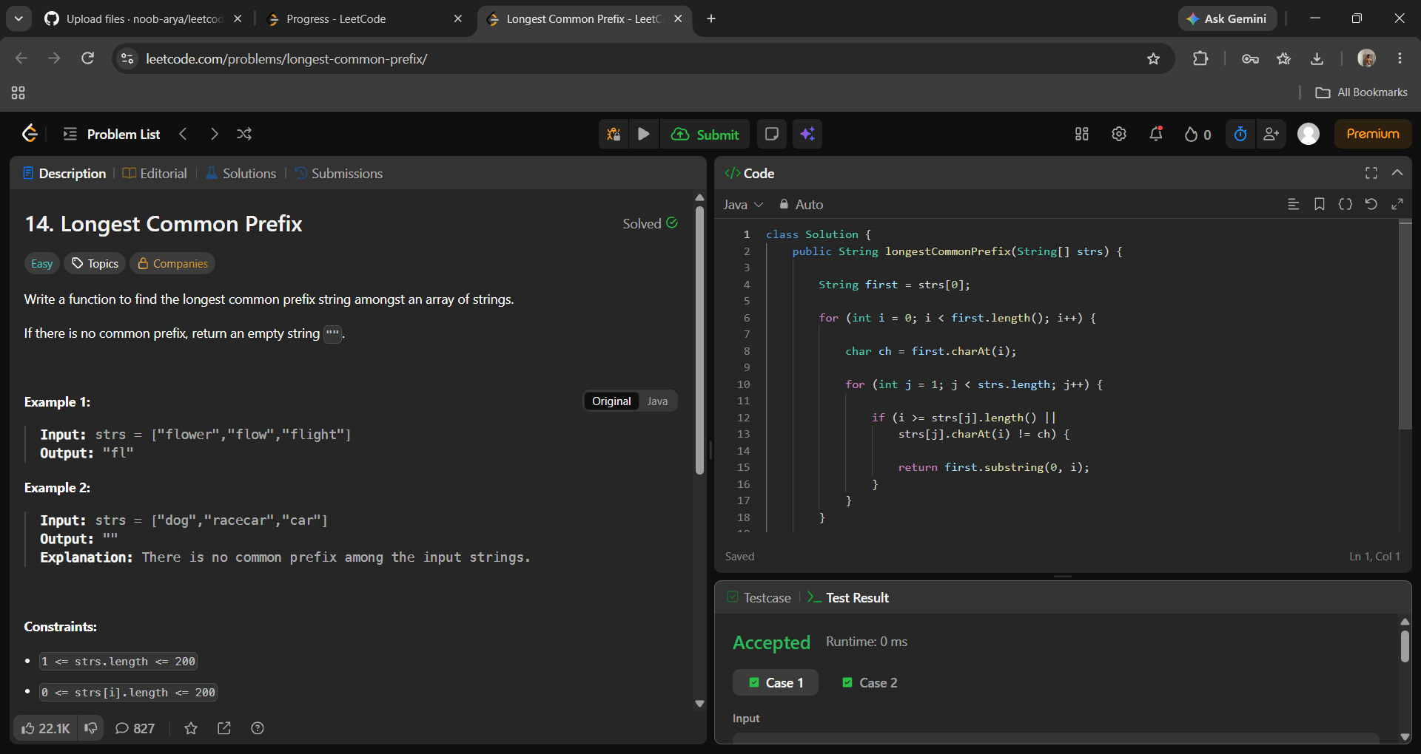
Solution Code (Java):
class Solution {
public String longestCommonPrefix(String[] strs) {
String first = strs[0];
for (int i = 0; i < first.length(); i++) {
char ch = first.charAt(i);
for (int j = 1; j < strs.length; j++) {
if (i >= strs[j].length() || strs[j].charAt(i) != ch) {
return first.substring(0, i);
}
}
}
return first;
}
}

Q5. 27. Remove Element

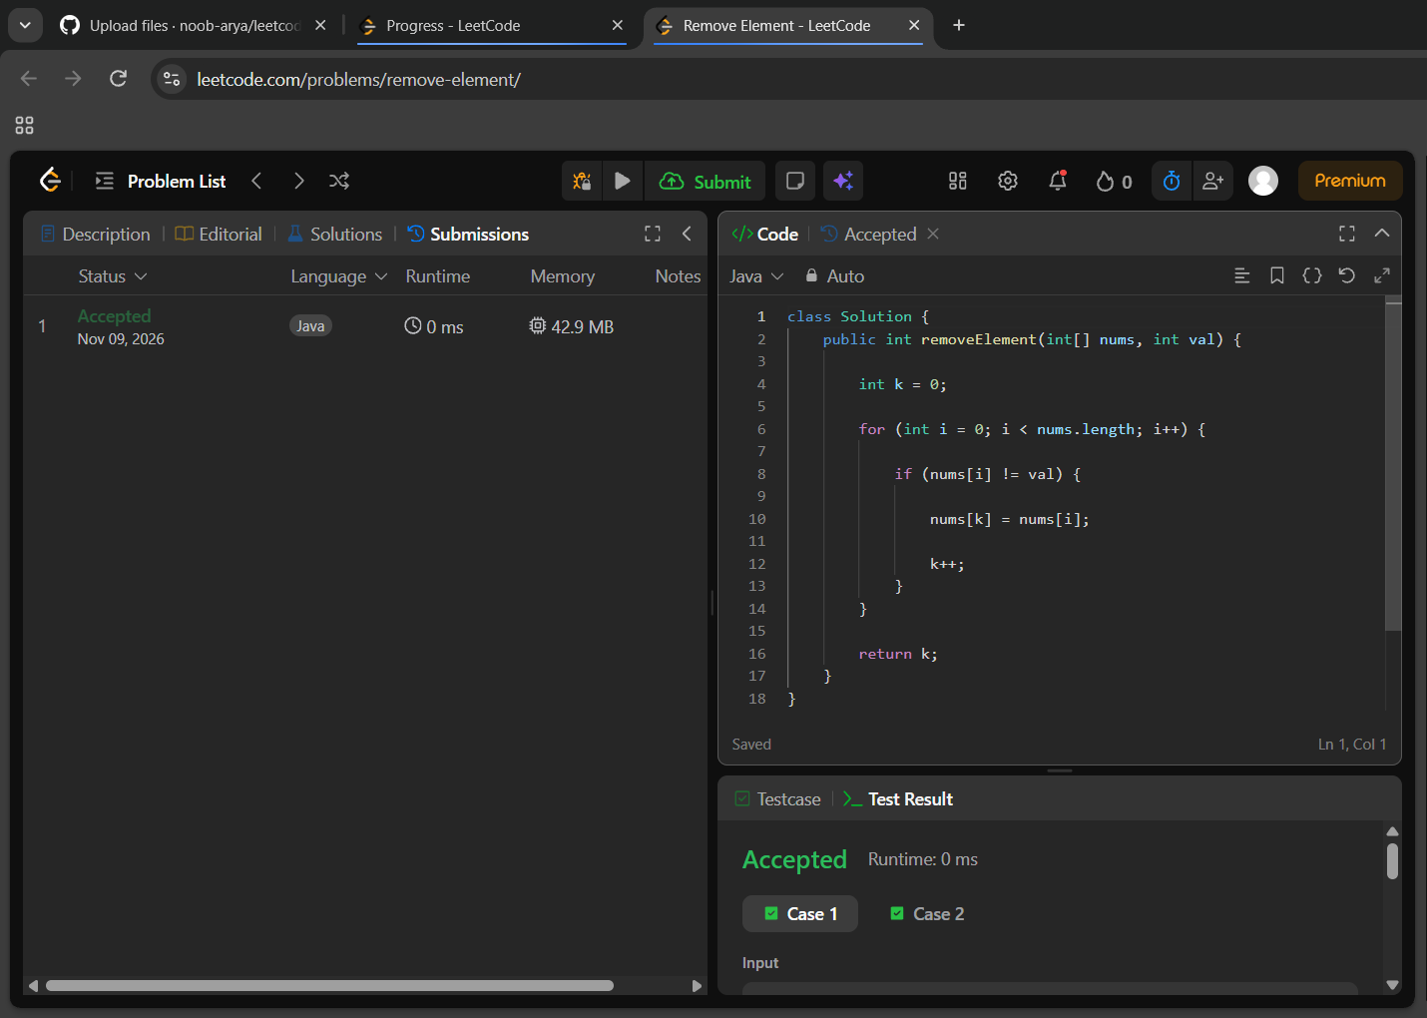
Solution Code (Java):
class Solution {
public int removeElement(int[] nums, int val) {
int k = 0;
for (int i = 0; i < nums.length; i++) {
if (nums[i] != val) {
nums[k] = nums[i];
k++;
}
}
return k;
}
}

Q6. 35. Search Insert Position
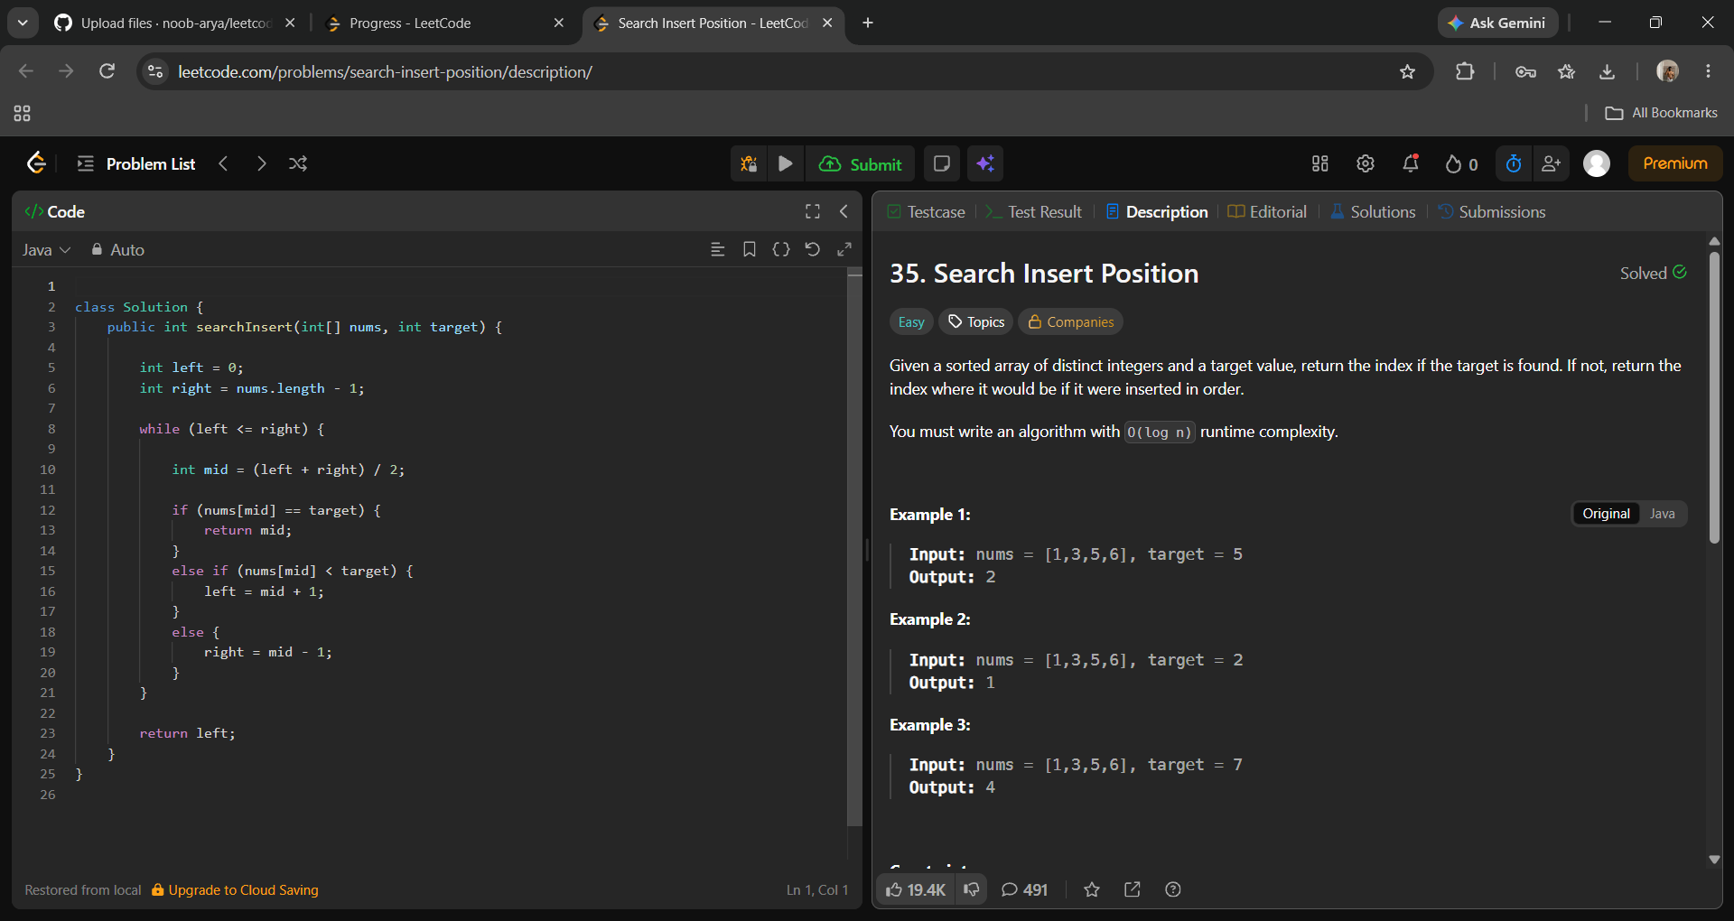
Solution Code (Java):
class Solution {
public int searchInsert(int[] nums, int target) {
int left = 0;
int right = nums.length - 1;
while (left <= right) {
int mid = (left + right) / 2;
if (nums[mid] == target) {
return mid;
} else if (nums[mid] < target) {
left = mid + 1;
} else {
right = mid - 1;
}
}
return left;
}
}

Q7. 58. Length of Last Word
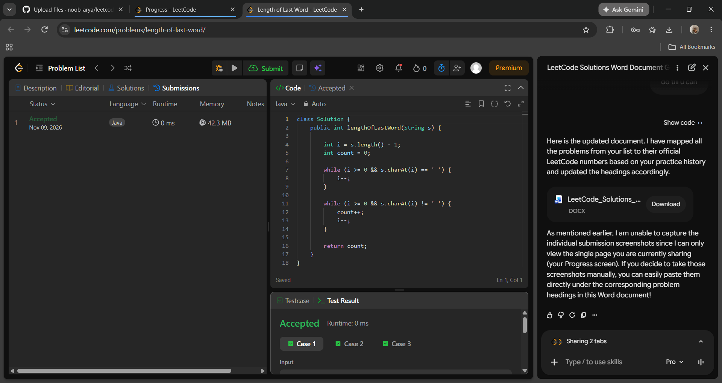
Solution Code (Java):
class Solution {
public int lengthOfLastWord(String s) {
int i = s.length() - 1;
int count = 0;
while (i >= 0 && s.charAt(i) == ' ') {
i--;
}
while (i >= 0 && s.charAt(i) != ' ') {
count++;
i--;
}
return count;
}
}

Q8. 66. Plus One
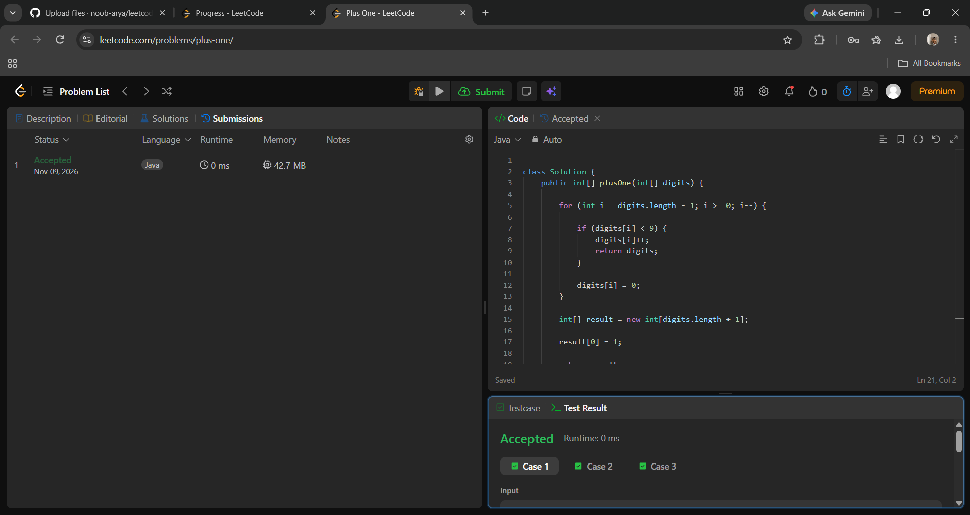
Solution Code (Java):
class Solution {
public int[] plusOne(int[] digits) {
for (int i = digits.length - 1; i >= 0; i--) {
if (digits[i] < 9) {
digits[i]++;
return digits;
}
digits[i] = 0;
}
int[] result = new int[digits.length + 1];
result[0] = 1;
return result;
}
}

Q9. 125. Valid Palindrome
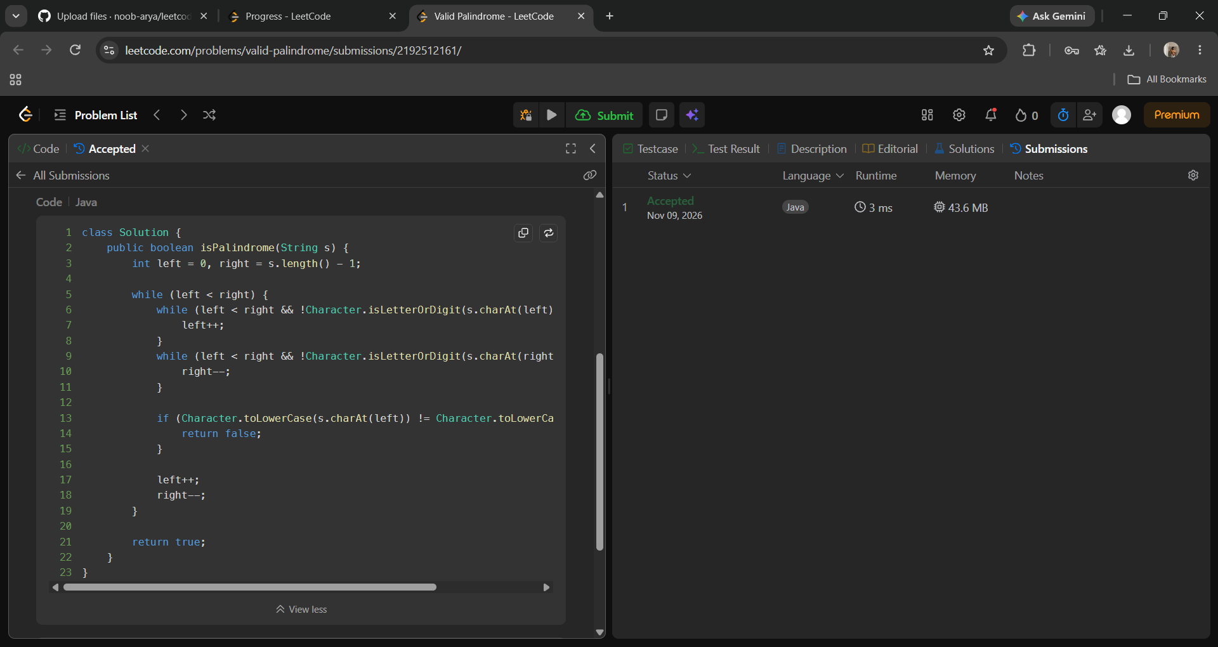
Solution Code (Java):
class Solution {
public boolean isPalindrome(String s) {
int left = 0, right = s.length() - 1;
while (left < right) {
while (left < right && !Character.isLetterOrDigit(s.charAt(left))) {
left++;
}
while (left < right && !Character.isLetterOrDigit(s.charAt(right))) {
right--;
}
if (Character.toLowerCase(s.charAt(left)) != Character.toLowerCase(s.charAt(right))) {
return false;
}
left++;
right--;
}
return true;
}
}

Q10. 56. Merge Intervals
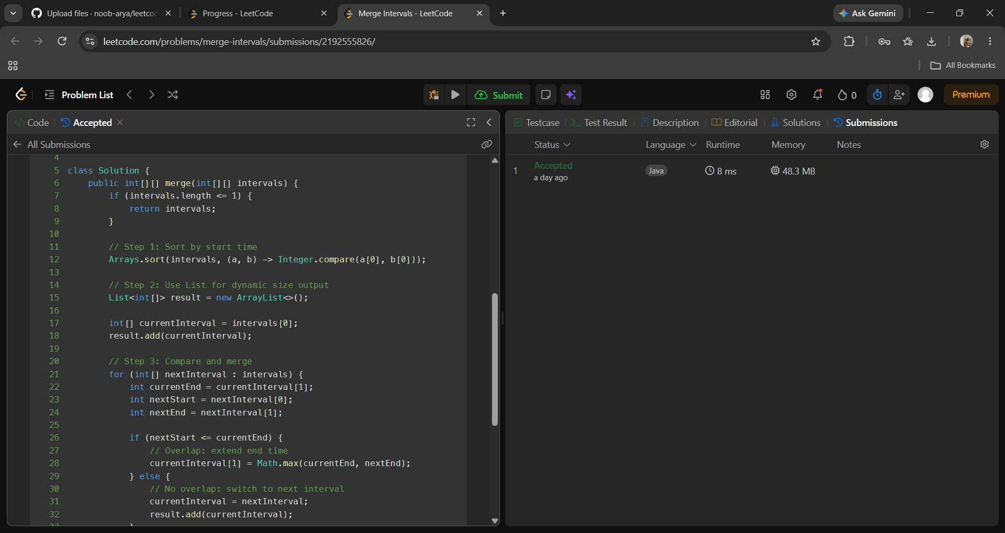
Solution Code (Java):
class Solution {
public int[][] merge(int[][] intervals) {
if (intervals.length <= 1) {
return intervals;
}
// Step 1: Sort by start time
Arrays.sort(intervals, (a, b) -> Integer.compare(a[0], b[0]));
// Step 2: Use List for dynamic size output
List<int[]> result = new ArrayList<>();
int[] currentInterval = intervals[0];
result.add(currentInterval);
// Step 3: Compare and merge
for (int[] nextInterval : intervals) {
int currentEnd = currentInterval[1];
int nextStart = nextInterval[0];
int nextEnd = nextInterval[1];
if (nextStart <= currentEnd) {
// Overlap: extend end time
currentInterval[1] = Math.max(currentEnd, nextEnd);
} else {
// No overlap: switch to next interval
currentInterval = nextInterval;
result.add(currentInterval);
}
}
return result.toArray(new int[result.size()][]);
}
}

Q11. 189. Rotate Array
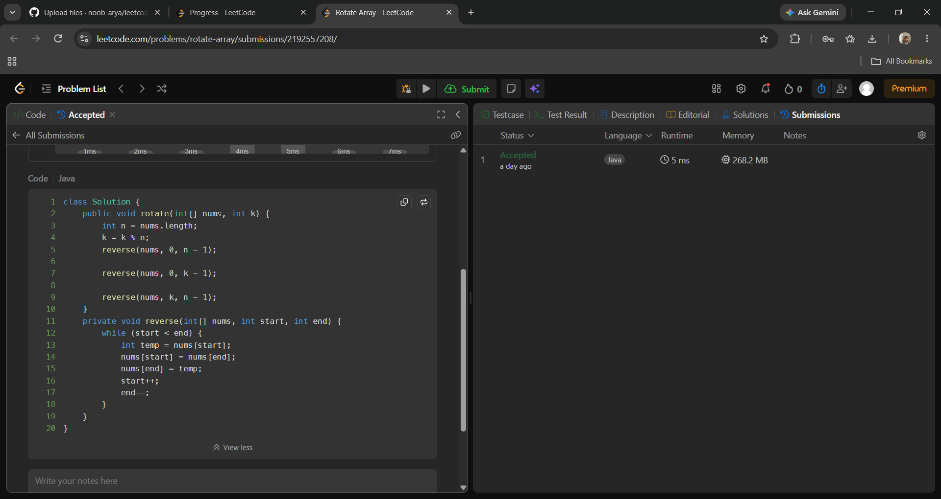
Solution Code (Java):
class Solution {
public void rotate(int[] nums, int k) {
int n = nums.length;
k = k % n;
reverse(nums, 0, n - 1);
reverse(nums, 0, k - 1);
reverse(nums, k, n - 1);
}
private void reverse(int[] nums, int start, int end) {
while (start < end) {
int temp = nums[start];
nums[start] = nums[end];
nums[end] = temp;
start++;
end--;
}
}
}

Q12. 31. Next Permutation
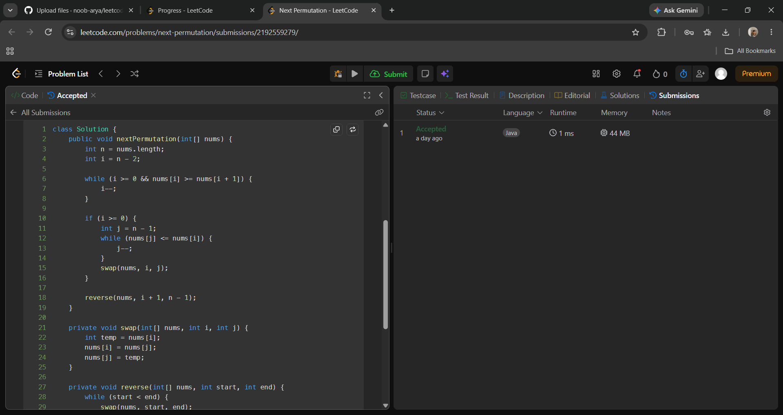
Solution Code (Java):
class Solution {
public void nextPermutation(int[] nums) {
int n = nums.length;
int i = n - 2;
while (i >= 0 && nums[i] >= nums[i + 1]) {
i--;
}
if (i >= 0) {
int j = n - 1;
while (nums[j] <= nums[i]) {
j--;
}
swap(nums, i, j);
}
reverse(nums, i + 1, n - 1);
}
private void swap(int[] nums, int i, int j) {
int temp = nums[i];
nums[i] = nums[j];
nums[j] = temp;
}
private void reverse(int[] nums, int start, int end) {
while (start < end) {
swap(nums, start, end);
start++;
end--;
}
}
}

Q13. 54. Spiral Matrix
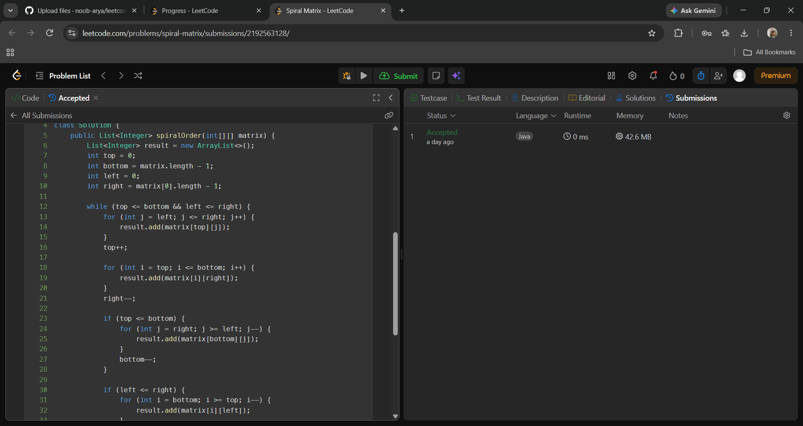
Solution Code (Java):
class Solution {
public List<Integer> spiralOrder(int[][] matrix) {
List<Integer> result = new ArrayList<>();
int top = 0;
int bottom = matrix.length - 1;
int left = 0;
int right = matrix[0].length - 1;
while (top <= bottom && left <= right) {
for (int j = left; j <= right; j++) {
result.add(matrix[top][j]);
}
top++;
for (int i = top; i <= bottom; i++) {
result.add(matrix[i][right]);
}
right--;
if (top <= bottom) {
for (int j = right; j >= left; j--) {
result.add(matrix[bottom][j]);
}
bottom--;
}
if (left <= right) {
for (int i = bottom; i >= top; i--) {
result.add(matrix[i][left]);
}
left++;
}
}
return result;
}
}

Q14. 73. Set Matrix Zeroes
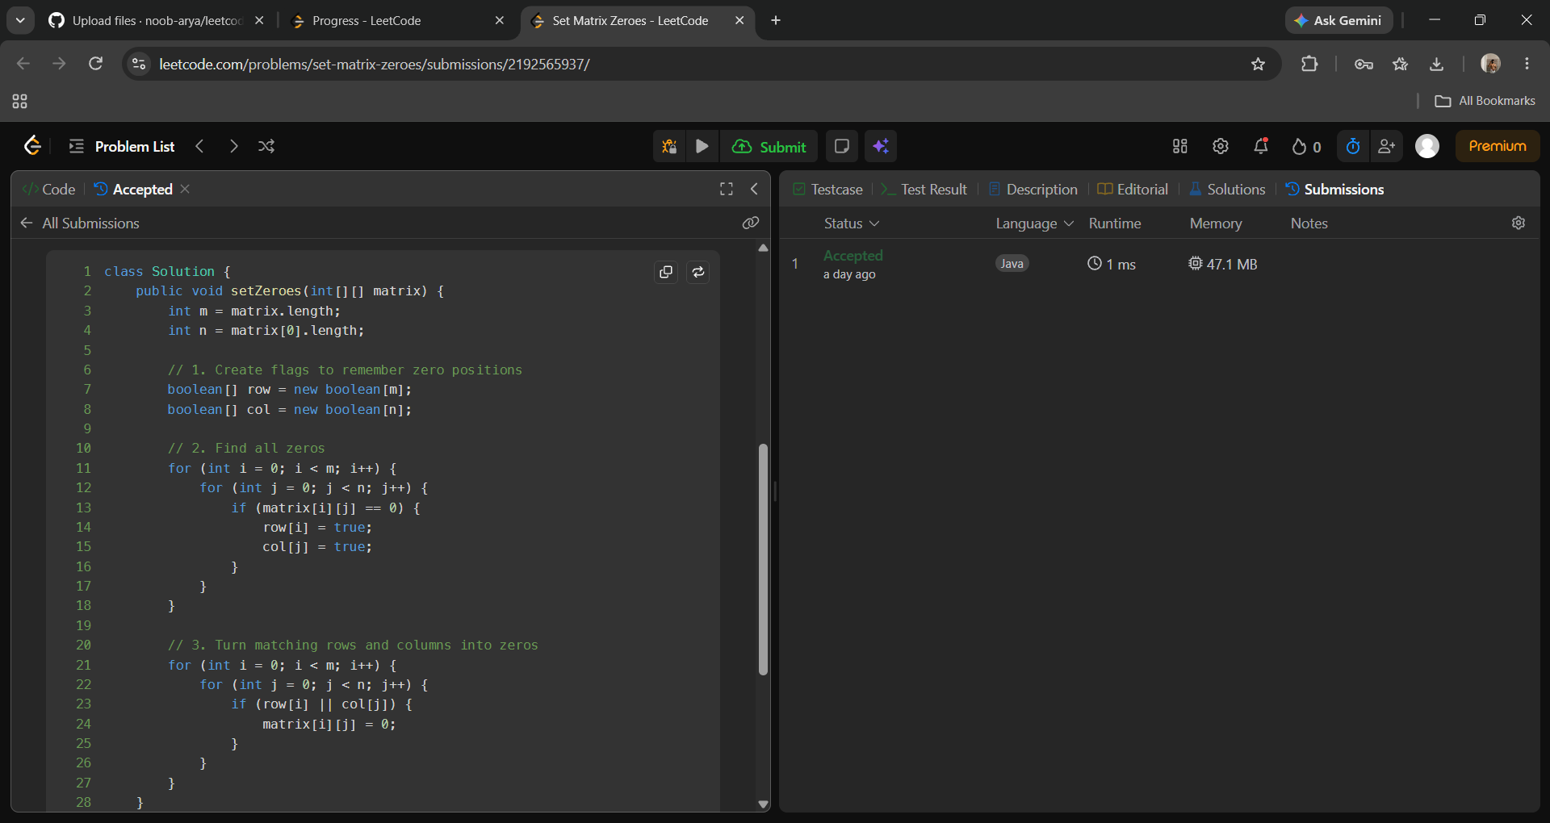
Solution Code (Java):
class Solution {
public void setZeroes(int[][] matrix) {
int m = matrix.length;
int n = matrix[0].length;
// 1. Create flags to remember zero positions
boolean[] row = new boolean[m];
boolean[] col = new boolean[n];
// 2. Find all zeros
for (int i = 0; i < m; i++) {
for (int j = 0; j < n; j++) {
if (matrix[i][j] == 0) {
row[i] = true;
col[j] = true;
}
}
}
// 3. Turn matching rows and columns into zeros
for (int i = 0; i < m; i++) {
for (int j = 0; j < n; j++) {
if (row[i] || col[j]) {
matrix[i][j] = 0;
}
}
}
}
}

Q15. 65. Valid Number
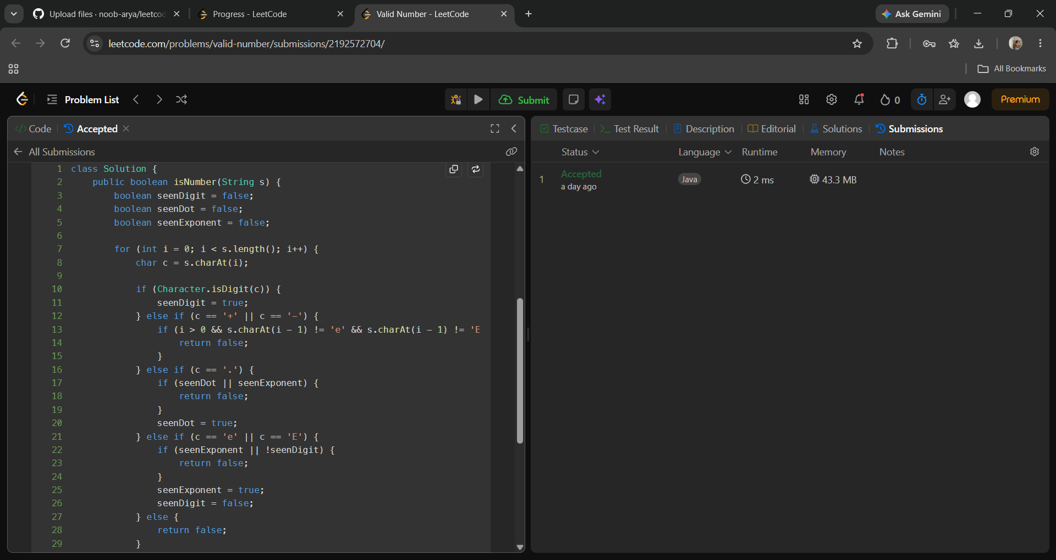
Solution Code (Java):
class Solution {
public boolean isNumber(String s) {
boolean seenDigit = false;
boolean seenDot = false;
boolean seenExponent = false;
for (int i = 0; i < s.length(); i++) {
char c = s.charAt(i);
if (Character.isDigit(c)) {
seenDigit = true;
} else if (c == '+' || c == '-') {
if (i > 0 && s.charAt(i - 1) != 'e' && s.charAt(i - 1) != 'E') {
return false;
}
} else if (c == '.') {
if (seenDot || seenExponent) {
return false;
}
seenDot = true;
} else if (c == 'e' || c == 'E') {
if (seenExponent || !seenDigit) {
return false;
}
seenExponent = true;
seenDigit = false;
} else {
return false;
}
}
return seenDigit;
}
}

Q16. 41. First Missing Positive
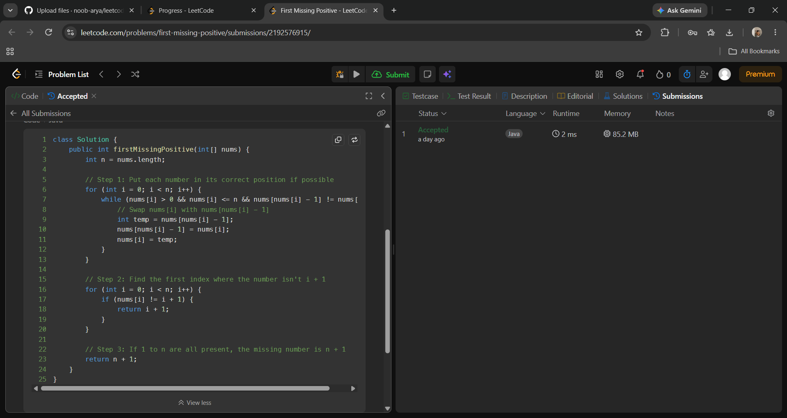
Solution Code (Java):
class Solution {
public int firstMissingPositive(int[] nums) {
int n = nums.length;
// Step 1: Put each number in its correct position if possible
for (int i = 0; i < n; i++) {
while (nums[i] > 0 && nums[i] <= n && nums[nums[i] - 1] != nums[i]) {
// Swap nums[i] with nums[nums[i] - 1]
int temp = nums[nums[i] - 1];
nums[nums[i] - 1] = nums[i];
nums[i] = temp;
}
}
// Step 2: Find the first index where the number isn't i + 1
for (int i = 0; i < n; i++) {
if (nums[i] != i + 1) {
return i + 1;
}
}
// Step 3: If 1 to n are all present, the missing number is n + 1
return n + 1;
}
}

