**Using Variable**

1. **What is variable?**

* A variable is simply a container to store value or information.
* All programs are built to process data, so variables are created to store those data.
* Commonly, PHP has two types of variables, scalar variable and array.

1. **Defining a variable**

* To create a variable, we simply use “$” sign and no need to specify data type.
* Below is an example.

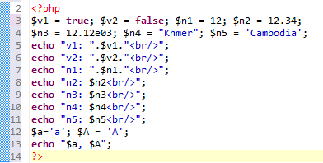

* Some rules to follow when creating a variable:
  + No special characters
  + No space
  + Cannot start by number
  + Cannot be number
  + Cannot $this
  + Can start with underscore
  + Should have a meaning full name

**Activity 1**

Create a simple PHP program to calculate your age by input born year. If your age is less than 20 years, its color should be blue. If your age between 20 and 30 years old, its color should be green. Otherwise, its color should be red.

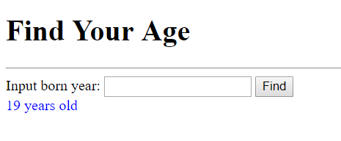

**Activity 2**

Create a simple PHP application to allow user input a URL and redirect to that URL. If the URL does not contain http or https, we need to add it. If user does not input any URL, show them the message “Please input a valid URL!” with red color.

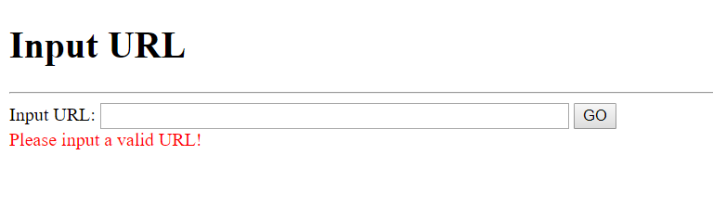

**Activity 3**

Let input production information as seen in form below and find its total after discount.

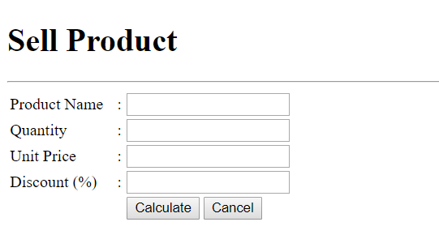

**Activity 4**

Write a simple PHP application to convert from one unit to another unit.

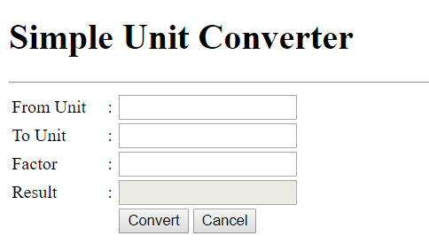

1. **Double quote and single quote**

* With double quote, you can use variable inside.
* With single quote, you cannot use variable inside, everything will be treated as string
* You cannot use constant inside double and single quote
* It is better to use a block “{ }” inside the quote

1. **Constant**

* Constant is like variable except that once it is created, its value cannot be changed or modified.
* Syntax:
  + define(“name”, value)
  + echo CONST_name;

**Activity 5**

Find the difference between two dates.

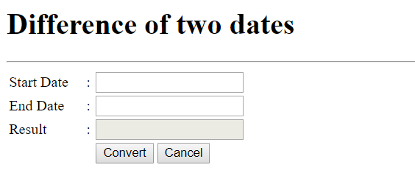

**Activity 6**

Write a simple PHP application to solve the following equation.

