

**WIA3002 ACADEMIC PROJECT I**

Faculty of Computer Science and Information Technology

Department of Artificial Intelligence

University of Malaya



**WeCare**

**Indoor Positioning Module**

Name : Ong Jia Aun

Matrix Number : WEA150022

Supervisor : Dr. Zati Hakim Binti Azizul Hasan

**Abstract**

With the most recent report released by United States Department of Labor, the Census of Fatal Occupational Injuries concludes that the construction industry ranks in the top four industries with the highest rate of fatal injuries [7], while in Malaysia, according a recent report by the Department of Occupational Safety and Health Administration (*OSHA*)1, the construction industry ranked number one [8]. Among the factors contributing to the high fatality rate are there is no way for a site supervisor to track a worker’s location and health status in real-time currently. This project aims to provide that solution to the industry by involving wearable devices to be worn by the worker, and a graphical user interface used by site supervisors to gain insight on the location and health status of the workers.

Indoor positioning has been a hot topic in the industry for some time as it has a lot of potential and needs in the current state of technology. One of the many application is to track people in a building. While plenty of research has been done on the topic, many involve complex hardware requirement to be able to gather sufficient data for processing. In this project, trilateration is put to the test as it requires one of the, if not the least amount of data.

_______________________________________________________________________________________________________________________________

1 Malaysia’s Department of Occupational Safety and Health Administration (OSHA) is a department under the Ministry of Human Resources, which is responsible for ensuring the safety, health and welfare of people at work as well as protecting the people from safety and health hazards arising from the activity sectors.

**Table of Contents**

Project Introduction 1

Problem Statements 2

Project Objectives 2

Project Modules Structure 2

Module Problem Statement 3

Module User Requirements 3

Module Objectives 3

Literature Review 4

1. What is an Indoor Positioning System? 4

2. Survey of Existing Indoor Positioning Techniques and System 4

2.1. GPS 4

2.2. Cellular based 5

2.3. WLAN 5

3. Techniques used by existing system 6

3.1. Triangulation technique 6

3.2. Fingerprinting technique 7

Research Methodology 8

System Analysis and Design 11

Technical Implementation 12

Conclusion 14

Industry Collaboration Initiative 15

References 17

# **Project Introduction**

Safety is defined by Oxford Dictionaries as “the condition of being protected from or unlikely to cause danger, risk, or injury”. However, it is near impossible to get away from being injured while at work no matter how small the injury might be [6]. According to Census of Fatal Occupational Injuries (CFOI), private construction industry is ranked first in number of fatal injuries, and fourth in fatal injury rates across all industry [7]. In Malaysia, the construction industry is ranked fourth in number of accidents and highest fatal injuries and fatal injury rate [8]. Yet, contractors, especially here in Malaysia, are lack of appropriate approach to comply with the Occupational Safety and Health Administration (OSHA) standard to ensure their worker’s safety in the site.

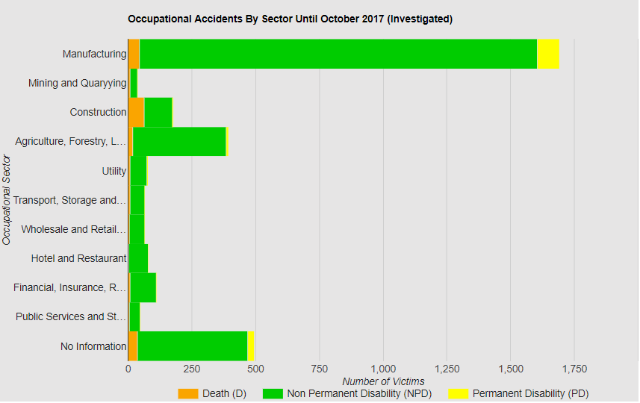

Figure 1 Graph provided by OSHA

Besides that, there is an obvious lack of immediate two-way communication between site supervisors and the workers. This is crucial and felt when there is an accident happen at the construction site. Sometimes, the difference of a few seconds is life or dead matter. Being able to send out SOS signal to site supervisor when accident occurs will enable the supervisor to react faster and more efficient.

In recent years, with the rise of Internet of Things, there have been many new proposed solutions in the market. Among these solutions comes a common theme, to be able to track user location and be able to have a source of health indicator of the user. WeCare is in the vein of this theme. WeCare aims to provide the solution for an organization to monitor the safety of its members or staffs while being a cost-effective and robust system.

# **Problem Statements**

Construction site workers, especially in Malaysia, usually does not comply to the OSHA standard of equipment requirement. This is very dangerous as it increases the rate of injury significantly. With buildings getting taller and bigger, so do construction sites. Site supervisors are having a hard time to determine where a worker might be at a given time. Thus, it might be hard for the supervisors to react on time when an accident occurs.

Current market trend indicates that the worker health status and location is important to keep track as it provides some indicator to an accident might occur.

# **Project Objectives**

The main objectives of the project are:

* To be able to monitor the heart conditions of the workers in real time.
* To be able to track the locations of the workers in real time.
* To enable two-way communication between the site supervisors and workers.

# **Project Modules Structure**

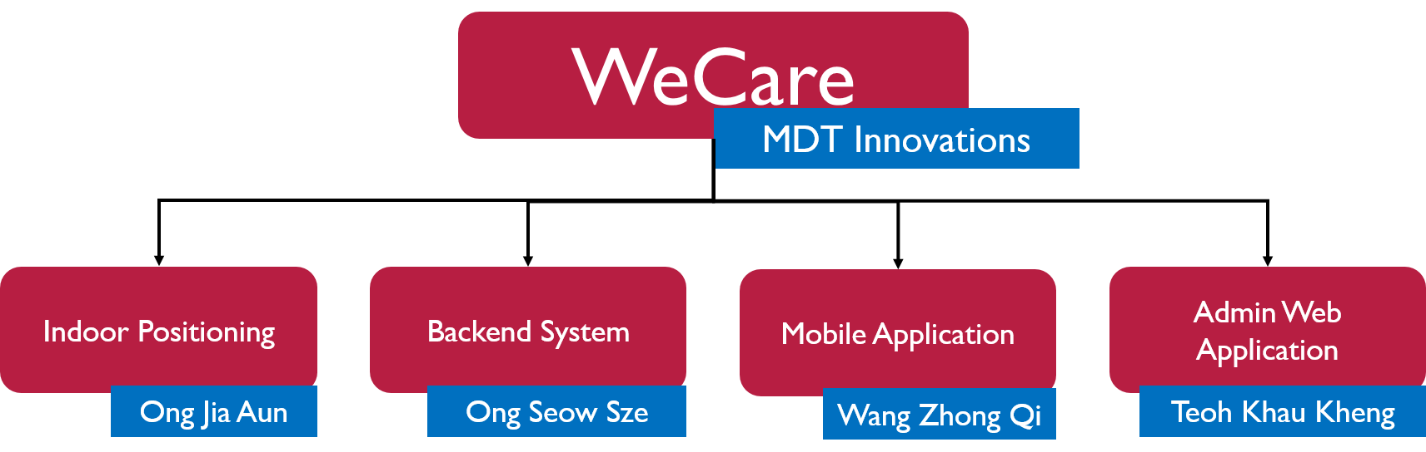

As an Innovative Product Project Initiative Final Year Project, the project is breakdown into four modules with a team member helming a module each. This paper discussing the indoor positioning module specifically.

# **Module Problem Statement**

The wearable device that is using for the project provides three important positioning data:

* Global Positioning System (GPS)
* Cellular tower (Cell tower)
* Wi-Fi access points

However, the only ready-to-use data for positioning is GPS. For cell tower and Wi-Fi data, additional processing is required to be able to get any meaningful information. Besides that, solely relying on GPS is not feasible as GPS module in the device might fail.

# **Module User Requirements**

The module-specific user requirements are:

* To be able to provide a usable positioning data in indoor environment
* To provide more than one way for positioning at outdoor environment

# **Module Objectives**

The module-specific objectives are:

* To come up with an indoor positioning system using the data provided from the device.
* To be able to switch between using GPS and the indoor positioning system when in outdoor or indoor environment

# **Literature Review**

## **What is an Indoor Positioning System?**

An indoor positioning system (IPS) is a system that only concern about the indoor environment, such as the inside of a building [5]. Dempsey [10] defines it as a system that able to determine the position of something or someone in real-time continuously in a physical space. As such, IPS should be able to work all the time with a reasonable accuracy and delay between each updated position within a specific area.

## **Survey of Existing Indoor Positioning Techniques and System**

As the IoT industry soars with all the new flashy techs, indoor positioning systems have become increasingly popular over the years. Many of such systems have been implemented in various applications such as asset tracking and inventory management system for huge warehouses where items tend to be misplaced or hard to find. There are several different approaches to indoor positioning system using different technologies in the market, but we will only look into the following few as it is the only available data from the hardware device to be used in the project.

### **GPS**

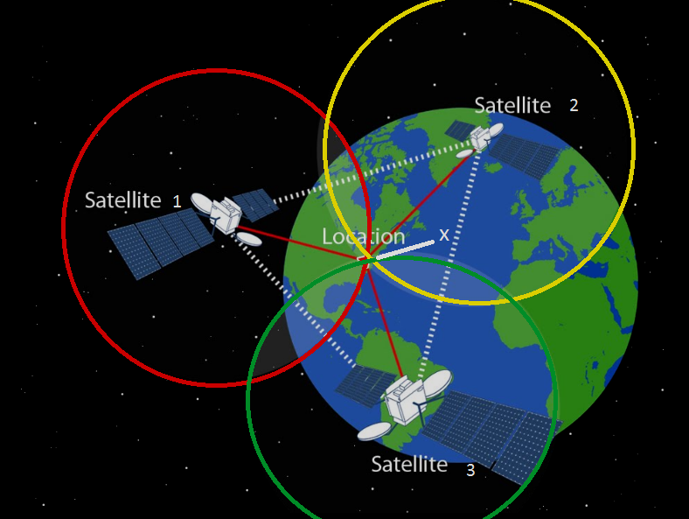

Figure 2 How does GPS work

The most widely used positioning system is the appropriately named Global Positioning System (GPS) developed by United States, and its Russian counterpart, Globalnaya Navigatsionnaya Sputnitkovaya Sistema (GLONASS). As anyone who has ever used Google Map or Waze or Apple Map to navigate through the streets, GPS is an essential, robust and proven system in determining one’s location in the globe. It is a satellite-based system, in which the device receiver attempts to connect to at least four satellites to gain an accurate or valid location. However, the coverage of satellite signals dramatically reduces when in indoor environment, and thus its accuracy [1]. This makes it unsuitable for indoor location estimation. To overcome this limitation, SnapTrack, a Qualcomm company, pioneered wireless assisted GPS (A-GPS).

### **Cellular based**

A cell tower, or a Base Transceiver Station (BTS) is a site where antenna and electronic communication equipment are installed, serving as a cell in a cellular network. In layman’s term, a cell tower works to receive and transmit radio-frequency signals from a cell phone to another. With the availability of cell tower data, GPS system can get a faster fix on the satellite signals [2], by the means of A-GPS. Cellular based positioning can yield between 50m to 200m of accuracy [3]. The accuracy is generally higher in urban places where there are many cell towers in close proximity of each other [1].

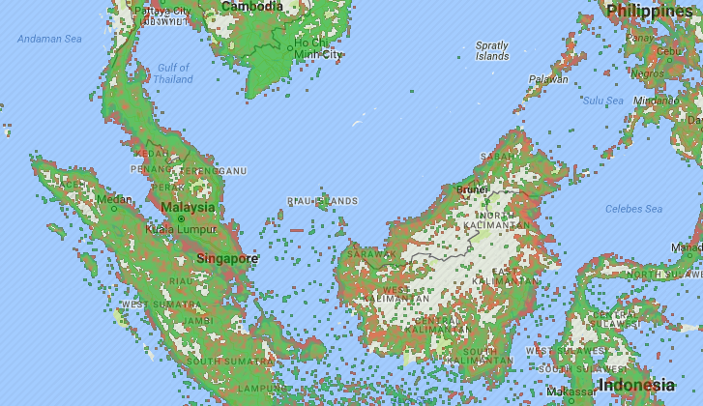

Figure 3 Cell tower coverage of Malaysia taken from OpenSignal.com

### **WLAN**

With the rise of internet connectivity, Wi-Fi access points (AP) began dotting the face of the earth. The idea of positioning using Wi-Fi AP becomes less of an idea, and more of a solution. WLAN based indoor positioning system has a higher accuracy of around 3 to 30 meters [1,5]. Microsoft’s RADAR is once such system that utilizes WLAN data for positioning, with an accuracy of 2 to 3 meters.

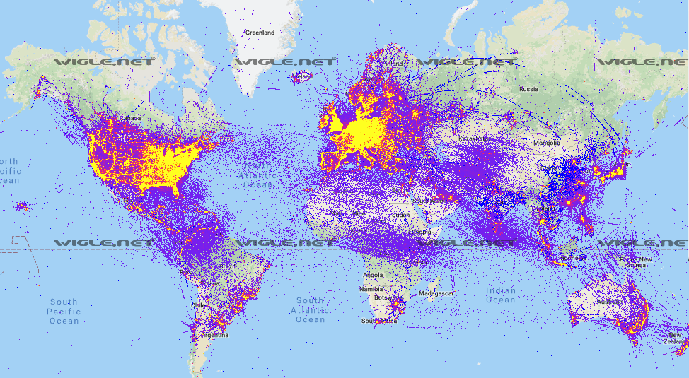

Figure 4 Wi-Fi access points heatmap taken from Wigle.net

## **Techniques used by existing system**

### **Triangulation technique**

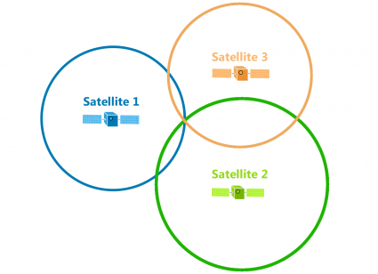

Figure 5 Triangulation example

There are a multitude of positioning algorithm today in practice, with triangulation being the most prominent of all. Triangulation, as the name suggests, is related to trigonometry, basing on the geometric properties of triangles and angles to estimate location. Triangulation can be further derived into two distinct techniques, lateration and angulation [1]. Lateration (trilateration) technique refers to the estimation of location by measuring its distance from multiple reference points. By calculating the intersection point of the RSSI circle around each reference points, the location of a device can be estimated. On the other hand, angulation (triangulation) technique takes into account the angle of relative reference points for more precise estimation while requiring less reference points. However, triangulation comes with a higher cost and more complex hardware requirements.

### **Fingerprinting technique**

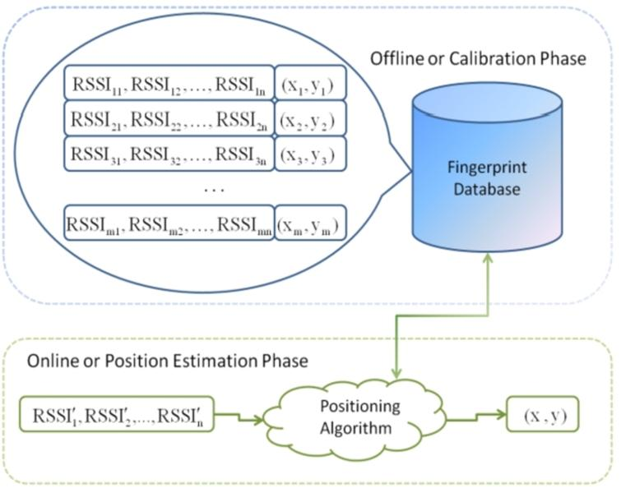

Figure 6 Fingerprinting example

Another positioning algorithm used is the scene analysis technique [1]. Scene analysis is a type of algorithm that builds databases of fingerprints (features) of a scene then subsequently estimates the location of an object by matching the stored fingerprints. There are two stages in location fingerprinting, the offline stage and the online (run-time) stage. During the offline stage, a site survey is performed in the environment to gather location coordinate and its RSSI of nearby cell tower/Wi-Fi AP. The data is then stored in a database as fingerprints. The online stage is simply the running stage where device location is determined based on the fingerprints in the database.

One glaring limitation of such technique is that any changes to the environment will affect the fingerprints in the database [11]. This is due to the fact that the fingerprints are statically stored in database, and RSSI is affected by anything that might block, reflect, diffract or scatter it. Hence, even a simple action of removing a furniture from the room, might affect the fingerprint’s accuracy, requiring an update to correct the fingerprint.

# **Research Methodology**

The project consists of a wearable device manufactured in China.

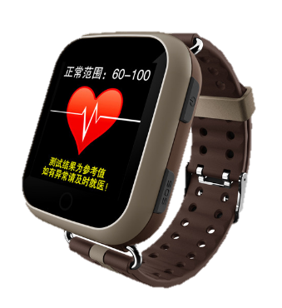

**ON/OFF Button**

* Long press (3s): Power on/off device
* Short press (1s): Turn on/off display

**SOS Button**

* Long press (3s): Send SOS signal to server
* Short press (1s): Heart rate interface

**Screen Display**

* GSM + WiFi Signal
* Battery level indicator
* Date
* Time
* Heart rate

Figure 7 Wearable device functions

The device itself connects to a server TCP socket using mobile SIM data. At a settable period, the device will send a position data packet to the socket connected.

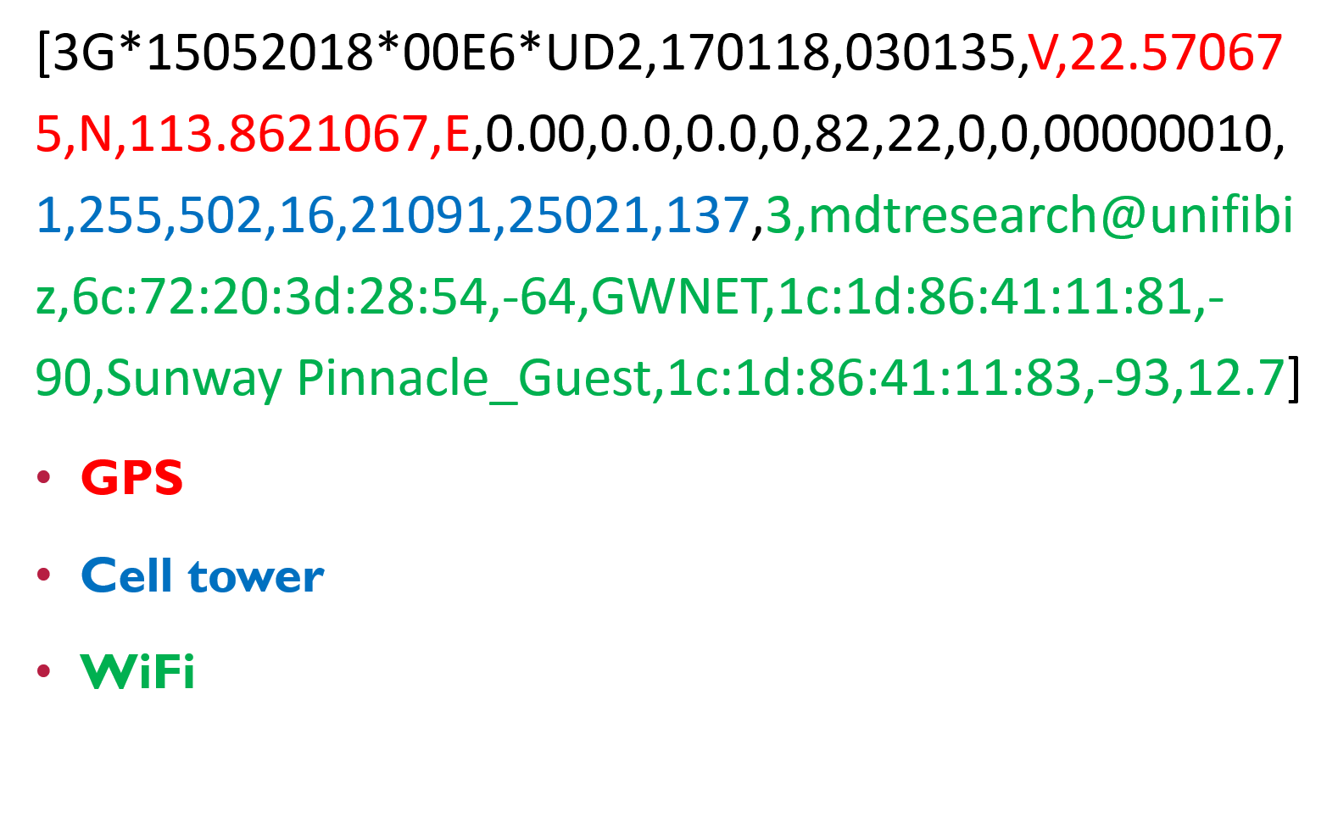

Figure 8 Raw data packet

For GPS data, as highlighted in red, the data received can be used as it is, given that the device transmit latitude and longitude already. However, for the cell tower data and Wi-Fi access points data, as highlighted in blue and green respectively, some processing of data is needed to extract any meaningful information from it. For cell tower data, data transmitted from the device includes MCC, MNC, cell tower area code, cell tower ID and RSSI for each detected cell tower, whereas for Wi-Fi data, data transmitted from the device includes Service Set Identified (SSID), Basic SSID (BSSID) or MAC address and RSSI for each detected Wi-Fi access points.

After reviewing a few research papers, it is decided that the best way to proceed with the indoor positioning is to use a trilateration algorithm. This is due the device being only able to transmit RSSI data for both cell tower and Wi-Fi.

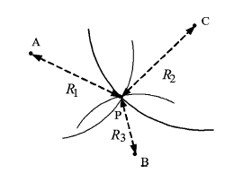

Figure 9 Trilateration

Let the we have 3 points {A, B, C} as input and target being {P} as shown in figure 3.

Using the equation , which is the equation of a right-angle triangle, we get



From (1), we can assume that the R of each points as the hypotenuse, we get that

And by rearranging we get that

From (3), we can apply to the reference points,

By equating the equations (4) and (5), we get

By equating the equations (5) and (6), we get

Since all the values for he equations (7) and (8) is known, except for the only two unknowns , the equation can be solved by substituting the equations with each other to get the values.

By using the above equations, the coordinate or position of a device can be located [4]. The same algorithm can be used for cell tower positioning and Wi-Fi AP positioning.

For cell tower database, there are a few online sources that can be found. Alexandar Mylnikov’s cell tower database is used for the project as the database provided is amalgamation of several online database into one [9]. It contains of more than 60 million rows of data as of now.

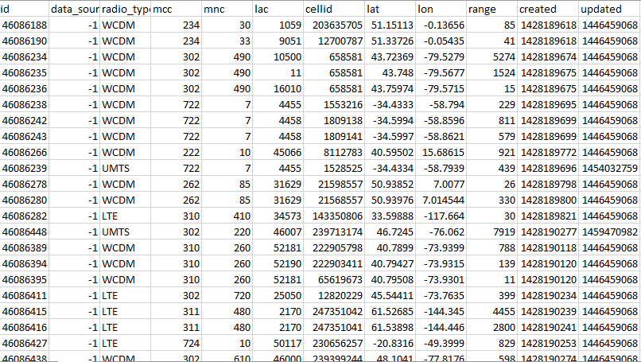

Figure 10 Snippet of the downloaded database

However, the database downloaded is in the format of .csv, hence additional work is required to transform the csv database into a SQL database. The reason for the need of SQL database is that query using SQL is way faster than reading through an entire file. SQLite3 is chosen as the database as it is natively available in PHP and is known for being lightweight.

# **System Analysis and Design**

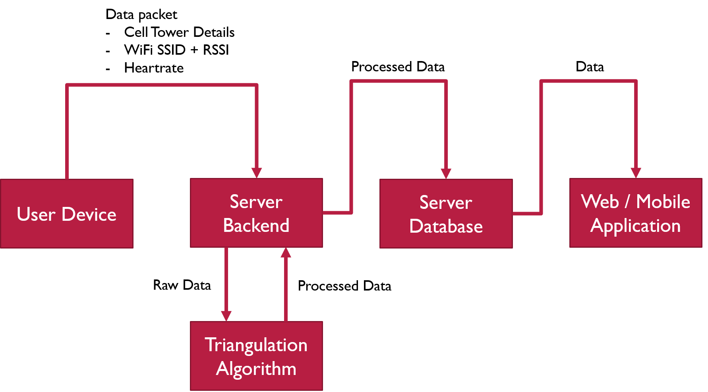

Figure 11 Data flow in the system

The system work as a whole with a wearable device connected to the server backend. In the server backend, data packets from the device will be interpreted and pass to this module for indoor positioning before injecting into server database. Site supervisor will then access the data from a web application or mobile application.

On this particular module, the algorithm will coexist with the server backend in the server itself. The algorithm will be run by the server backend when a new data packet is received from a wearable to device to determine its location and then pass back to the server backend to inject into database. This module can be separated into algorithm and database, where the database containing position of cell tower and Wi-Fi will be queried by the algorithm during calculation to output appropriate location.

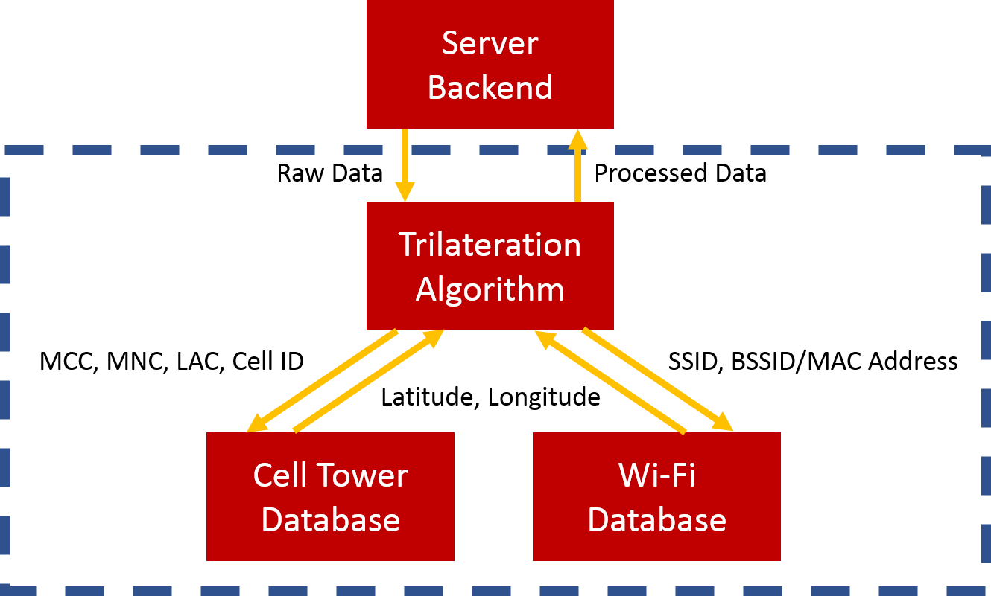

Figure 12 Module structure

# **Technical Implementation**

The proposed solution is work with the available but limited data gather from the device data packet. Due the severe limitations, trilateration algorithm is the way to go for implementing indoor positioning.

The programming language used for the implementation of the algorithms is PHP. This is to facilitate the integration of modules because that the algorithm is going to be running with the server backend, which is written in PHP.

With cell tower database, it can be acquired from free online open source, which is roughly 6 to 7 GB worth of data in csv format. SQLite3 database is chosen for the conversion of csv file as it is super lightweight and is readily available as native extension for PHP. Using a database speeds up query time exponentially, from roughly 5 seconds to read the csv file to less than 0.01 second. As for Wi-Fi database, it has to be manually input by user as not all Wi-Fi access points (AP) is stored in open source database.

With database ready, trilateration algorithm can be implemented and tested. For quick deployment, a simple basic trilateration algorithm is used [Figure 2].

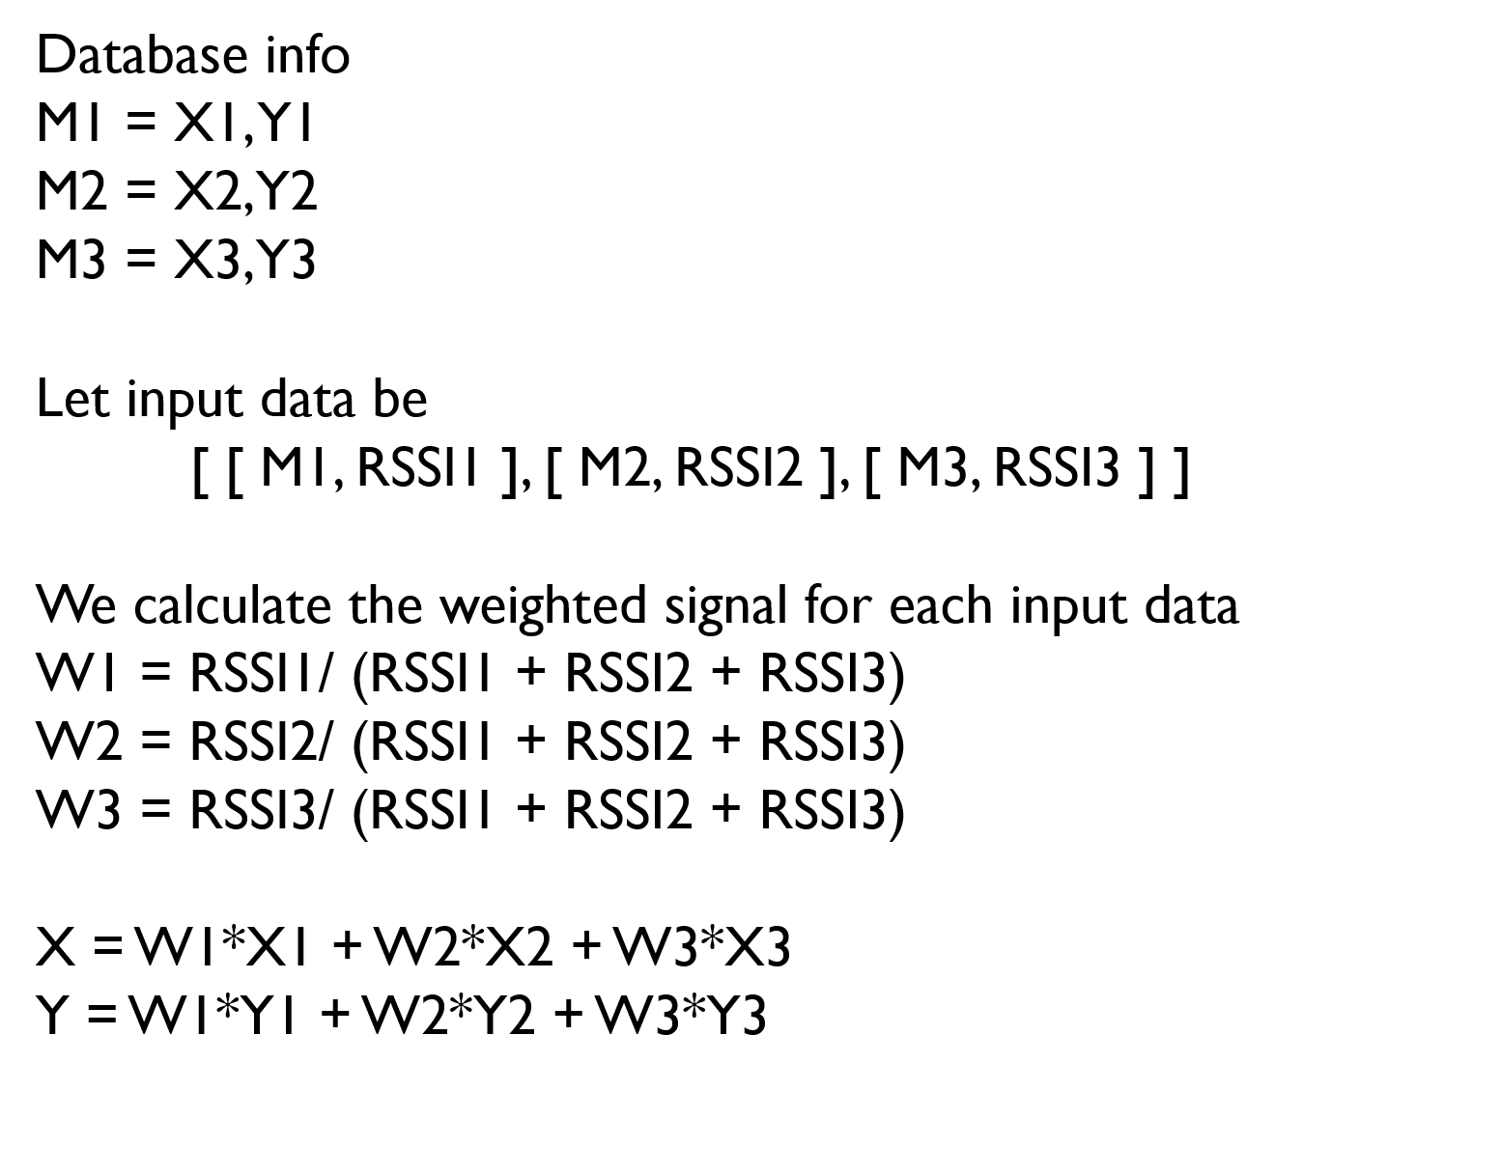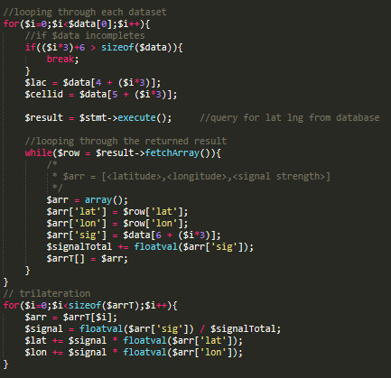

Figure 13 Pseudocode and Implemented Code

Several thousand data packets are gathered from the device from the server backend module logs. The algorithm is tested against the data packets to see if the algorithm works well against the unstable and moving wearable device in a vehicle as well as in indoor environment. The sample data packets are from a device moving along the Lebuhraya Damansara-Puchong (LDP), in MDT office at Sunway Pinnacle, and in an apartment unit at Lily and Rose Apartment, SS26.

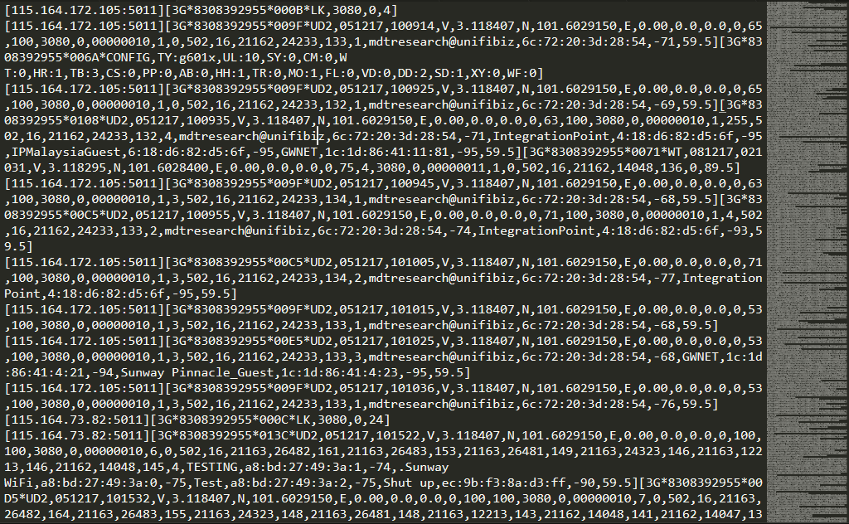

Figure 14 Snippet of data samples

After data pre-processing, the cell tower data is extracted for each data packet.

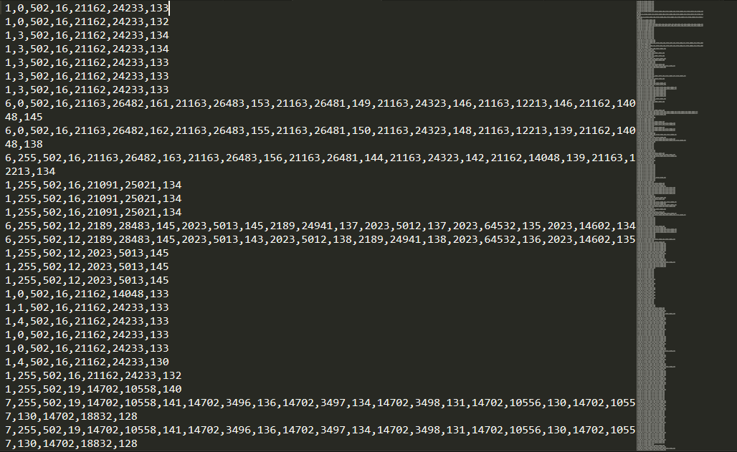

Figure 15 Cell tower data extracted

The extracted data is now ready to be use for testing. A total of 4431 data samples are extracted. After running through the algorithm, 3177 coordinates are acquired. The missing coordinates are due to insufficient cell tower detected, of which at least three cell tower is needed for calculation.

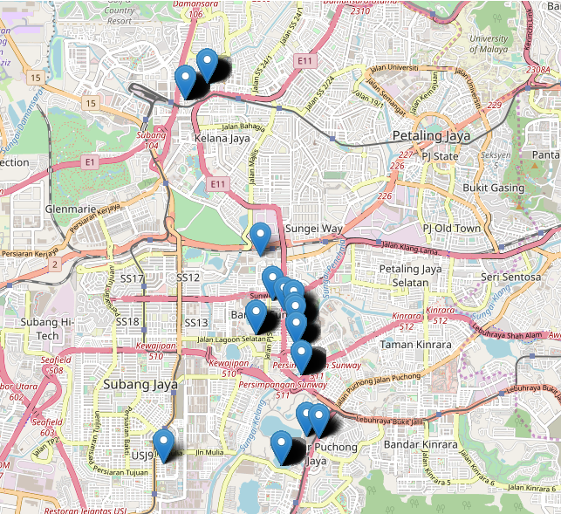

Figure 16 Testing on sample data packets

As shown in Figure 8, the algorithm provides promising result on indoor positioning using cell tower data. The plotted location deviates from the actual location, noticeably a few stray markers on the lower left corner on the map, but it is normal and acceptable as cell tower trilateration has an accuracy of at best 50 meters.

# **Conclusion**

Indoor positioning is a prominent research field at the moment as it provides a better navigation experience. With a lot of research going on in this, a robust indoor positioning in the near future is very promising.

With the current state of this project, the future work will be to benchmark its accuracy and research more ways to increase its accuracy. The problem with some outliers with the result is due to the hardware limitation, which there is nothing much can be done. There is also another factor of the limitation of cell tower positioning, where its accuracy at best is 50 meters. Wi-Fi positioning will be a better solution for indoor positioning as 50 meters accuracy at best is not very good when taking into account that 50 meters can be a position in another building across the street.

# **Industry Collaboration Initiative**

Formal collaboration with the industry has been done with Multimedia Display Technologies (MDT) Innovations Sdn. Bhd. MDT Innovations Sdn. Bhd. specializes in Internet-of-Things as well as proprietary RFID technologies. In recent years, they are venturing into personnel tracking systems.



Figure 17 Collaboration initiative with MDT Innovations

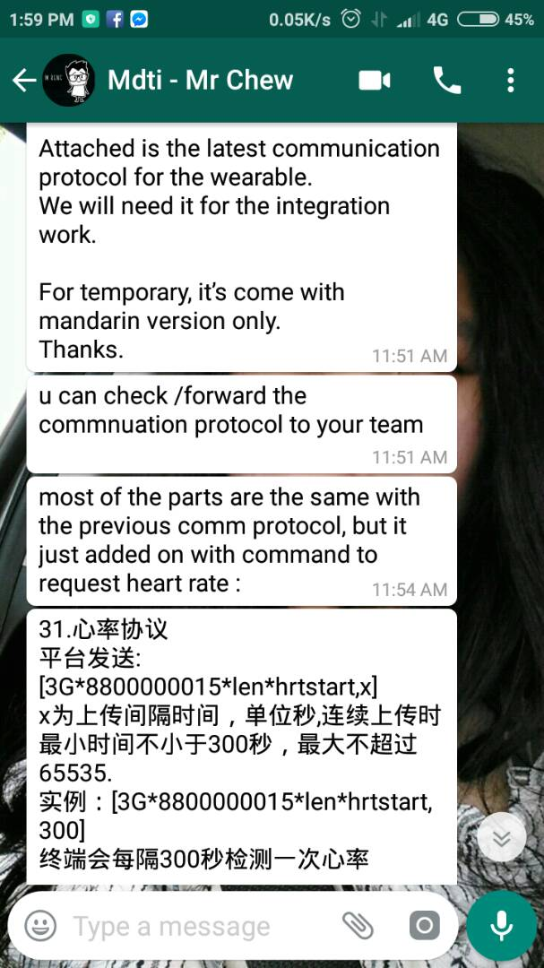

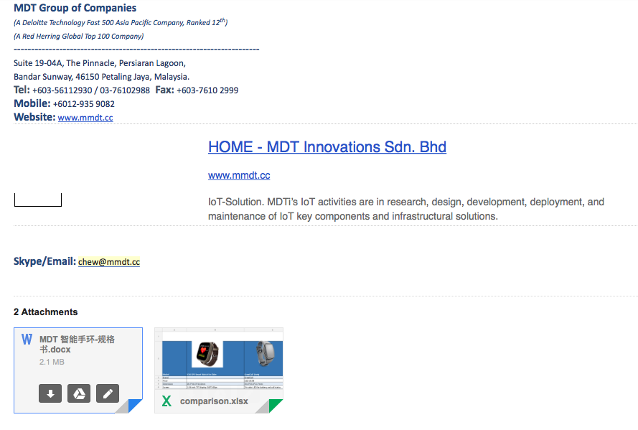

Figure 18 Communications with the Person In Charge



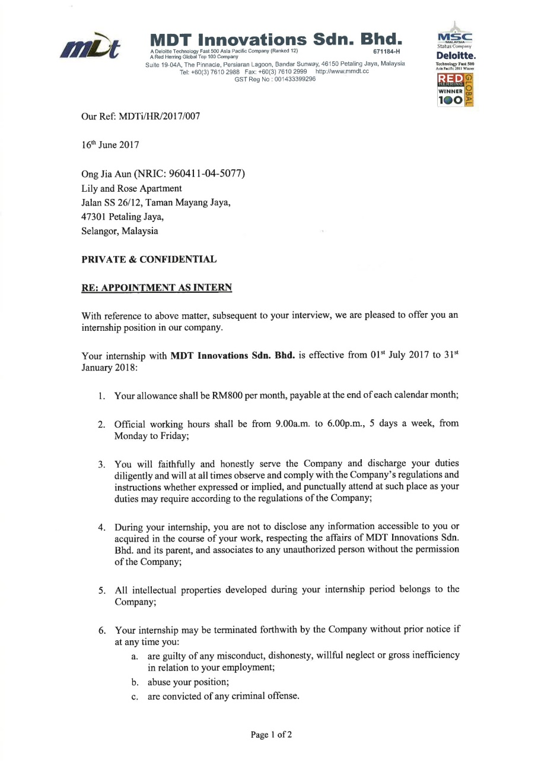

Figure 19 Internship offer at the collaborator's company

# **References**

1. Liu, H., Darabi, H., Banerjee, P., & Liu, J. (2007). Survey of wireless indoor positioning techniques and systems. *IEEE Transactions on Systems, Man, and Cybernetics, Part C (Applications and Reviews)*, *37*(6), 1067-1080.
2. Dedes, G., & Dempster, A. G. (2005, September). Indoor GPS positioning-challenges and opportunities. In *Vehicular Technology Conference, 2005. VTC-2005-Fall. 2005 IEEE 62nd* (Vol. 1, pp. 412-415). IEEE.
3. Yang, J., Varshavsky, A., Liu, H., Chen, Y., & Gruteser, M. (2010, September). Accuracy characterization of cell tower localization. In *Proceedings of the 12th ACM international conference on Ubiquitous computing* (pp. 223-226). ACM.
4. Rida, M. E., Liu, F., Jadi, Y., Algawhari, A. A. A., & Askourih, A. (2015, April). Indoor location position based on bluetooth signal strength. In *Information Science and Control Engineering (ICISCE), 2015 2nd International Conference on*(pp. 769-773). IEEE.
5. Gu, Y., Lo, A., & Niemegeers, I. (2009). A survey of indoor positioning systems for wireless personal networks. *IEEE Communications surveys & tutorials*, *11*(1), 13-32.
6. Hazardous Work (Occupational Safety and Health). (2018). Retrieved from http://www.ilo.org/safework/areasofwork/hazardous-work/lang--en/index.htm
7. Census of Fatal Occupational Injuries (CFOI) - Current and Revised Data. (2018). Retrieved from https://www.bls.gov/iif/oshcfoi1.htm
8. Idris, N. (2018). Website Department of Occupational Safety and Health Malaysia - By Sector. Retrieved from http://www.dosh.gov.my/index.php/en/occupational-accident-statistics/by-sector
9. Public mobile cells position database. Geo-Location API « Alexander Mylnikov. (2018). Retrieved from https://www.mylnikov.org/archives/1059
10. Depsey, M. (2003). Indoor positioning systems in healthcare. *Radianse Inc., White Paper*, *123*.
11. Xia, S., Liu, Y., Yuan, G., Zhu, M., & Wang, Z. (2017). Indoor fingerprint positioning based on Wi-Fi: an overview. *ISPRS International Journal of Geo-Information*, *6*(5), 135.