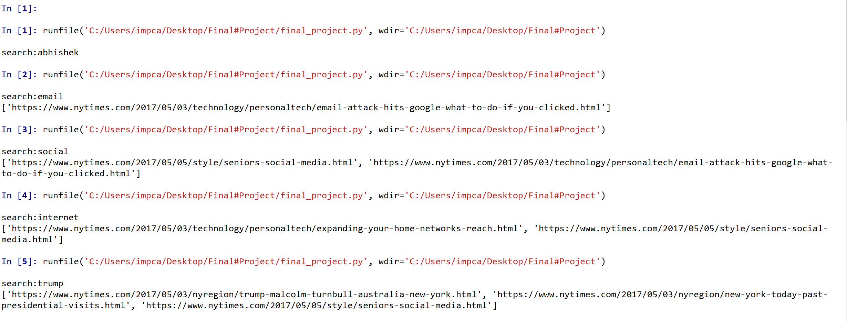

Search

1 abhishek (no match)

2 email (1 match)

3 social(2 matches)

4 internet(2 matches)

5 trump(3 matches)