E-Wallet

This Project contain two independent Spring Boot Applications. They are UserService & WalletService

**UserService**:

"UserService" is a Spring Boot JPA application that stores user information. We have used MySql Databse.

This project contain UserResource class that containa API of User. We have used Swagger for API documentation.

<http://localhost:9011/swagger-ui.html#/>

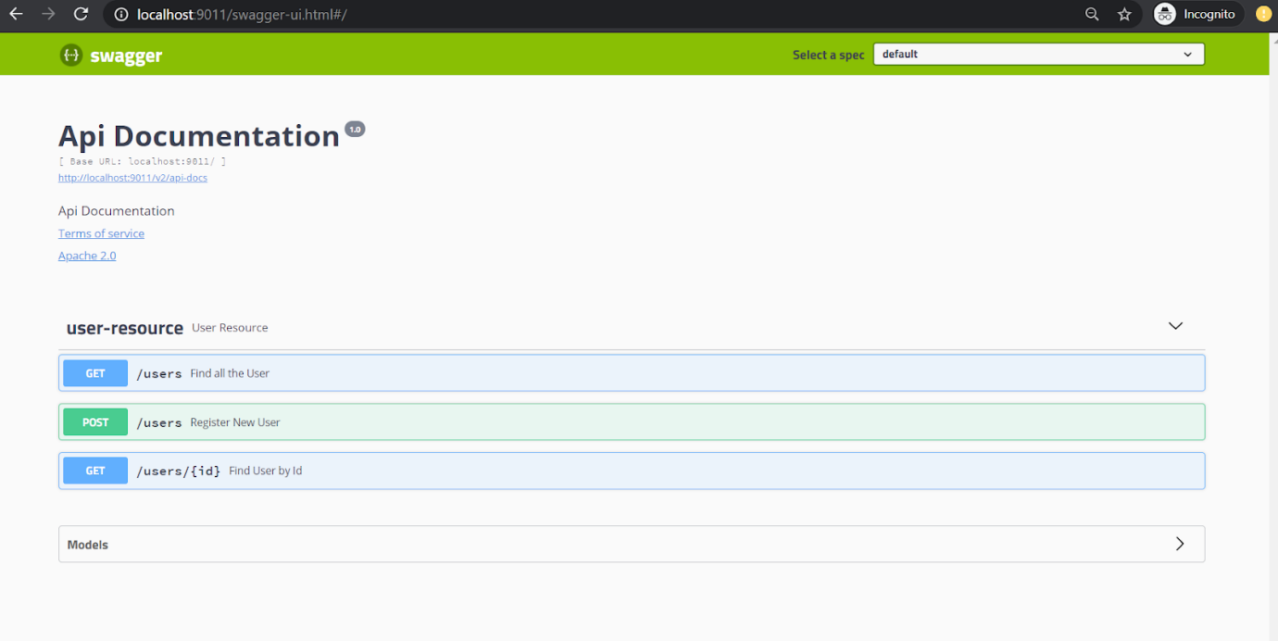

Database Name: e_wallet2

Table: User

**WalletService**

"WalletService" is a Spring Boot JPA application that stores user wallet information. We have used MySql and Redis database. We have used Kafka for messaging queue.

***TransactionResource***class contain Api's of transaction like sendMoney, getBalance etc.

***WalletResource*** class contain Api's related to Wallet like createNewWallet, updateWallet etc.

***WalletDaoRedis*** class store id and balance of a user in Redis.

***UserService*** class intracts with the "UserService" Spring Boot JPA application via resttemplate.

**EmailService** class is responsible for sending email to a user for its transaction history.

***Consumer*** class is automatically call when we push data into Kafka. It is basically KafkaListener.

We have used Swagger for API documentation.

[http://localhost:9022/swagger-ui.html#](http://localhost:9022/swagger-ui.html)

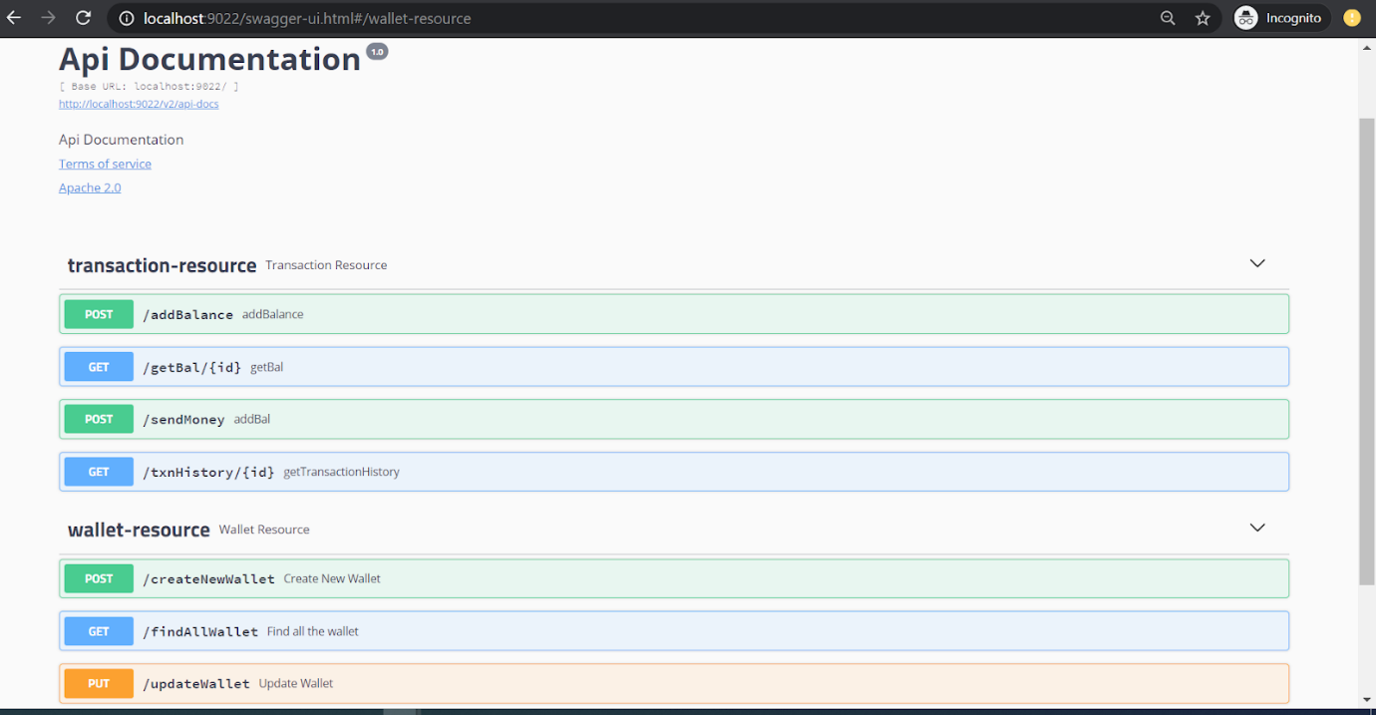

**Database:** e_wallet

**Tables**:    transaction, wallet

**Email**::

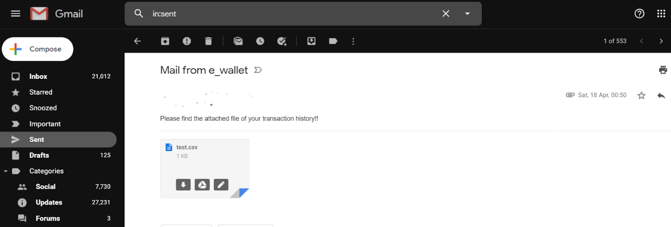

 Attachement::

This file contain transaction history.

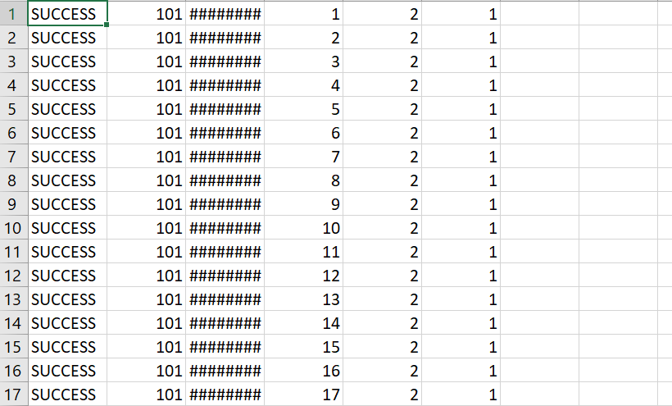

**Steps to run the Project:**

1.Start the redis server.

2.Start the zookeeper

 Go to the path D:\jdbl\kafka_2.12-2.1.0\kafka_2.12-2.1.0\bin\windows>

And run the command

Zookeeper-server-start.bat D:\jdbl\kafka_2.12-2.1.0\kafka_2.12-2.1.0\config\zookeeper.properties

4. Start the kafka server

Go to the path D:\jdbl\kafka_2.12-2.1.0\kafka_2.12-2.1.0\bin\windows

And run the command

kafka-server-start.bat D:\jdbl\kafka_2.12-2.1.0\kafka_2.12-2.1.0\config\server.properties

5. Create  the topic:

           Go to the path D:\jdbl\kafka_2.12-2.1.0\kafka_2.12-2.1.0\bin\windows

And run the command

kafka-topics.bat --create --zookeeper localhost:2181 --replication-factor 1 --partitions 1 --topic test

6. Run the WalletService and UserService.

To check data is stored in Redis

hgetall wallet