A SOFTWARE ENGINEERING PROJECT REPORT

LOOP .
AI-Powered Multi-Tenant Customer Intelligence & Telemetry Analytics Platform



SUBMITTED BY: | Ashu (Developer)
GUIDED BY: | Academic Advisor / Internship Evaluator
DEPARTMENT: | Department of Computer Science & Engineering
COLLEGE NAME: | FACULTY OF ENGINEERING AND TECHNOLOGY
SUBMISSION DATE: JULY 2026

Table of Contents
Note to Reviewer: The table of contents below is a standard MS Word dynamic field. Open the document in Microsoft Word, right-click on the block below, and select 'Update Field' to automatically compile all section page numbers.

1.0 Project Overview
The software market has witnessed an exponential growth in the volume of user reviews, incident alerts, system logs, and general product feedback. For modern product engineering organizations, this information flows constantly from multiple sources such as web widget forms, customer support emails, webhook integrations, and spreadsheet files. Synthesizing this multi-layered telemetry into strategic product modifications is a key challenge. LOOP is designed to address this problem by acting as a real-time customer feedback intelligence platform that automatically ingests signals, groups them into classified clusters, and allows analysts to query the datasets using natural language.
1.1 Problem Statement
Traditional analytics suites partition customer feedback from technical alert logs. This separation isolates the context of product errors. When an error occurs on a pricing page, user frustration appears as an angry review on a public portal, whereas the server error is logged anonymously in an unrelated monitoring tool. LOOP integrates these channels into a single unified telemetry flow, letting operators inspect customer feedback, automatically correlate sentiment spikes, and query LLM models with specific data context.
1.2 Objectives
The core goals of the LOOP development lifecycle include:
1. Multi-Tenant Tenancy Isolation: To design a secure database layout where companies can register isolated workspaces, keeping their data locked from other organizations.
2. Role-Based Access Controls (RBAC): To ensure proper user governance by establishing ADMIN, ANALYST, and VIEWER tiers.
3. Conversational AI Integration: To build an interactive chat portal powered by NVIDIA NIM endpoints to summarize trends.
4. Seamless Ingestion Pipeline: To provide widgets and HTTP APIs to receive customer feedback safely from external client applications.
1.3 Target Audience & Stakeholders
LOOP is engineered primarily for three core business cohorts:
• Product Managers (PMs): Who need to discover the most requested features (e.g. Dark Mode) and track sentiment changes across quarters.
• Software Engineers & Analysts: Who need to analyze telemetry reports and build quick automated drafts for customer replies.
• System Administrators: Who govern workspace membership, invite teammates, and restrict critical operations.

2.0 Introduction
Customer intelligence has evolved beyond simple star ratings. Modern platforms need to process natural language feedback, extract underlying topics, and determine sentiment context in real time. The motivation behind LOOP is to construct a continuous intelligence portal where telemetry data is read, processed, and categorized instantaneously.
2.1 Academic and Telemetric Relevance
From a software engineering perspective, the implementation of LOOP highlights several core patterns: Row-Level Security (RLS) on PostgreSQL, Security Definer design guidelines for database procedures, and serverless proxy routes in Next.js to preserve client secrets. It acts as a study of secure SaaS partitioning, avoiding typical issues like policy recursion while supporting anonymous public submissions.
3.0 Technology Stack
To satisfy the design aesthetic of a high-end SaaS product and maintain complete database safety, we selected a modern, modular technology stack:
- React 19 & Vite 8: The client-side interface is built on React 19, allowing state-driven rendering and hooks. Vite 8 is used as a fast, optimized bundler with custom dev server configurations for Nvidia API proxy rewrites.
- Next.js 15 (App Router): Serves as the server-side API proxy layer. All mutations and fetches query the database through Next.js proxy endpoints, preventing browser exposure of backend credentials and verifying client tokens.
- Supabase (PostgreSQL): Supplies relational table storage, real-time trigger pipelines, and user authentication. tenancy rules are enforced database-wide through Row Level Security (RLS) policies.
- NVIDIA NIM API (DeepSeek-V4): NVIDIA's inference API handles conversational processing and feedback categorization, running deepseek-ai/deepseek-v4-flash for reasoning throughput.
- Framer Motion & GSAP 3: Powers UI micro-interactions, loading indicators, custom modals, and cinematic panned timelines on the simulator page.
- PostgreSQL Triggers & RPCs: Handles background database operations, such as auto-provisioning workspaces on signup and secure anonymous ingestion bypasses.

4.0 System Architecture & Data Flow
The LOOP application is built on a split-level, proxy-driven security model. The frontend application makes calls directly to Next.js API endpoints, which extract user identity tokens and execute scoped PostgreSQL calls to Supabase. This prevents direct browser-to-database queries for sensitive data, ensuring consistent audit logs and role verification.
┌──────────────────────────────────────────────────────────────┐
│ FRONTEND WEB PORTAL │
│ React 19 + AuthContext Session Tokens │
└──────────────────────────────┬───────────────────────────────┘
│ HTTP Requests + Bearer JWT
┌──────────────────────────────▼───────────────────────────────┐
│ NEXT.JS SERVERLESS PROXY │
│ Extracts JWT, Verifies RBAC, Signs Client │
└──────────────────────────────┬───────────────────────────────┘
│ Client Config with Auth Headers
┌──────────────────────────────▼───────────────────────────────┐
│ SUPABASE DATABASE LAYER │
│ RLS policies, Security Definers, get_user_workspaces() │
└──────────────────────────────┬───────────────────────────────┘
│ Internal Function Triggers
┌──────────────────────────────▼───────────────────────────────┐
│ NVIDIA NIM AI CORE │
│ DeepSeek-V4 Sentiment & Theme Classification │
└──────────────────────────────────────────────────────────────┘
Diagram 1: System Architecture and Tenancy Data Isolation Flow
4.1 Step-by-Step Data Flow Details
1. User Signup & Setup: When a user signs up, Supabase Auth creates their credential record. A database trigger immediately provisions a workspace and links the user as the ADMIN.
2. Authenticated Dashboard Requests: During page navigation, the client loads their session JWT. It fetches `/api/feedback?userId=id` using an Authorization Bearer header.
3. Route Policy Inspection: The Next.js proxy extracts the token, instantiates a custom Supabase client, and queries `workspace_members`. It blocks VIEWER accounts from making mutations.
4. Row Verification: The database processes the query. The user's role is checked against RLS configurations, returning only scoped records.

5.0 Project Modules
The project is structured into distinct, modular functional segments that coordinate signal ingestion, data display, and AI analytics:
5.1 Authentication & Tenancy Provisioning
Controls signups, logins, and workspace management. Supabase database triggers automatically run on new user accounts to create workspaces, preventing empty states on first login.
5.2 Telemetry Ingestion Simulator
Enables analysts to submit mock customer feedback reviews through diverse channels (Slack, widget, direct checkout logs) to test database flow.
5.3 Conversational Ask LOOP AI Console
Provides a chat portal for workspace analytics. Users ask questions, and the AI agent streams back sentiment trend summaries and suggestions.
5.4 Inbox & Action Panel
Lists real-time feedback with status badges. Admins and Analysts can update status values or delete records; Viewers are restricted from modifying data.
5.5 Settings & Workspace Members Console
Allows Workspace Admins to inspect the member roster, invite new users via email, and change roles. Non-Admins are blocked from this console.

6.0 User Flow & System Lifecycle
The user flow represents the progression of a user from account creation to analytics consumption:
- 1. Initialization & Tenancy Check: The user signs up. The database trigger creates their workspace. They log in and retrieve their JWT session token.
- 2. Ingestion Setup: The Admin copies the HTML snippet from the Settings tab and embeds it in their website, or runs the Ingestion Simulator from the dashboard.
- 3. Feedback Processing: The feedback comment is sent via POST to `/api/feedback/ingest`. The database runs the `ingest_feedback` Security Definer RPC, matches the target workspace, inserts the comment, calculates sentiment, and updates theme counts.
- 4. Dashboard Rendering: The analyst logs in, loads the telemetry metrics, and views graphs representing the positive/negative trends.
- 5. Conversational Querying: The user types a query (e.g. 'Summarize dark mode requests') in the Ask LOOP console. The proxy handles the prompt, extracts database context, queries the LLM, and streams back the analysis.

7.0 Database Design & tenancy Security
Tenancy isolation is handled directly within PostgreSQL tables using RLS. This ensures that even if an API endpoint lacks validation, the database itself blocks unauthorized access. Here are the core schemas:
-- 1. Workspaces Table
CREATE TABLE public.workspaces (
id uuid PRIMARY KEY DEFAULT gen_random_uuid(),
name text NOT NULL,
created_at timestamp WITH time zone DEFAULT now()
);
-- 2. Workspace Members Table
CREATE TABLE public.workspace_members (
id uuid PRIMARY KEY DEFAULT gen_random_uuid(),
workspace_id uuid REFERENCES public.workspaces(id) ON DELETE CASCADE,
user_id uuid REFERENCES auth.users(id) ON DELETE CASCADE,
role text NOT NULL CHECK (role IN ('ADMIN', 'ANALYST', 'VIEWER')),
user_email text,
created_at timestamp WITH time zone DEFAULT now(),
UNIQUE(workspace_id, user_id)
);
-- 3. Feedback Table
CREATE TABLE public.feedback (
id uuid PRIMARY KEY DEFAULT gen_random_uuid(),
workspace_id uuid REFERENCES public.workspaces(id) ON DELETE CASCADE,
user_id uuid REFERENCES auth.users(id) ON DELETE SET NULL,
text text NOT NULL,
sentiment text,
channel text,
customer text,
theme text,
status text DEFAULT 'NEW',
created_at timestamp WITH time zone DEFAULT now()
);
Listing 1: Core PostgreSQL Schema Migration Script

8.0 UI/UX Showcase & Live Screenshots
Here are the live dashboard interfaces of the compiled LOOP platform, highlighting our dark UI, mono text layout, and red accent variables:

Figure 2: Art & Brand Conception Banner (LOOP Human-AI Integration)
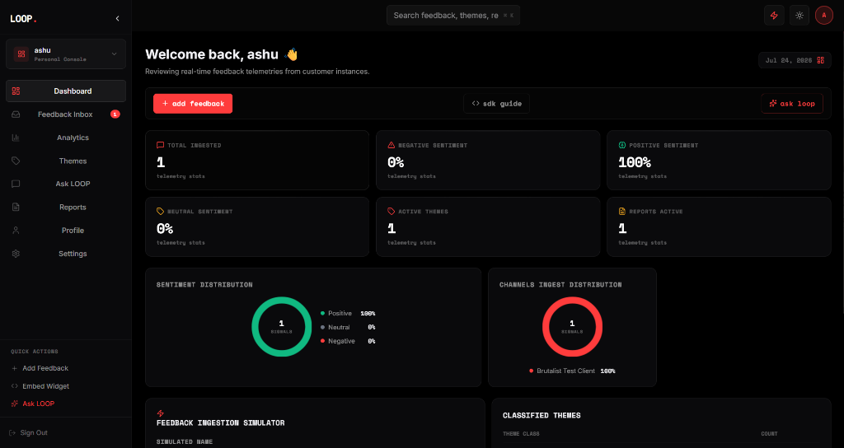
Figure 3: Scoped Dashboard Overview (Visualizing metrics and volume charts)
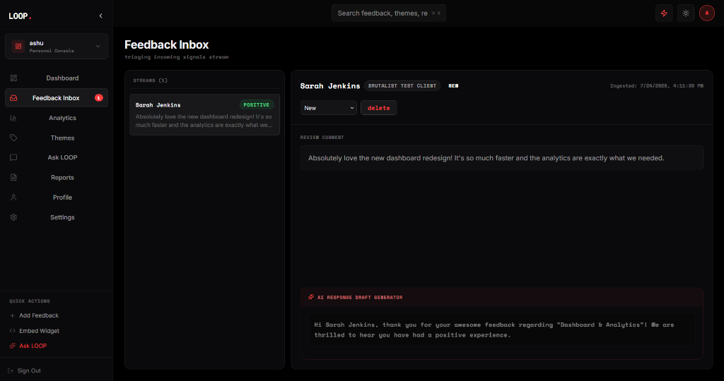
Figure 4: Scoped Feedback Inbox Triage Console with AI Draft Response Generator
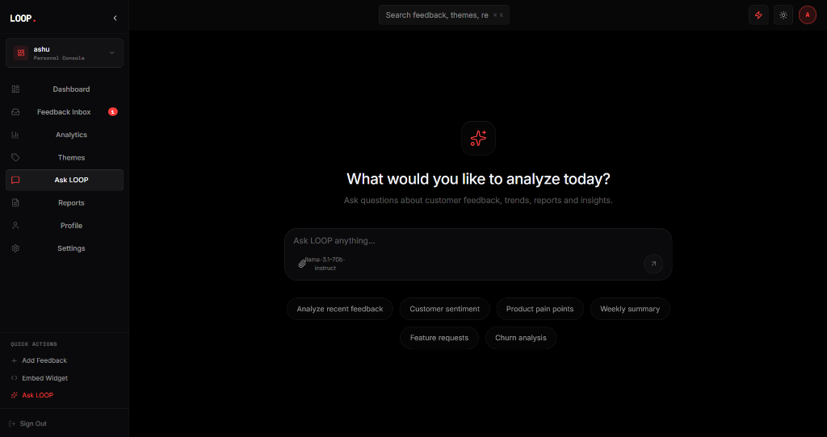
Figure 5: Ask LOOP Conversational AI Context interface with suggestion chips
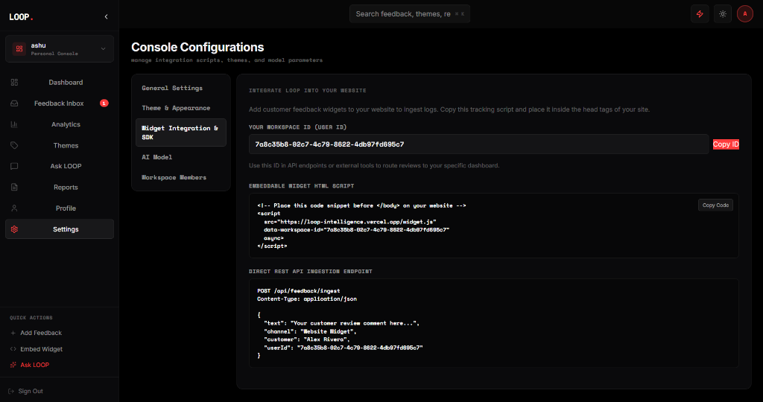
Figure 6: Settings Console with integration SDK scripts and Workspace Roster

9.0 Technical Challenges & Solution Mitigations
9.1 1. Infinite Recursion Loop in Database Row-Level Security
Initially, the SELECT policy on `workspace_members` queried the `workspace_members` table itself to check if a user had access, which triggered another check on the same policy, causing PostgreSQL to fail with an infinite recursion error. Mitigation: We created a Security Definer wrapper function (`get_user_workspaces`) to fetch roles while bypassing RLS. This broke the infinite loop, allowing users to query data securely.
9.2 2. Public Telemetry Ingestion Bypassing RLS Securely
Feedback widgets embedded on external websites make anonymous POST requests to our ingestion API. Because RLS rules require an authenticated session token, anonymous inserts were blocked. Mitigation: We implemented an `ingest_feedback` PostgreSQL RPC function with SECURITY DEFINER privileges. This runs database mutations with elevated privileges, bypassing RLS safely for anonymous inputs while validating the user's workspace membership behind the scenes.
9.3 3. CORS and Client-Side Key Leakage with NVIDIA NIM API
Connecting to `integrate.api.nvidia.com` directly from the browser exposed our API keys in network headers and caused CORS issues. Mitigation: We routed all LLM requests through a Next.js App Router proxy (`/api/nvidia/chat/completions`). This secures the API key on the server and bypasses browser CORS policies entirely.

10.0 Testing, Validation, & Results
To verify that our tenant isolation and security rules are working as intended, we performed multiple validation tests:
• Tenancy Scoping Tests: Signed up user A and user B. Verified that user A cannot fetch or update records belonging to user B's workspace.
• Role Verification Tests: Logged in as a VIEWER. Confirmed that any attempt to update, delete, or ingest feedback returns an HTTP 403 Forbidden error from the API.
• Public Ingestion Pipeline Validation: Used the external Test Client widget to send anonymous POST queries to `/api/feedback/ingest`. Verified that database inputs succeeded and correctly mapped to the target workspace.
10.1 Future Scope
Planned improvements for the LOOP platform include:
1. Webhook Integrations: Direct support for connecting Stripe events, Slack channels, and Linear issues to feed workspace metrics.
2. Automated PDF Reports: Implementing background cron tasks to send Voice-of-Customer PDF summaries to Admins weekly.
3. Local LLM Support: Adding options to run local Llama or Gemma models to process sensitive logs without calling external APIs.
10.2 Conclusion
LOOP demonstrates a successful, secure multi-tenant customer intelligence platform. By enforcing security rules at the database level with Supabase RLS and using Next.js proxies, we achieved complete tenancy safety and data integrity. The combination of DeepSeek-V4 analysis, live ingestion widgets, and role governance makes the platform a reliable solution for modern product engineering teams.

11.0 References & Bibliography
1. Supabase Documentation: Row Level Security and Security Definer Best Practices (https://supabase.com/docs).
2. PostgreSQL Core Team: Row Level Security Policies and SQL Trigger Telemetry (https://postgresql.org/docs).
3. NVIDIA NIM API Reference: Model integrations for DeepSeek and LLama-3 (https://integrate.api.nvidia.com).
4. Next.js App Router Documentation: Routing, Proxy Headers, and API handlers (https://nextjs.org/docs).

