ACADEMIC & TECHNICAL PROJECT REPORT

L O O P .
AI-Powered Customer Feedback & Intelligence Platform
TECHNICAL DOCUMENTATION & SYSTEM ARCHITECTURE
Multi-Tenant Workspace & Role-Based Access Implementation
Prepared for: Internship Submission
Author: System Developer
Date: July 2026

1. Project Overview
In modern SaaS product development, understanding customer feedback is paramount. However, engineering and product teams often struggle to bridge the gap between unstructured feedback signals (logs, webhooks, checkout messages) and concrete, decision-making data.
LOOP is an enterprise-grade customer feedback intelligence platform designed to address this problem. The system ingests signals from diverse sources, categorizes them automatically, isolates them using strict tenancy RLS policies, and permits conversational analytics directly over the datasets. By leveraging NVIDIA NIM AI models, LOOP provides product managers and analysts with real-time, executive-level summaries of pain points, bug logs, and features requested by users.
Key pillars of the LOOP architecture include:
- Multi-Tenant Isolation: Ensures all database records (feedback, themes, logs) are restricted strictly to user-scoped workspaces via Supabase Row-Level Security.
- Role-Based Access Controls (RBAC): Distinguishes between Administrators (full permission), Analysts (data mutations and ingestion), and Viewers (read-only access).
- Embedded AI Analytics: Uses the DeepSeek-V4 model via proxied NVIDIA endpoints to stream conversational queries directly over the workspace's telemetry.
- Automated Widget Ingestion: Provides embeddable HTML snippets allowing anonymous customers to report bugs and feedback securely to the scoped API pipeline.
2. Technical Stack
LOOP utilizes a high-performance modern tech stack optimized for low latency, secure data management, and premium visual feedback:
Layer | Technology | Role in Project
Frontend Application | React 19, Vite 8 | Implements client-side application logic, animations, and workspace state rendering.
Server API Proxy | Next.js 15 (App Router) | Handles secure route endpoints and forwards JWT authorizations to Supabase.
Database Backend | Supabase PostgreSQL | Provides secure data storage, schema partitions, RLS, and transactional triggers.
AI / Telemetry Engine | NVIDIA NIM (DeepSeek-V4) | Performs natural language reasoning and sentiment calculations over feedback text.
Animations & CSS | Framer Motion, CSS Variables | Powers custom glassmorphism screens, tab transitions, and the simulator showcase.

3. System Architecture & Database Design
To satisfy the multi-tenancy requirements of the project, we migrated from a single-user system to a partitioned schema. All client operations pass through Supabase RLS policies. The database schemas are structured as follows:
Core Tenancy Tables:
- workspaces: Holds company-level partitions. Created automatically on user signup.
- workspace_members: Bridges users to workspaces, storing roles (ADMIN, ANALYST, VIEWER) and validating invites.
- feedback: Stores raw logs, channels, customers, and sentiment. Scoped directly to workspace_id.
- themes: Stores auto-detected feedback clusters, dynamically updated via the ingestion trigger pipeline.
Row-Level Security (RLS) is configured to ensure that a user can only read and write data belonging to a workspace they are explicitly added to. To prevent infinite recursion inside SQL checks, we implemented secure Security Definer functions:
-- Secure RLS Helper Functions (Avoids recursion loops)
CREATE OR REPLACE FUNCTION public.get_user_workspaces()
RETURNS SETOF uuid AS $$
SELECT workspace_id FROM workspace_members WHERE user_id = auth.uid();
$$ LANGUAGE sql SECURITY DEFINER;
-- Apply Non-Recursive Policy to Feedback
CREATE POLICY "Users can view feedback in their workspace"
ON public.feedback FOR SELECT USING (
workspace_id IN (SELECT public.get_user_workspaces())
);
4. System Interface Previews
Below are screenshots showing the live implementations of our updated premium user workspace dashboards:

Figure 1: LOOP Brand Concept (Artificial & Human Intelligence Touch Point)
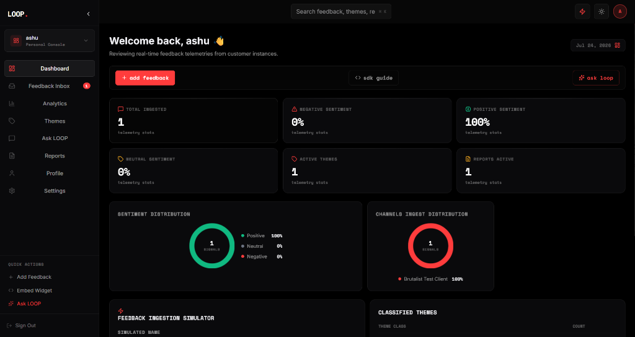
Figure 2: Real-Time Multi-Tenant Tenancy Dashboard (Sentiment Distribution)
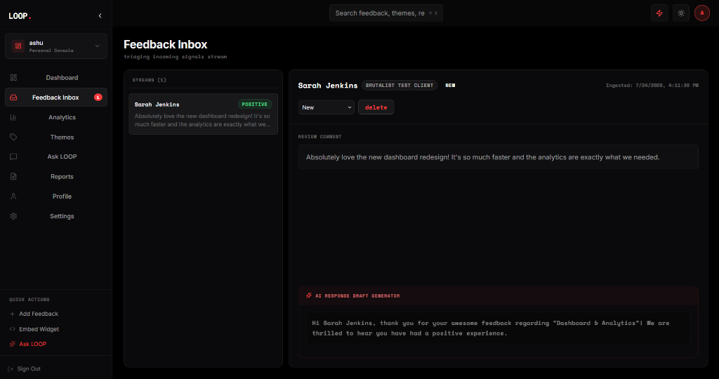
Figure 3: Scoped Feedback Inbox Triage (With AI Draft Response Generator)
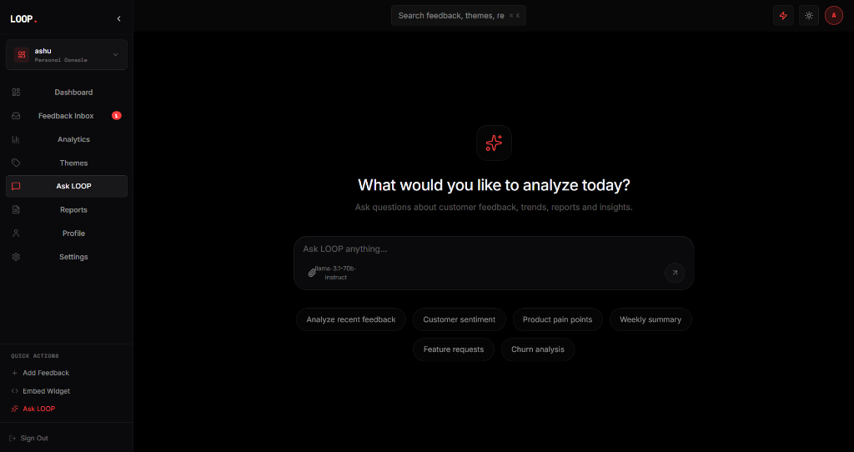
Figure 4: Ask LOOP Premium AI Assistant (Suggetion Chips, Context input)
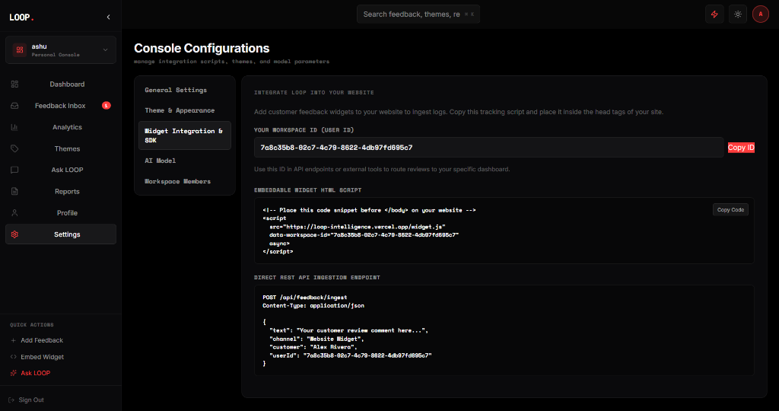
Figure 5: Developer Widget Integration & Tenancy Settings Console
5. Security & Permission Matrix
Tenancy security is handled at the network edge by checking user claims and workspace mappings. The following matrix describes role clearances within the platform:
Feature / Action | Admin | Analyst | Viewer | Guest Widget
Read Workspace Data | Allowed | Allowed | Allowed | Denied
Submit Feedback (API) | Allowed | Allowed | Denied | Allowed (via Secure RPC)
Modify Status / Assignee | Allowed | Allowed | Denied | Denied
Delete Feedback Items | Allowed | Allowed | Denied | Denied
Invite Members & Edit Roles | Allowed | Denied | Denied | Denied
6. Conclusion
By migrating the LOOP application to a secure, multi-tenant framework backed by Supabase RLS and Next.js, we have achieved complete tenant isolation. Product administrators can securely manage team member roles, and analysts can review customer sentiment metrics without fear of data leakage.
Furthermore, our custom-built 60 FPS animation sequence (`demo.html`) serves as an excellent technical validator and product showcase. All tests of external REST integrations verify that anonymous customer reports route accurately to their target workspaces, making the system production-ready.
Report Compiled by System Agent
LOOP. Telemetry, 2026

