|  |  |
| --- | --- |
|  | King Mongkut’s University of Technology  **CPE 333 Software Engineering**  Suthep Madarasmi, Ph.D**.**  **LAB SHEET for Project Management Lab. Class A/B on 22 April 2015**  **Due on Sun May 3, 2015 at 23.59. THIS IS NOT A GROUP ASSIGNMENT.** |

**Key Points to Effective Project Management:**

1. Define entire project scope
2. Project Risks and Mitigation Plan: Technology risks, People risks, Organizational risks, Requirements risks, Estimation risks
3. Resources Needed and Allocation: Materials, Personnel, Equipment, Facility, Time, Budget
4. Project Timeline
5. Project Monitoring and Review (Re-planning and change Timeline)
6. Communication Plan
7. Procurement (Purchasing) Management – includes supplier management.
8. Quality Management (Testing etc.)
9. Other Key Process Management

**Introduction to Microsoft Project**

This lab is designed to familiarize students to Microsoft Project software, a useful tool to manage projects for time planning and resource management.

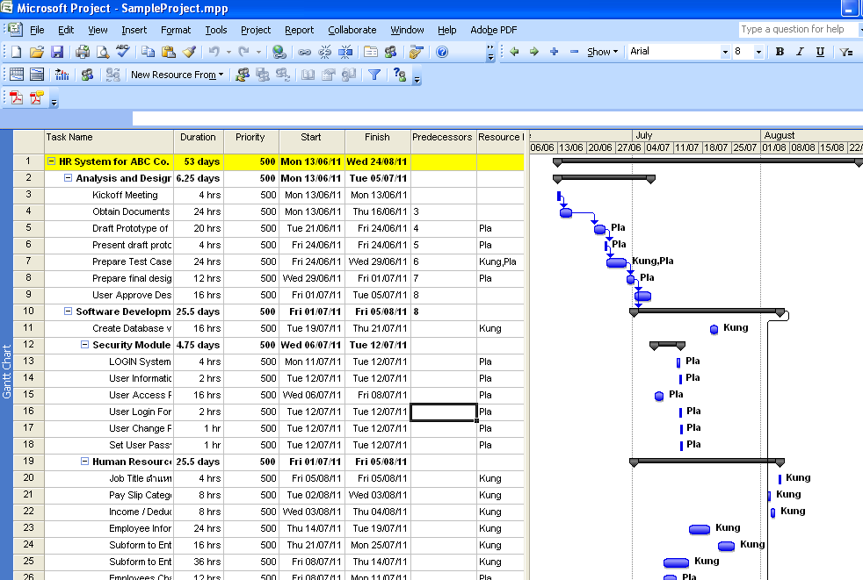

**Download Sites**

1. Software: <http://technet.microsoft.com/en-us/evalcenter/hh973401>
2. Document: <http://www.tumcivil.com/engfanatic/article_gen.php?article_id=392&hit=1>
3. Demo: <http://office.microsoft.com/en-us/project/HA102820011033.aspx>

**Assignment to be submitted by EACH student:**

“Online 3-Digit Lottery” software requirements description:

* The online lottery ticket is sold via a web application using credit card / debit card payment
* A direct buyer must register first time with Citizen ID, Name, credit/debit card information, and password. They will be allowed to make a purchase immediately, but each purchase must check credit card / debit card verification through the credit card broker agent. They can change their user name, password later. In their next purchase they only need to enter user name and password to start selecting the 3-digit numbers.
* Each lottery costs 10 baht and you must guess all 3 numbers correctly to win 500 baht.
* Buyers will first login. The system will know who they are including their credit card information. They then enter 3-digit lottery number and number of bets for this number. The amount to pay will be 10 baht * number of bets, which will be credited to the buyer’s debit/credit card. A receipt will be printed with information Buyer ID:___, Buyer Name: ____, Number: ____, Number Bets: ____, Total Price: ____, Purchase Verification Number: __20 digits__.
* Buyers who win the lottery will automatically get money debited into their account without having to do any work.

Use MS Project to create the Gantt chart for the “Online 3-Digit Lottery System” described above to be developed for Thailand’s Government Lottery System. Assume it will be developed using PHP with MySQL where the servers are already available to install the software. Break the project into tasks based on deliverables such as components, forms, reports, etc. Assume your team consists of 1 analyst and 2 programmers. The analyst does analysis, design, develops test cases, manages/tracks the project, and does configuration management. The 2 programmers do programming, testing, training, installation, and documentation. Each module must be tested by a person who did not develop it, thus each module will have 2 tasks to estimate programming and testing time.

1. Print a Gantt chart showing your task categories, tasks, milestone tasks, resource assignments (*use resource leveling*), task dependencies, and baselined (planned) vs. actual schedule with following details:
   1. *20 points.* List the tasks needed to accomplish above work including their grouping category. You should have at least 20 tasks, each grouped into at least 5 categories. You may use project phase (analysis, design, implementation, testing, migration, training, live run, maintenance) as the first level category, for example. You may have 2 levels of categories, although you are required to only have 1 level. Among your tasks please include all the deliverables for your project (items given to customer; i.e., requirement document, design document, executable, technical manual, source code, user manual, etc.).
   2. *10 points.* Define the milestones of your project among the tasks. Milestones are task endpoints used to track project progress by management.
   3. *20 points.* Create a resource sheet for each team member. Assume the project will start with requirements gathering in March 1, 2013. Create a different time table of available time per week for each team member based on the project calendar. Do not forget to include holidays such as Songkran for the project. Assign each task one resource sheet, taking into account their available time per day. Assume second programmer has agreed to work on Saturdays as well in order to finish this project on time.
   4. *10 points.* Set a schedule as baseline and then modify the schedule to show changes in some tasks due to delays. Your printed Gantt Chart, should show the baselined vs. actual timeline.
2. *20 points.* Show a weekly resource usage sheet for each person for two weeks of April and two weeks of May. Show that you have different calendar available time set for the two weeks.
3. *20 points.* Create a Risk List containing the information shown below for each risk (can put in table form also). Note that you are developing for a governmental organization and you have a small team. You should have a minimum of 8 risks listed, but not over 20 please. How much will you charge extra for this project?

|  |
| --- |
| **Project:** Embedded software for XYZ system  **Risk ID:** R001  **Risk type:** Schedule Risk  **Priority (1 low ... 5 critical):**  4  **Risk factor:** Project completion will depend on tests which require hardware component under development. Hardware component delivery may be delayed  **Probability:** 60 %  **Impact:** Project completion will be delayed for each day that hardware is unavailable for use in software testing  **Monitoring approach:** Scheduled milestone reviews with hardware group  **Contingency plan:**   1. Modification of testing strategy to accommodate delay using software simulation. 2. Confirmation from user that delay will not be counted as project delay. 3. Compensation will be made per additional person-month of testing involved for such a delay for 2 persons.   **Estimated resources:** 6 additional person programmer months beginning in July.  **Estimated Cost if Risk Occurred:** 6 person-months x 40,000 cost per person month = 240,000 baht. |

**SUBMIT INDIVIDUAL WORK THROUGH THE LMS AS ONE PDF DOCUMENT. DO NOT FORGET TO INCLUDE YOUR NAME AND ID IN THE PDF DOCUMENT.**

**WARNING: COPIED ASSIGNMENTS WILL BE SUBJECT TO THE STRICTEST PENALTY.**