CST4245
Data Visualisation, Computer Vision and Imaging
Coursework 1: Tabular Data Analytics and Dashboard
Global Metabolic Syndrome Indicators: A Visual Analysis of Hypertension,
Obesity, and Diabetes Across 200 Countries (1980–2014)

Name: Mohammad Talha Mohammad Salim Shaikh
Student ID: M01090463
Email: talhatalha1971@gmail.com
Contact: +971 54 786 4418

Tool: Altair (Python) Dataset: NCD Risk Factor Collaboration (NCD-RisC)

1. Introduction
Non-communicable diseases, particularly the cluster of conditions associated with metabolic syndrome, represent one of the defining public health challenges of the modern era. Hypertension, obesity and type 2 diabetes don’t exist independently, they form a reinforcing triad that affects each other. Obesity drives insulin resistance and increases diabetes risk; both obesity and diabetes push blood pressure up; and hypertension makes the cardiovascular consequences of the other two worse. Understanding how these three conditions have moved together across populations, and where the trends diverge, has real implications for how health systems should allocate resources (Ng et al., 2014).
The dataset used in this analysis was produced by the NCD Risk Factor Collaboration (NCD-RisC), a global network of researchers that pools national health survey data to construct consistent, long-run prevalence estimates using Bayesian pooling across national surveys of variable quality and coverage (NCD-RisC, 2016a; 2016b; 2017). The dataset covers three conditions: raised blood pressure (systolic ≥ 140 mmHg), obesity (BMI ≥ 30 kg/m²), and age-standardised diabetes prevalence. Each is broken down by sex and spans from 1975 to 2016 depending on the condition, covering all 200 countries with sufficient survey data. For this analysis, the common 1980–2014 window is used throughout, giving a consistent 35-year comparative view.
The central questions I wanted to address were: how have these three conditions evolved globally over that period, and can we identify meaningful patterns by sex, region, or country? And more specifically, given that the three conditions are clinically linked: do obesity and diabetes actually move together at the country level, or is that relationship complicated by geography and population biology? A secondary interest was the gender dimension, which turned out to be far less uniform than I initially assumed.
Living in the UAE, I had a natural curiosity about where the Gulf region sits in the global picture. The Emirates have undergone dramatic economic and demographic shifts over the study period, and the data throws up some findings that are striking even in a regional context, particularly around female obesity. I have flagged this at several points where the UAE numbers are markedly different from the global pattern.
All visualisations were produced using Altair, a Python library based on the Vega-Lite grammar of graphics. Altair lets you describe charts using Python in a relatively concise way, which made it easier to iterate on the designs. The analytical structure follows Munzner’s (2014) What-Why-How framework, which provides a disciplined way of justifying design choices. Each visualisation section below uses this structure to explain not just what the chart shows but why a particular chart type was chosen and how the specific encoding decisions serve the analytical goals. An interactive version of this dashboard is also available at:
https://cst-4245-cw-1-submission.vercel.app
One practical note: the NCD-RisC estimates are modelled figures rather than direct census counts. Country-level figures for smaller or lower-income nations should be read with that in mind. Where I reference specific numbers, these are NCD-RisC published estimates rather than figures independently calculated beyond the aggregations described in Section 2.

2. Dataset Overview and Data Preparation

2.1 Dataset Description
The source file is an Excel workbook with three sheets, one per condition, each sharing the same four-column structure: country name, sex, year, and a prevalence metric.
Blood Pressure sheet: 16,400 rows, 200 countries, years 1975–2015, prevalence stored as a proportion (0–1).
BMI / Obesity sheet: 16,800 rows, 200 countries, years 1975–2016, prevalence as proportion.
Diabetes sheet: 14,000 rows, 200 countries, years 1980–2014, prevalence as proportion.
All 200 entries in the country column are actual countries. There are no regional aggregate rows or world totals embedded in the data, which made the merge process cleaner than expected. The raw prevalence values are expressed as proportions between 0 and 1 rather than percentages, which is easy to miss at first glance. The first transformation applied was converting all values to percentages (multiplying by 100), both to make the numbers immediately interpretable and to avoid scale confusion when comparing conditions. Before any transformation, the data quality was checked: zero null values were found across all three sheets, and the country lists are identical across all three. The year ranges differ. Diabetes starts in 1980 while the others start in 1975, and BMI extends to 2016 while diabetes ends in 2014, which is why the merged analysis is restricted to 1980–2014.

2.2 Documented Transformations and Justifications
The following changes were made to the raw data. All are documented in the output file (cw1_cleaned_dataset.xlsx) and implemented in the analysis script so they are fully reproducible:
Column renaming. The original column headers were verbose and included a special character in the BMI sheet header (the ≤ symbol). All three prevalence columns were renamed to BP_Prevalence, BMI_Prevalence, and Diabetes_Prevalence respectively, and the country column standardised to Country across all sheets. This was necessary for the merge to work correctly on matching column names.
Unit conversion to percentages. All prevalence values were multiplied by 100 and rounded to two decimal places. I chose to do this at the data preparation stage, rather than at the charting stage, because it ensures that derived calculations, particularly the gender gap feature described below, are also expressed in percentage points from the start.
WHO region classification. A region column was added to all three sheets, assigning each of the 200 countries to one of six WHO-style groupings: Africa, Americas, Europe, Eastern Mediterranean, South-East Asia, and Western Pacific. I initially tried to match countries automatically but a few like 'Lao PDR', 'Brunei Darussalam' and 'Cote d'Ivoire' didn't match standard lists, so I ended up doing the region mapping manually using a Python dictionary. Three countries (Occupied Palestinian Territory, Puerto Rico, and Russian Federation) were initially unmatched and fell into an 'Other' category. They show up as a seventh grouping in some charts.
Year restriction and merge. The three sheets were joined on Country, Sex, and Year, restricted to the 1980–2014 window. I used an inner join so I only kept rows where all three conditions had data for that year, which gave a clean 14,000 row dataset with no null values. An outer join would have introduced gaps for years outside each sheet's coverage and I didn't want to deal with that in the charts.
Gender gap feature engineering. A wide-format version of the merged dataset was created by pivoting on the Sex column, bringing men's and women's values for each condition side by side. This made it straightforward to compute a derived Gender Gap column for each condition (Men minus Women, in percentage points). A positive value means men have higher prevalence; negative means women are higher. This engineered feature is used directly in Chart 2. The full wide dataset is saved as the Wide_With_GenderGap sheet in the output workbook.

Transformation | Reason | Output Location
Column rename | Standardise for merge; remove special chars | All three clean sheets
×100 unit conversion to % | Readability; avoid scale confusion | All three clean sheets
WHO region mapping (manual dict) | Enable geographic grouping not in raw data | Added column in all sheets
Year restriction to 1980–2014 | Common coverage window | Merged_1980_2014 sheet
Inner join merge on Country×Sex×Year | Ensures no NaN in merged rows | Merged_1980_2014 sheet
Gender gap column (Men − Women) | Derived insight; needed for Chart 2 | Wide_With_GenderGap sheet
Figure T1: Summary of data transformations applied to the source dataset.

3. Analytical Framework
For each visualisation in this report I used Munzner's (2014) What-Why-How framework (the book is called Visualization Analysis and Design). I found it a bit abstract at first but it helped me think about why a bar chart made more sense than a pie chart in some cases. I'll be honest, I initially picked chart types by gut instinct, and going back to apply the framework made me rethink a few decisions. It forces you to say why you're using a particular chart rather than just going with the default.
The What dimension is basically asking: what kind of data are we dealing with? In this dataset, Year is temporal, Country and Sex are nominal, and the three prevalence measures are quantitative and continuous. Region is also nominal, though there is a loose geographic ordering to it. This matters because it limits your options. You can't really encode a continuous number as a shape, for example, and using colour saturation to represent a category like region doesn't make much sense either.
The Why dimension is about what task the visualisation is actually trying to support. Munzner (2014) lists several task types including discover, present, compare and summarise, and others I didn’t end up using. Looking at my six charts, most of them fall into summarise or compare categories. Charts 1 and 5 are about showing overall patterns across many countries, Charts 2 and 3 are directly comparing groups. Chart 4 is more of a discovery task because I wasn't sure going in whether the obesity-diabetes relationship would be as clear at the country level as the literature suggests. Chart 6 is mainly a present task, it's there to show geographic spread to a reader who might not sit and read a table.
The How dimension is about marks and channels, specifically what visual variables you actually use to represent the data. Cleveland and McGill (1984) rank position as the most accurately perceived channel, with length, angle, area, and colour saturation below it in that order. Based on this, I tried to use position on an axis for the main quantitative comparisons in all six charts, and kept colour mostly for categorical distinctions like sex or region. The one exception is the heatmap in Chart 5, where colour does the quantitative work, but I added numeric labels inside the cells to compensate for the fact that colour alone isn't very precise. For sex encoding across Charts 1 and 2, I used both colour and line style together (solid vs dashed), which means it still reads clearly in greyscale or for someone with colour blindness. I also kept the same region colour palette across all charts so you only need to learn it once. For sex encoding I used both colour and line style together so it still works for colourblind readers or if it gets printed in greyscale.
One thing I should be upfront about: I didn't design every chart using the framework from scratch before writing any code. In practice I built the charts first, then applied the What-Why-How structure to explain the choices I'd already made. For some of them, like the small multiples decision in Chart 1, that felt a bit circular because the framework was justifying something I'd already decided on practical grounds. A cleaner approach would have been to plan the encodings before coding, but honestly the analysis process involved a lot of back and forth between the data and the visualisations, and that's probably normal for exploratory work.

4. Visualisation 1, Global Prevalence Trends (1980–2014)

4.1 What, Why, and How
What: The data here is tabular. The key attributes are Year (temporal, quantitative), mean global prevalence (quantitative, in %), Sex (nominal, binary), and Condition (nominal, three categories). Before charting, the data was aggregated by computing the unweighted mean across all 200 countries for each year × sex × condition combination, so each line represents a simple average across all countries in the dataset.
Why: The task this chart supports is primarily to summarise and present the overall trajectory of all three conditions over a 35-year period, split by sex. It is the entry-point chart. The job here is to give the reader an immediate intuition for what has happened globally before getting into geographic or country-level detail. Secondary to that, it allows comparison between men and women within each condition.
How: Line marks were used with Year on the x-axis and mean prevalence on the y-axis. The three conditions are shown as separate facets (small multiples) instead of on a single shared chart, because they operate at very different absolute prevalence levels. Hypertension runs at 20–35%, obesity at 5–25%, and diabetes at 5–11% across this period. Putting them on a single y-axis would either compress the obesity and diabetes lines to near-invisibility or push the hypertension line off the top. Independent y-axis scales within each facet is the standard approach when the conditions have very different value ranges. Sex uses both colour and line style as redundant encodings.
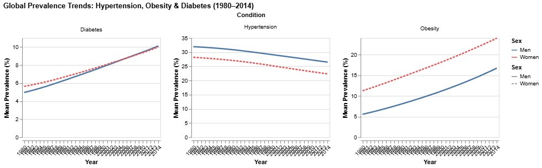
Figure 1: Global mean prevalence (%) of hypertension, obesity, and diabetes by year and sex (1980–2014). Independent y-axis per condition. Blue solid = Men, Red dashed = Women. Source: NCD-RisC (2016a; 2016b; 2017).

4.2 Findings
The main thing this chart shows is that the three conditions aren't all moving in the same direction, which I think is actually the most important point in the whole report. Hypertension has been going down at the global average level, going from around 31.9% (men) and 28.2% (women) in 1980 to roughly 26.5% and 22.3% by 2014. That's a drop of around 5–6 percentage points over 35 years. Meanwhile obesity has more than doubled for both sexes: women went from 11.2% to nearly 24%, men from 5.5% to 16.7%. Diabetes also roughly doubled, from around 5% to 10% (NCD-RisC, 2016a; 2016b).
The hypertension decline makes sense given the wider context. Antihypertensive medication became much more accessible from the 1980s onward, and salt reduction campaigns picked up in many high-income countries around the same time (NCD-RisC, 2017). But what the chart really highlights is that this improvement on blood pressure happened at the same time as obesity and diabetes were getting worse. There's no pill equivalent for obesity. It needs behavioural change at a population level, which is a much harder problem.
Looking at the sex split within each panel: for hypertension, men sit above women throughout, the gap averages around 3–4 percentage points. For obesity it's the opposite. Women run 5–7 points higher than men across the whole period, and the gap actually gets wider over time. Diabetes is interesting because the two lines are much closer together. Women start slightly higher, they converge somewhere around 2005, and by 2014 men have pulled very slightly ahead. I wasn't expecting that crossing pattern and it pushed me to look more closely at the gender gap chart (Chart 2).
One limitation worth flagging: the global average here is unweighted, so Nauru (population around 10,000) counts the same as India (1.3 billion) in the calculation. A population-weighted average would probably look different, especially for obesity and diabetes, since South and South-East Asian countries, which have low obesity rates, would pull the mean down significantly. I couldn't population-weight because the dataset doesn't include population figures, but it's worth keeping in mind that the "global average" here is really an average of 200 country averages, not a true population-level figure.

5. Visualisation 2, Gender Gap in Hypertension by Region (1980–2014)

5.1 Design Rationale
What: The engineered Gender Gap attribute (mean BP prevalence for men minus mean BP prevalence for women, calculated at the region level per year) is the key variable. It is a derived quantitative attribute that does not exist in the raw dataset. Year is temporal; Region is nominal with seven categories including the small "Other" group.
Why: The task this chart supports is to identify where the sex difference in hypertension is widest, which direction it runs in different regions, and whether those patterns have shifted over time. Chart 1 showed that at the global unweighted average, men have higher hypertension than women, but it did not reveal whether this holds across all regions or whether some regions show the opposite. That question is what this chart addresses.
How: Line marks were chosen with Year on the x-axis and the gender gap in percentage points on the y-axis. A dashed reference line at y = 0 marks the dividing point: above it, men have higher prevalence in that region; below it, women are higher. All seven regions are on a single chart, because the comparison between regions, particularly where their lines cross the zero reference or each other, is the main analytical point. Using separate facets would have hidden those crossing patterns. Colour encodes region using the consistent palette maintained across the analysis.
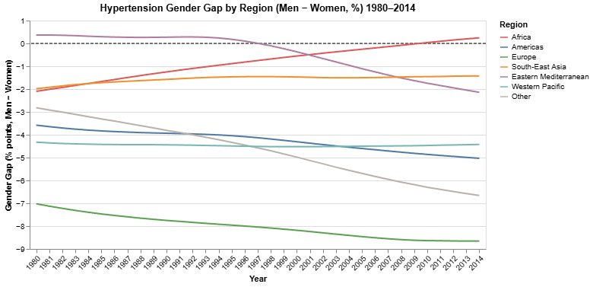
Figure 2: Mean regional gender gap in hypertension (Men − Women, percentage points) 1980–2014. Lines below zero mean women have higher prevalence in that region. Dashed reference line at zero.

5.2 Findings
The first thing that jumps out is that almost every region sits below zero for the whole period, meaning women have higher hypertension than men on a regional average basis across most of the world. By 2014, Africa is basically the only region where men are at a similar level or slightly higher than women. This seems to directly contradict what Chart 1 showed, where men were above women at the global level. The reason they don't match is that Chart 1 takes an unweighted average across all 200 individual countries, which is pulled upward by the large number of African and Asian countries where male hypertension does exceed female at the country level. Chart 2 averages within regions first, then across regions, which is a different calculation and can go in a different direction.
Europe sits the furthest below zero throughout. Women there have substantially higher hypertension than men, with the regional gap sitting between −7 and −9 percentage points. A lot of this is driven by Eastern European countries specifically: looking at the wide dataset, countries like Iceland, Estonia, Latvia, and the Czech Republic each had gaps of over −13 percentage points by 2014 (author's own calculation from NCD-RisC dataset). Mills et al. (2016) point to elevated hypertension among older women in post-Soviet countries, where high salt diets and limited screening access have historically hit women harder. There's also probably a treatment gap. Male cardiovascular disease has generally got more clinical attention in European health systems, so men tend to get diagnosed and put on medication earlier, which brings their measured prevalence down faster than women's.
Africa is actually the most interesting one to watch over time. It starts at around −2 percentage points in 1980, gradually moves toward zero, crosses into positive territory around 2009–2010, and ends up at roughly +0.24 by 2014. That makes Africa the only region where the gender gap actually reversed direction during the study period. The change is plausible. Rising male cardiovascular risk from urbanisation and alcohol consumption, alongside a slow expansion of hypertension treatment access for women in parts of sub-Saharan Africa, would both push the gap in this direction (Mills et al., 2016).
The Eastern Mediterranean is the only region that started above zero, with men slightly higher at +0.37pp in 1980, and then it crossed below around 1997. After that point, women in this region have had higher mean hypertension than men, reaching about −2.1pp by 2014. My best guess for why this happened is the sharp rise in female obesity across Gulf and MENA countries from the 1990s onward, which would push women's cardiovascular risk up relative to men. UAE female obesity was at 41.4% in 2014, more than 14 percentage points above the male figure, and that kind of gap has real effects on blood pressure risk. The Americas and Western Pacific sit at a fairly stable negative gap throughout with no obvious trend either way.
One thing I'm not happy with in this chart: when six or seven lines are all bunched between −3 and −5 percentage points in the middle years, it becomes genuinely hard to read. If I was doing this again I'd put region labels directly at the end of each line on the right side rather than relying purely on the legend. That would make it much easier to trace which line belongs to which region without having to glance back and forth.

6. Visualisation 3, Obesity Prevalence by Country (2014): Top and Bottom 15

6.1 Design Rationale
What: Country (nominal), Sex (nominal, binary), and BMI_Prevalence (quantitative) for the snapshot year 2014. The 30 countries shown, 15 highest and 15 lowest by average obesity across both sexes, were selected to communicate the full range of the global obesity distribution in a single comparison.
Why: The task is comparison and identification of extremes. I wanted to answer who sits at each end of the global obesity distribution in 2014, and whether the sex pattern looks different at the top versus the bottom. Showing all 200 countries would answer a ranking question but make the extremes hard to read; restricting to the top and bottom 15 keeps the chart focused on the contrast.
How: A horizontal bar chart sorted by overall country average is the conventional choice for ranked categorical data. The country axis runs along y, the prevalence axis along x, and the eye scans from top to bottom to read the ranking. Faceting into two panels (Top 15 and Bottom 15) keeps the x-axis scale consistent within each group while visually separating the extremes. The bars are stacked: men's obesity (blue) forms the base and women's (red) is added on top, so the x-axis shows the combined male+female total rather than individual values. A stacked design was chosen because the primary question is about country-level burden, with the sex comparison secondary. I'm not entirely convinced stacked was the right call. Grouped bars would be better if the sex difference were the main point, since it's harder to compare bars when they don't share the same baseline. It is a genuine trade-off.
One visual issue worth flagging: the x-axis scale is unified within each panel, but the two panels have very different practical ranges. The Bottom 15 panel has bars barely reaching 10% for most countries, while the Top 15 panel runs to over 120% combined. First-time viewers may need a moment to register that the Bottom 15 bars are not empty. They are simply very small relative to the scale that the stacked totals in the Top 15 require. This is a visual artefact of the stacked design and not an error.
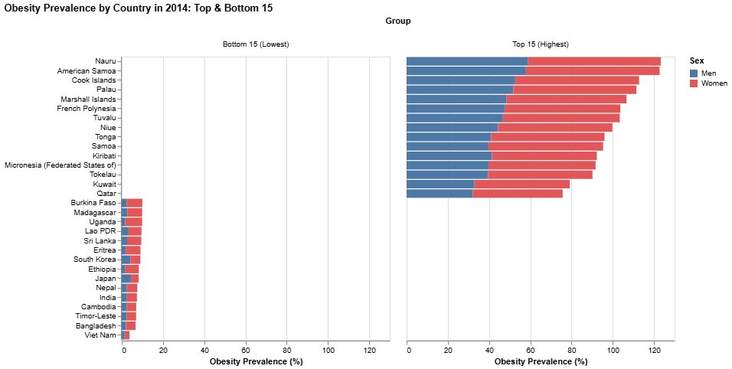
Figure 3: Obesity prevalence (%) in 2014 for the 15 highest and 15 lowest countries. Bars are stacked: blue = Men (base), Red = Women (stacked on top). X-axis shows the sum of both sexes' rates. Source: NCD-RisC (2016a).

6.2 Findings
The top 15 is dominated almost entirely by Pacific Island nations. Nauru, American Samoa, Cook Islands, Palau, Marshall Islands, Tuvalu, Tonga, Samoa, Tokelau, Niue, French Polynesia, and Kiribati are all there. When I first saw this I went to check it wasn't a data error, and then read around to understand why. The basic explanation is a combination of genetic factors, a fast shift away from traditional diets toward cheap imported processed food, and the fact that small island economies have almost no control over their own food supply, they're largely dependent on what gets shipped in (Ng et al., 2014; Popkin et al., 2012). Nauru in 2014 had men at roughly 59% and women at 64% obesity. The majority of the adult population is clinically obese. That's not a slightly elevated rate, it's a fundamentally different situation from most of the world.
Kuwait and Qatar also make the top 15. Both have high-calorie diets, extreme heat that makes outdoor activity difficult for much of the year, and rapid urbanisation that built cities without much walkability or active commuting infrastructure. Ng et al. (2014) describe this pattern across GCC states generally. The UAE doesn't quite make the top 15 at a combined average of around 68%, but with women at 41.4% obesity it sits in the same cluster as these countries. The difference is a few positions, not a fundamentally different situation.
The bottom 15 is almost the complete opposite, mostly South and South-East Asian and African countries. Vietnam is at the very bottom by a clear gap: men at 1.4%, women at 2.4%. Bangladesh, India, Nepal, Cambodia, Timor-Leste, and Sri Lanka make up much of the rest, along with African nations like Ethiopia, Uganda, Eritrea, and Madagascar. Japan is the one that surprised me most. It's the only high-income country in the bottom 15. Despite being wealthy and highly urbanised, it has managed to keep obesity very low, which the literature links to food culture: relatively high fish consumption, smaller portion sizes, and social norms around not overeating (Tsugane and Sawada, 2014). It's unusual to see Japan and Bangladesh in the same category for anything.
One pattern that runs through both panels: women consistently have higher obesity than men, with Japan being the only exception. In the Pacific Island nations the gap is wide. Women are typically 10–15 points above men. In the bottom 15 it's smaller, usually 3–6 points, but it's still there. This female excess in obesity alongside the male excess in hypertension from Chart 1 is what makes gender in this dataset complicated. It doesn't point in one clean direction across all three conditions.

7. Visualisation 4, Obesity vs Diabetes by Country (2014)

7.1 Design Rationale
What: Both axes encode quantitative attributes, mean obesity prevalence (x-axis) and mean diabetes prevalence (y-axis) for 2014, each the average of men's and women's values. Region is nominal, encoded by colour. Country is a nominal identifier used in tooltips and for the UAE text annotation.
Why: The task is discovery, to find out whether a relationship exists between obesity and diabetes at the country level and characterise it. Scatter plots are purpose-built for correlation exploration as opposed to confirming an assumed relationship (Few, 2009). The region colour encoding allows a second question to be asked simultaneously, whether the relationship differs by geography, without requiring a separate chart.
How: Filled point marks, one per country. A linear regression line is overlaid via Altair's transform_regression for a directional reference. The UAE is labelled with a text annotation because it is the country of most personal interest in this analysis. Point opacity is set to 0.75 so you can see where points overlap in busier areas of the chart.
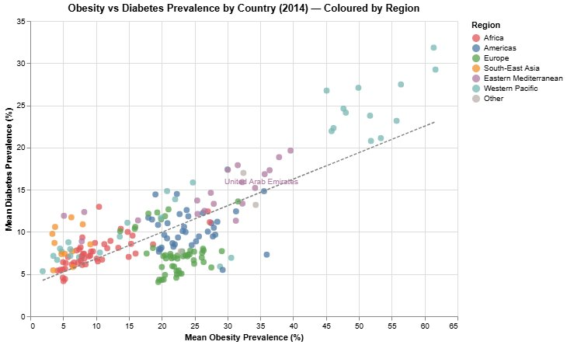
Figure 4: Scatter plot of mean obesity (x) vs mean diabetes (y) prevalence per country in 2014. One point per country, coloured by WHO region. Dashed line = linear regression. UAE labelled.

7.2 Findings
There is a clear positive relationship overall. As obesity goes up across countries, diabetes tends to follow. That part isn't surprising. What's more useful is looking at where individual regions fall relative to the regression line, because that's where the regional story gets interesting.
The Eastern Mediterranean cluster (purple) sits above the regression line throughout. These countries have more diabetes than you'd predict from their obesity rate alone. Afghanistan is an extreme case: around 5% obesity but nearly 12% diabetes. Pakistan is similar, roughly 8% obesity and 12% diabetes. This matches what the epidemiology literature says about South Asian and Arab populations. They tend to develop type 2 diabetes at lower body weight than European populations, probably due to differences in visceral fat distribution and how insulin sensitivity is affected (Misra and Khurana, 2011; NCD-RisC, 2016b). It's a known finding, but seeing a whole regional cluster sit consistently above the regression line in a 200-country scatter is a reasonably clear visual demonstration of it.
The Pacific Island nations (teal cluster) are in the upper-right corner, with very high obesity and very high diabetes, but they sit on or close to the regression line rather than above it. Nauru is at around 29% diabetes, American Samoa at 32%, which are extreme numbers in absolute terms, but they're roughly in line with what you'd predict from their obesity levels. So the mechanism there seems to be the standard one: high obesity drives high diabetes, without the extra risk factor you see in the Eastern Mediterranean cluster.
The UAE sits above the regression line, with obesity around 34%, diabetes around 15.2%. What I can't figure out from this dataset is how much of that is driven by the large South Asian expatriate population, who tend to get diabetes at lower BMI. The data is national averages, so that demographic split is completely hidden. That's probably the biggest limitation in what I can actually say about the UAE from this source. The positioning above the line is real, but to explain it properly you'd need data broken down by nationality or ethnicity, which this dataset doesn't have.
Japan and South Korea cluster in the bottom-left, with low obesity and low diabetes, and both below where you'd expect for their income level. East Asian countries generally sit in a different part of the scatter from European or Gulf nations with comparable obesity rates, which comes up across several Lancet studies on global metabolic risk (Ng et al., 2014). China is interestingly positioned. It's noticeably further right and higher than Japan and South Korea, which makes sense given how fast its diabetes rate has grown since the late 1990s (NCD-RisC, 2016b). The US is worth mentioning too: at roughly 36% obesity, its diabetes rate of around 7% actually sits below the regression line. That's a relatively low diabetes figure for such high obesity, which might reflect how the US health system diagnoses and medicates diabetes, and that could be affecting the reported prevalence figures.

8. Visualisation 5, Hypertension by Region and Decade

8.1 Design Rationale
What: Region (nominal, seven categories) and Decade (ordinal, four values: 1980s, 1990s, 2000s, 2010s) are the two categorical dimensions. The quantitative value in each cell is mean BP prevalence, averaged across both sexes and all countries in each region × decade combination. Year was binned into decades because the regional story is about broad directional trends, using annual granularity would produce a 35-column matrix that is unreadable as a heatmap.
Why: The task is to compare hypertension levels across regions and track change across decades simultaneously. A heatmap encodes two categorical dimensions as axes, freeing colour for the quantitative prevalence value. This is precisely the use case heatmaps are designed for. It would not be possible to make the same comparison in a single line chart without the lines overlapping into an unreadable tangle.
How: Rectangle marks with Region on the y-axis and Decade on the x-axis. Colour encodes mean BP prevalence using a sequential red scheme (darker = higher prevalence). Numeric labels inside each cell make it possible to read exact values, which avoids the precision problem with continuous colour scales. Text colour inverts to white for cells above 38% for legibility.
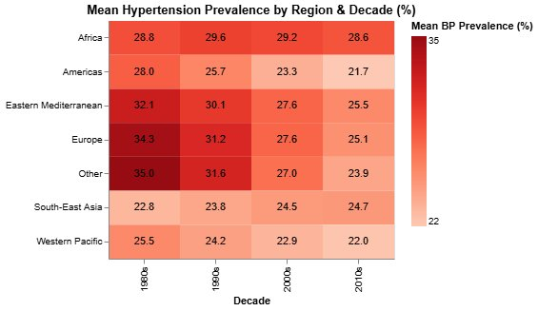
Figure 5: Mean hypertension prevalence (%) by WHO region and decade, averaged across both sexes and all countries in each region.

8.2 Findings
Going into this chart I expected Africa to show at least some improvement, given the general decline visible in Chart 1. The flat line across all four decades was the result that made me stop and look again. Africa's mean hypertension sits between 28.6% and 29.6% across all four decades, basically no change over 35 years. In the 1980s it was actually lower than Europe and the Eastern Mediterranean. But because those regions improved while Africa stayed flat, Africa has moved from the bottom of the regional distribution to the middle. Mills et al. (2016) point to a set of structural reasons for this: most people with high blood pressure in sub-Saharan Africa have no idea they have it, primary care screening is inconsistent, and medication is too expensive for many households. None of those things get fixed quickly.
Europe and the "Other" group had the highest rates in the 1980s, both above 34%, and have seen the biggest drops. Europe went from 34.3% to 25.1%, a fall of over 9 points. The Americas also improved consistently, from 28.0% to 21.7%. These are the clearest success stories in the heatmap, and they match what NCD-RisC (2017) describe as the effect of wider antihypertensive medication access and salt reduction programmes in higher-income countries. The Eastern Mediterranean also improved from 32.1% to 25.5%, roughly keeping pace with Europe.
South-East Asia is the only region where hypertension actually went up across the four decades, from 22.8% in the 1980s to 24.7% in the 2010s. A 1.9 point rise isn't huge on its own, but the direction is going the wrong way while every other region is improving. The likely explanation is the urbanisation and dietary shift happening across countries like India, Indonesia, Bangladesh, and Thailand. Higher-sodium processed foods, less physical activity as people move from agricultural into service-sector work. NCD-RisC (2017) describe this as a fairly predictable pattern in countries at an early stage of economic development, and it's visible here at the regional level.
Western Pacific improved from 25.5% to 22.0%, which is a reasonable reduction. Overall, the thing this chart communicates most clearly is Africa staying flat while everywhere else improves, and I think that's probably the most practically important finding in the whole report from a policy standpoint.

9. Visualisation 6, Global Diabetes Choropleth Map (2014)

9.1 Design Rationale
What: This chart combines two data types: tabular (country-level diabetes prevalence for 2014, both sexes mean) and geospatial (Natural Earth 110m country boundary polygons joined via ISO 3166-1 numeric codes). The diabetes prevalence attribute is quantitative and continuous; the geographic encoding adds a spatial dimension absent from every other chart in this report.
Why: The primary task is to present the geographic distribution of diabetes and allow the reader to identify spatial clusters that would be invisible in a table or bar chart. A choropleth is appropriate here because geography is genuinely informative, neighbouring countries often share dietary cultures, economic development levels, genetic population characteristics, and public health infrastructure, all of which influence diabetes rates. A ranked bar chart would answer "who is highest?" but hide whether high-risk areas are geographically clustered.
How: Filled geographic shapes with colour encoding mean diabetes prevalence using a sequential orange-red gradient (lighter = lower, darker = higher). The Natural Earth 1 projection provides reasonable shape preservation without severe distortion at the scale of individual countries. Countries unmatched to the topojson boundary file appear in grey. The colour scale limitation, viewers can distinguish very dark from very light but cannot read precise values, is offset by pairing the map with specific numbers in the surrounding text.
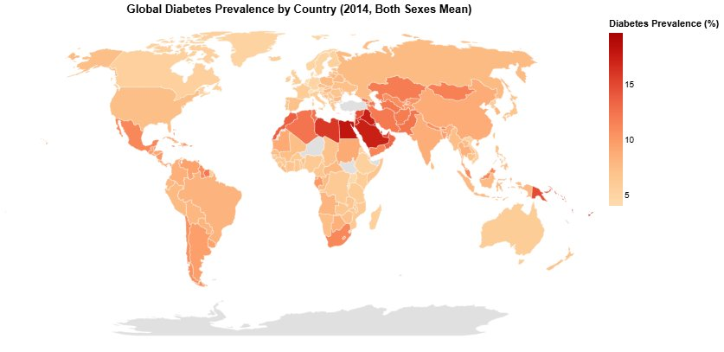
Figure 6: Global diabetes prevalence (%) by country in 2014, both sexes mean. Sequential orange-red scale. Grey = no boundary match in topojson. Source: NCD-RisC (2016b).

9.2 Findings
The Gulf and Middle East is the first thing you notice on this map, a solid block of deep red across Egypt, Iraq, Jordan, Saudi Arabia, Kuwait, Qatar, Libya, and the UAE, all above 15% diabetes. That's actually where I looked first too. What the choropleth adds that the scatter plot couldn't show is the geographic continuity. These countries aren't scattered randomly, they form a connected high-risk zone. The reasons are overlapping: diets high in refined carbohydrates, limited physical activity partly because of extreme heat, and the higher diabetes risk of South Asian and Arab populations at moderate BMI levels that was already flagged in Section 7 (Misra and Khurana, 2011).
Papua New Guinea shows up as a small but noticeably dark patch in the Pacific, with diabetes around 15% despite being a lower-middle-income country with relatively low obesity. I had to look this up because it seemed unusual. The clinical literature links it to a form of malnutrition-related diabetes that works differently from the obesity-driven type more common in high-income countries, alongside genetic susceptibility in Melanesian populations (NCD-RisC, 2016b). It's exactly the kind of outlier that would disappear in a table but stands out immediately on a map.
Sub-Saharan Africa is mostly in the lightest colour band, with most countries below 8% diabetes. This lines up with the low obesity rates from Chart 3, but it's also partly explained by the younger age structure of African populations. Diabetes prevalence rises sharply with age, and age-standardisation only partially accounts for that. As African populations age over the coming decades, even if nothing else changes, diabetes rates there are projected to rise considerably (NCD-RisC, 2016b).
East Asia has a visible gradient across the region. Japan, South Korea, and Vietnam are in the lightest shades, while China is in a noticeably darker band despite being geographically right next to them. That difference between China and its neighbours is something you can actually see at map scale, which is one of the things a choropleth does well. South-East Asia sits in a middle band, neither as low as Vietnam and Japan nor as high as the Gulf.
The main limitation of a choropleth is that colour isn't very precise. You can clearly tell dark from light, but you can't read an exact number off a continuous gradient. That's why I've tried to pair this map with specific figures in the text and earlier charts rather than using it as the main evidence for any numerical claim. It's best read as a broad picture of where the burden sits geographically.

10. Conclusion
Six visualisations across six analytical frames have produced a picture of global metabolic syndrome that is more complicated than any single headline can capture. The three conditions are not uniformly worsening, they are not uniformly improving, and they do not move in lockstep across countries and regions. That complexity is, in itself, the most important finding.
Hypertension stands apart from obesity and diabetes as the one condition where global trends have moved in a positive direction, down by roughly 5–6 percentage points over 35 years (NCD-RisC, 2017). This improvement is real but unevenly distributed: Europe and the Americas have seen the sharpest declines, while Africa has seen essentially none. Against a background of globally declining rates, a region that fails to improve ends up in a worse relative position even if its absolute rate barely changes. That is the Africa story in Chart 5, and it is worth taking seriously as a policy finding rather than a statistical footnote.
The gender analysis produced the result I found most unexpected in this project. Chart 1 shows men above women at the global unweighted average for hypertension throughout the period. Chart 2 then shows that at the regional level, women are actually higher than men in almost every region, Europe by a large margin, the Americas and Western Pacific by a consistent but smaller margin, and the Eastern Mediterranean crossing from male-higher to female-higher around 1997. The resolution of this apparent contradiction lies in how the averages are constructed, but the substantive implication is that sex should not be used as a simple, universal modifier in metabolic risk discussions. Sex differences in hypertension are regional, directional, and changing over time.
The scatter plot confirmed the expected positive relationship between obesity and diabetes at the country level. More useful was the finding that the Eastern Mediterranean cluster sits above the regression line, higher diabetes per unit of obesity than most other regions, pointing to a biological and demographic context where diabetes risk accumulates faster than BMI alone would predict (Misra and Khurana, 2011). This has direct relevance for the UAE and neighbouring Gulf countries, and it argues for diabetes screening and prevention efforts that do not rely solely on BMI thresholds calibrated for European or Western populations.
Several limitations deserve acknowledgement. Looking back, I think a population-weighted average would have told a more accurate global story. Nauru counting the same as India in the mean is a real problem I only fully appreciated when I was writing this up. The 1980–2014 window also misses more than a decade of recent trends. Country-level averages conceal substantial within-country variation by income, education, and urban/rural residence, in the UAE's case, the large South Asian expatriate population and the Emirati national population likely have quite different metabolic risk profiles that the national average cannot separate, and that is the one gap in what I can say with confidence about the UAE from this data. Unweighted averaging gives Nauru the same weight as India. Despite these limitations, the dataset and the visualisation approach have surfaced patterns at the regional and country level that align with what the broader epidemiological literature would expect, and that would be difficult to communicate through any means other than careful visual analysis.

References
Cleveland, W.S. and McGill, R. (1984) 'Graphical perception: Theory, experimentation, and application to the development of graphical methods', Journal of the American Statistical Association, 79(387), pp. 531–554.
Few, S. (2009) Now You See It: Simple Visualization Techniques for Quantitative Analysis. Oakland: Analytics Press.
Mills, K.T., Bundy, J.D., Kelly, T.N., Reed, J.E., Kearney, P.M., Reynolds, K., Chen, J. and He, J. (2016) 'Global disparities of hypertension prevalence and control', Circulation, 134(6), pp. 441–450.
Misra, A. and Khurana, L. (2011) 'Obesity-related non-communicable diseases: South Asians vs White Caucasians', International Journal of Obesity, 35(2), pp. 167–187.
Munzner, T. (2014) Visualization Analysis and Design. Boca Raton: CRC Press. [Chapters 2–5 used for framework]
NCD Risk Factor Collaboration (NCD-RisC) (2016a) 'Trends in adult body-mass index in 200 countries from 1975 to 2014: a pooled analysis of 1698 population-based measurement studies with 19.2 million participants', The Lancet, 387(10026), pp. 1377–1396.
NCD Risk Factor Collaboration (NCD-RisC) (2016b) 'Worldwide trends in diabetes since 1980: a pooled analysis of 751 population-based studies with 4.4 million participants', The Lancet, 387(10027), pp. 1513–1530.
NCD Risk Factor Collaboration (NCD-RisC) (2017) 'Worldwide trends in blood pressure from 1975 to 2015: a pooled analysis of 1479 population-based measurement studies with 19·1 million participants', The Lancet, 389(10064), pp. 37–55.
Ng, M., Fleming, T., Robinson, M., Thomson, B., Graetz, N., Margono, C., and Gakidou, E. (2014) 'Global, regional, and national prevalence of overweight and obesity in children and adults during 1980–2013: a systematic analysis for the Global Burden of Disease Study 2013', The Lancet, 384(9945), pp. 766–781.
Popkin, B.M., Adair, L.S. and Ng, S.W. (2012) 'Global nutrition transition and the pandemic of obesity in developing countries', Nutrition Reviews, 70(1), pp. 3–21.
Tsugane, S. and Sawada, N. (2014) 'The JPHC study: design and some findings on the typical Japanese diet', Japanese Journal of Clinical Oncology, 44(9), pp. 777–782.

