
ARELLANO UNIVERSITY
Expanded Tertiary Education, Equivalency
and Accreditation Program
Legarda, Sampaloc, Manila

In partial fulfillment of the requirements in the course

ITC 122– INTRODUCTION TO WEB DESIGN
FINAL PROJECT

<Section 3 / Schedule>

Submitted by:

Name | Student Number
Gizzle M Saygo | 2502153

Submitted to:

MR. JONNIFER C. MANDIGMA
Subject Professor

Date Submitted:

TABLE OF CONTENTS

I. Title of the Website
Uni-Protect Security Surveillance Services

II. Introduction

a. Purpose/Objectives:
The purpose of the website is to provide an online platform for Uni-Protect CCTV Services to promote its security solutions, showcase available CCTV products, and offer easy communication between the company and its clients.

The objectives of the website are:

To present company information and services clearly to customers
To showcase CCTV products and trusted brands
To provide an easy way for clients to request quotations and inquiries
To improve accessibility of services through online presence
To enhance customer engagement and trust through professional presentation

III. Description of the Website
Our project website is a static informational and business-oriented platform designed for Uni-Protect CCTV Services. It features sections such as Home, Services, Products, About Us, Trusted Brands, and Contact Information.

It is built using HTML and CSS, providing a clean and responsive layout that works on both desktop and mobile devices. The website highlights CCTV installation services, maintenance, and remote viewing setup, as well as showcasing different CCTV brands and products.

The design follows a professional security-themed interface to reflect the nature of the business.

IV. Website Address/URL
https://noobits.github.io/cctv/

V. Screenshot of the HOME/MAIN PAGE

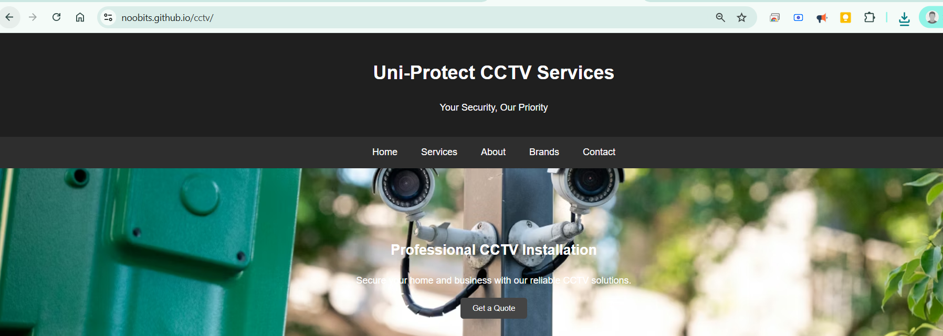

VI. Screenshots of the CONTENTS

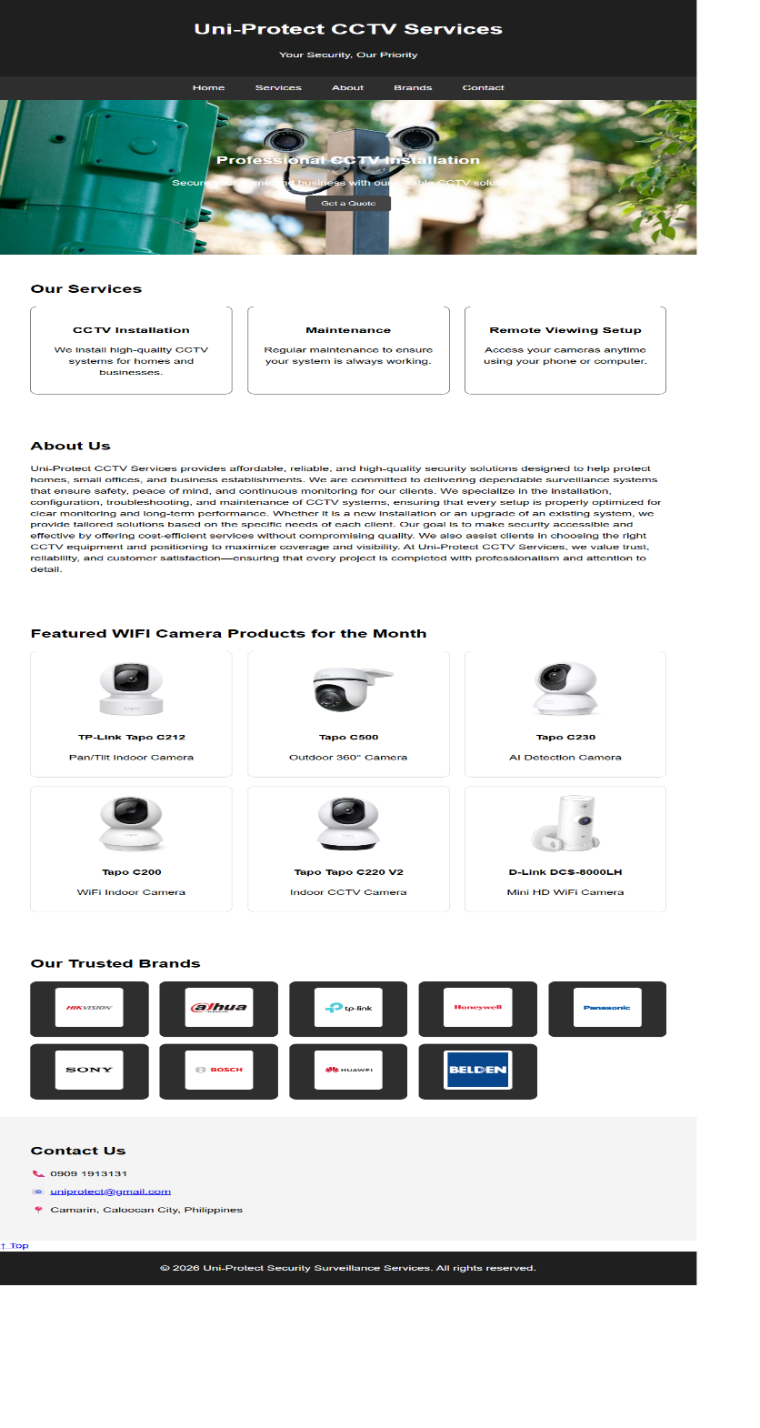

IV. Evaluation
When uploading a website to a web hosting provider, what are the important factors to consider ensuring a smooth and successful deployment? Give at least 10 factors and explain each briefly.
- Domain Name Setup
Ensure that the domain name is properly registered and correctly linked to the hosting server to make the website accessible online.
- Hosting Reliability and Uptime
Choose a hosting provider with high uptime (99.9%) to ensure the website is always accessible to users.
- File Organization
Properly organize website files (HTML, CSS, JS, images) to avoid broken links and ensure smooth loading.
- Database Configuration (if applicable)
For dynamic websites, ensure the database is properly configured, connected, and secured.
- Security and Access Control
Implement proper security measures such as strong passwords, user access restrictions, and protection against unauthorized access.
- Website Performance Optimization
Optimize images, scripts, and files to ensure fast loading speed.
- Compatibility Testing
Check if the website works properly across different browsers and devices.
- Backup System
Maintain backups of website files and databases to prevent data loss.
- Mobile Responsiveness
Ensure the website adapts properly to different screen sizes such as mobile phones, tablets, and desktops.
- 10. Error Handling and Debugging
Ensure that all links, pages, and scripts are working correctly before deployment.

B. How would you recommend your created website in a certain company or organization.

I would recommend the created website to be formally adopted by the company or organization as part of its official digital presence to improve accessibility, visibility, and customer engagement. The website serves as a centralized platform where clients can easily view services, products, and company information without needing to physically visit the office.

VII. SOURCE CODES (Google Drive Link)

https://drive.google.com/drive/folders/1dew9tO8gSUN5sLdIDdumyko16xiPigfV?usp=sharing

