***AMAZON Honeycode***

**What Is Amazon Honeycode?**

Amazon Honeycode, which is available in beta, is a fully managed service that allows customers to quickly build powerful mobile and web applications – with no programming required. Customers who need applications to track and manage things like process approvals, event scheduling, customer relationship management, user surveys, to-do lists, and content and inventory tracking no longer need to do so by error-prone methods like emailing spreadsheets or documents, or hiring and waiting for developers to build costly custom applications.

With Amazon Honeycode, customers can use a simple visual application builder to create highly interactive web and mobile applications backed by a powerful AWS-built database to perform tasks like tracking data over time and notifying users of changes, routing approvals, and facilitating interactive business processes. Using Amazon Honeycode, customers can create applications that range in complexity from a task-tracking application for a small team to a project management system that manages a complex workflow for multiple teams or departments.

**Is Amazon Honeycode free?**

**Amazon Honeycode** is **free** to use for teams with up to 20 members and 2,500 rows per workbook. Upgrade to a paid plan when you need additional capacity.

**Benefits of using Amazon Lex:**

With Honeycode, one can create web & mobile apps that can work on a desktop browser, Android, and iOS platforms.

* No programming skills are needed so that anyone can be an app developer.
* Honeycode apps can help teams stay in a loop by giving them access to the same data.
* Personalized features of Honeycode apps can make teams remain focused. This is possible because these apps show data that are relevant to each team member.
* Honeycode can automate manual steps

**Features of Amazon Honeycode:**

* Customized apps without programming.
* Personalize data for each team member.
* Workflow automation
* Share the app
* Access anywhere and update anytime.
* After having basic knowledge about Amazon Honeycode, let’s learn about how to start working with it.

## How it works:

Amazon has built-in templates that can be chosen:

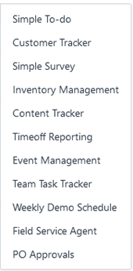

Or you can even build one from scratch with a similar process, we’ll go with a built-in template.

**Steps:-**

1) GO onto the Amazon Honeycode website, and click on Sign Up.

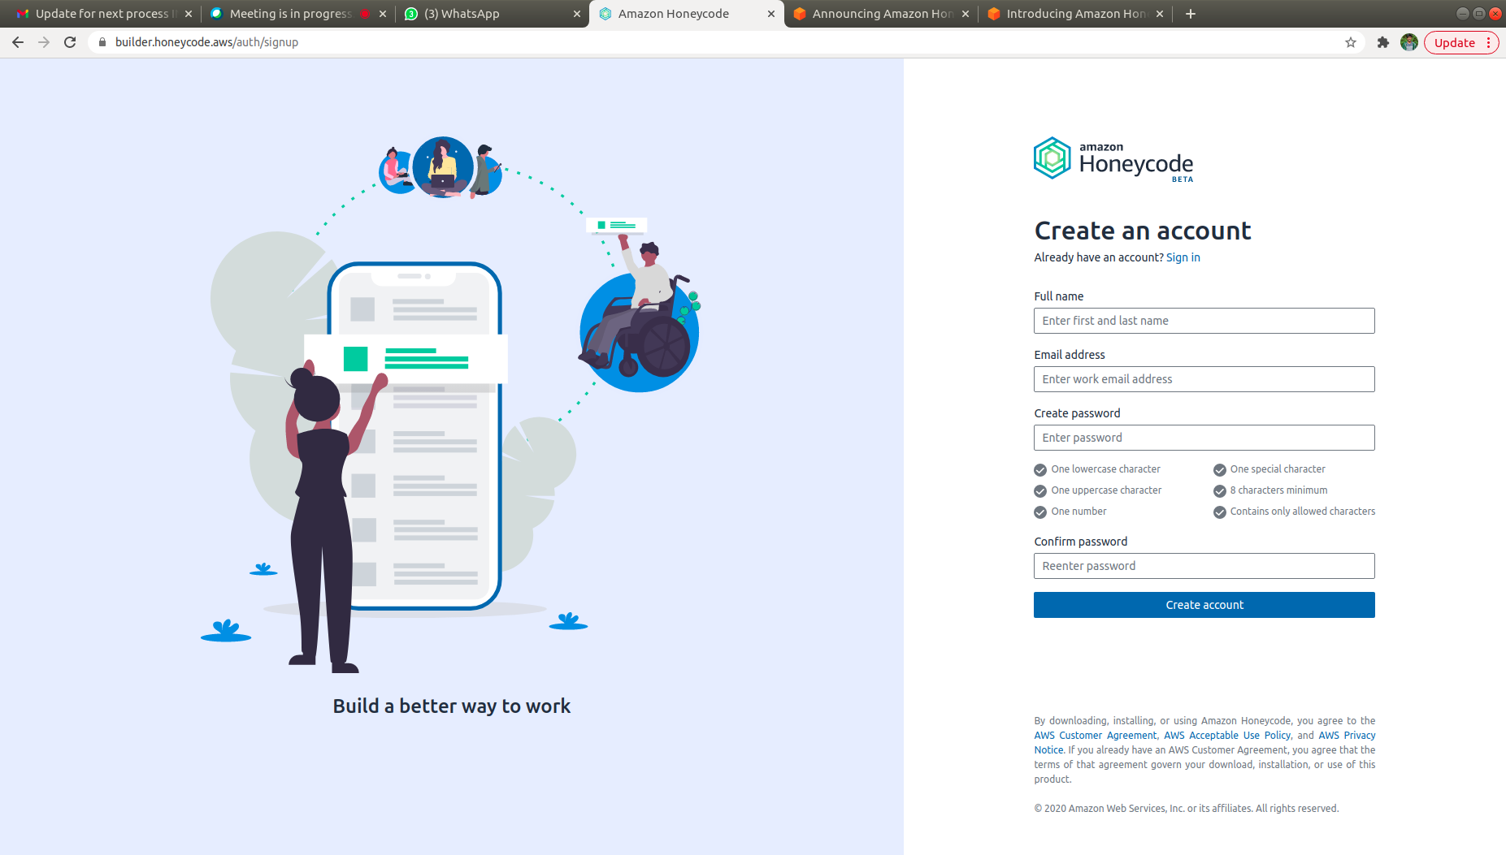

2)Creating an account will lead you to the Honeycode Dashboard.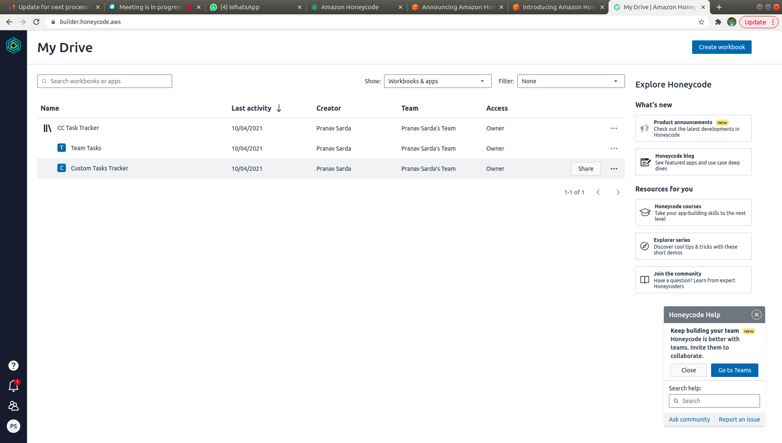

3)Click on Create new Workbook on Right Top Corner.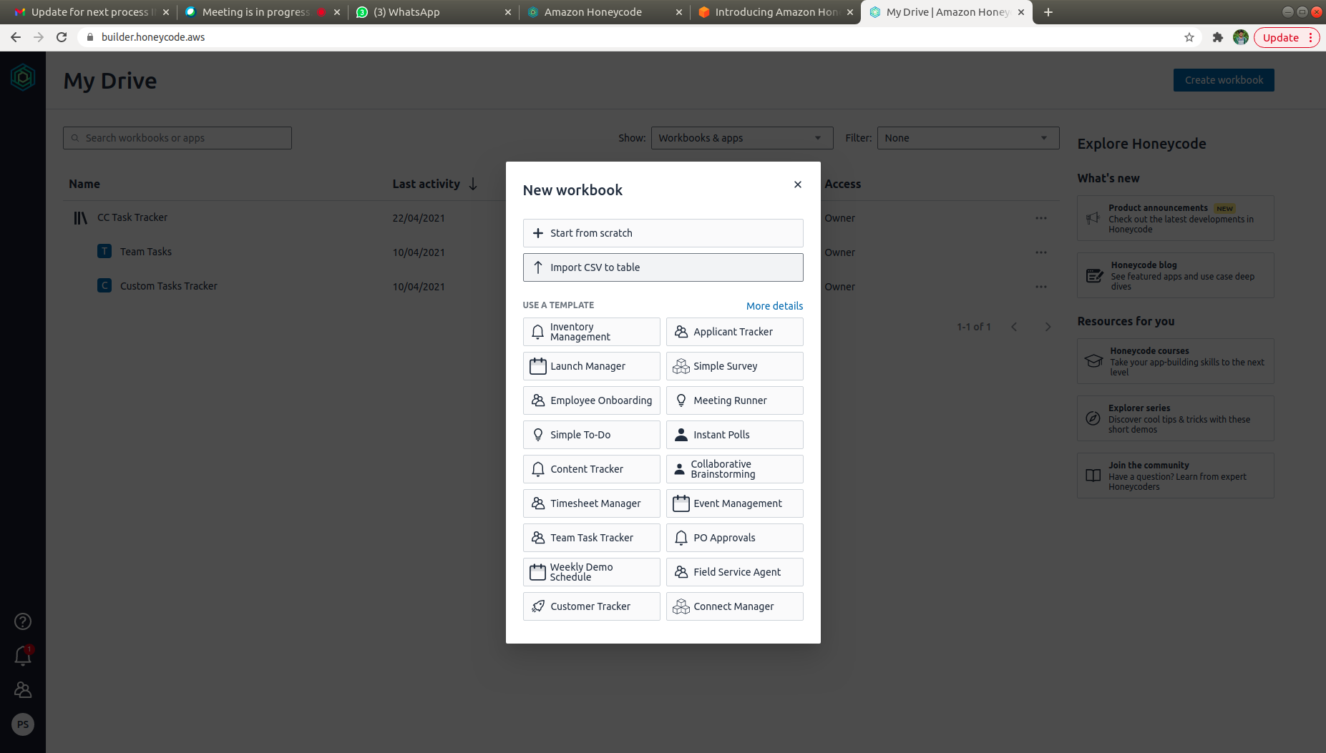

4)Select a Built-In Template for now. We’ll go with To-Do App. We get this spreadsheet for the data in our To-DO App.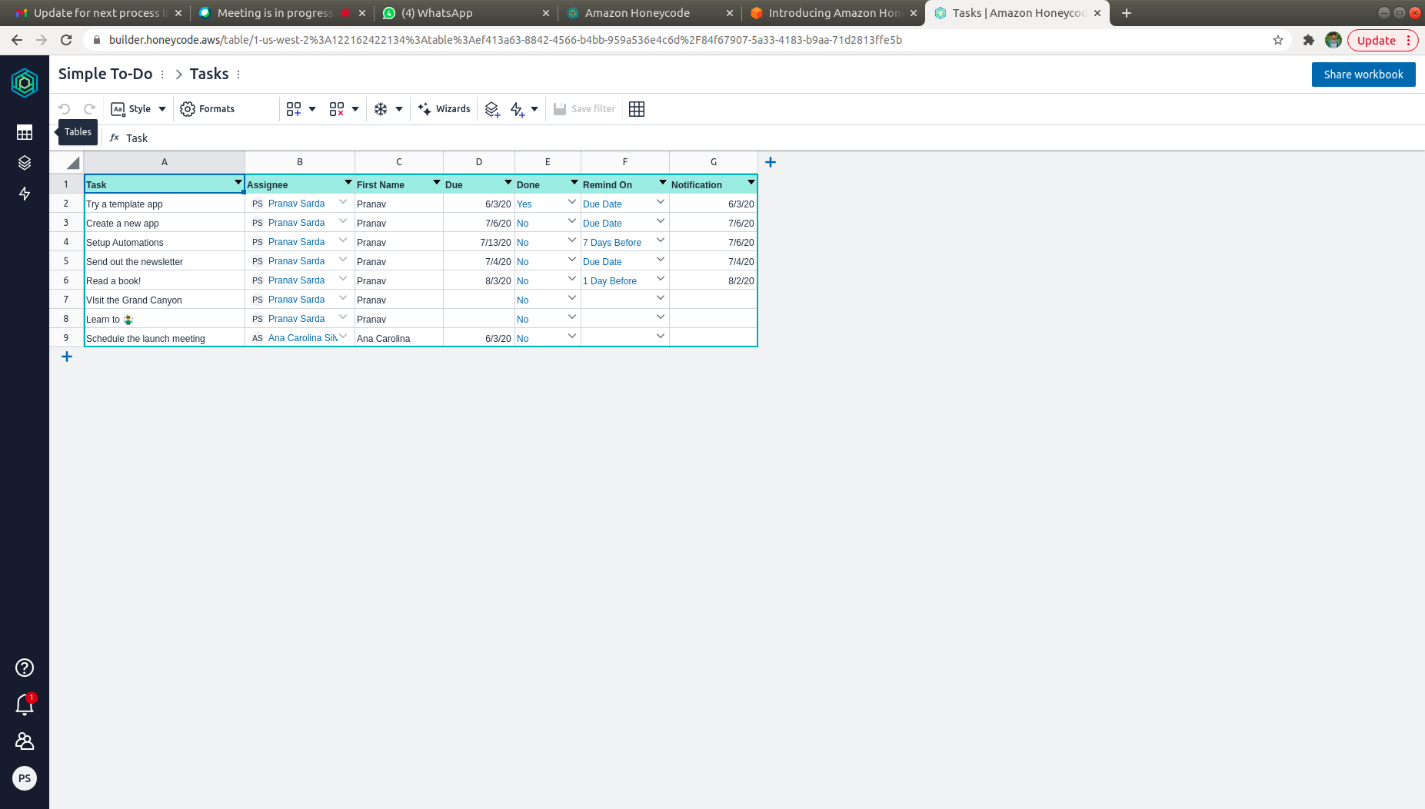

5) Now, click on Builder tab on left panel below the Tables tab, and select ToDo from there.

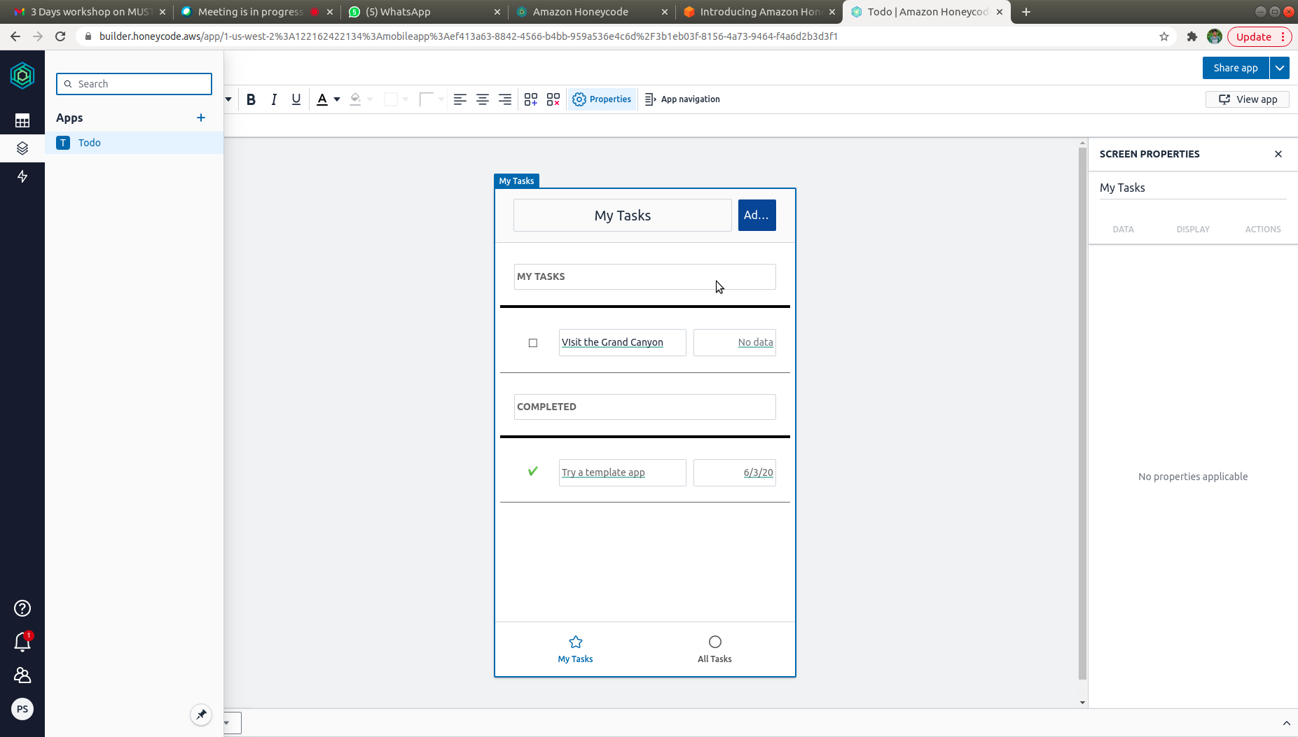

6)Here you can edit anything that should be displayed in your app. From the Bottom Navigation Bar to each and every element present.

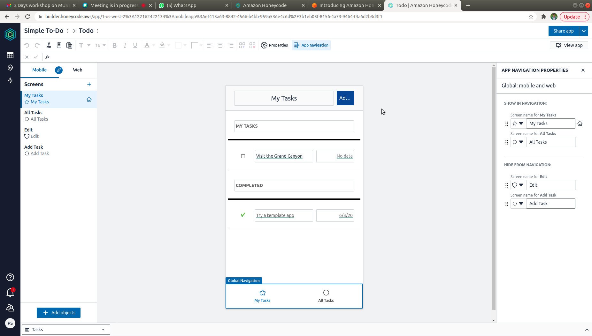

7)We can also add any kind of automations we want from the Automations tab below Builder Tab. Publish the automation from top-right corner once you set it up.

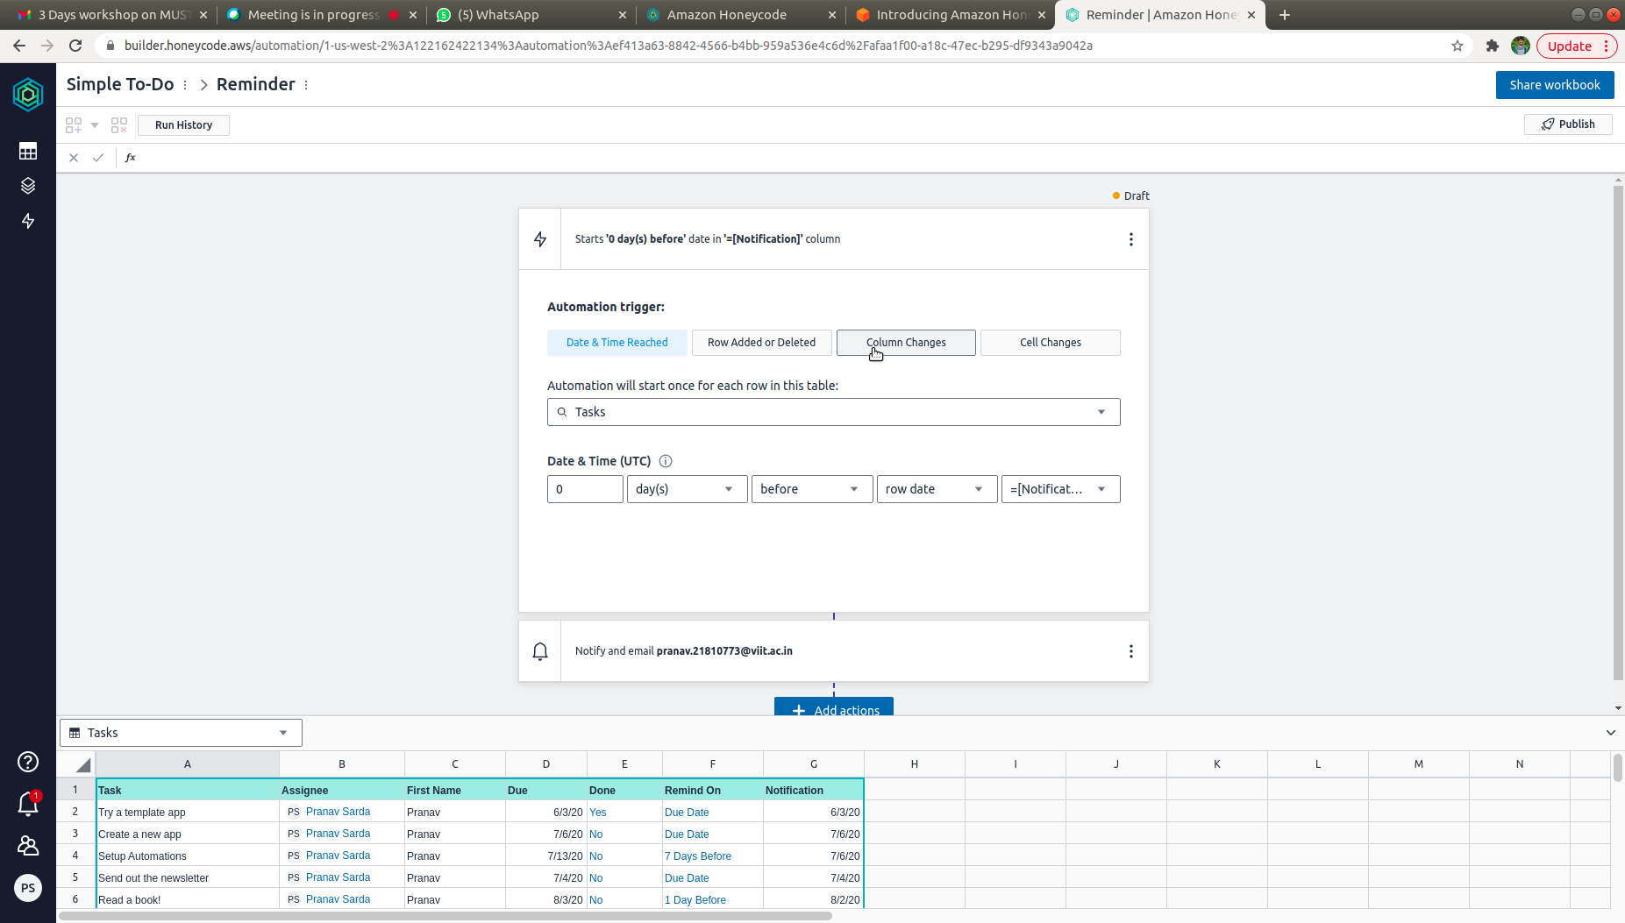

8) Go back to Builder tab and make sure your app looks good, by checking it in the Preview tab.

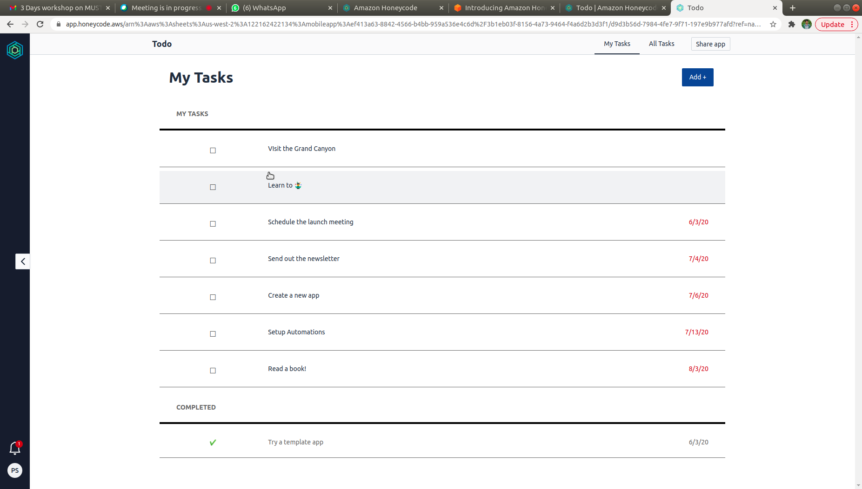

9)Click on Share App, and add all your teammates’ mails.

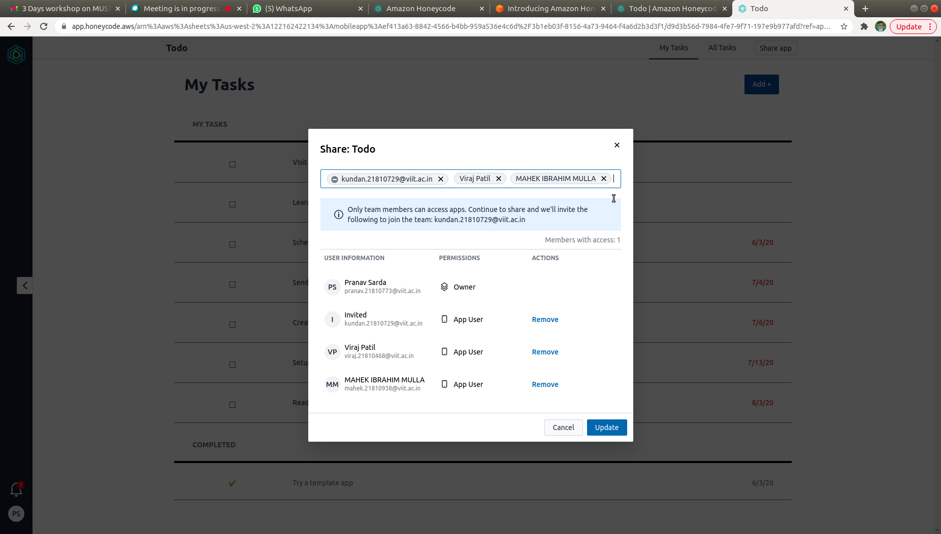

10)Install Amazon Honeycode app on your mobile phone for easy access. Lets see its various screens now.

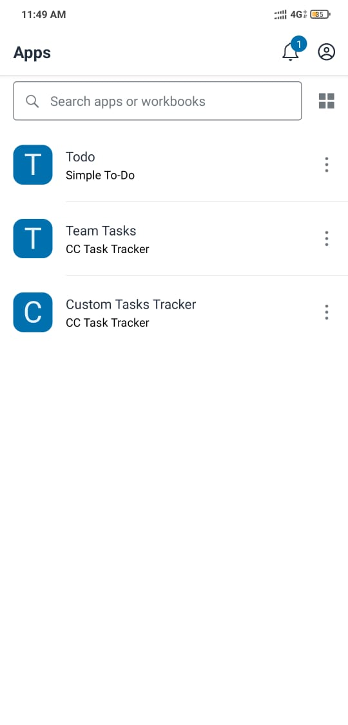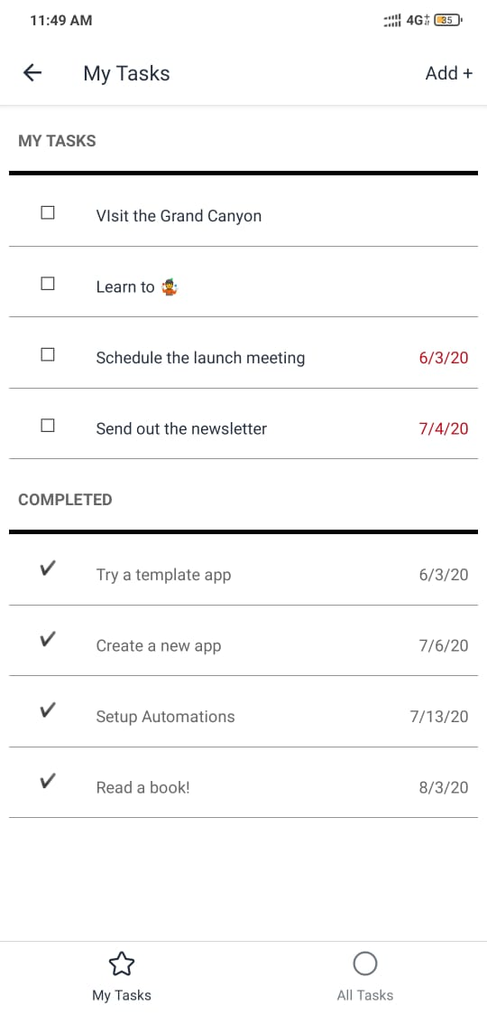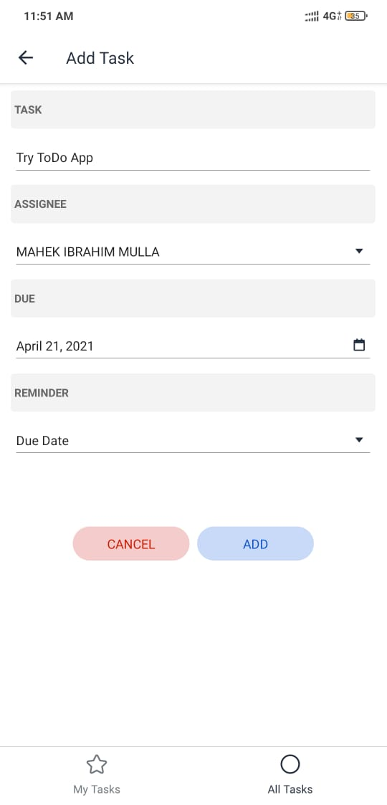

And, with that we’re done. A new custom app within 30 mins can be set up for your team!