**Archnipun hackathon user guide**

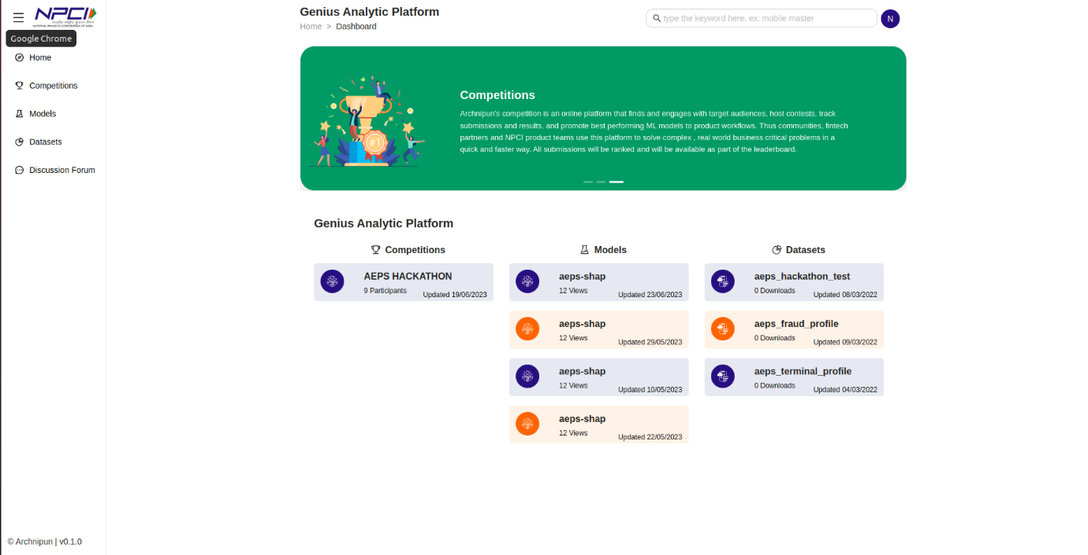

Welcome to the Archnipun, the open AI and data portal for India’s payment ecosystem hosted by NPCI.This guide will provide you with step-by-step instructions on how to login to the site and participate in a competition process and submitting your machine learning models.

**INTRODUCTION**

Archnipun is an online platform for NPCI that hosts various competitions for machine learning models focused on fraud detection in online banking transactions. This documentation will guide you through the features and functionalities of the website and instructions on how to participate in the hackathon and submit your machine learning models.

The Website is designed to facilitate a machine learning competition focused on improving online banking transaction security. Participants can develop and submit their machine learning models to detect fraudulent transactions accurately. The most accurate models will be rewarded, and winners will be announced at the end of the competition.

**Table of Contents:**

* Logging in
* Dashboard
* Competitions
* Download dataset
* Launch notebook
* Model training
* Submission & Evaluation
* Dataset

**LOGGING IN**

Visit the Hackathon Website at [website URL].

On the homepage click on "Sign In" button to access your account. Enter your registered email address and password and provide the one-time code.

**DASHBOARD**

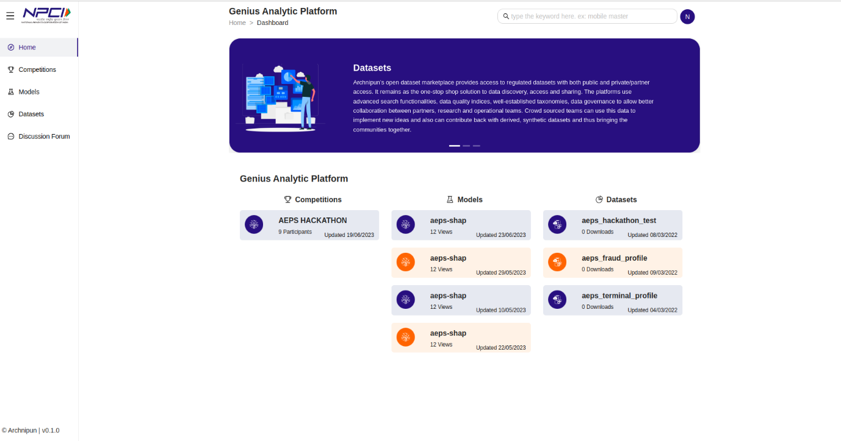

On the user dashboard you can see competition, models, and datasets. click on competition to navigate to competitions section having list of all the active competitions.

**COMPETITIONS**

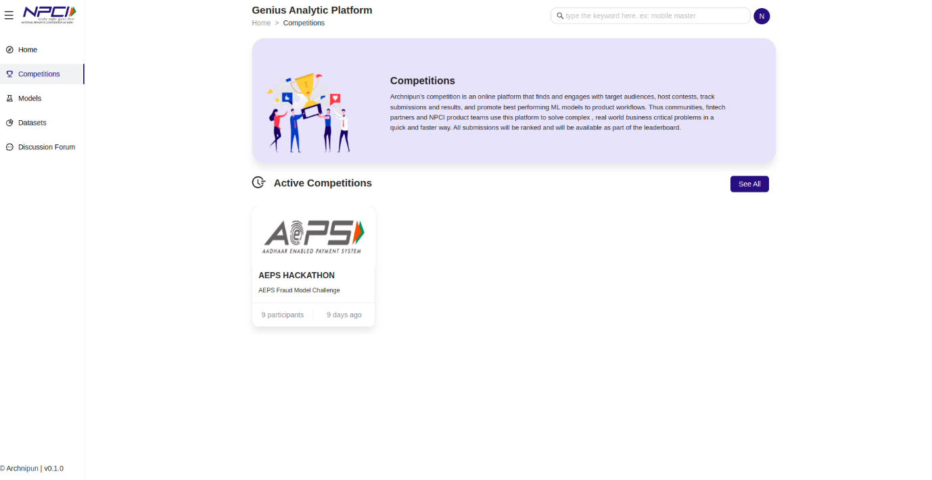

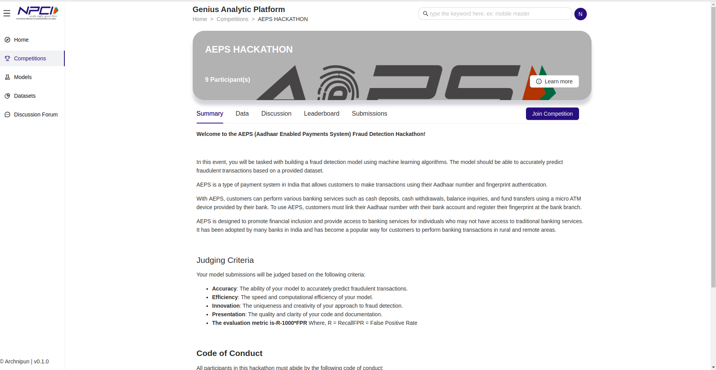

Select from the list of competitions you want to take part in (say AEPS HACKATHON). You will be directed to the competitions page. Click on join competition button, a pop up will appear on the screen. Read the rules provided and click on submit button.

**Rules:**

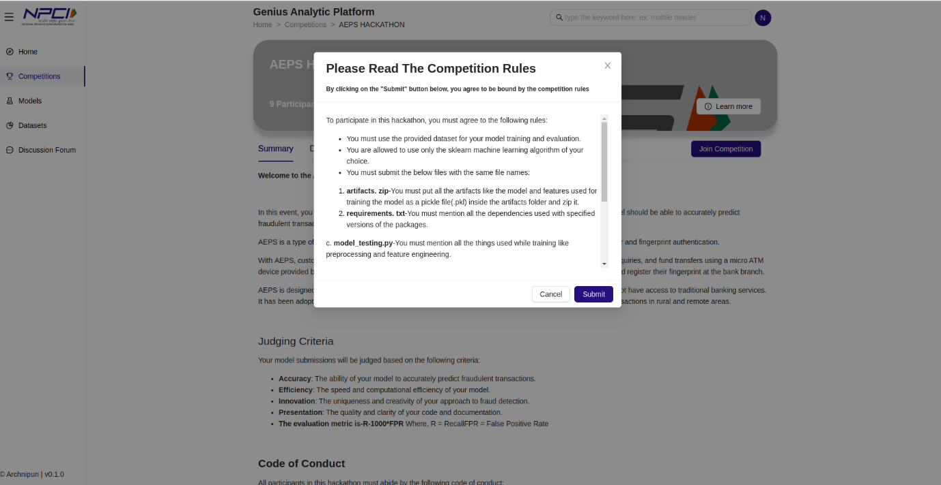

>> You must use the provided dataset for your model training and evaluation.

>> You are allowed to use only sklearn machine learning algorithm of your choice.

>> You must submit the below mentioned files with same file names:

1)artifacts.zip - You must put all the artifacts like model and features used for training the model as a pickle file(.pkl) inside the artifacts folder and zip it.

2)requirements.txt - You must mention all the dependencies used with specified versions of the packages.

3)model_testing - You must mention all the things used while training like processing and feature engineering.

>> You must put all csv files under dataset folder.

>> You must put all artifacts under artifacts folder.

>> The model_testing.py must return the submission file as "predictions.csv".

>> The model must be able to predict whether a transaction is fraudulent or not and provide a score of 0 and 1.

>> Your model should not exceed a maximum file size of 100MB.

>> You must adhere to the code of conduct.

**DOWNLOAD DATASET**

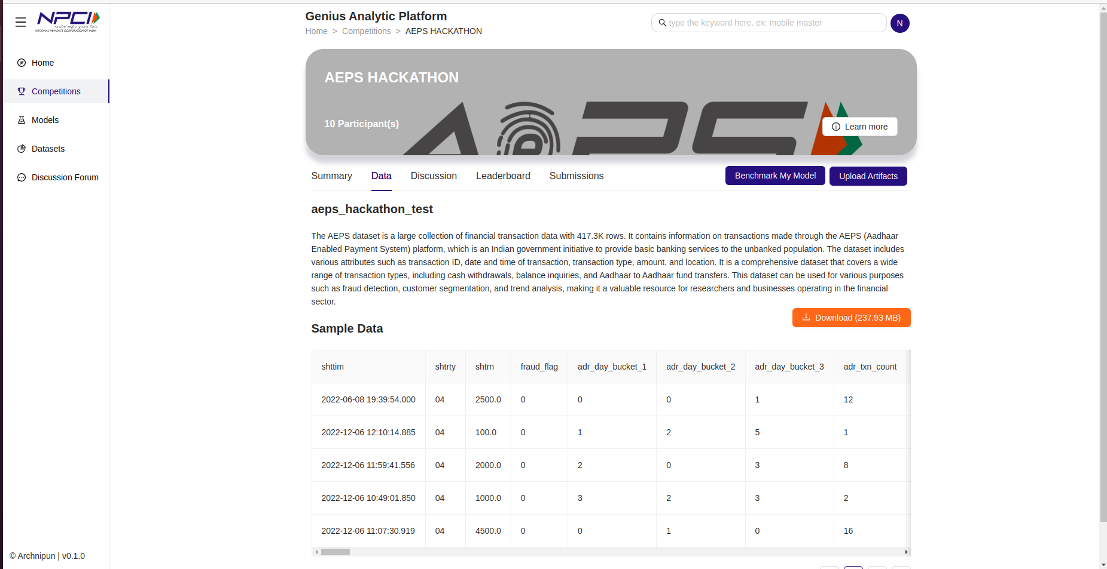

Navigate to data and click on Download button to download the training and testing dataset.

**LAUNCH NOTEBOOK**

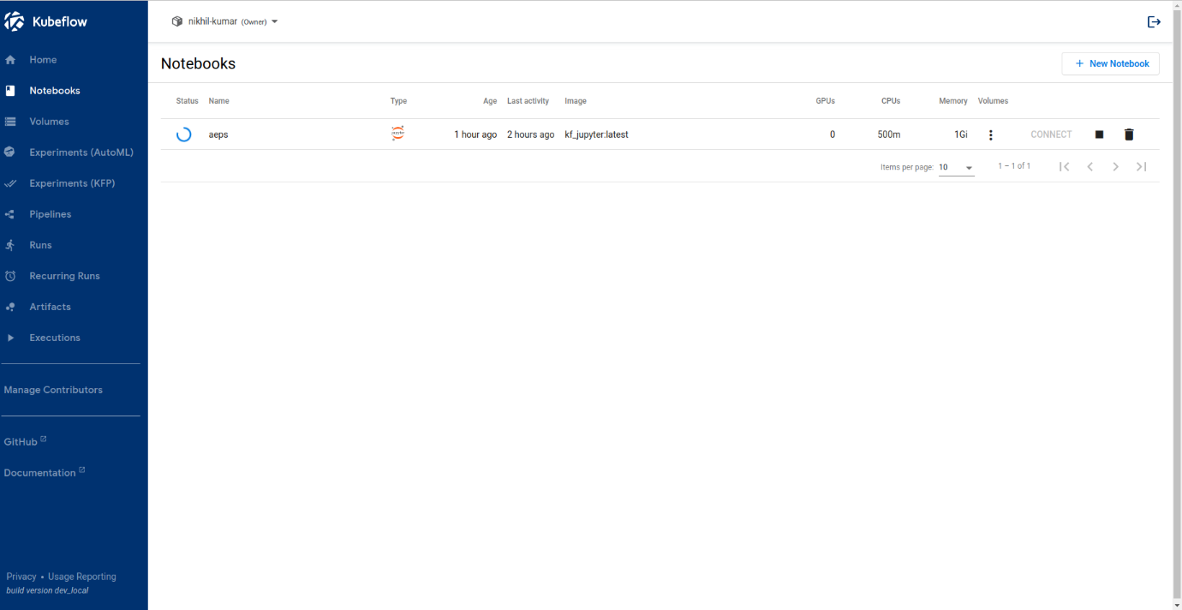

Open kubeflow navigate to notebook section and click on new notebook button. provide a name for your notebook, create a namespace and select a docker image. Leave the remaining settings to default and click on launch button.

**MODEL TRAINING**

Create a datasets and artifacts folder and a python file and run your machine learning algorithm to generate the pickle files in the artifacts folder. Download the 'model_testing.py' file.

SUBMISSION AND EVALUATION

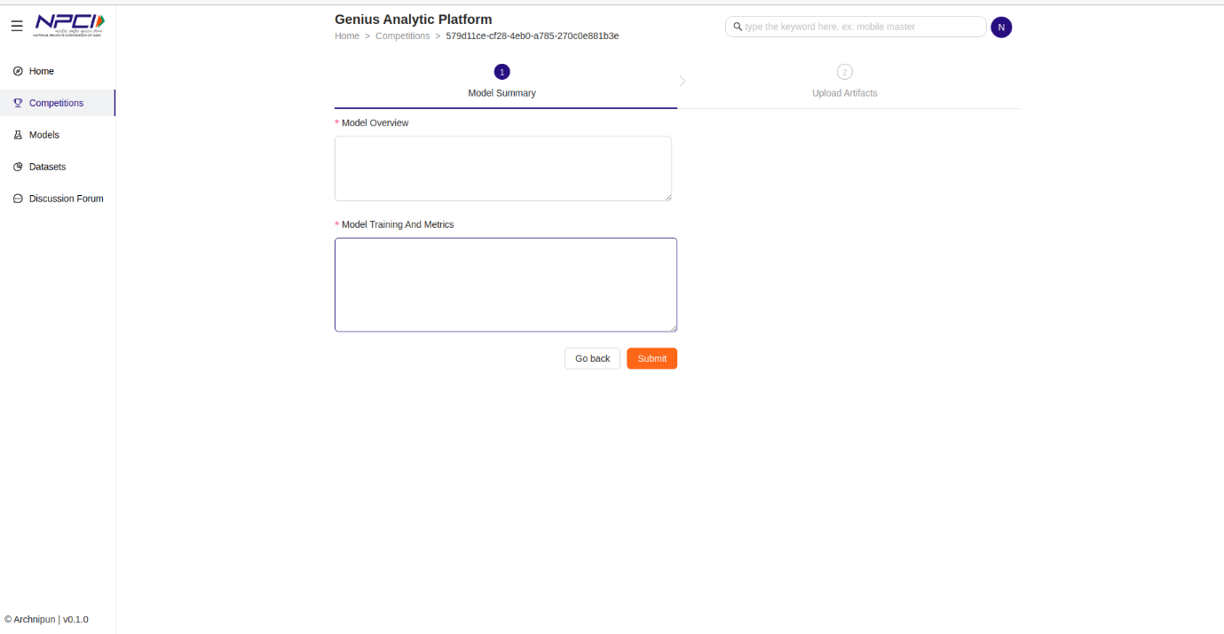

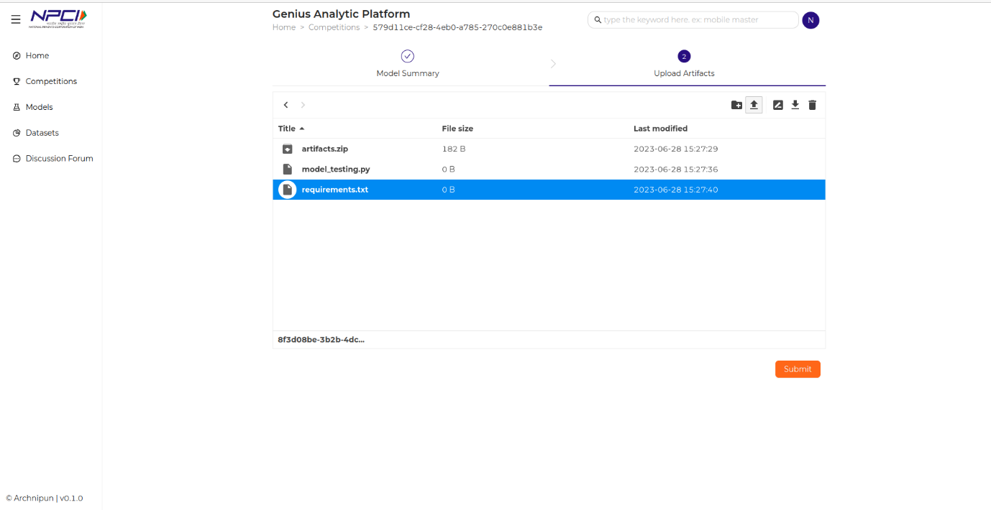

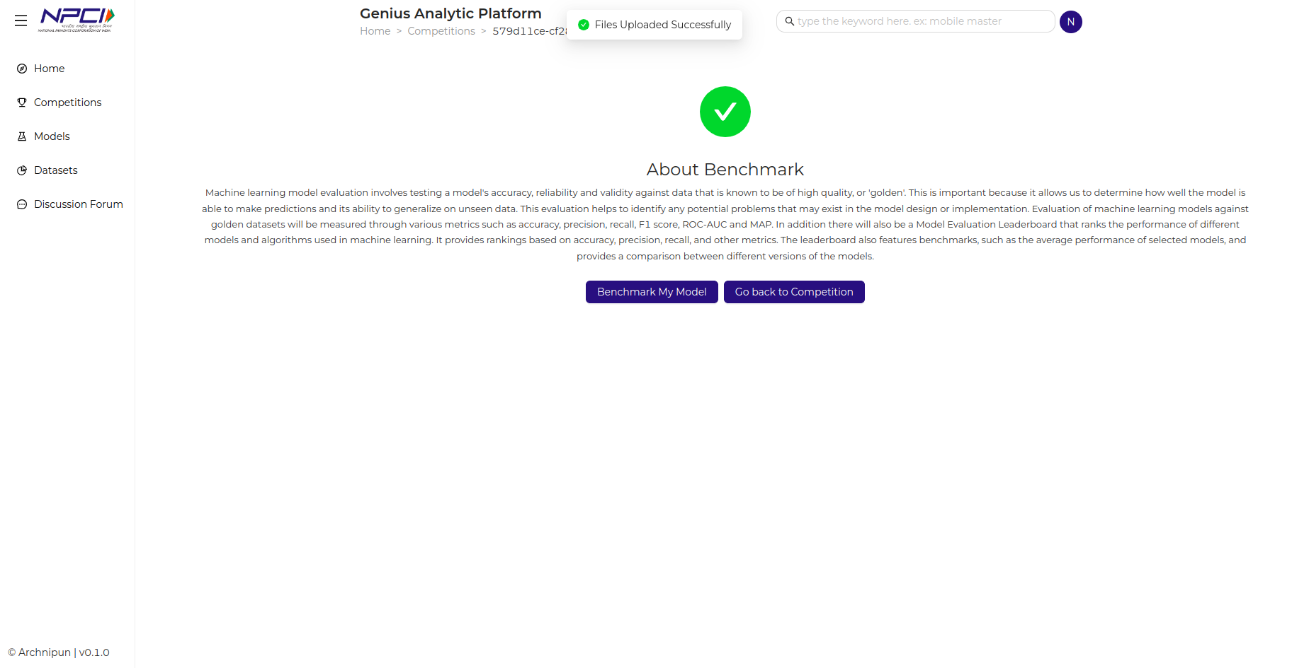

Navigate to the competitions page open the competition and click on "Upload Artifacts" button. On the submissions page provide the model summary (Model overview and Model training metrics). Click on "submit" button and proceed to upload the required files.

Upload the artifacts.zip, model_testing.py and requirements.txt file and click submit.

Click on Benchmark My Model in the next page. A pop-up message will appear on the screen stating "Submitted for evaluation".

Click on "Go back to competitions”. Now you can see your submitted models and their status under submissions section. You can also navigate to the leaderboard section.

**DATASETS**

The users are provided with various regulated datasets to test their model. Users can click on the dataset to know more about it.