02_Multi_tasks Overview

This project illustrates the timing service provided by uC/OS-II. The function OSTimeDly delays a task by a number of system ticks.

In order to start the timing service, we need a system timer interrupt the RTOS at fixed interval. In uC/OS-II port provided by Micrium, you can choose to use Timer2 or Timer4 . The choice is specified by BSP_OS_TMR_SEL (in bsp.h).

The number of ticks per second is specified by OS_TICKS_PER_SEC (in os_cfg.h). It is set to 1000 for the here, which gives 1ms per tick.

The codes in bsp.c will calculate the required settings for the timer. The system oscillator frequency can be specified in bsp.h.

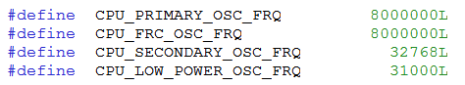

I have made some changes the values as compared to the one given by Micrium.

According to the documentation in uC/OS-II, we can only start the system timer after at least one task is created. We start the timer in Task_1. Note that Task_1 is the highest priority task in the program and as such it will run first when the scheduler starts.

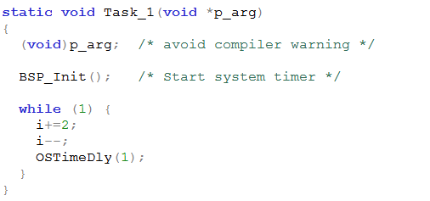

Running the program
You can simulate the program in MPLAB IDE by using the MPLAB SIM. Run the program for a while and stop it. Use the Watch window to check the values of the two global variables i and j. Now both tasks will run.

On Interrupt Service Routine with uC/OS
Note that the interrupt service routine in uC/OS-II has to be written in assembly language. However, you only need to write a small amount of code in the assembly language.

The Timer2 interrupt service routine is show below. You can modify it for other ISR. Only those in the red boxes need to be changed. The ISR name follows the name as used in C. However, you add an extra underscore “_”.

