Student ID | Student Name | Contribution %
p2518031 | Phan Jun Hao
p2518127 | Gan Hao Ern
 | Kayden Sim
SCHOOL OF COMPUTING (SOC)

This is the submission template for CA2 task a) to d) by group. Fill group members’ name and student ID below, and your answers to respective tasks in subsequent pages. Put group leader in the first row and only leader makes the submission on Brightspace.

Class: DAAA/FT/2B/24
Group Number:

CA2 Group Template
Diploma in Applied AI & Analytics
ST1501
Data Engineering

2026/2027 Semester 1

- Fill below tables for data quality issues found and how it is fixed (the changes made instead of tools/procedures). Extend the table if necessary. One sample error with description is shown here and you should delete it from your answers. Reminder that you can assume no timetable clash in the appointments and hence do not need to check it. Focus on issues described in topic E including inconsistencies, invalid values, etc.
File | Row | What’s the problem? | How do you fix it?
Loans.csv | 9107, 12230, 12231, 12232, 12233, 12234, 12235 | The ‘LoanStatus’ column had missing values. Additionally, row 9107 is missing its ‘ReturnedDatetime’ column. | For row 9107, as we are unable to determine ReturnDatetime. For the rest of the rows, we corrected the value in ‘LoanStatus’ to ‘Returned’.
Members.csv | 196 | The ‘TierID’ column was recorded as ‘T00001' | We corrected the ‘TierID’ column back to ‘T0001’
BookCopies.csv | 1173, 1186, 1123, 1240 | The ‘Status’ column was recorded as ‘Availble’ | We corrected the ‘Status’ column to the right spelling of ‘Available’.
Loans.csv | 387 | The ‘StaffID’ column has been recorded as ‘S0101’ | We corrected the ‘StaffID’ column to ‘S0001’
Members.csv | 300 | The ‘DateOfBirth’ column was null. | We corrected the ‘DateOfBirth’ column to ‘1990-05-08’ using pd.to_datetime.
Staff.csv | 27 | The ‘StartDateTime’ format was null. | We corrected the ‘StartDateTime’ column to ‘2/18/2011 13:55’ using pd.to_datetime

Submit your SQL INSERT statements for data insertion to the OLTP tables in OLTP_insert.sql. If you apply bulk loading, submit each of the cleaned data files used during insertion as well.

Paste your database diagram of your OLTP tables with the use of “database/reverse engineer” function in MySQL workbench. 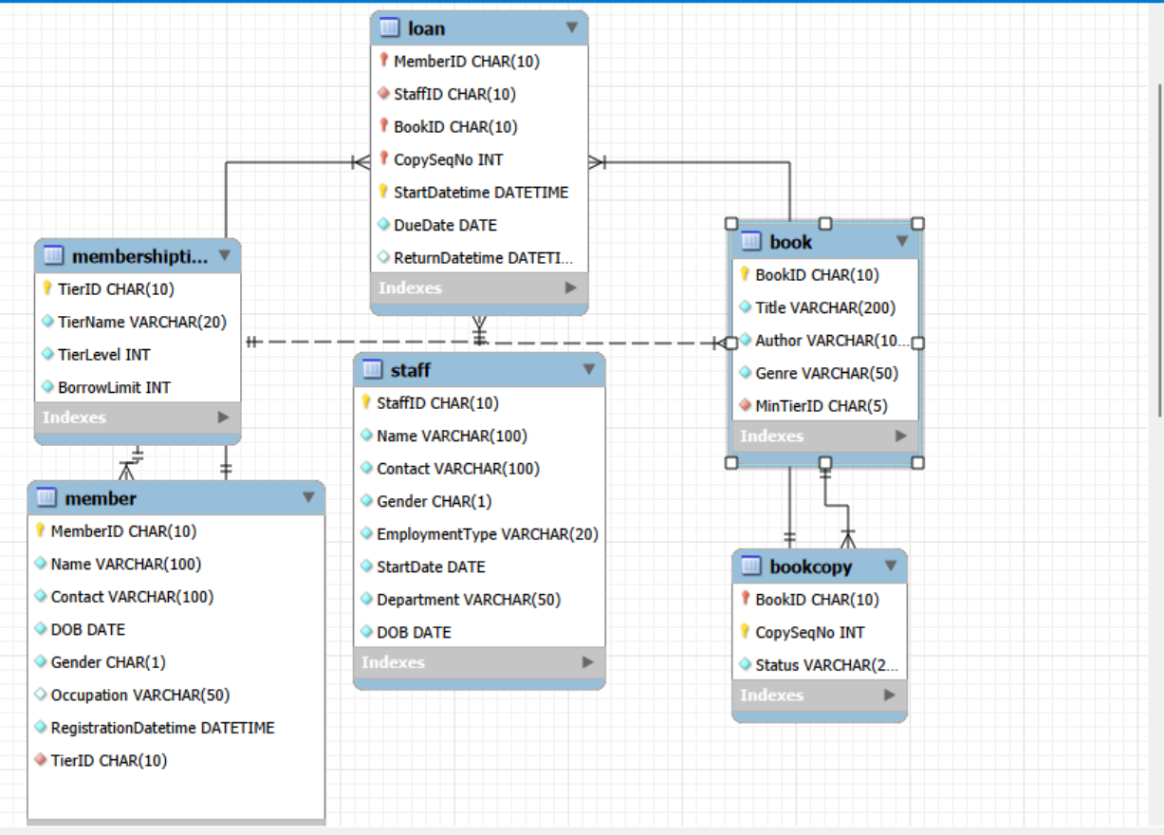

INSERT INTO MembershipTier (TierID, TierName, TierLevel, BorrowLimit)
VALUES ('T0001', 'Basic', 1, 20),
('T0002', 'Advanced', 2, 30),
('T0003', 'Premium', 3, 50),
('T9999', 'SuperAdmin', 9999, 9999);

LOAD DATA LOCAL INFILE 'C:/Users/JunHao/Downloads/DENG CA2/cleaned_members.csv'
INTO TABLE Member
FIELDS TERMINATED BY ','
OPTIONALLY ENCLOSED BY '"'
LINES TERMINATED BY '\n'
IGNORE 1 ROWS;

LOAD DATA LOCAL INFILE 'C:/Users/JunHao/Downloads/DENG CA2/cleaned_staff.csv'
INTO TABLE Staff
FIELDS TERMINATED BY ','
OPTIONALLY ENCLOSED BY '"'
LINES TERMINATED BY '\n'
IGNORE 1 ROWS;

LOAD DATA LOCAL INFILE 'C:/Users/JunHao/Downloads/DENG CA2/cleaned_books.csv'
INTO TABLE Book
FIELDS TERMINATED BY ','
OPTIONALLY ENCLOSED BY '"'
LINES TERMINATED BY '\n'
IGNORE 1 ROWS;

LOAD DATA LOCAL INFILE 'C:/Users/JunHao/Downloads/DENG CA2/cleaned_bookcopies.csv'
INTO TABLE BookCopy
FIELDS TERMINATED BY ','
OPTIONALLY ENCLOSED BY '"'
LINES TERMINATED BY '\n'
IGNORE 1 ROWS;

LOAD DATA LOCAL INFILE 'C:/Users/JunHao/Downloads/DENG CA2/cleaned_loans.csv'
INTO TABLE Loan
FIELDS TERMINATED BY ','
OPTIONALLY ENCLOSED BY '"'
LINES TERMINATED BY '\n'
IGNORE 1 ROWS;

- Design your DW using star or snowflake schema. Paste your ERD that illustrates your design in the box below, with a short explanation of key design focus and considerations.

Briefly explain your design, such as choice of dimensions/measurements, assumptions and considerations, etc.

- Submit your CREATE table statements for DW table creations in DW_create.sql. Use appropriate SQL statements to extract and load data from OLTP tables to the DW and submit all your queries in DW_insert.sql.

Paste your database diagram for your DW in the box below. Explain with data to show how you verify that your insertion is successful.
CREATE TABLE MembershipTier (
TierID CHAR(10) PRIMARY KEY,
TierName VARCHAR(20) NOT NULL,
TierLevel INT NOT NULL,
BorrowLimit INT NOT NULL
);

CREATE TABLE Member (
MemberID CHAR(10) PRIMARY KEY,
Name VARCHAR(100) NOT NULL,
Contact VARCHAR(100) NOT NULL,
DOB DATE NOT NULL,
Gender CHAR(1) NOT NULL,
Occupation VARCHAR(50) NULL,
RegistrationDatetime DATETIME NOT NULL,
TierID CHAR(10) NOT NULL,
FOREIGN KEY (TierID) REFERENCES MembershipTier(TierID)
);

CREATE TABLE Staff (
StaffID CHAR(10) PRIMARY KEY,
Name VARCHAR(100) NOT NULL,
Contact VARCHAR(100) NOT NULL,
Gender CHAR(1) NOT NULL,
EmploymentType VARCHAR(20) NOT NULL,
StartDate DATE NOT NULL,
Department VARCHAR(50) NOT NULL,
DOB DATE NOT NULL
);

CREATE TABLE Book (
BookID CHAR(10) PRIMARY KEY,
Title VARCHAR(200) NOT NULL,
Author VARCHAR(100) NOT NULL,
Genre VARCHAR(50) NOT NULL,
MinTierID CHAR(5) NOT NULL,
FOREIGN KEY (MinTierID) REFERENCES MembershipTier(TierID)
);

CREATE TABLE BookCopy (
BookID CHAR(10) NOT NULL,
CopySeqNo INT NOT NULL,
Status VARCHAR(20) NOT NULL,
PRIMARY KEY (BookID, CopySeqNo),
FOREIGN KEY (BookID) REFERENCES Book(BookID)
);

CREATE TABLE Loan (
MemberID CHAR(10) NOT NULL,
StaffID CHAR(10) NOT NULL,
BookID CHAR(10) NOT NULL,
CopySeqNo INT NOT NULL,
StartDatetime DATETIME NOT NULL,
DueDate DATE NOT NULL,
ReturnDatetime DATETIME NULL,
PRIMARY KEY (MemberID, BookID, CopySeqNo, StartDatetime),
FOREIGN KEY (MemberID) REFERENCES Member(MemberID),
FOREIGN KEY (StaffID) REFERENCES Staff(StaffID),
FOREIGN KEY (BookID, CopySeqNo) REFERENCES BookCopy(BookID, CopySeqNo)
);
- Describe and discuss your analysis done using the DW. Briefly explain clearly your objective, results and insights for each analysis. Your group should produce 6 different analyses if group size is 3, or 8 different analyses if group size is 4. Separately submit all your queries in DW_query.sql. (So do not include your statements in this template, only results and discussion)
1.

2.

3.

4.

5.

6.

7.

8.

