Noodlefighter OSU keyboard简易组装说明书

完整版组装：
螺母
螺丝 | 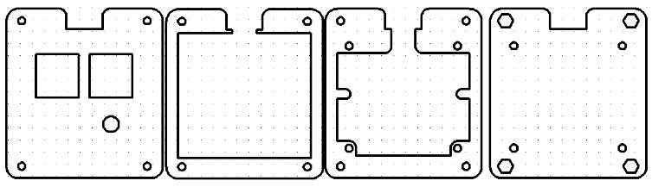 |  |  |  | 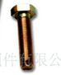  12mm | 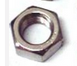  普通螺母 | 10mm | 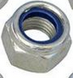  防滑螺母
数量 | 1 | 3 厚x1,薄x2 | 1 | 1 | 4 | 4 | 4 | 4
说明 | 外壳  顶部 | 外壳  边框 | 外壳  电路板支撑 | 外壳  底板 | 外壳固定 |  | 电路板固定  装配防滑螺母时需要钳子固定
其他：电路板x1，樱桃轴键帽x2，微动按键键帽x1，防滑垫x1，mini-usb数据线x1
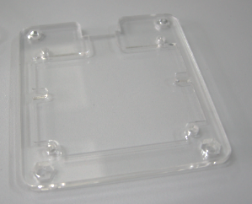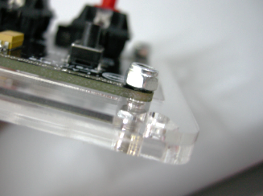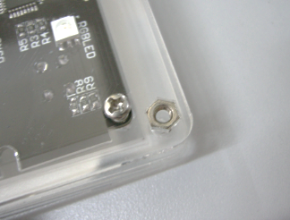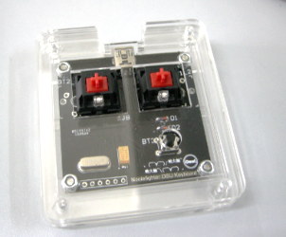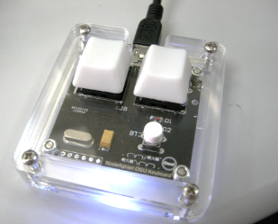
步骤：
1.洗手（油污粘在亚克力上效果啧啧啧），撕下亚克力外壳的保护膜
2.将“外壳底板”“外壳-电路板支撑”“电路板”，依次叠放，以“防滑螺母”“10mm螺丝”固定（螺母在上，请用钳子固定螺母）
3.将“普通螺丝”装入底板里，将“外壳顶部”“外壳边框”堆叠，置于“外壳-电路板支撑”之上，以“12mm螺丝”固定。
4.装上键帽，贴上防滑垫（请自行剪裁。为稳定，尽量贴在边缘；为防滑，可以适当增大使用面积）

Brief Noodlefighter OSU keyboard instructions of assembly

Full version of the assembly：
Nut

Screw |  |  |  |  | 12mm | Normal nut | 10mm | Antiskid nut
Number | 1 | 3 thickx1,thinx2 | 1 | 1 | 4 | 4 | 4 | 4
Of each | Top of  shell | Frame of  shell | Strut of circuit board | Bottom of  shell | Fixing shell |  | Fixing circuit board  need a plier to fix the antiskid nut
Other：circuit board x1，keyboard cap with Cherry shaft x2，microswitch cap x1，Antiskid mat x1，mini-usb datawirex1
Steps：
1. Wash your hand（Acrylic met with greasy hands may cause some ‘ops’）, and tear off the protective film on the Acrylic shell.
2. Stack up the bottom of shell, the strut of circuit board and the circuit board in proper order, and use 10mm screw and antiskid nut to fix them（nut above screw, please use plier to fix them）.
3. Load the normal screw into bottom shell, then stack up the top of shell and the frame of shell in proper order, which should be placed above the struct of circuit borad, finally use 12mm screw to fix them.
4. Mount the caps, and paste the antiskid mat（Please clip it yourself. For stabilization, try to paste it on the margin; For anti-skidding, you can enlarge the area of use properly）.

