Computer Communications and Networks (COMN)
2020/21, Semester 2

Assignment 2 Results Sheet

Forename and Surname: | Minsung Kim
Matriculation Number: | S1857642

Question 1 – Number of retransmissions and throughput with different retransmission timeout values with stop-and-wait protocol. For each value of retransmission timeout, run the experiments for 5 times and write down average number of retransmissions and average throughput.

Retransmission timeout (ms) | Average number of  re-transmissions | Average throughput  (Kilobytes per second)
5 | 994.6 | 72.27
10 | 632.6 | 65.42
15 | 121 | 63.77
20 | 95.8 | 67.69
25 | 112.2 | 56.98
30 | 107 | 55.35
40 | 105.6 | 53.51
50 | 108.8 | 52.05
75 | 100.4 | 39.62
100 | 96.4 | 33.55

Question 2 – Discuss the impact of retransmission timeout value on the number of retransmissions and throughput. Indicate the optimal timeout value from a communication efficiency viewpoint (i.e., the timeout that minimizes the number of retransmissions while ensuring a high throughput).

There are more retransmissions if a value of retransmission timeout is low because there are more premature timeouts. Less retransmissions if retransmission timeout value is high. Throughput will be high and low if values of retransmission timeout are low and high because it does not need to wait more than actual delay which is 5ms one way in this case. For the optimal timeout, ideally, 10ms will be the best since it is supposed to take 10ms to send a data packet and get an ack packet, so there will be no premature timeout if I wait for 10ms; therefore, I will get the minimum retransmission and high enough throughput. I got average 17ms round trip delay by using ping 127.0.0.1 command under 5ms one way delay setting, so 20ms seems the best in my case.

Question 3 – Experimentation with Go-Back-N. For each value of window size, run the experiments for 5 times and write down average throughput.

 | Average throughput (Kilobytes per second)
Window Size | Delay = 5ms | Delay = 25ms | Delay = 100ms
1 | 8.53 | 4.34 | 0.94
2 | 21.13 | 7.91 | 2.53
4 | 41.41 | 14.23 | 4.4
8 | 55.48 | 21.01 | 8.32
16 | 86.53 | 32.74 | 13.96
32 | 95.05 | 55.89 | 20.29
64 | 111.13 | 61.7 | 23.88
128 | 108.02 | 52.75 | 21.9
256 | 76.05 | 55.94 | 17.49

Create a graph as shown below using the results from the above table:

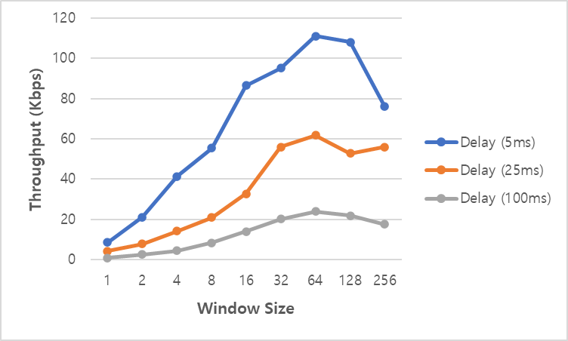

Question 4 – Discuss your results from Question 3.

I chose 60ms and 210ms timeout values for 25ms and 100ms delay for sake of margin. I would not get immature timeout by this setting. It seems more window size make the transfer faster; however, the connection seems to get chocked by bandwidth when the window size is same or more than 128 because I send hundreds of packets every single time. I verified this by changing bandwidth from 10Mbps to 100Mbps, so window size 256 becomes to have the highest throughput. Average throughput gets smaller as delay gets higher.

Question 5 – Experimentation with Selective Repeat. For each value of window size, run the experiments for 5 times and write down average throughput.

 | Average throughput (Kilobytes per second)
Window Size | Delay = 25ms
1
2
4
8
16
32

Question 6 - Compare the throughput obtained when using “Selective Repeat” with the corresponding results you got from the “Go Back N” experiment and explain the reasons behind any differences.

There will be no difference between them since their efficiency is identical. If the window size gets bigger, then Selective Repeat will get benefits from it since it wastes less bandwidth.

Question 7 – Experimentation with iperf. For each value of window size, run the experiments for 5 times and write down average throughput.

 | Average throughput (Kilobytes per second)
Window Size (KB) | Delay = 25ms
1
2
4
8
16
32

Question 8 - Compare the throughput obtained when using “Selective Repeat” and “Go Back N” with the corresponding results you got from the iperf experiment and explain the reasons behind any differences.

