

**APP 4080 COLLABORATIVE SOFTWARE DEVELOPMENT**

**Project Management Using GitHub Group Assignment**

**Project Name: Online Marketplace Platform**

**GROUP MEMBERS**

1. **Alex Samia 664268**
2. **Amos Ongere 662916**
3. **Ahmed Kale 665024**
4. **Katana Tumaini 66523**

**Introduction**

As per the objectives of the assignment this is an **Online Marketplace Site in PHP**. This web-based application project we developed in **PHP** and **MySQL Database**. It allows sellers to publish their selling items. The application has a pleasant user interface using the **Bootstrap v5 Framework** and **Material Kit Template**. It also consists of user-friendly features and functionalities.

**About the Online Market Place Site in PHP**

We developed this project using the following:

1. [**XAMPP v3.3.0**](https://apachefriends.org/)
2. **PHP**
3. **MySQL Database**
4. **HTML**
5. **CSS**
6. **JavaScript**
7. **Ajax**
8. **jQuery**
9. **Bootstrap**
10. **Google Material Icon**
11. [**Material Kit 2 Template**](https://demos.creative-tim.com/material-kit/presentation)

This **Online Marketplace Site in PHP** is composed of 3 User Interfaces which are the **Admin Panel**, **Seller Panel**, and **Public Site**. The **Admin Panel** is the side of the system where the system management can manage all the project data. **Admin Users** have the privilege to access and manage all the products or items that the seller published. They can also manage the list of users where they can update and delete sellers' data. The **Seller Panel** is the side of the system where the seller can manage their published items. The seller can add images and some information about the product that they are selling such as the item's specifications. They can set the quantity or stock that they have in each item they published. On the **Public Site**, site visitors or anonymous users can search for their desired product to check if someone posted a product that they wanted. Users can list all the available products and view each item's details. The posted product details also contain or display the seller's basic information and links where the possible buyer can contact them.

**Creation of repository and adding of the collaborators**

**Repository named as Collab-lab 2**

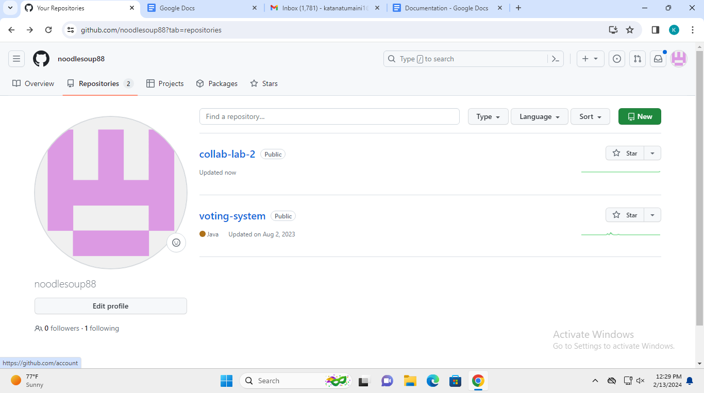

**collaborators**

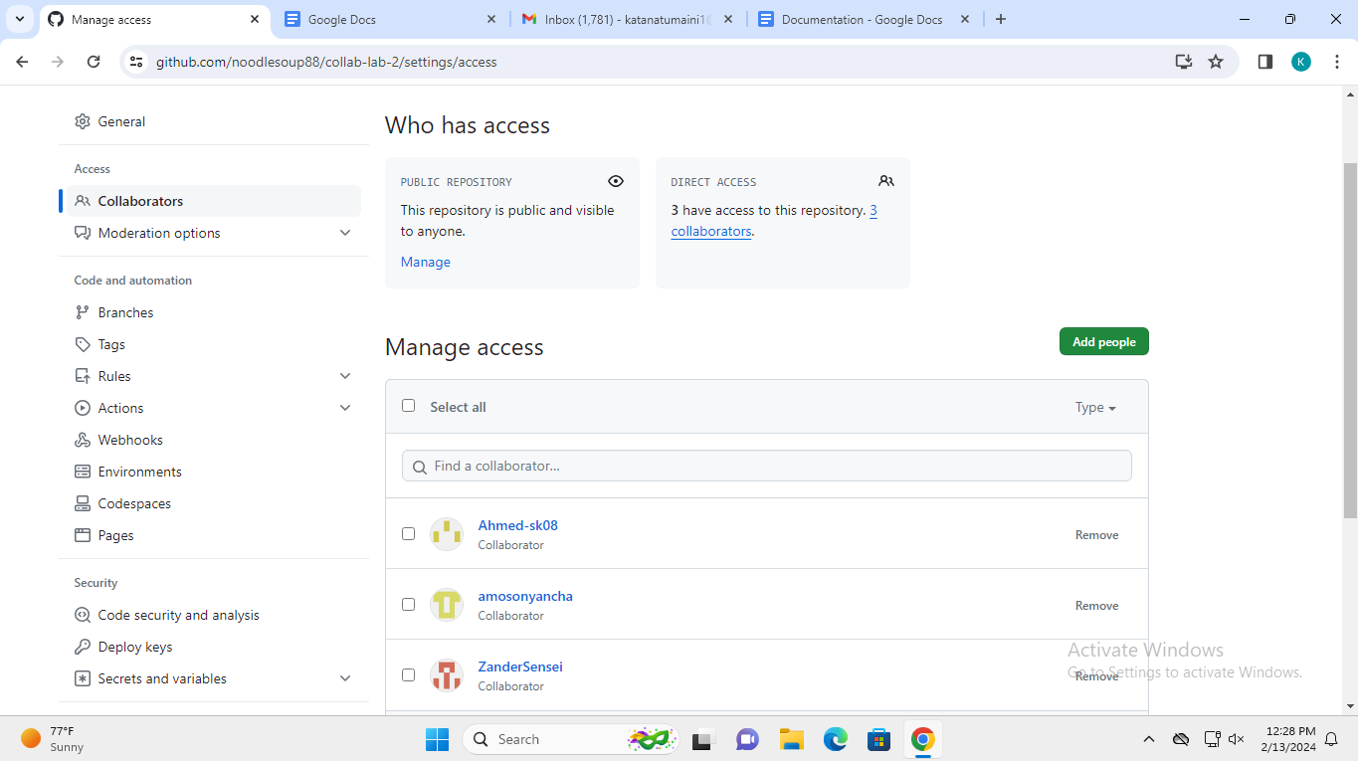

**Creation of project that contains the kanban board**

**lab2**

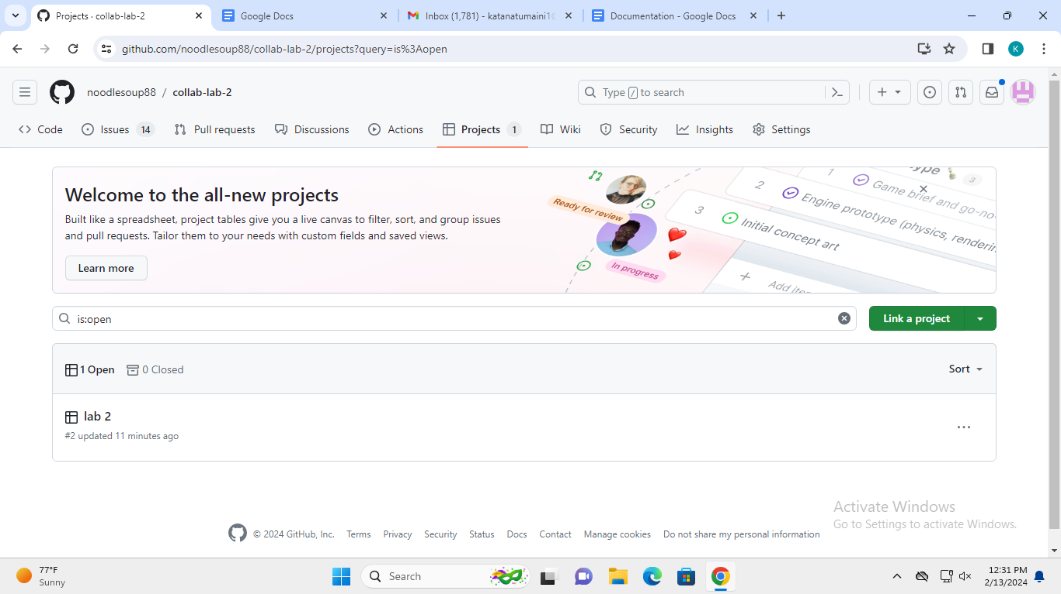

**Addition of the group members to the project**

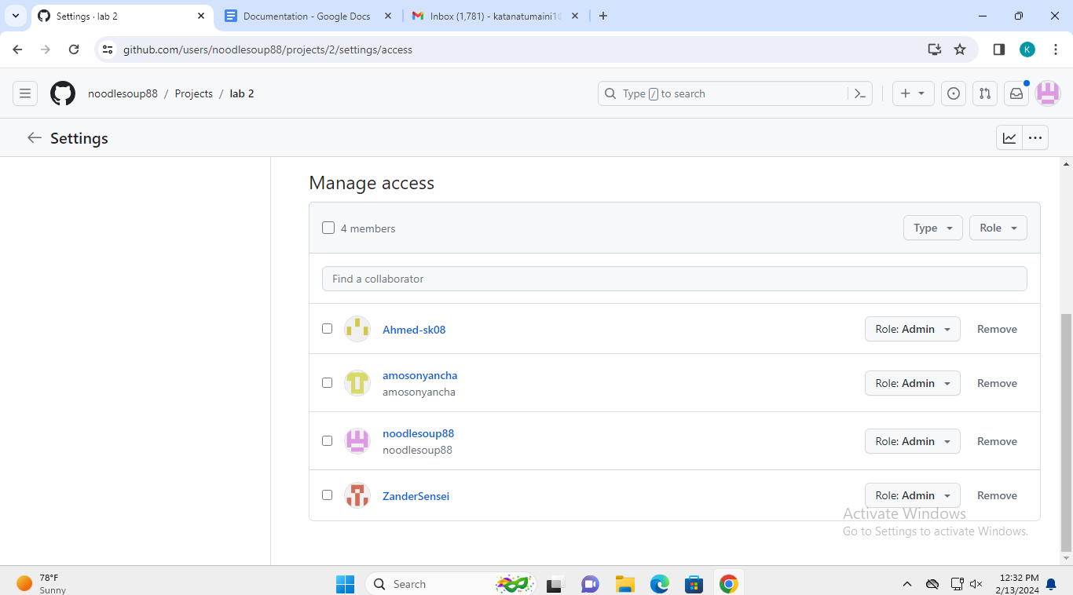

**Kanban board containing the tasks to be addressed, tasks in progress and tasks that have been completed**

Each task has a group member assigned to complete it, note the avatars at the end of the each issue.

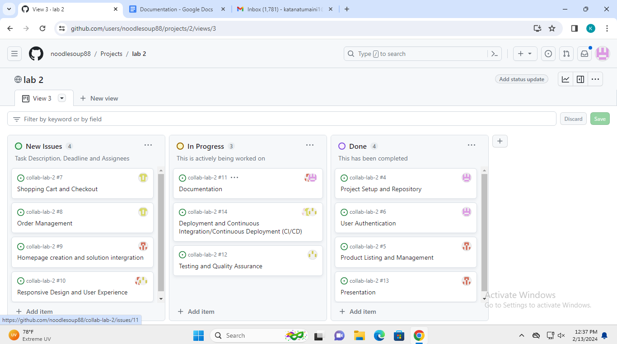

**Features of the Online Market Place**

**Admin-Side**

* **Home Page**
  + Display the summary of the list.
* **Category Management**
  + Add New Category
  + List All Categories
  + View Category Details
  + Edit Category Details
  + Delete Category Details
* **User Management**
  + Add New User
  + List All Users
  + View User Details
  + Edit User Details
  + Reset User Password
  + Delete User Details
* **Product Management**
  + List All Products
  + View Product Details
  + Edit Product Details
  + Delete Product Details
* **Update System Information**
* **Update Account Details/Credentials**
* **Login and Logout**

**Seller-Side**

* **Home Page**
  + Display the summary of the list.
* **Product Management**
  + Add New Product
  + List All Products
  + View Product Details
  + Edit Product Details
  + Delete Product Details
* **Update Account and Contact Details/Credentials**
* **Login and Logout**

**Public-Side**

* **Home Page**
  + Display the Welcome Content.
* **'About Us' Content**
* **List All Available Products**
* **View Product Details**
* **Redirect to Seller's Website**
* **Redirect to Seller's FB Page**
* **Get Seller's Contact Details**
* **Search Product**

System Snapshots of some Features implemented

**Public Site**

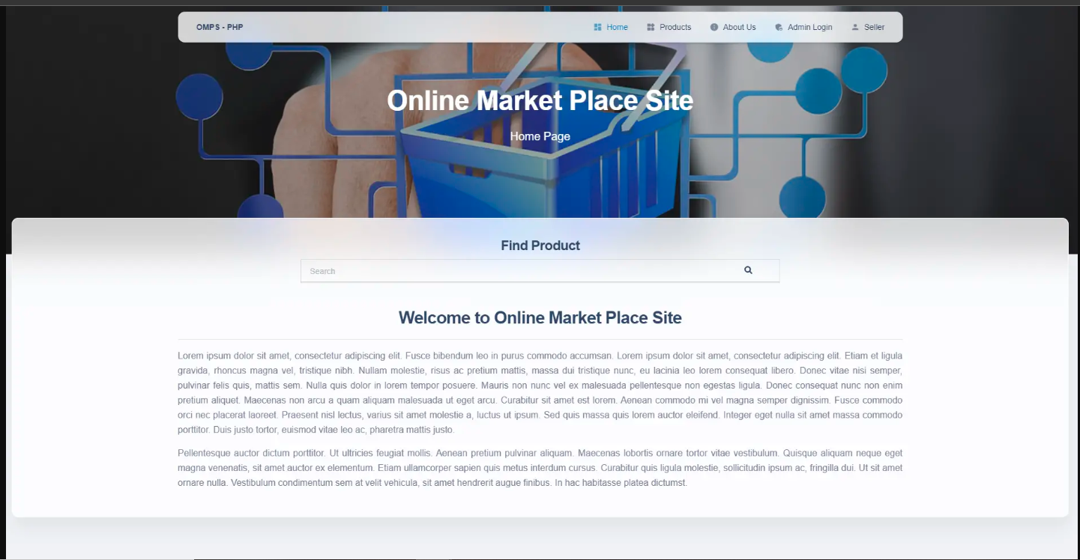

**Product List (Public-Side)**

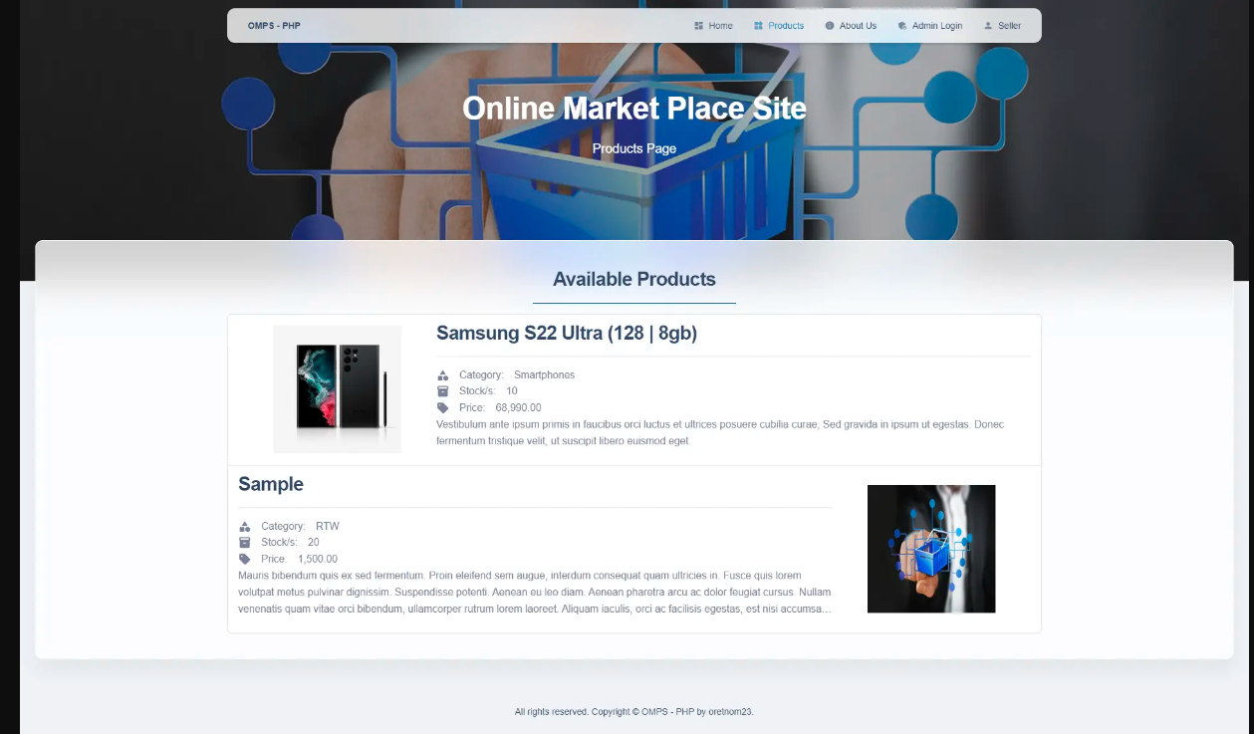

**Product Details**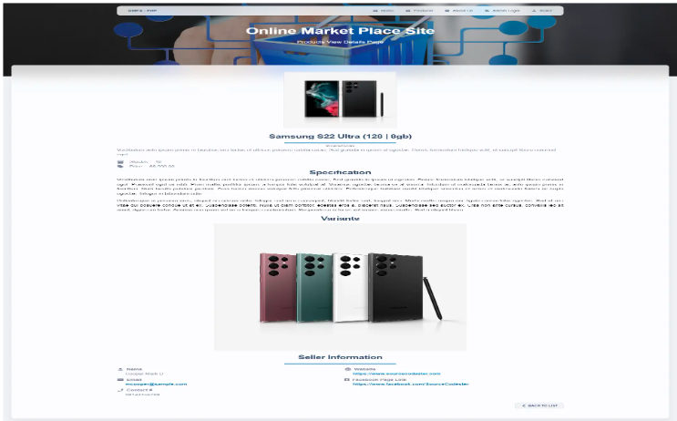

**Seller Registration Form**

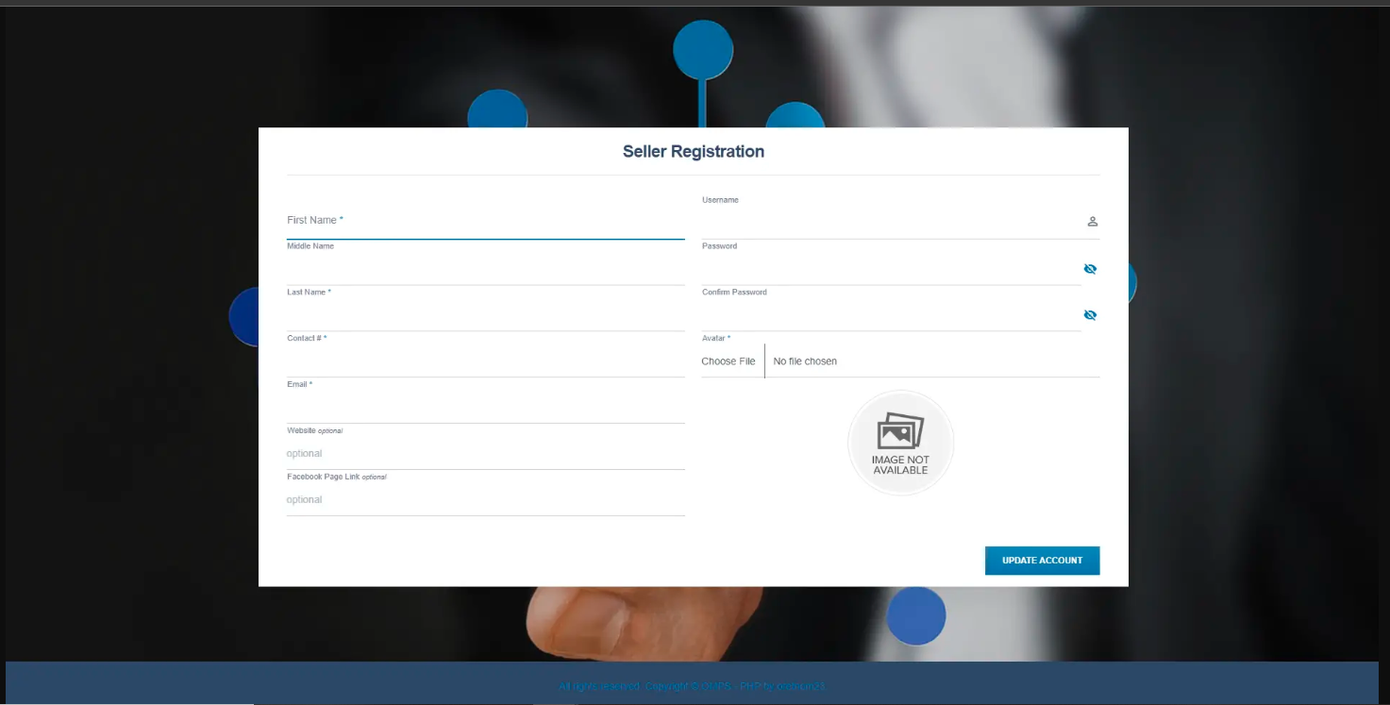

**Seller Panel**

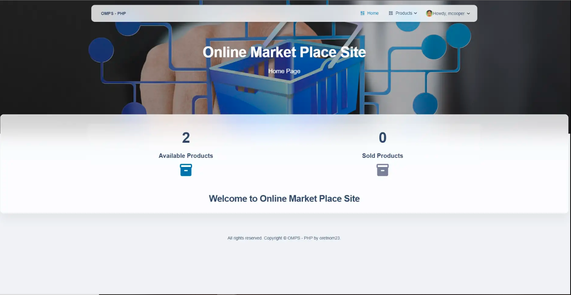

**Admin Panel**

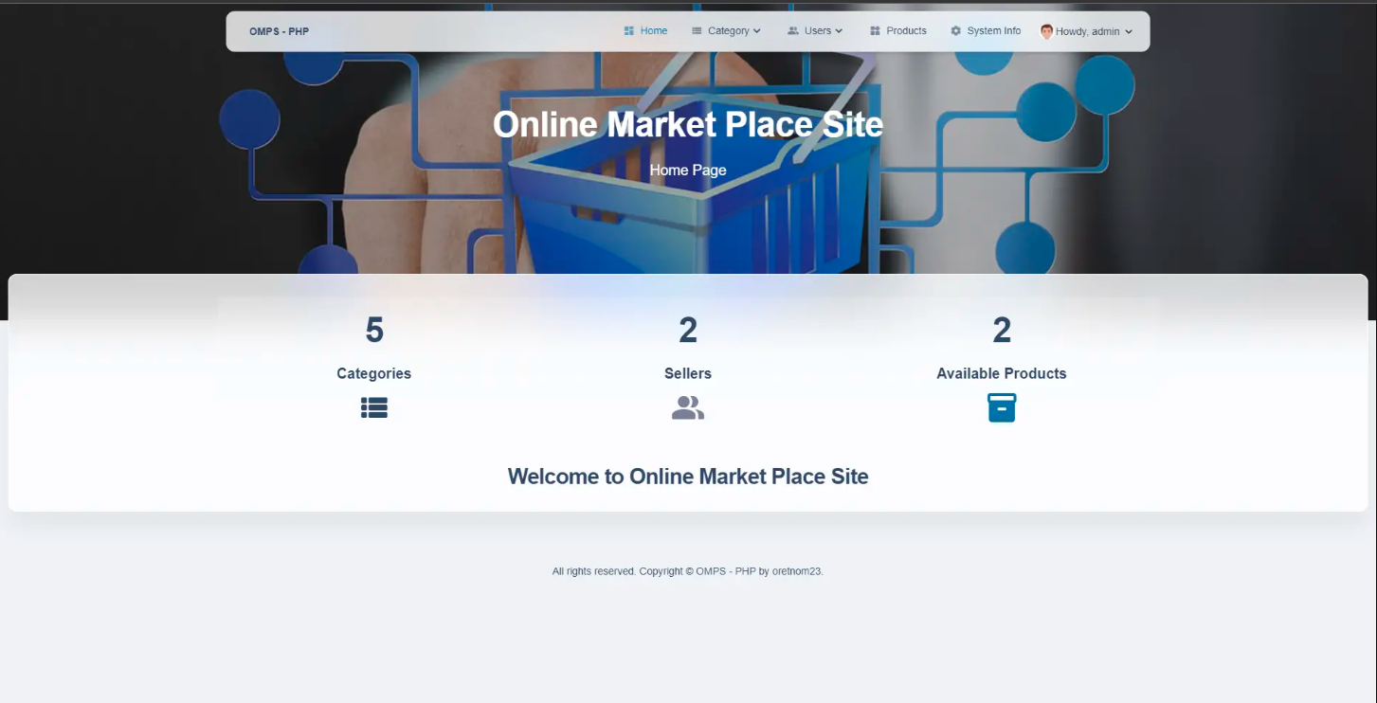

**Testing and Quality assurance Documentation**

Below are the steps by which the project was pulled, the test documentation was added and pushed back

**SCREENSHOTS**

(a) Pulling the Project

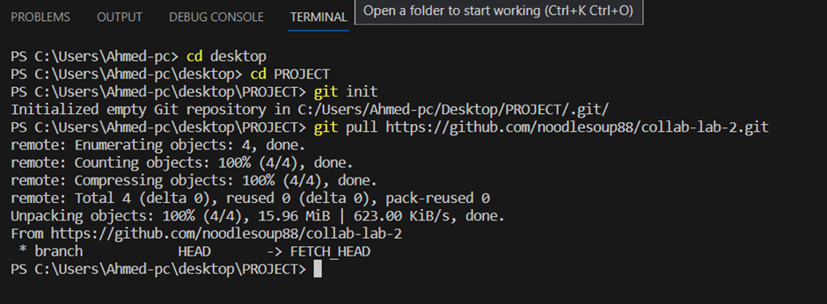

(b) Created the Testing and Quality Assurance Document

(c) Pushing the Project after adding the Testing and Quality Assurance Document

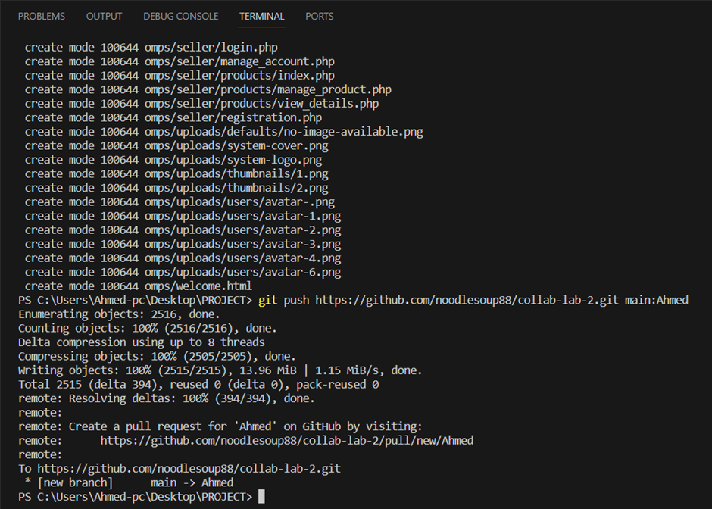

(d) Commitment

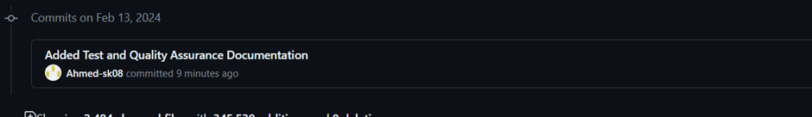

Here is the actual test documentation;

**Testing and Quality Assurance Document**

**Introduction**

This document outlines the testing and quality assurance procedures for the online marketplace platform project. The primary goal of testing is to ensure that the platform meets functional requirements, performs reliably, and delivers an optimal user experience.

**Scope**

The testing and quality assurance process covers all aspects of the online marketplace platform, including but not limited to:

* User interface
* Functionality
* Performance
* Security
* Compatibility

**Testing Strategy**

Our testing strategy consists of the following key components:

1. **Unit Testing:** Testing individual components/modules to ensure they function correctly in isolation.
2. **Integration Testing:** Verifying that different modules interact correctly with each other.
3. **System Testing:** Testing the entire system as a whole to ensure it meets the specified requirements.
4. **User Acceptance Testing (UAT):** Involving end-users to evaluate the system's functionality, usability, and overall satisfaction.
5. **Performance Testing:** Assessing the platform's performance under various loads to ensure scalability and responsiveness.
6. **Security Testing:** Identifying and addressing potential vulnerabilities to protect user data and ensure the integrity of transactions.

**Testing Procedures**

**1. Unit Testing**

* Each developer is responsible for writing unit tests for their code before integration.
* Unit tests will be run automatically upon code submission to ensure that changes do not break existing functionality.

**2. Integration Testing**

* Integration tests will be conducted after multiple components/modules are integrated.
* Test cases will cover various scenarios to ensure seamless interaction between modules.

**3. System Testing**

* A dedicated testing team will execute test cases covering all functional requirements.
* Emphasis will be placed on user workflows, error handling, and edge cases.

**4. User Acceptance Testing (UAT)**

* End-users will be invited to participate in UAT.
* Test scenarios will mimic real-world usage to evaluate the platform's usability and satisfaction.

**5. Performance Testing**

* Performance tests will simulate different loads to assess system responsiveness and scalability.
* Key metrics include response time, throughput, and resource utilization.

**6. Security Testing**

* Security experts will conduct comprehensive tests to identify vulnerabilities.
* Measures will be implemented to safeguard user data and transactions.

**Tools and Technologies**

* Unit Testing: Jest, JUnit
* Integration Testing: Selenium, Postman
* Performance Testing: Apache JMeter, LoadRunner
* Security Testing: OWASP ZAP, Burp Suite

**Reporting**

* Test results will be documented in a centralized repository.
* Issues and bugs will be tracked using a project management tool such as Jira.
* Regular status reports will be provided to stakeholders.

**Conclusion**

By adhering to this testing and quality assurance plan, we aim to ensure that the online marketplace platform meets the highest standards of functionality, performance, security, and user satisfaction.