Coffee:

Input:

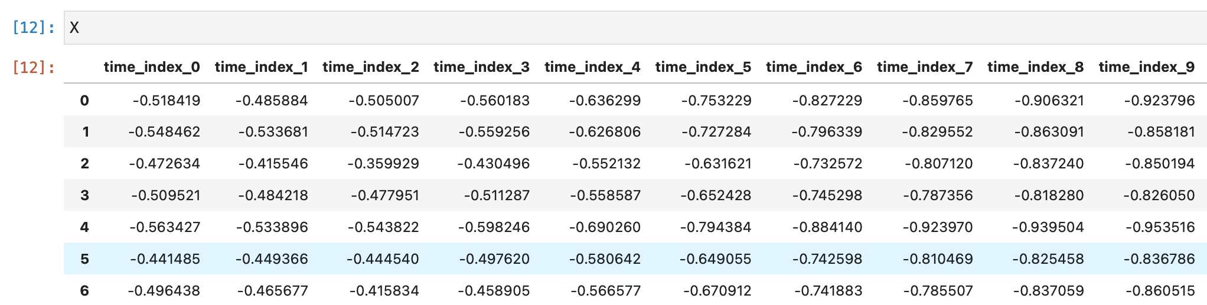

To model:

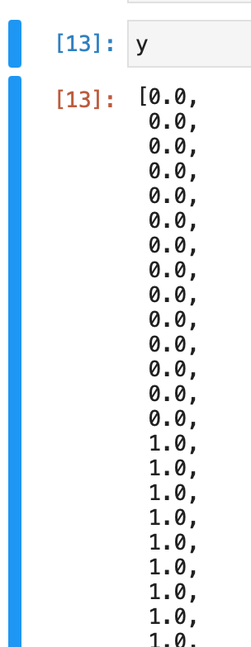

Result from test file: 96.43% accuracy

