Chapter 1

  - Introduction
Effective communication between teachers and students has the potential to improve the learning experience and create a positive environment in the classroom, schools and even colleges on a larger scale. However, the relationship works on both ends. Communication barriers in the classroom certainly make it difficult for students to get the most out of their education and the teachers also face various difficulties in managing the mass number of students.
So we consider the problem of managing the whole student system and for the ease of teachers. In most of the educational institutions, there are the few common problems that the students face on a daily basis. For e.g. problems like they don’t find the important notices, study materials, and are not aware about the syllabus also. So we have tried to minimize that problem by combining the online examination system and student management system so that the teachers could upload the study materials, notices or whatever they wants to share with the students and students will get that stuffs via their mail. In this system teachers can upload the test questions also so that students can give the exam via their portal and get their results too. So this can be considered as a moderate way to minimize the problems and minimize the gap between teachers and students. The Admin maintains this portal and keeps track of the whole system for better flexibility.

Chapter 2
2.1 Scope of the Project
In our web application, named “Test System and Student Management System” we have the following functionalities or perform the following activities:-
- View Student Time-Table of BBA and BCA departments.
- View Syllabus of BBA and BCA course curriculum.
- View the Academic Calendar for the present academic year.
- Students can give online tests based on their stream, year and subjects after registering and login to their portal.
- Students can view their score and solutions after completion of the test.
- Teachers can view their time-table of which class to take on which period.
- Teachers can upload and send study materials to the students based on the stream and academic year.
- Teachers can upload and send notices to students based on academic year and stream.
- Teachers can upload question papers for tests to be given by students in .xls or excel format. Sample can be downloaded from their portal.
- Teachers can see the score of all the students after a test is given.

- Teachers can even view their uploaded question paper for a particular test as and when required.
- Teachers can activate or deactivate a test as and when needed.
- The Admin can add users to the database as teacher or student.
- The Admin can update the details of students and teachers who are already registered to the portal.
- The Admin can view the already registered users.
- The Admin can view the already registered students based on department and year.
- The Admin can view the already registered teachers.
- The Admin can also update subject details and can view them also based on stream and semester.

2.2 User-Wise Functionalities

- STUDENTS
- View Time Table.
- View Syllabus.
- View Calendar.
- Give Feedback about performance of teachers.
- Give Online Test based on stream, year and subject.
- View Score/Result of the given test.

- TEACHERS
- View Time Table.
- Upload and Send Study Materials to students based on stream and academic year.
- Send Notices to Students based on stream and academic year.
- Upload Question Paper for online tests based on stream and academic year.
- Activate of deactivate test as and when required.
- View results of all the students based on test ID.

- ADMIN
- Add single or multiple users as teacher or student.
- View registered users based on group (student or teacher).
- Update Student Details based on stream and admission year.
- Update Teacher Details
- Update Subject Details based on stream and semester number.

Chapter 3

3.1 DFD

LEVEL 0

GET NOTICE/TIMETABLE/SYLLABUS
Student

MANAGE SYSTEM GIVE
Student management system & online test system 0.0
0
ADMIN

EXAM

Upload TEST Student/teacher databases
Teacher

LEVEL 1

Student login
MANAGEMENT SYSTEM
0.0
0
STUDENT/TEACHER INFO

TEACHER LOGIN
0.1

STUDENT LOGIN
0.2
0
TEST
0.3

UPLOAD QUES/ANS CONDUCT TEST
PERFORMS
TEST

TEACHER STUDENT
SENT/RECEIVE NOTICE/SYLLABUS/T.T 0.4
0
0.1

UPLOADS FETCH

Level 2
Teacher
Student papers
Upload 0.3.2
0.3

Result fetch
0.3.1
test qstn/ans
Student teacher conduct
Test
0.3
Give test test fetch questions

Result evaluated result

3.2 ERD

Chapter 4

4.1 Software Requirements
Platform (OS) used: Windows 7 and above
IDE used: Visual Studio Code 2016 and above or any other text editor.
Core Technologies Used: Node.js, ExpressJS, MySql, HTML, CSS , Embedded JS
Supporting Technologies Used: Git 2016 and MS EXCEL 2007 and above

4.2 Hardware Requirements
Processor: 1 Gigahertz (GHz) or faster.
RAM: Minimum 1 GB
Hard Disk: Minimum 10 GB
Graphics Card: DirectX 9 or later with WDDM 1.0 driver.
Display Resolution: 1920 x 1080 pixels

Chapter 5

5.1 Screenshots
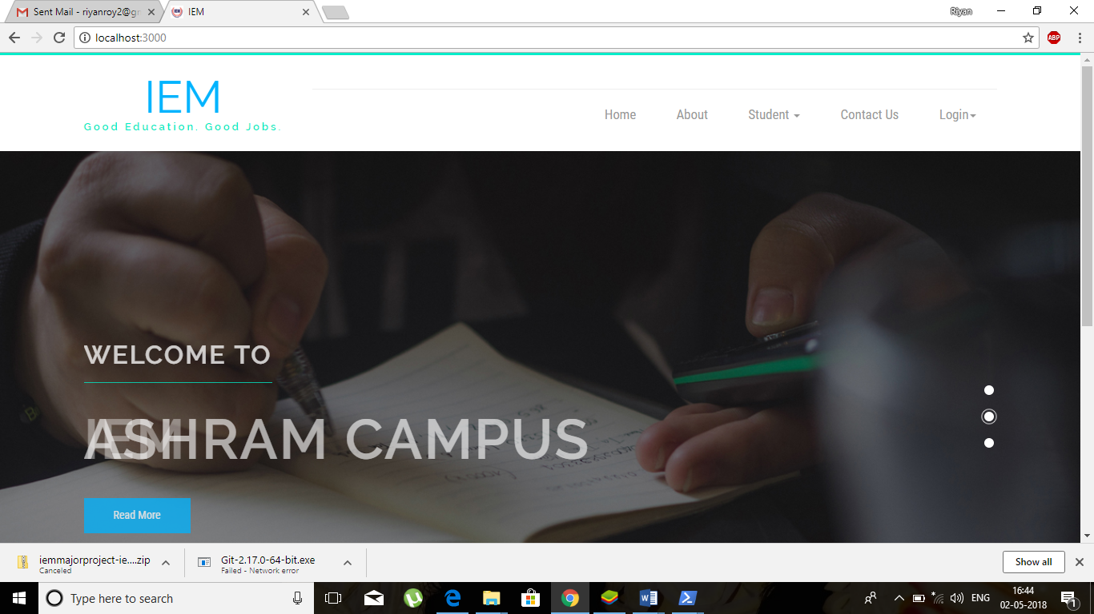
This is the Homepage of the Portal

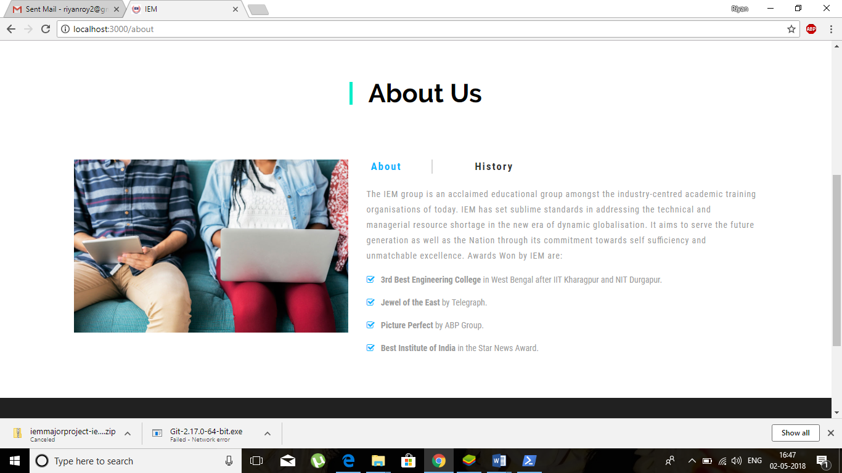
This is the About Page of the College
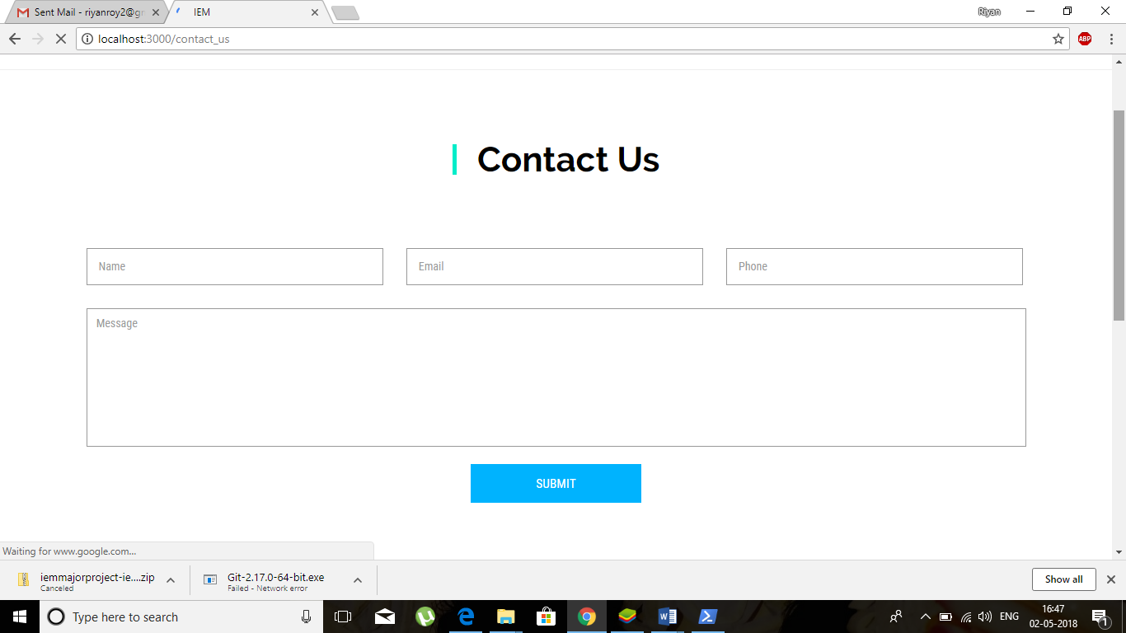
This is the Contact Page for anybody who would like to communicate with the college.

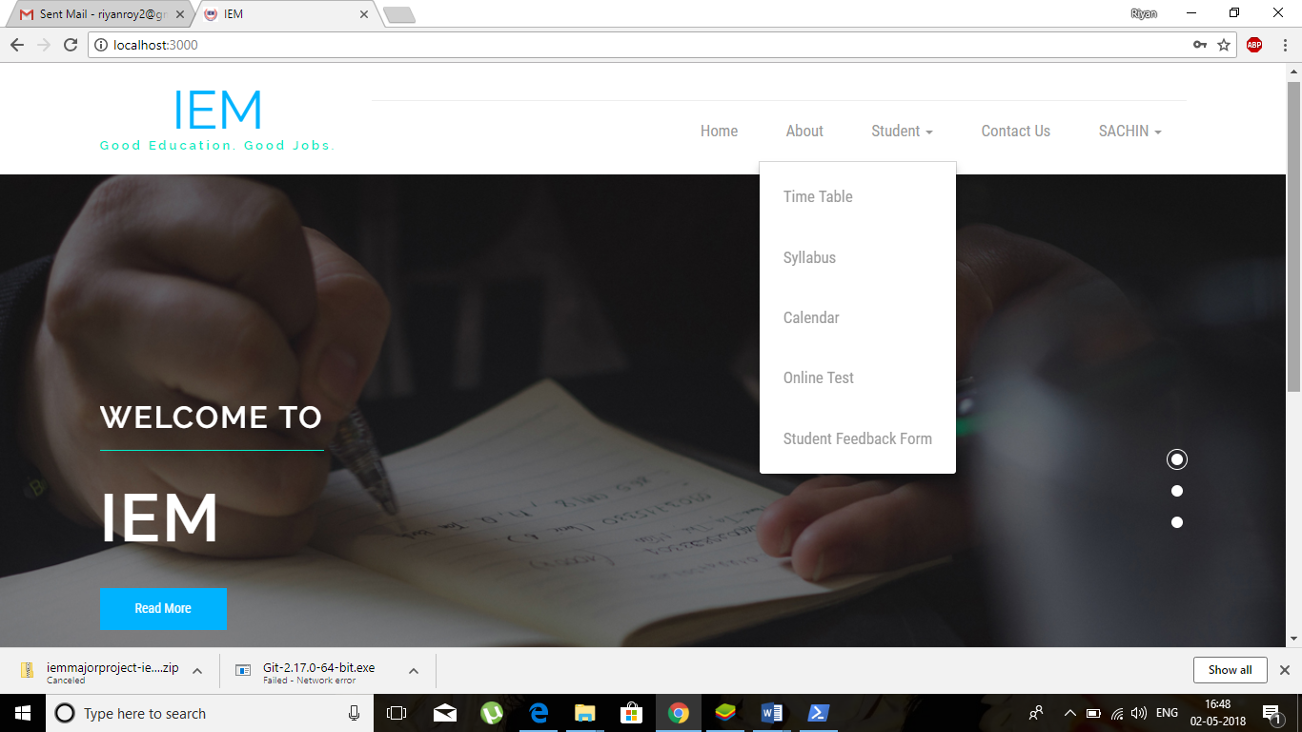
The Student can view his time table, syllabus, the academic calendar and can also give online tests. Students can also download feedback form and give feedback about teachers and classes.

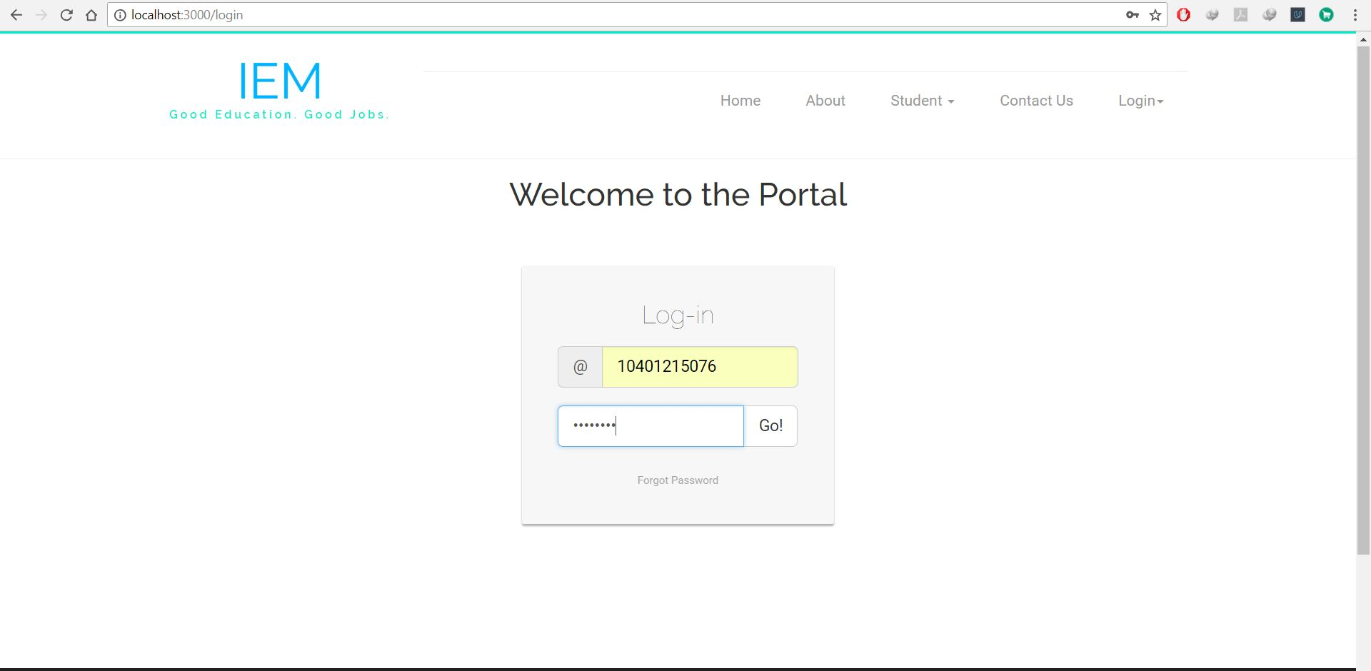
This is the login page for the users – both for students and teachers. A sample login id and password has been shown in the screenshot.

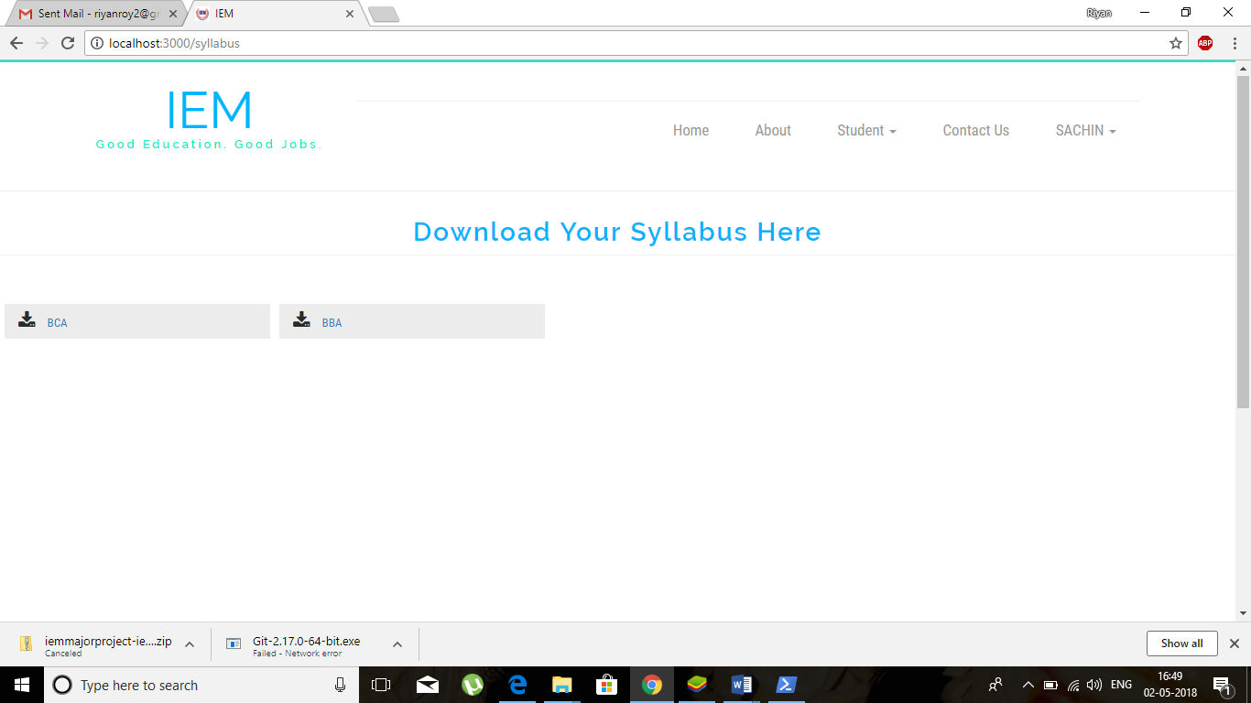
The Students can download their academic syllabus from the portal depending on their stream. I.e. either BBA or BCA.
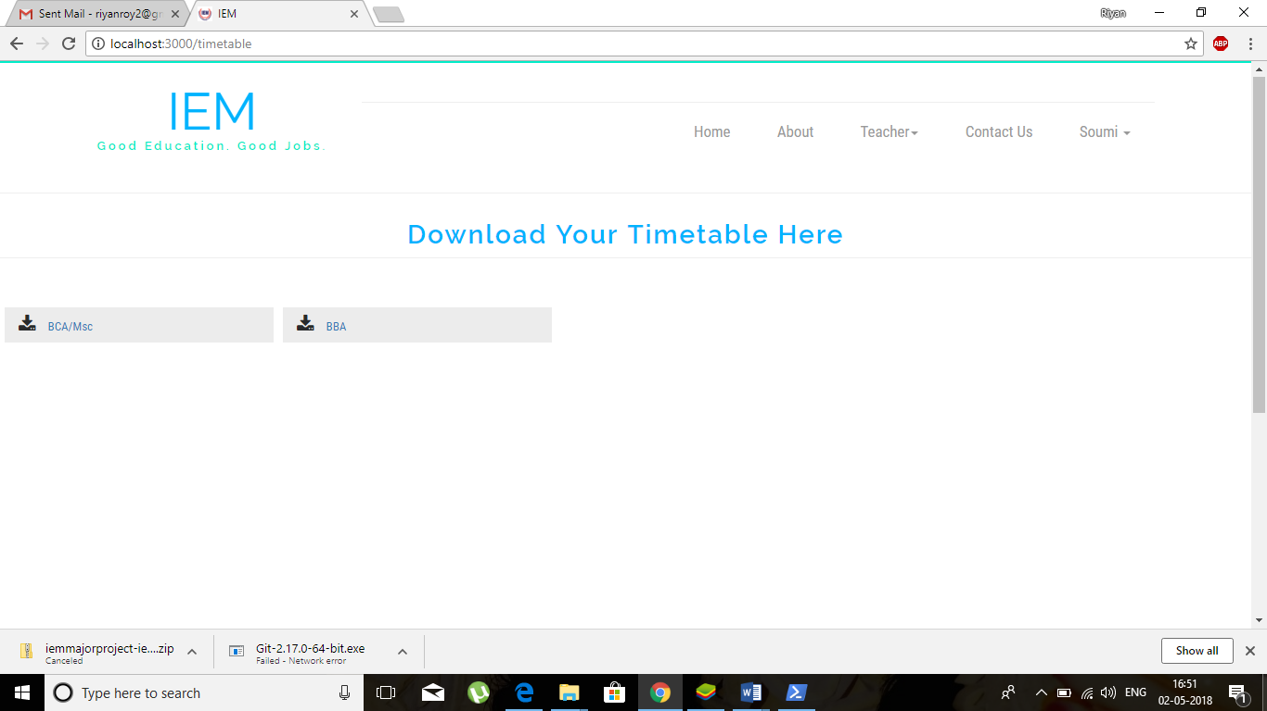
The Students can download their class timetable from the portal based on their stream irrespective of their academic year.

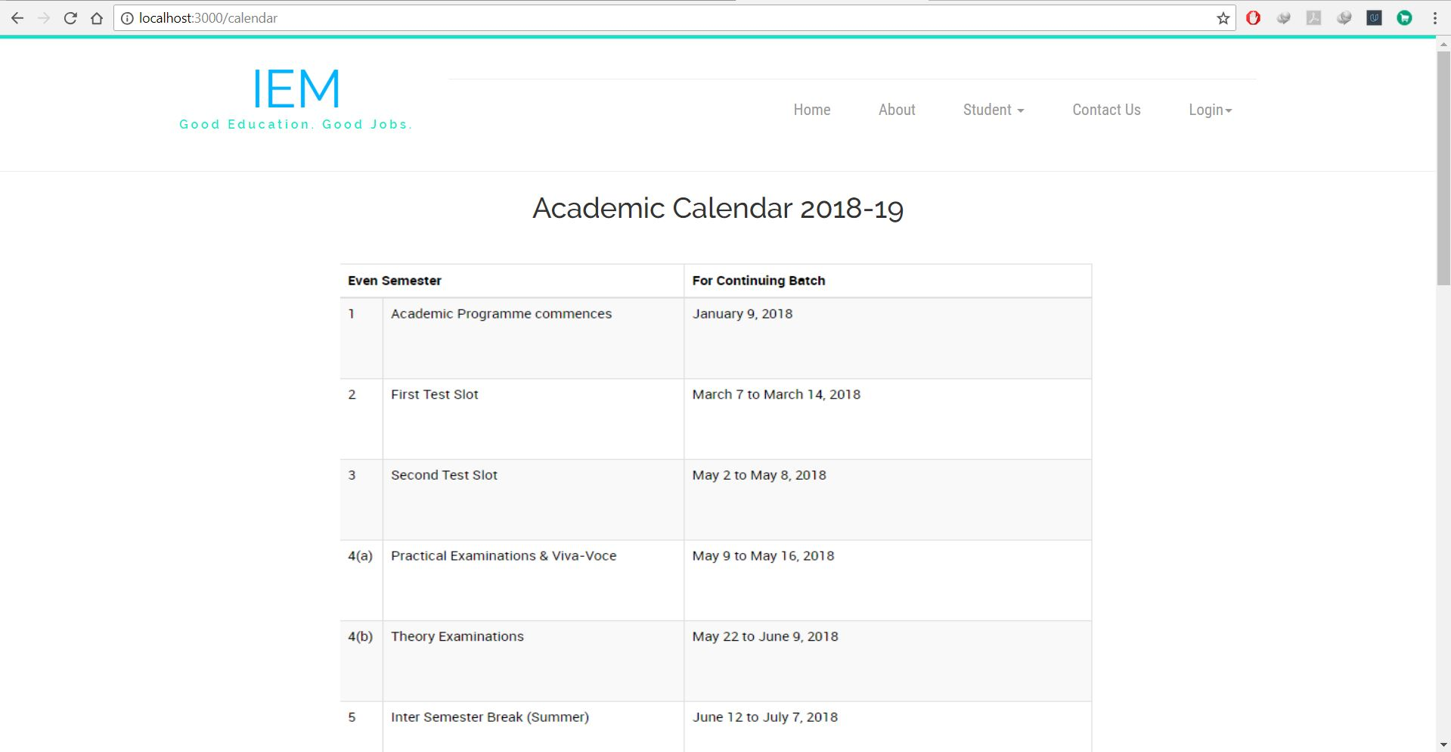
A Sample Screenshot of the Present Academic Calendar which the students can view.
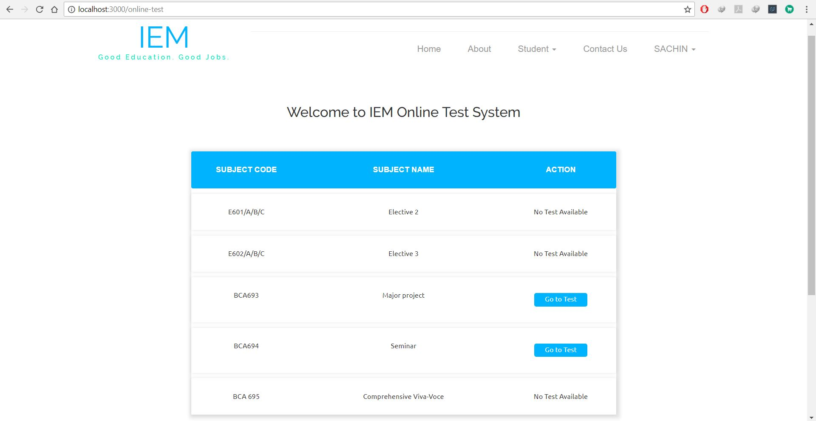
A logged in student can appear for online tests. The Student can view available tests for him/her and can give them accordingly.

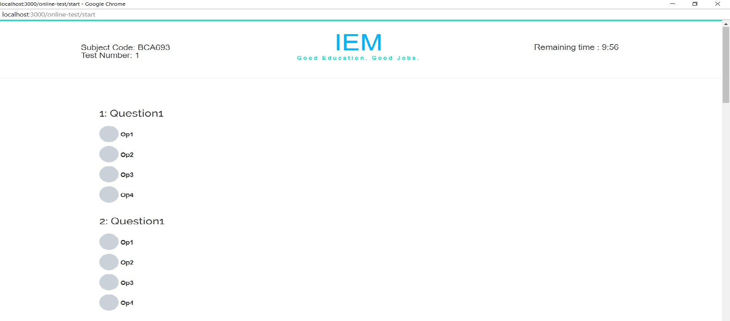
A Sample Screenshot of a student appearing for a test with questions

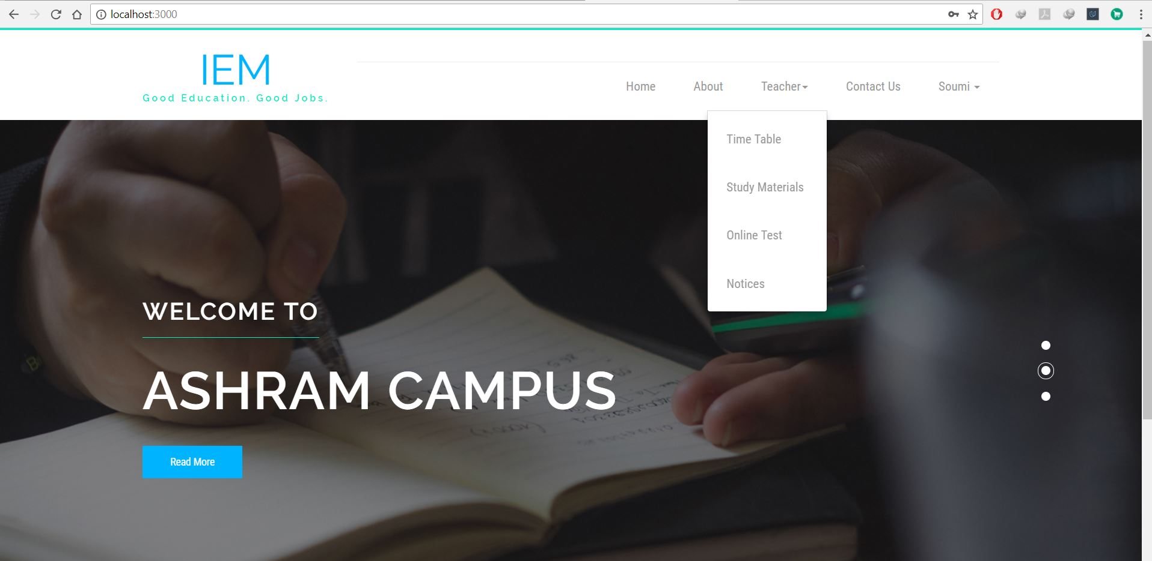
After a teacher logs in, he/she can view the teacher’s time table, can send study materials and notices depending on stream and academic year of students. The teacher can also upload question papers to the test portal and can view marks of all students for a particular test after the students have given the test.

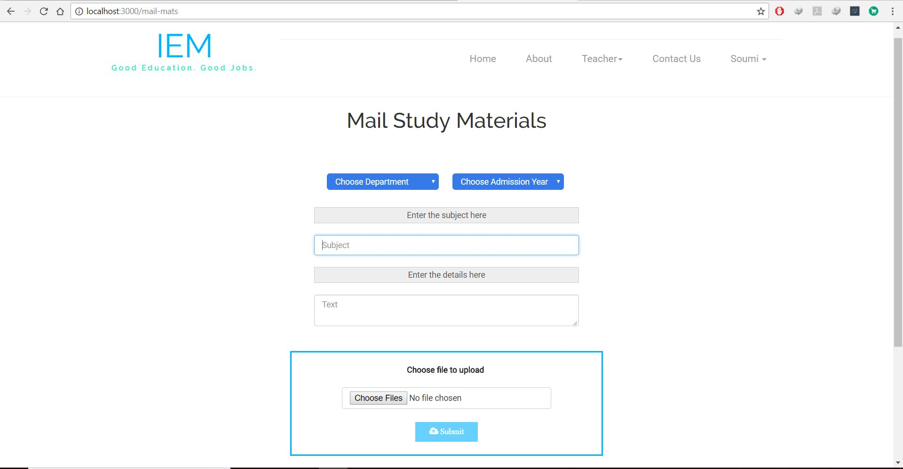
A Sample Screenshot where the teacher can send study materials to the students based on department and admission year.

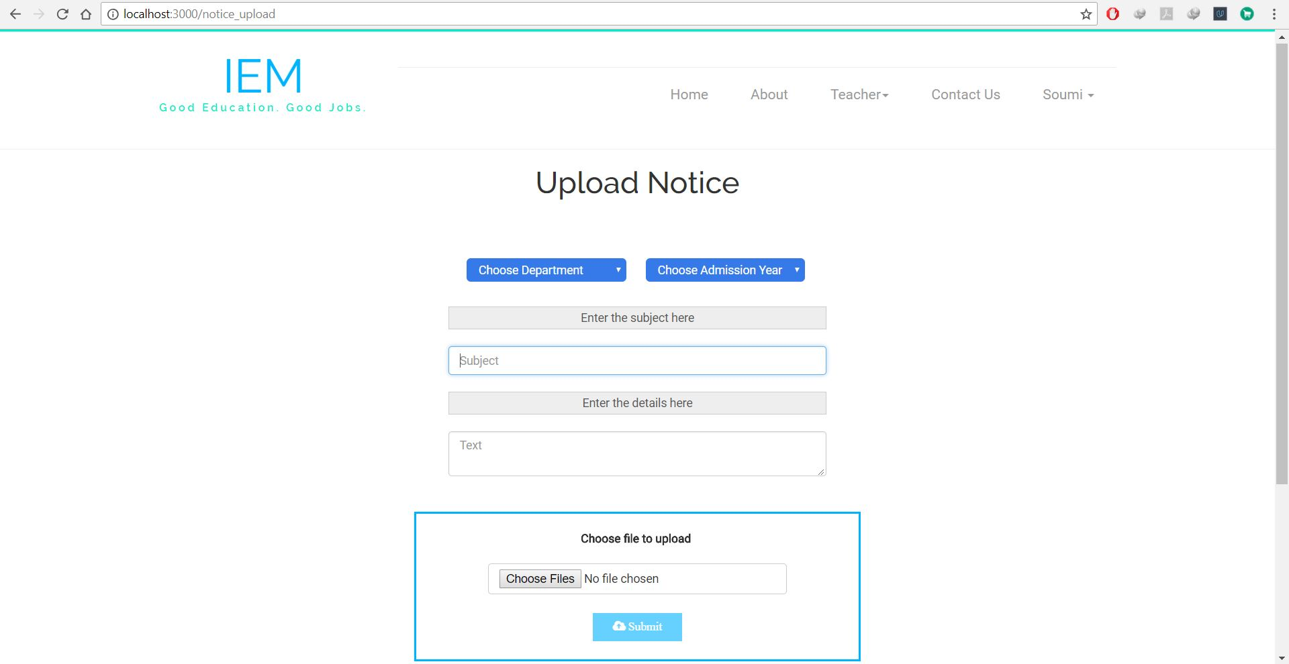
A Sample screenshot where the teacher can send notices to students based on department and admission year of students.

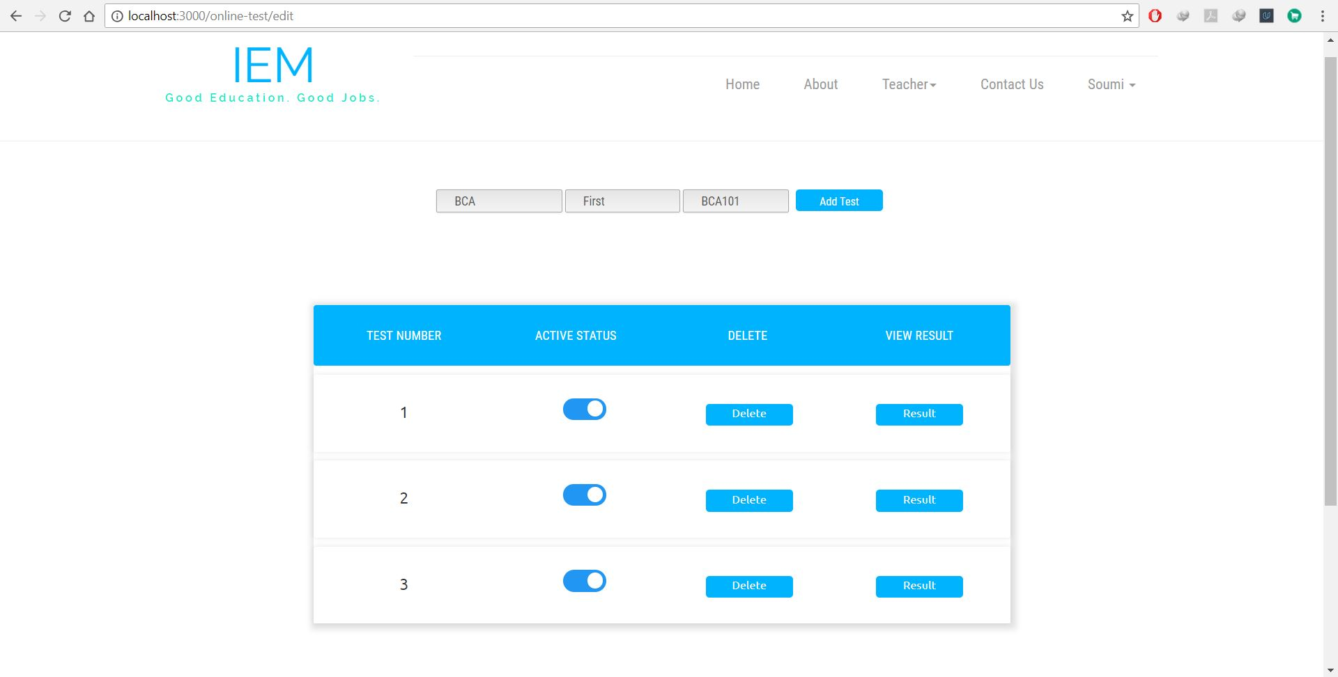
A Sample Screenshot from the teacher’s portal where the teacher can see the list of tests, activate or deactivate them, delete them and can see the result of the tests after the test has been given by the students of a particular test for a particular subject of a department and semester.

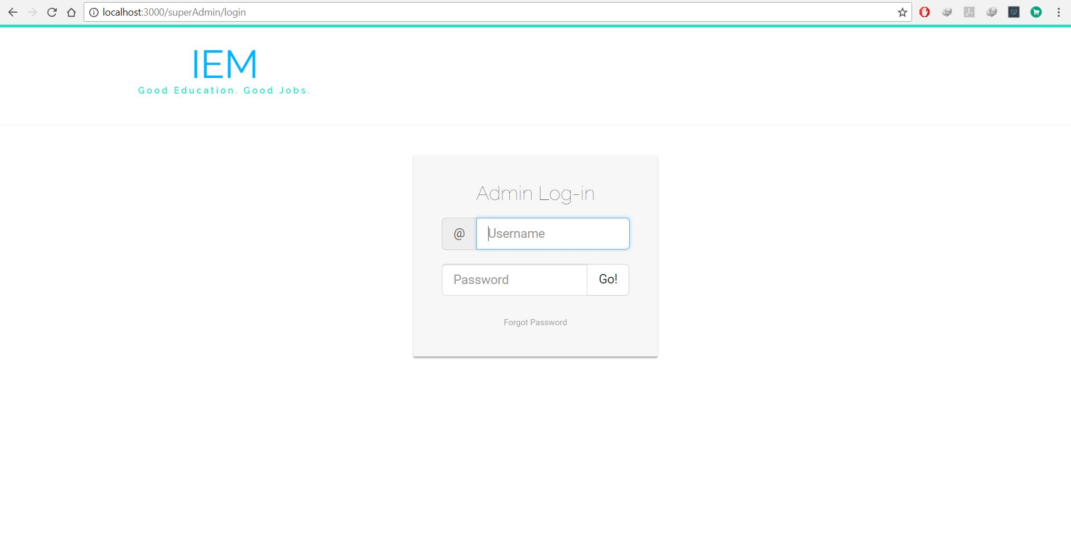
Sample Screenshot of Admin Login Screen.

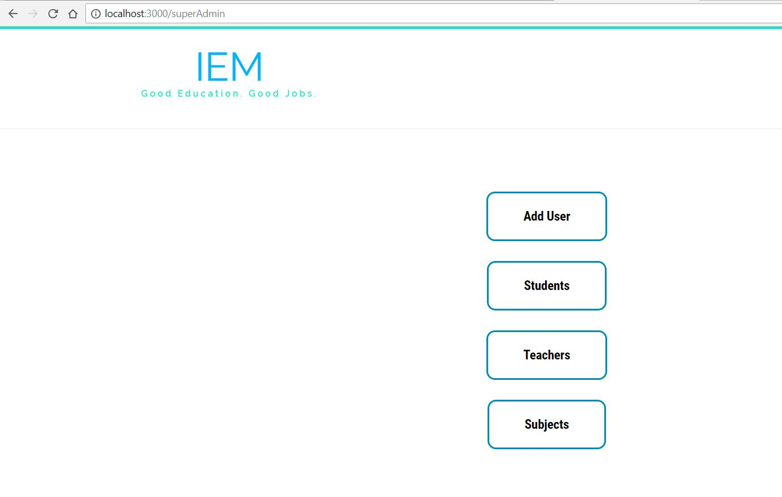

Sample Screenshot showing the operations that can be performed by the admin. The admin can add users, view and update student and teacher details and can update or add subject details.
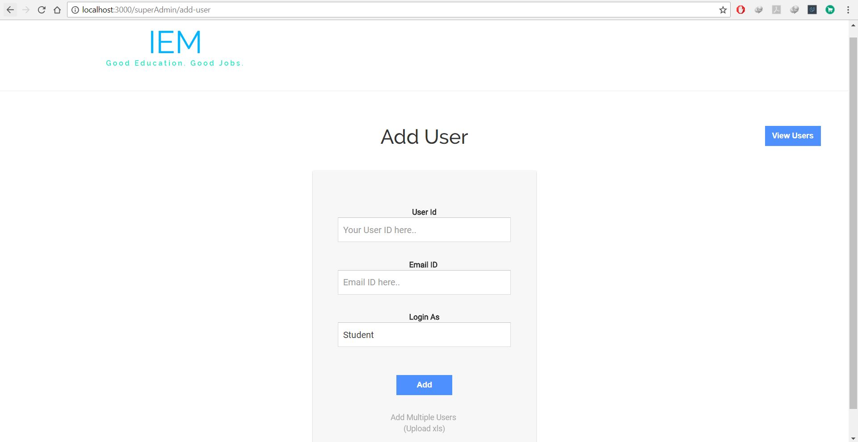
Sample screenshot showing how the admin can add single or multiple users and can also view already registered users.

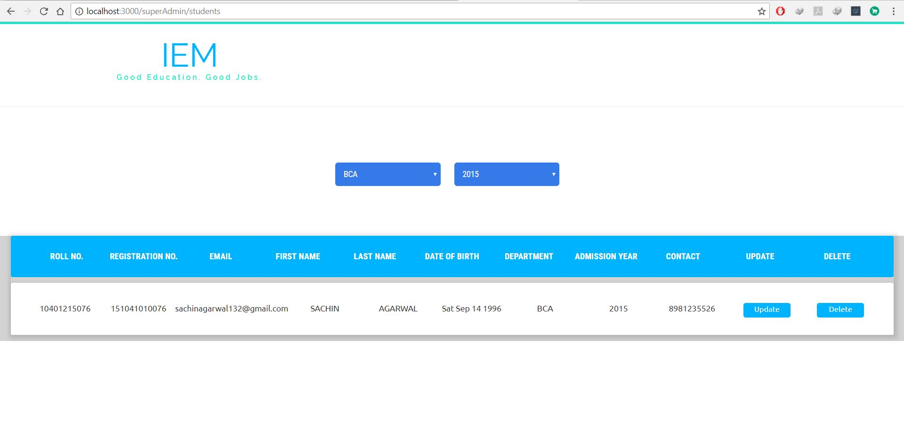
A Sample screenshot of the students section view from the admin’s end as he can update or delete student details and can view them depending on the stream and admission year.
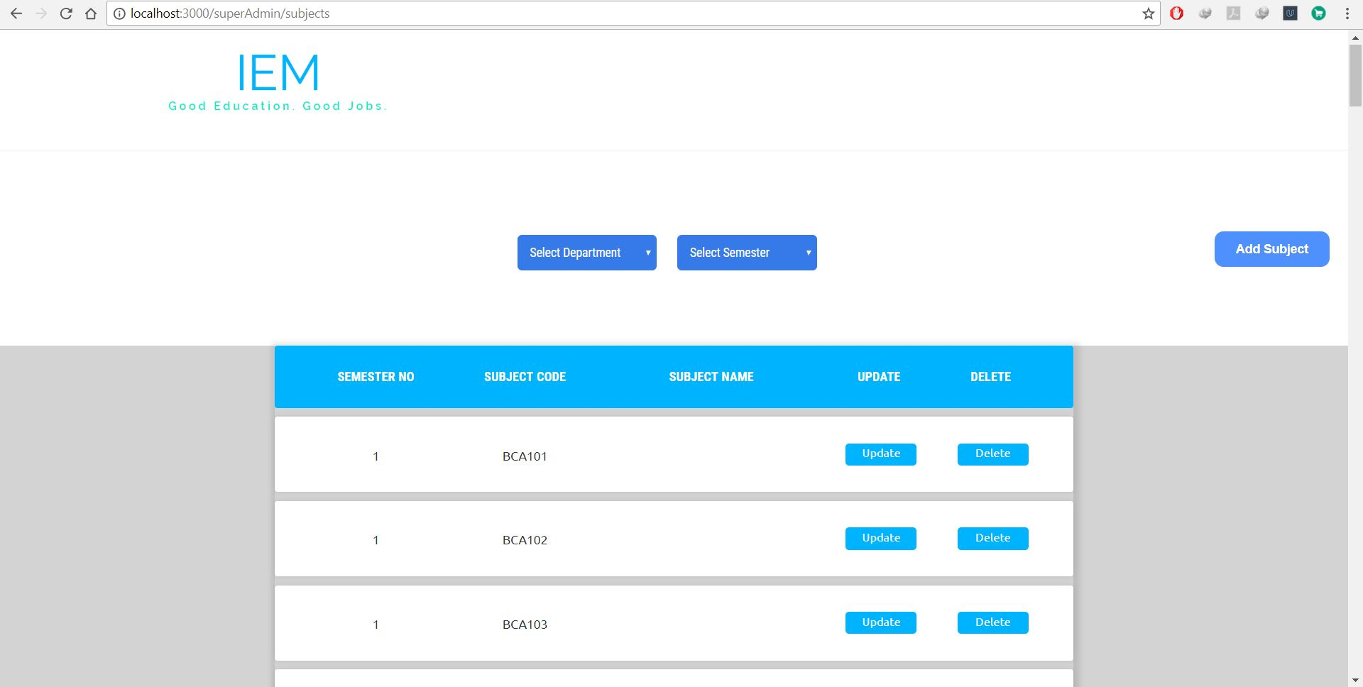

A Sample Screenshot of the subject section from the admin’s point of view where he can view the subjects based on stream and semester. He can update the subject details and can even add subjects.

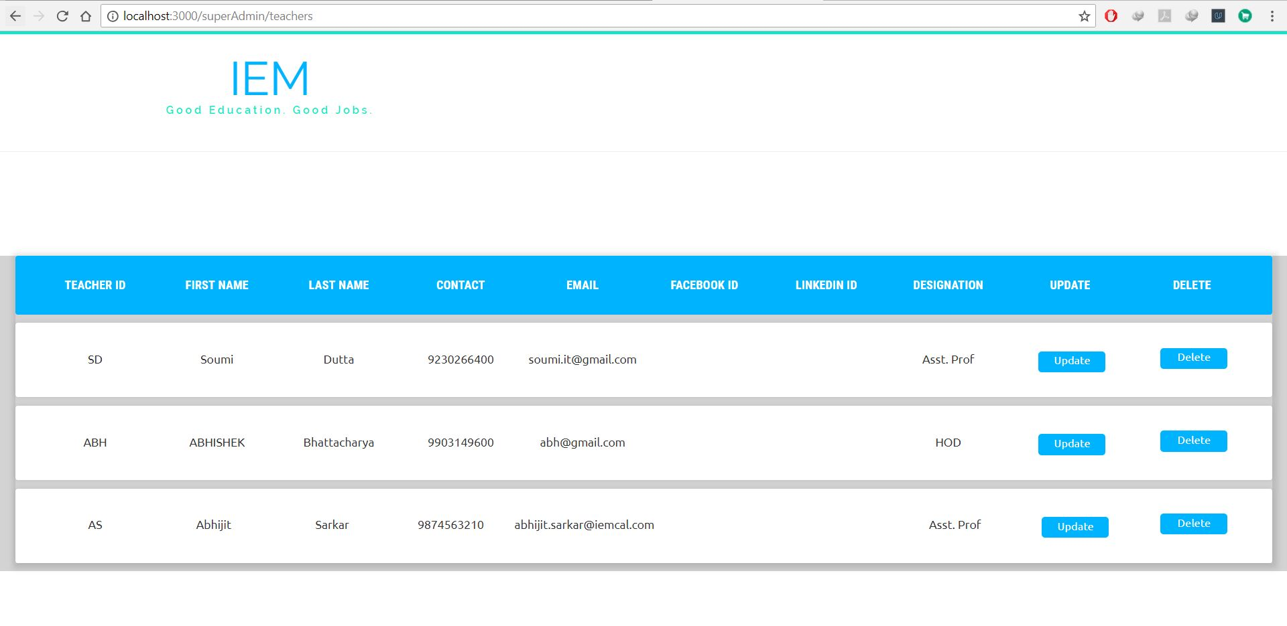
A Sample screenshot of the teacher details from the admin’s point of view where he can update and delete the details of the teachers.

Chapter 6
6.1 Conclusions
- The project was successfully designed and is tested for accuracy and quality.
- During this project I have accomplished all the objectives and this project meets the needs of the College major project.
- The developed project can be used in schools, colleges and other educational institutions.
- Since, it is developed using latest technology, so it has got great value in the IT industry.
- It was a wonderful learning experience for us while working on this project.
- This project took us through the various phases of software development and gave us a real insight of the world of concept of SDLC.
- The effort of working together as a team and tackling the various problems and challenges in the due course gave us a feel of a development teams of the corporate world.
- Working on this project we came to know about various new concepts related to programming.
- However, this project is further extendable and has a vast list of future scope.
- Overall, we enjoyed each and every bit of work done for the successful completion of this project.
6.2 Future Scope
The project is further extendable and the following modules can be added to it:-
- Admission Process Management.
- Student Attendance Management.
- Library Management.
- Recruitment System Portal.
- Alumni Portal

