TLEN 7000-011 – INTRODUCTION TO ENTERPRISE NETWORKS

Lab 3

**Spring 2020**

**OBJECTIVES**

1. **Learn how to configure static routes and populate a routing table using static routing.**
2. **Learn the operation and limitations of RIP version 2.**
3. **Learn the application of default routes in a simple network environment.**
4. **Static Routing**

Router R3 is the wireless router from previous lab. Connect routers R2 and R4 as shown in the network diagram.

* 1. Use static routes to achieve endpoint connectivity as follows:

When PC1 pings PC2, echo request follows path R1-R2-R4; echo reply R4-R2-R1. Remember ping makes roundtrip from source to destination, so you can configure different routes for outgoing and incoming ping packets.

* 1. Use **extended pings** at R1 and R4 to check the path followed by the traffic

# RIPv2

1. Create 2 loopback interfaces on R1: 140.140.140.0/30 and 140.140.139.32/28
2. Create another loopback interface on R2: 140.140.142.0/30
3. Create 2 loopback interfaces on R4: 140.140.139.16/28 and 140.140.140.4/30
4. The link between R1 and R2 is in the subnet 140.140.141.0/30
5. The link between R2 and R4 is in the subnet 140.140.143.0/30
6. Enable RIP version 2 on routers R1, R2 and R4. (Do not enable RIP on R3)
7. Using **show ip route,** document propagation of network advertisements.
8. Use SNIFFER station to capture routing information exchanged by RIP. Document your findings.
9. Document as well any information you find related to: Auto-summarization, VLSM support, and Network Reachability.
10. Do you need Static Routes to support RIPv2?
11. Enable appropriate debug command to monitor RIP events, report what all information you could see in the debug output.
12. Add a link between R1 and R4. This link is a serial cable.

Use IP values of your preference to configure this new link and include this new subnet on your routing protocol.

Document your routing table after network re-convergence.

What is the fastest way from 139.16 to 139.32 networks? Does this match your routing table? Why or why not? Explain your result

**Extra Credit:**

 **Use appropriate configuration to make the router to allow**

**140.140.139.32/28 to ping 140.140.140.4/30 via 10Mbps – 128Kbps link and not the 64 Kbps link.**

**Hint: Select the more appropriate option between offset list or route**

**maps.**

1. **Default Route**

Your small corporate network needs to go online, and it is your task to connect one of your routers to your Internet provider (For the purpose of this lab, connect R2 to the Internet). In order to reach the Internet, you will need:

1. A default route to your provider (recall function of default gateway on a local subnet)

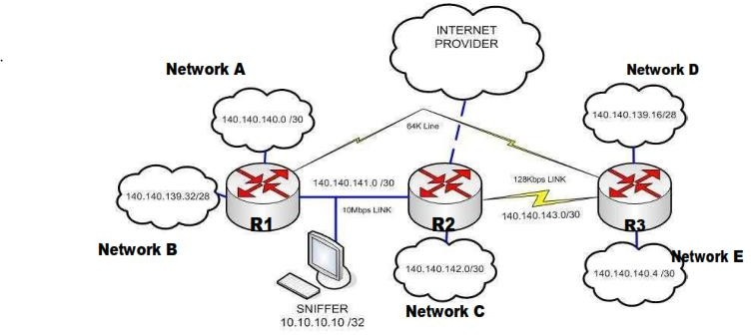

1. Configure default routes on appropriate sites in order to support any “other” route. Include in your report a copy of the configuration file of the routers after goal completion.

**Study Questions:**

1. What is meant by administrative distance and how is this important when one does a show ip route?
2. Why do routing protocols use metrics?
3. What is convergence time?
4. What is a distance vector routing protocol?
5. Name several problems associated with distance vector protocols?
6. What does a routing protocol communicate?
7. What does convergence mean? 10.What is meant by default route? 11.What is meant by load sharing?
8. What are the differences between RIPv1 and RIPv2 update packets?
9. In a RIP routing table, how do you determine which networks are discovered by the routing protocol?
10. List the different ways as to how RIP avoid loops?
11. List five major difference between RIPv1 and RIPv2