"Plugging into the Future: An Exploration of Electricity Consumption Patterns Using Tableau"

Introduction :

Global electricity consumption is surging, driven by electrification, economic growth, and emerging technologies like electric vehicles and AI-driven data centers. In 2024, global demand rose by 4.3%, with renewables surpassing 40% of electricity generation, signaling a transformative shift in energy patterns. Understanding these trends is critical for policymakers, businesses, and researchers aiming to optimize energy systems and achieve sustainability goals.

Tableau, a powerful data visualization tool, offers an interactive platform to explore and communicate these complex electricity consumption patterns. This project leverages Tableau to analyze historical and projected data, revealing insights into sectoral demand, regional variations, and influencing factors like weather and policy changes. By visualizing per capita consumption, renewable energy adoption, and future forecasts (e.g., 3.4% annual growth through 2026), this exploration aims to illuminate the trajectory of global energy use. Through dynamic dashboards and intuitive visualizations, we can uncover actionable trends, empowering stakeholders to navigate the electrified future

Steps for Tableau Exploration

1 Data Collection:

**Sources**: Gather data from reliable sources like the International Energy Agency (IEA), Energy Institute, or national energy databases (e.g., U.S. EIA). Include historical electricity consumption, renewable energy adoption, population growth, and economic indicators

**Variables**: Focus on per capita consumption, sectoral demand (residential, industrial, transport), renewable vs. fossil fuel contributions, and external factors like weather or GDP.

2 Data Preparation:

Clean and structure datasets in Excel or CSV format for Tableau import. Ensure consistency in time frames (e.g., post-COVID data for relevance).

Include time-series data (e.g., 2010–2024) and projections (e.g., to 2030 or 2050) to capture trends.

3 Tableau Visualization:

Visualization Techniques in Tableau:Time Series Analysis: Line plots and time-series charts visualize daily, monthly, or yearly consumption patterns. A study on a Brazilian smart campus used Tableau to model electricity use profiles for 128 buildings, distinguishing between working and non-working days to highlight temporal trends.Geographic Mapping: Tableau’s mapping capabilities display consumption by region or building location. Leppäkosken Sähkö in Finland used geographic visualizations to analyze energy consumption by district, aiding in customer advising and cross-selling opportunities.Clustering and Segmentation: Tableau supports clustering to group households or buildings by consumption patterns. A Dubai study segmented households based on cooling bill categories, using Tableau to visualize peak consumption periods and inform demand-side management.Dashboards: Interactive dashboards combine multiple visualizations (e.g., bar charts, scatter plots, and maps) for comprehensive insights. A 2019 study on LA energy and water efficiency used Tableau dashboards to summarize building attributes like energy use intensity and water consumption.

* + **Dashboards**: Create interactive dashboards to visualize:
    - **Global Trends**: Stacked area charts showing electricity consumption by region (e.g., Asia, North America) or source (renewables, fossil fuels).
    - **Per Capita Consumption**: Bar or line charts comparing countries like Qatar, Iceland, or the U.S.
    - **Sectoral Demand**: Pie charts or heatmaps to highlight residential vs. industrial vs. transport sectors.
    - **Forecasts**: Use time-series forecasting in Tableau to project demand to 2026 or 2050, incorporating IEA’s predicted 3.4% annual growth rate
  + **Geographic Insights**: Map visualizations to show regional consumption patterns or renewable energy adoption (e.g., solar PV growth in China).
  + **External Influences**: Correlate consumption with weather data (e.g., heatwave-driven demand spikes) or economic growth using scatter plots.

1. **Key Insights to Explore**:

Key Insights from Recent Studies:Household Consumption Patterns: Studies like Nesta’s analysis of Great Britain’s smart meter data used Tableau to develop energy-use profiles based on half-hourly consumption, identifying demographic and property influences on usage patterns. This revealed how home-working households consume more electricity during daytime hours.Commercial Sector Analysis: Functional data analysis (FDA) applied in Tableau helped cluster commercial buildings by monthly consumption patterns, highlighting distinct load profiles in urban areas. This approach overcame limitations of traditional clustering by capturing dynamic consumption behaviors.Energy Efficiency and Cost Savings: Companies like Panoramic Power used Tableau to monitor device-level consumption, enabling clients like The North Face to save $10,500 annually by detecting HVAC inefficiencies early.Policy and Planning: Tableau aids policymakers by visualizing demand response (DR) impacts. A Korean study on Peak Time Rebate (PTR) programs used Tableau to cluster households by consumption patterns, showing varied DR responses and informing targeted energy-saving strategies.

* + **Rising Demand**: Global electricity demand grew 4.3% in 2024, driven by electrification (e.g., EVs, data centers) and heatwaves. Expect 3.4% annual growth through 2026, with developing nations like China and India leading
  + **Renewable Shift**: Renewables surpassed 40% of global electricity in 2024, led by solar PV. By 2026, renewables may hit 37% of power generation.
  + **Sectoral Shifts**: Buildings (driven by air conditioning) and industry (electro-intensive manufacturing) accounted for ~60% and ~40% of 2024 demand growth, respectively.
  + **Regional Variations**: Advanced economies saw a 230 TWh consumption rise in 2024 after a 2023 decline, while Southeast Asia’s demand jumped 7%.

1. **Advanced Analysis**:
   * **Machine Learning Integration**: Use Tableau to visualize outputs from models like ARIMA or TBATS for consumption forecasts, leveraging datasets like OECD’s.
   * **Customer Behavior**: Analyze smart meter data to identify peak usage hours (e.g., morning/evening for households) or demographic influences.
   * **Policy Impact**: Visualize how energy-saving codes or EV adoption affect consumption patterns.
2. **Practical Example**:
   * **Case Study**: Replicate Leppäkosken Sähkö’s approach, integrating weather data to predict consumption and optimize grid operations. Use Tableau’s mapping to analyze regional usage in Finland or similar
   * 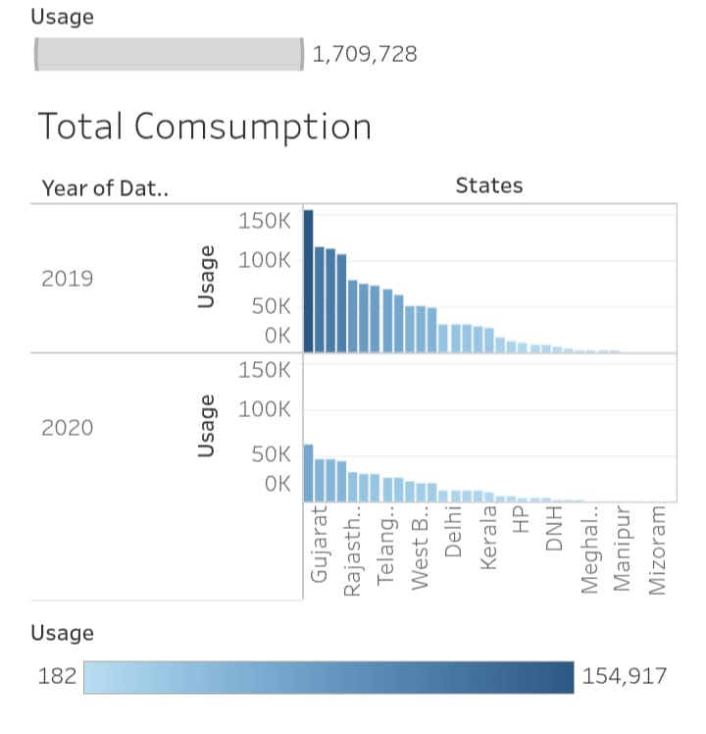regions.
   * **Dashboard Features**: Include filters for time, region, or sector, and hover-over details for metrics like kWh per capita or renewable share.

**Tableau Tips**

* **Interactivity**: Use filters and sliders to let users explore scenarios (e.g., high vs. low renewable adoption).
* **Storytelling**: Build a Tableau Story to guide users through historical trends, current patterns, and future projections.
* **Data Updates**: Automate data refreshes via Tableau Server to incorporate real-time data from sources like IEA’s .Stat Data Explorer.

**Future Considerations**

* **Challenges**: Account for data gaps in poorer nations reliant on biomass, which skews per capita metrics.
* **Opportunities**: Highlight the role of AI and data centers, projected to double energy demand by 2026, and visualize their impact.
* **Sustainability**: Emphasize the shift to renewables and nuclear to meet net-zero goals, using Tableau to track CO2 emissions vs. energy use
* 