**Pluralsight engagement**

Starting in the Week 7 of the current academic year, we were given access to the world’s most popular and yet most effective educational platform. In short, I would say it is the best experience I am having with my studies and as an additional supportive resource.

The first recommended course on Pluralsight “Getting started with the C language” I have completed in about 5 or 6 days. I have learnt new extra topics with the course such as ternary operators, anatomy of strings in depth, more about if-else statements in general and their replacement with switch-case blocks. We were taught so much in the class, but coming out of the class and watching a course and realizing that there is so much more to learn, was very exciting and motivational to keep going forward. I have found out more about structs and their use in the real-world cases. Although the online course did not give as much information as it did with if-else statements or string manipulation, I did not give up and researched online on different websites such as stackoverflow.com, geeksforgees.com, tutorialspoint.com and others. Pluralsight not only helped me with C development, but also, I could learn more about JavaScript and React what I like to code in free time.

Surely, I can say that my past 3 months of intensive studies in the Computer Science course and 1 month of supplementary online courses were strong and fundamental, so now I can go on and start working on a simple real-world projects, and at the same time keep learning advanced topics!

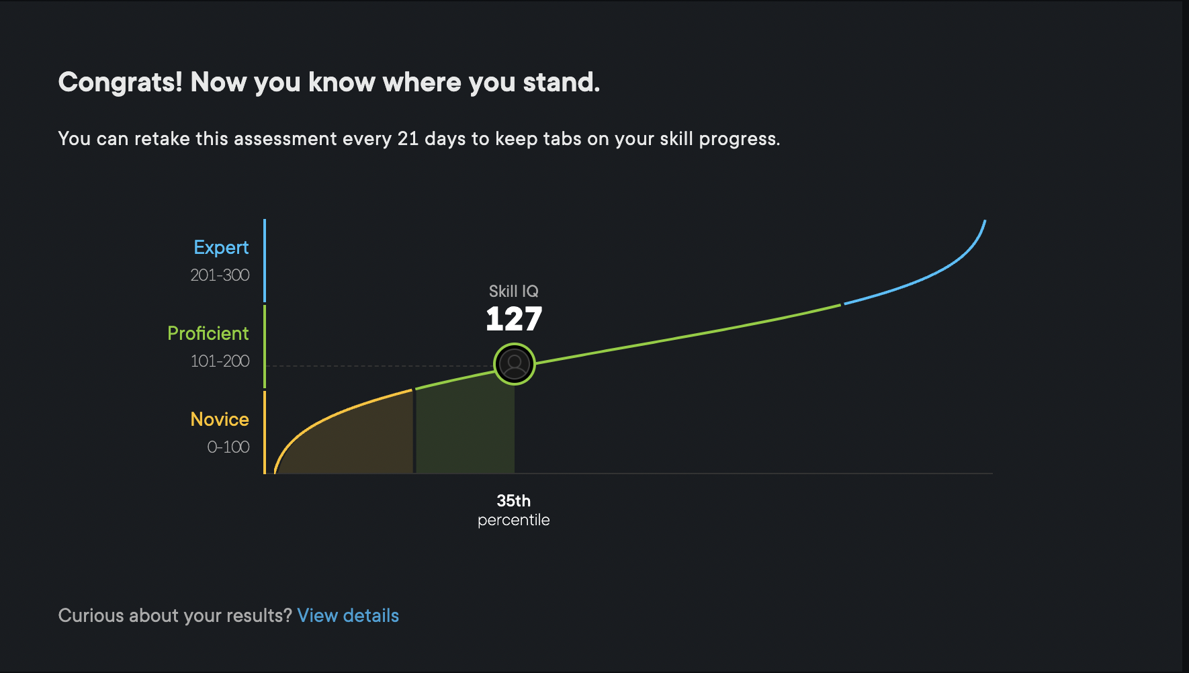

C development path IQ test result