## APPENDIX 1

**ONLINE CRIME REPORTING SYSTEM**

**END TERM REPORT**

***by***

**Anuj Agrawal, Bonishkumar Kshetrimayum, Ankur Paul**

Section: K19PT

Roll Numbers: 06, 09, 38



**Department of Intelligent Systems,**

**School of Computer Science Engineering,**

**Lovely Professional University, Jalandhar**

November, 2020

## APPENDIX 2

**Student Declaration**

This is to declare that this report has been written by me/us. No part of the report is copied from other sources. All information included from other sources have been duly acknowledged. I/We aver that if any part of the report is found to be copied, I/we are shall take full responsibility for it.

Signature & Name: Anuj, Bonish, Ankur

Roll Number : 06, 09, 38

Place: Lovely Professional University, Phagwara

Date: 31 Oct 2020

**APPENDIX 3**

**TABLE OF CONTENTS**

**TITLE PAGENO.**

|  |  |
| --- | --- |
| **1. Online crime reporting system .** | **5** |
| **1.1** Modules . | 6 |
| **1.1.1 Admin .** |  |
| **1.1.2 User .** |  |
| **1.2 Hardware requirement .** | 7 |
| **1.3 Software requirement .** | **7** |
| **1.4 Advantages .** | **8** |
| **1.3 Screenshot of the interface .** | **9** |
|  |  |
| **2 Conclusion .** | **21** |
|  |  |

APPENDIX 4

BONAFIDE CERTIFICATE

Certified that this project report “ONLINE CRIME REPORTING SYSTEM ” is the bonafide work of “Anuj Agrawal, Bonishumar Kshetrimayum, Ankur Paul” who carried out the project work under my supervision.

### <<Signature of the Supervisor>>(Due to Covid 19, signature is exempted )

<<Name of supervisor>>

<<Academic Designation>>

<<ID of Supervisor>>

<<Department of Supervisor>>

**Online Crime Reporting System in Python Project**

Crime is a part of illegal activities in human life. It is quite obvious that the rate of crimes is increasing day by day in all societies across the world, but we do believe that there is a lot which can be done by both the governments and the individuals to reduce the crimes in communities. The rise of population and complex society rises the range of anti-social conducts that must be restricted by the government through the military and different organizations particularly the Police Force. There are many current crime management systems which faces several difficulties, as there is no means to report crime instantly other than phone calls, messaging or face-to-face compliant filing. Hence, we have proposed an online crime reporting system which allows the user to file complaints or missing reports and keep a track of it. There are 3 categories that a user can file; Complaint, Crime Report and Missing Report and can see all the status of what action has been taken by the admin. To file any of the above 3 complaints, the user should register in to the system and provide his right credentials to file them. The crime reporting system project also allows other users who doesn’t want to register but can check the crimes happening at his/her or any other area, has to just provide the pin code and in return the system displays the list of crimes if any filed. The offline i.e. the unregistered user can also take advantage of checking the missing person details, but he/she is refrained from getting complaints done by the users. The Front End of the crime reporting system is done using Android Studio and SQL serves as a backend to store books lists and inventory data. The system, has both the user as well the Admin Part, the role of admin is to just check all the 3 modules or categories and update their status likewise. This system helps the users in tracking any report filed to the law and take an advantage of reporting any complaint from anywhere bringing the whole system online.

* **Modules:**

The system comprises of 2 major modules with their sub-modules as follows:

1. **Admin:**
   * **Login:** Admin can login in his personal account using id and password
   * **View Complaints:** Admin can view the complaints.
   * **Update cases:** Admin can update the crime cases.
2. **User:**
   * **User Registration:** User has to register to file complaints, crimes or missing report.
   * **User Login:** User can login to system to file and check the status of his complaints or missing reports.
   * **Complaints:** Complaints consist of basic details the system asks and the user has to fill in order to register a complaint and check the status of his complaints.
   * **Crimes:** Crimes consist of all the details that the user has to fill in to register a complaint and provide a picture, if he has one related to the crime, also can check the status of the crimes he has filed.
   * **Missing Persons:** The System asks the user to enter all the details of the person with a photograph. The system also allows the user to check the status his previous filed cases.
   * **Without Login:** The System allows the user to check for crimes against the pin code provided by the user. The User can also check for missing people.

* **Hardware Requirement:**
* i3 Processor Based Computer or higher
* Memory: 1 GB RAM
* Hard Drive: 50 GB
* Monitor
* Internet Connection
* **Software Requirement:**
* Windows 7 or higher
* Python
* Sqlite3 database
* **Advantages**
* The User can check the missing reports or crime without giving his credentials to the system.
* The user is allowed to file any number of cases.
* Admin and the user have the same App limiting the cost and size.
* **Screenshots of the interface**

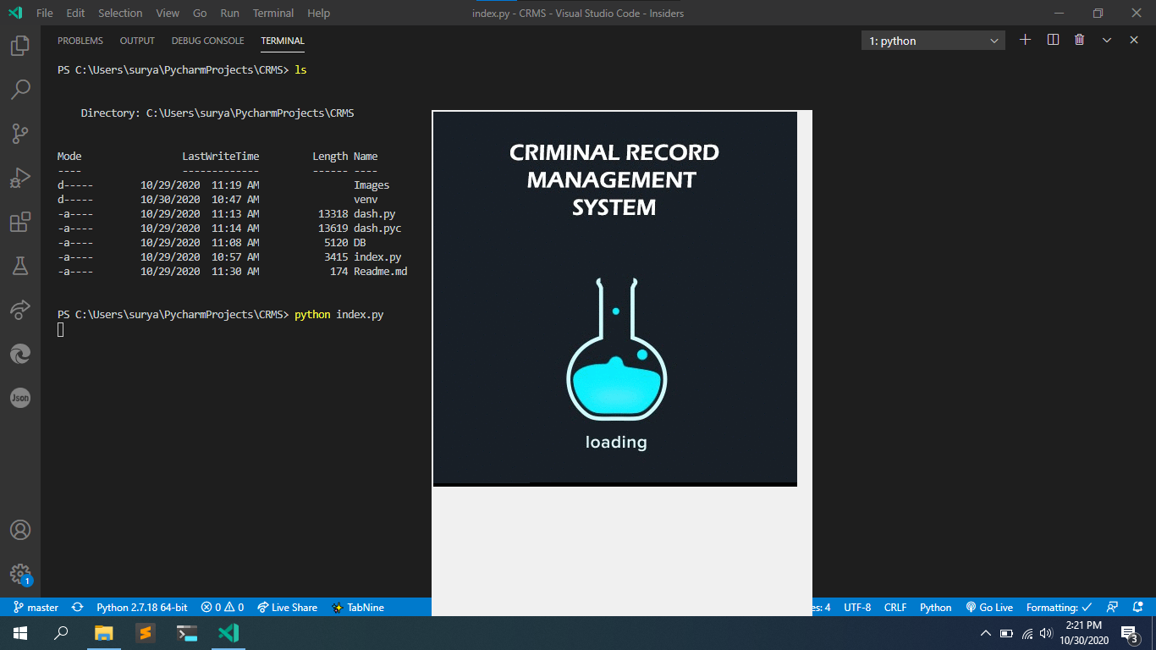

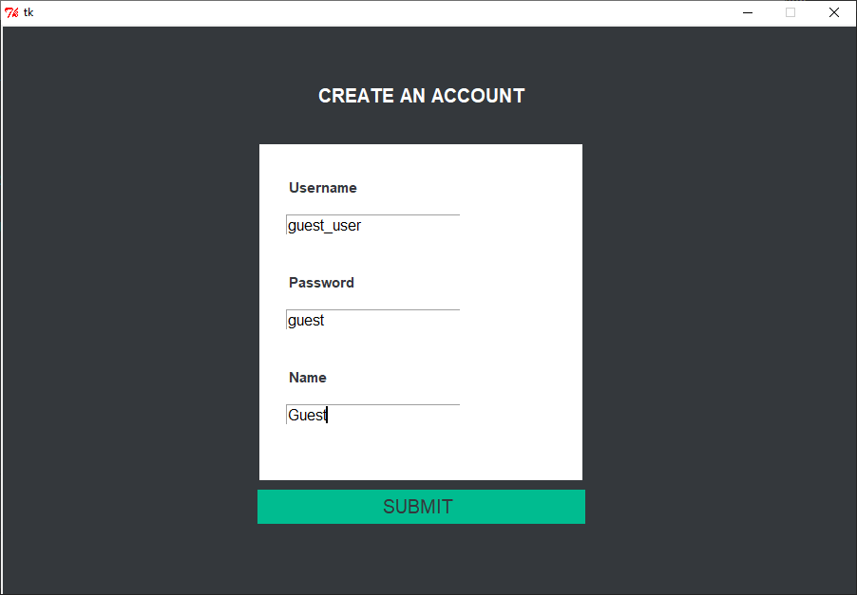

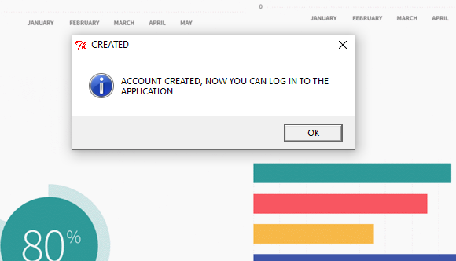

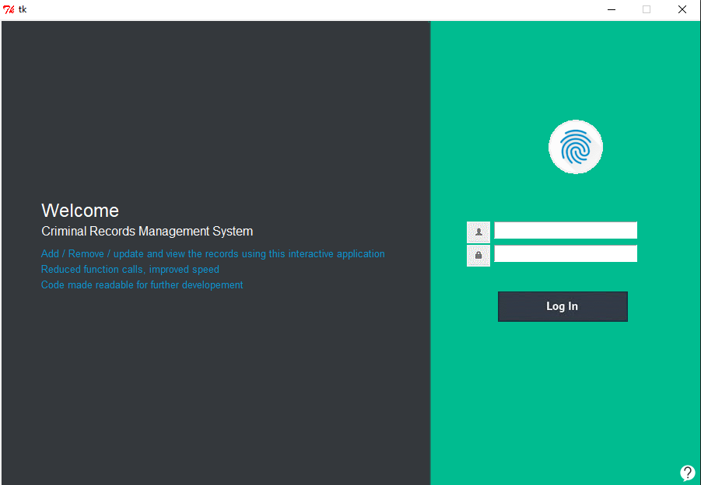

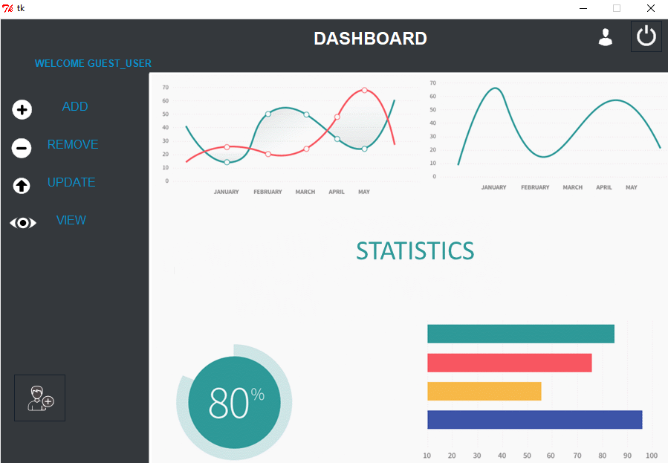

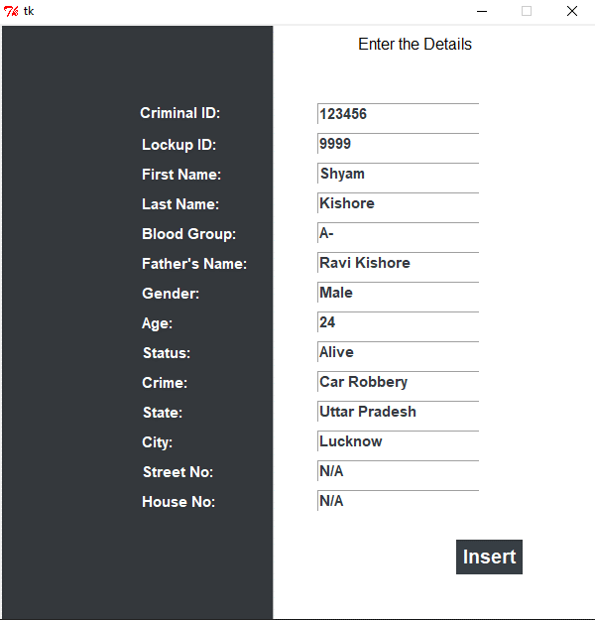

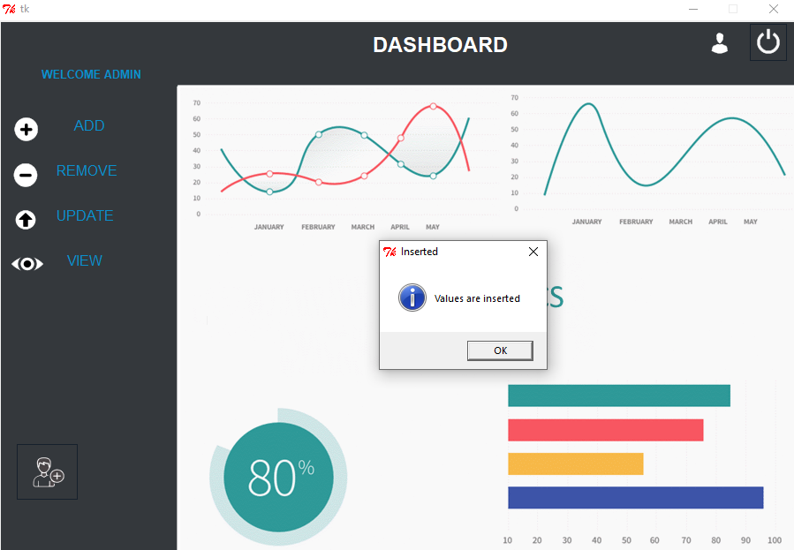

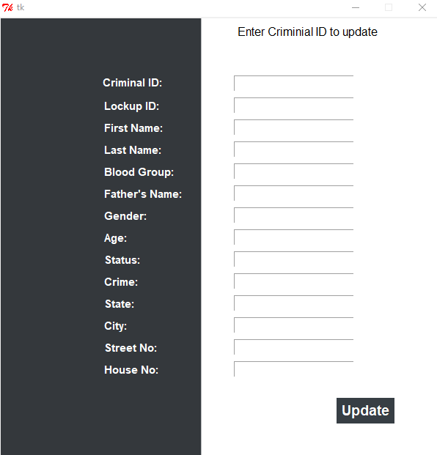

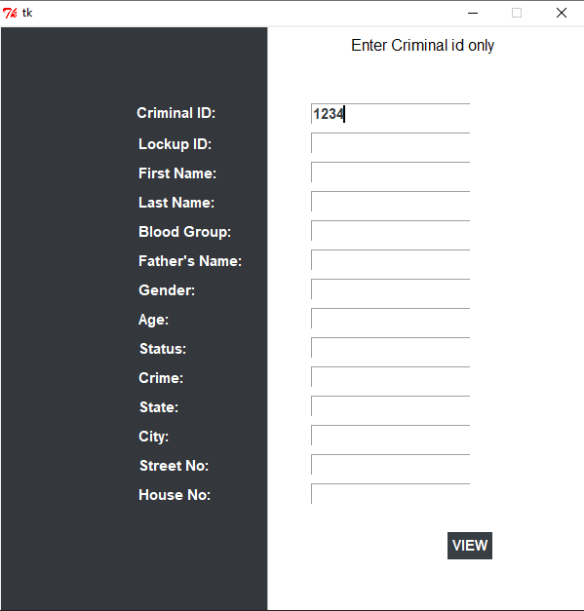

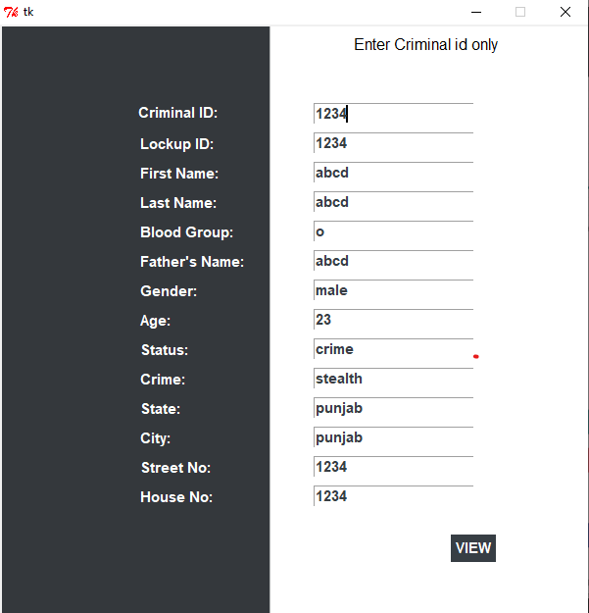

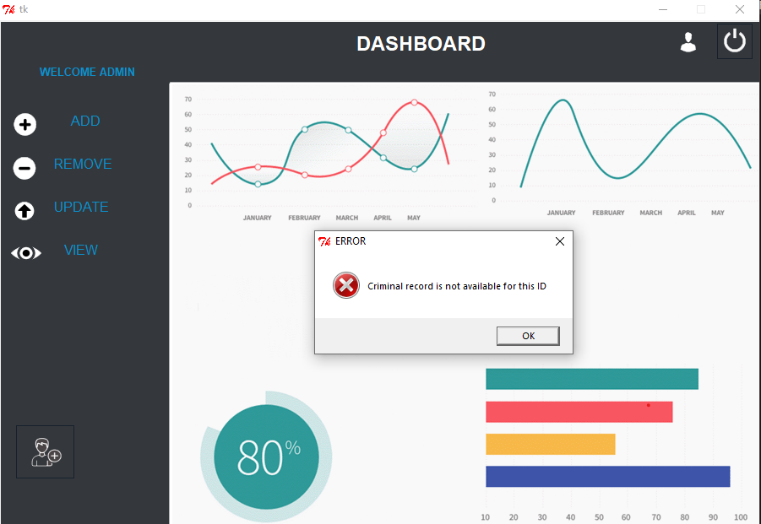

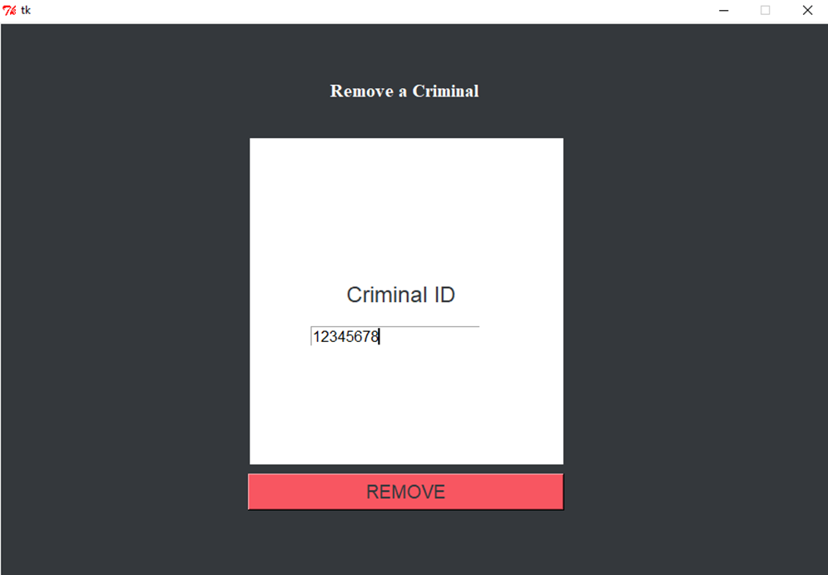

* **Conclusion**

Our project has proved to be very beneficial for people. For a peaceful and smooth governance of the people we can take examples from this project to come up with better platform for people where they can report the crimes happening around them. This will help the higher authorities to track the crime and have eye witnesses and delivering justice in time.