4. S0473 — Avenger
Name | Avenger
ATT&CK ID | S0473
Type | Malware — Downloader (Multi-Variant Toolkit Member)
Also Known As | Part of BRONZE BUTLER (TICK) Operation ENDTRADE downloader family
Version | 1.0
Created | 10 June 2020 (MITRE entry)
Last Modified | 21 October 2023

2. Description
Avenger is the fourth custom downloader in BRONZE BUTLER's Operation ENDTRADE toolkit, alongside BBK, build_downer, and down_new. Like its siblings, it uses HTTP for C2 and serves as a first-stage delivery mechanism for advanced backdoors. Maintaining four concurrent downloader variants means detection of any single variant does not halt BRONZE BUTLER's operations. Each downloader is named after its PDB string, a characteristic TICK naming pattern used to track internal variants.

Key Characteristics
- Fourth member of TICK's four-downloader operational toolkit
- HTTP-based C2 — downloads second-stage backdoors
- Provides signature diversity alongside BBK, build_downer, and down_new
- Named after PDB string — BRONZE BUTLER malware naming convention
- Delivered via spearphishing using compromised legitimate email accounts

3. Threat Actor Association
Threat Actor | BRONZE BUTLER
MITRE ID | G0060
Also Known As | TICK, REDBALDKNIGHT, Swirl Typhoon
Origin | China — state-linked espionage group
Active Since | At least 2008
Motive | Cyber Espionage — classified data theft from Japanese defense and industrial sectors

4. Supported Platforms
Platform | Notes
Windows | Primary platform — all variants target Windows environments

5. ATT&CK Techniques Used
Tactic | ID | Technique Name
Initial Access | T1566 | Phishing — spearphishing via compromised legitimate email accounts
Execution | T1204 | User Execution — victim opens and executes initial payload
Defense Evasion | T1027 | Obfuscated Files or Information — AV evasion parameters between versions
C2 | T1071.001 | Application Layer Protocol: Web Protocols — HTTP-based C2
C2 | T1105 | Ingress Tool Transfer — downloads second-stage payloads from C2

Attack Chain Flow Diagram
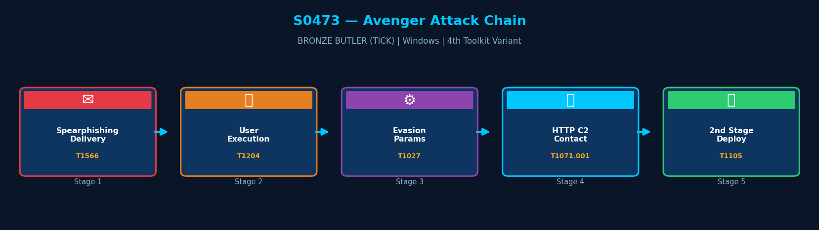
Figure: Avenger attack chain with MITRE ATT&CK technique IDs

6. Execution Method
Avenger is delivered via spearphishing to high-value targets in Japanese defense, aerospace, and satellite industries. On victim execution, it contacts its HTTP C2 server to download the second-stage payload, feeding BRONZE BUTLER's multi-stage intrusion chain.
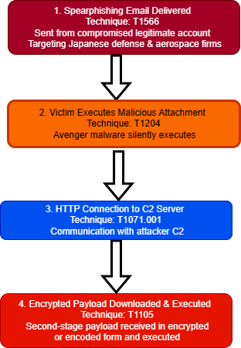

7. Persistence Techniques
Avenger delegates persistence to second-stage payloads. It does not set its own Registry keys or scheduled tasks.

Detail | Explanation | Technique
No Own Persistence | Avenger does not set persistence mechanisms | —
Delegates to Payload | Second-stage backdoors set persistence via Registry or scheduled tasks | T1547, T1053

8. Privilege Escalation
Detail | Explanation
No Explicit Escalation | Avenger does not perform privilege escalation
Victim Account Privileges | Operates with whatever privileges the victim holds at execution

9. Defense Evasion
Avenger uses adjustable internal parameters between versions to evade AV pattern-based signatures, consistent with BRONZE BUTLER's toolkit-wide evasion strategy. Delivery via compromised legitimate email accounts also reduces email gateway detection probability.

Layer | Technique | Detail
Adjustable Parameters | T1027 | Per-version parameter modification to evade AV signature detection
Legitimate Account Delivery | T1566 | Compromised email accounts reduce phishing detection probability
Multi-Variant Toolkit | — | Four concurrent downloaders reduce operational impact of any single detection

10. Credential Access
Method | Technique | Detail
No Credential Access | — | Avenger does not perform credential theft
Delegates to Payload | — | Second-stage backdoors handle all credential harvesting

11. Discovery Techniques
Avenger performs no discovery operations. All enumeration is conducted by the second-stage tools it deploys.

Detail | Explanation | Technique
No Built-in Discovery | Avenger performs no enumeration | —
Delegates to Payload | Second-stage tools handle discovery after deployment | T1082, T1016

12. Lateral Movement
Avenger does not perform lateral movement. This is handled by companion tools deployed after the second-stage backdoor is established.

Detail | Explanation
No Lateral Movement | Avenger deploys no lateral movement capability
Delegates to Payload | Second-stage tools handle lateral movement

13. Command & Control (C2)
Avenger uses HTTP to contact its C2 server and download second-stage payloads. BRONZE BUTLER's C2 infrastructure has historically included servers registered to entities in East Asia.

Method | Technique | Detail
HTTP | T1071.001 | Primary C2 channel — HTTP requests to attacker-controlled server
Ingress Tool Transfer | T1105 | Downloads and executes second-stage backdoors from C2

14. Exfiltration
Method | Technique | Detail
No Exfiltration | — | Avenger does not collect or exfiltrate data
Delegates to Payload | — | Second-stage backdoors perform data collection and exfiltration

15. Impact Analysis
Avenger's impact is enabling the delivery of advanced backdoors to high-value targets. As the fourth concurrent downloader in TICK's toolkit, it ensures operational continuity even when other variants are detected.

Impact Type | Technique | Detail
Initial Access Enabler | T1105 | Downloads and executes second-stage backdoors for long-term espionage
Operational Resilience | — | Fourth of four TICK downloaders — provides toolkit redundancy
Espionage Gateway | — | Enables classified data theft from Japanese defense and industrial targets

16. Indicators of Compromise (IOCs)

File System IOCs
IOC | Detail
PDB string in memory | TICK malware PDB naming (Avenger variant) in process memory
Unknown executable in user directory | Binary dropped in %TEMP% or %APPDATA% by email attachment

Behavioral IOCs
IOC | Detail
Immediate HTTP outbound | Process initiates HTTP connection to unknown domain on first execution
No persistence artifact | Avenger leaves no Registry or task artifacts — secondary payload check required

Network IOCs
IOC | Detail
Regular HTTP beaconing | HTTP requests at regular intervals to previously-unseen external domain

17. Detection & Mitigation

Detection Methods
Method | Technique | Detail
HTTP Outbound Monitoring | T1071.001 | Alert on HTTP connections from unsigned executables in user-writable directories
Email Attachment Sandbox | T1566 | Sandbox all email attachments before delivery to endpoints
AppLocker Enforcement | T1027 | Block unsigned binaries from executing in user-writable paths
PDB String Hunt | — | Search endpoint memory telemetry for TICK PDB naming convention

Mitigation Methods
Method | Detail
AppLocker | Block execution of unsigned binaries from %TEMP% and %APPDATA%
Email Security Gateway | Block and sandbox archive attachments from external senders
Network Monitoring | Alert on HTTP connections from new processes to unfamiliar external IPs
Threat Intelligence | Subscribe to BRONZE BUTLER / TICK IOC feeds for C2 infrastructure blocking

Overall Defensive Posture
Avenger's role as one of four concurrent TICK downloaders means blocking it alone is insufficient. A comprehensive TICK defense must address all four downloader variants alongside the second-stage backdoors they deliver.

18. References & Sources
# | Author / Source | Title | URL
1 | MITRE ATT&CK | S0473 — Avenger | https://attack.mitre.org/software/S0473/
2 | Trend Micro | Operation ENDTRADE (2019) | https://www.trendmicro.com/
3 | Secureworks | BRONZE BUTLER Threat Profile | https://www.secureworks.com/

